GitHub Branching & Merging Assignment - Evidence Document

1. Repository Creation & Username Branch
Created GitHub repository, initialized local repo, created Tutedude branch, committed Flask files and pushed to GitHub.
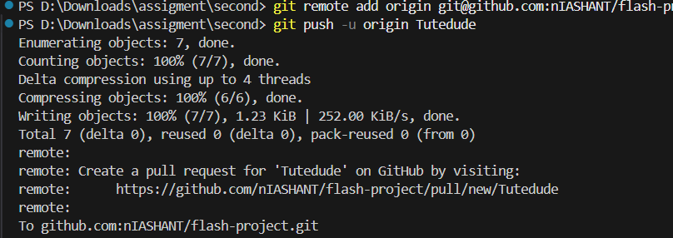

2. JSON Update in Tutedude_new Branch
Created Tutedude_new branch, modified data.json for API route, merged into main and pushed updates.
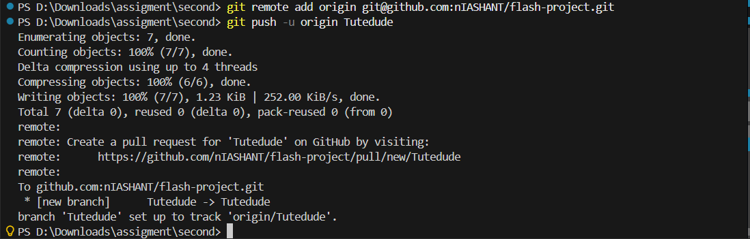

3. Creating master_1 and master_2 Branches
Created master_1 for frontend changes and master_2 for backend API implementation.
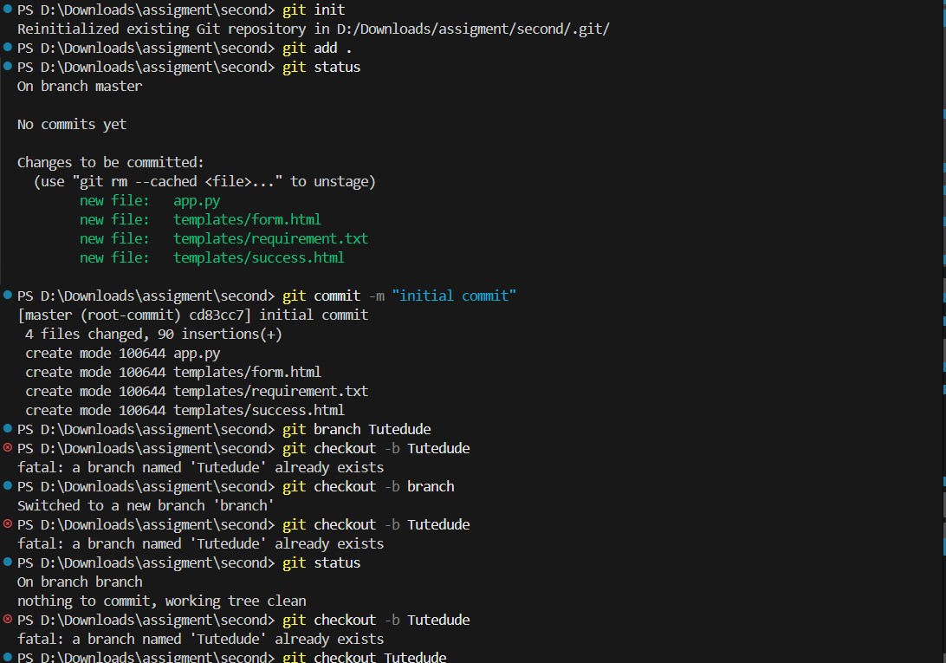

4. Frontend To-Do Form Development (master_1)
Added Item Name, Description and additional form fields step‑by‑step with commits.
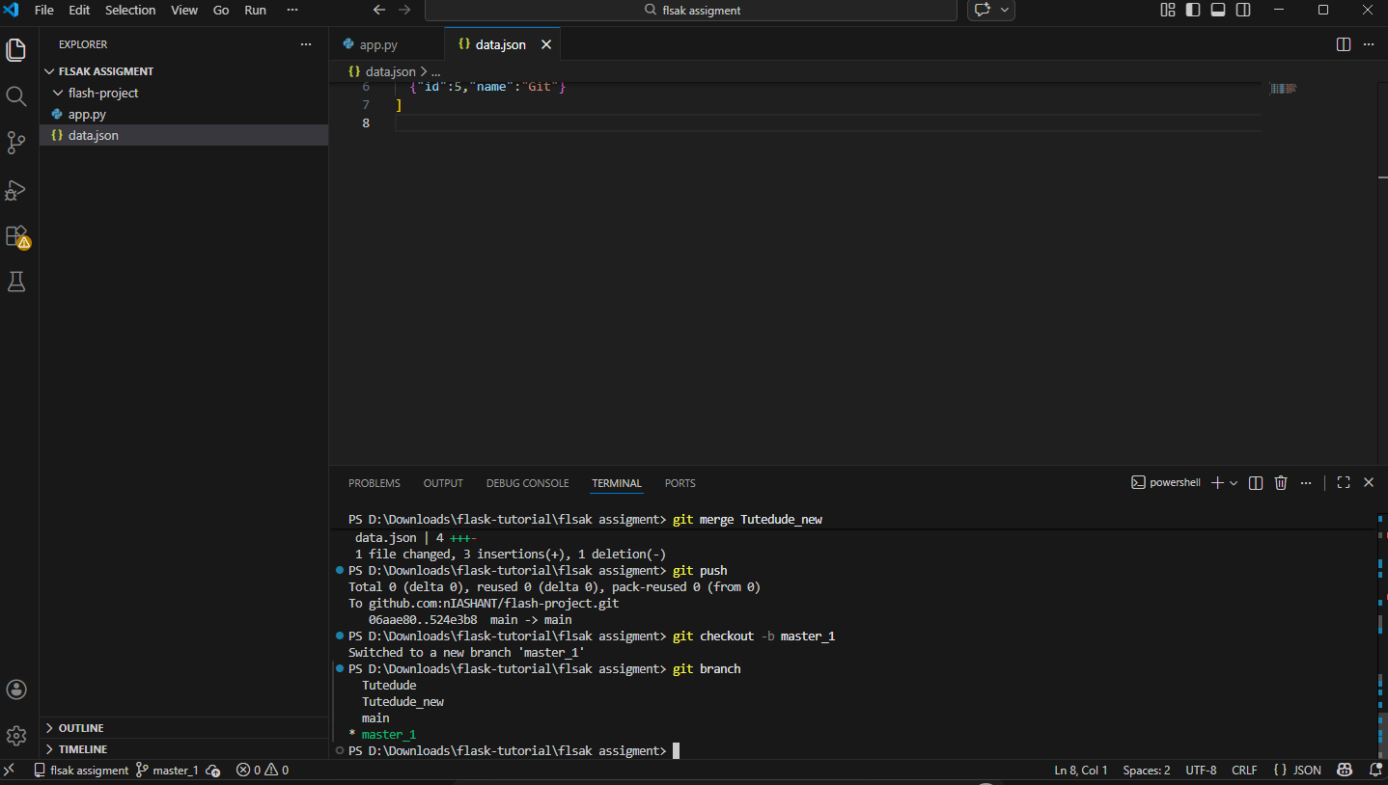

5. Backend Route Implementation (master_2)
Created /submittodoitem API route and committed backend logic.
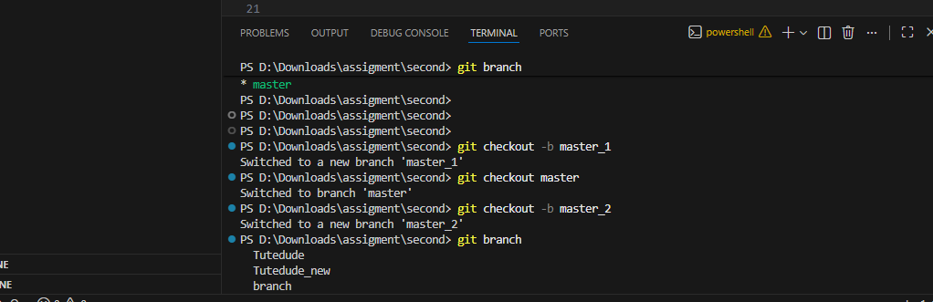

6. Merge master_1 & master_2 into main
Merged both branches into main branch and resolved conflicts using master_1 changes.
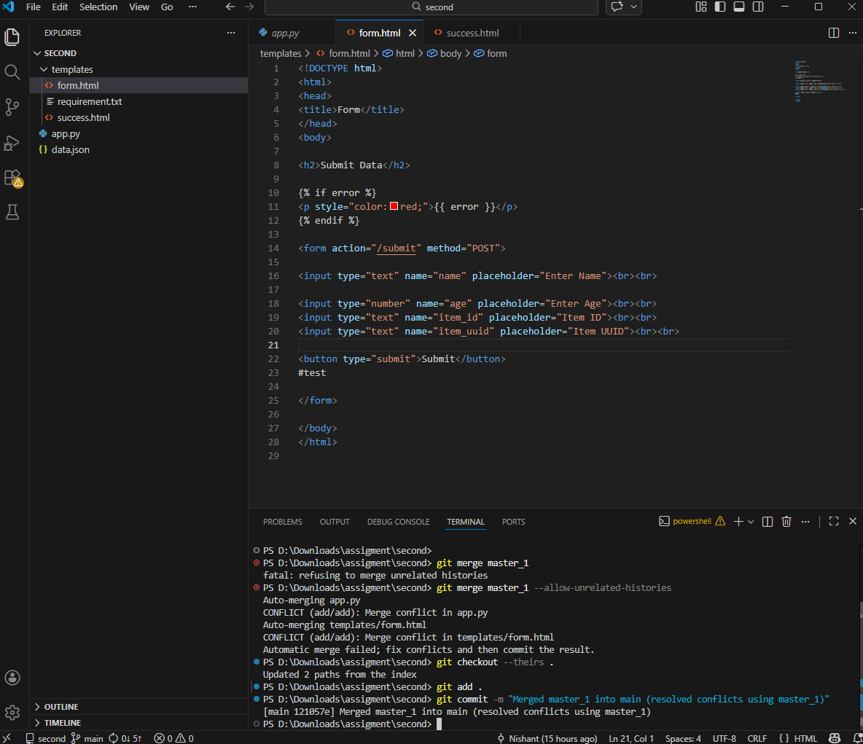

7. Enhancing Form Fields (Item ID, UUID, Hash)
Committed Item ID, UUID and Hash fields sequentially in master_1 branch.
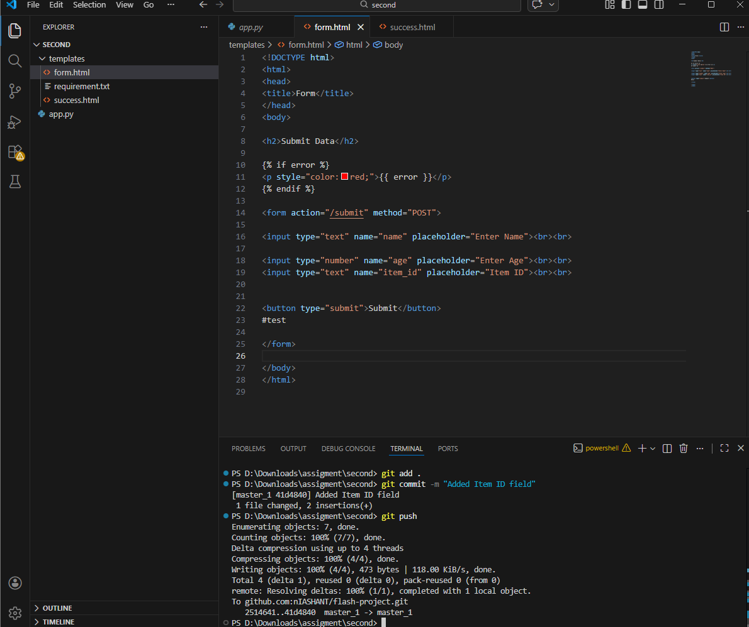

8. Git Reset (Soft) on main Branch
Performed git reset --soft to revert main branch back to Item ID only state and recommitted changes.
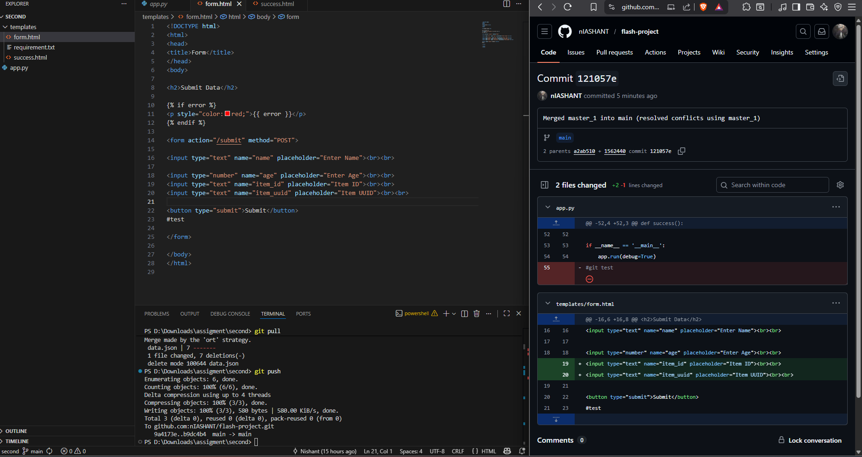

9. Rebase main into master_1
Rebased master_1 branch on top of updated main while preserving commit history.
