Flask + MongoDB Atlas Assignment Documentation

1. Overview
This project demonstrates a Flask application with two main functionalities:
1) An /api route that reads data from a backend JSON file and returns it as a JSON response.
2) A frontend form that submits data to MongoDB Atlas. On success, the user is redirected to a success page. If an error occurs, it is shown on the same page.

2. API Route (/api)
The Flask application reads data from a backend file (data.json) using Python's JSON module. When the /api endpoint is accessed, it returns the data along with status and count in JSON format.

3. Screenshots & Explanation
Backend data.json file used for API response.
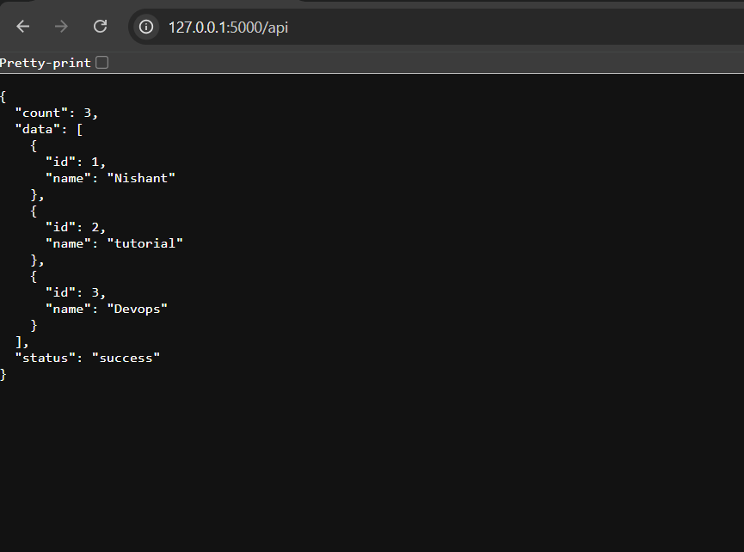
Flask API route code reading JSON file.

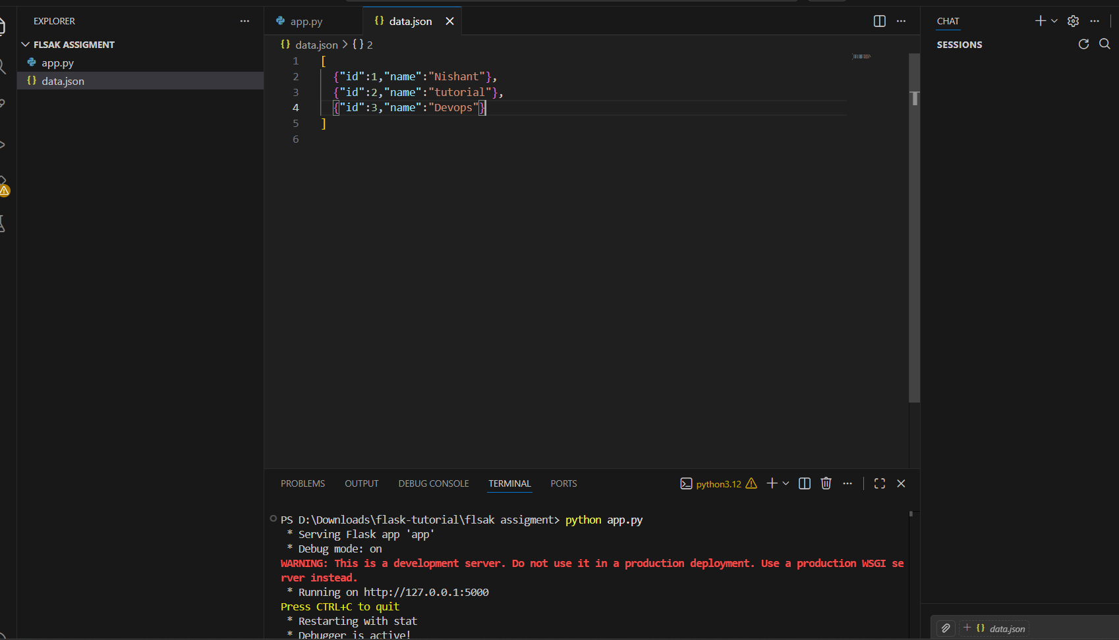

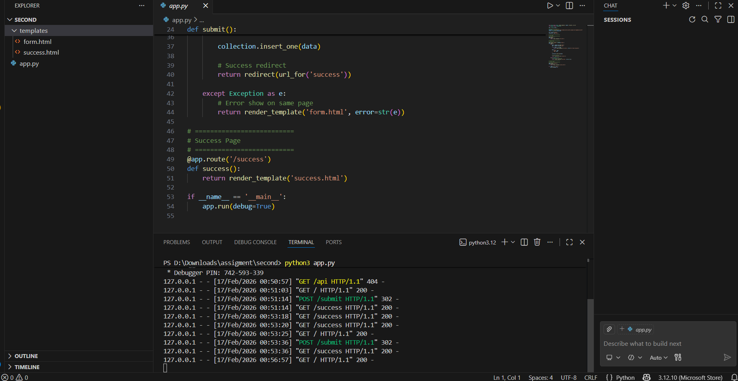Frontend form for submitting data.
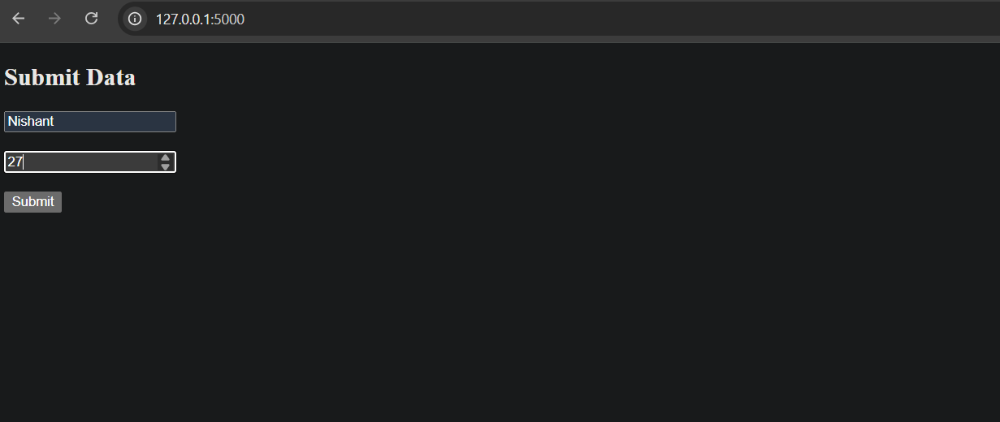
Success page displayed after submission.
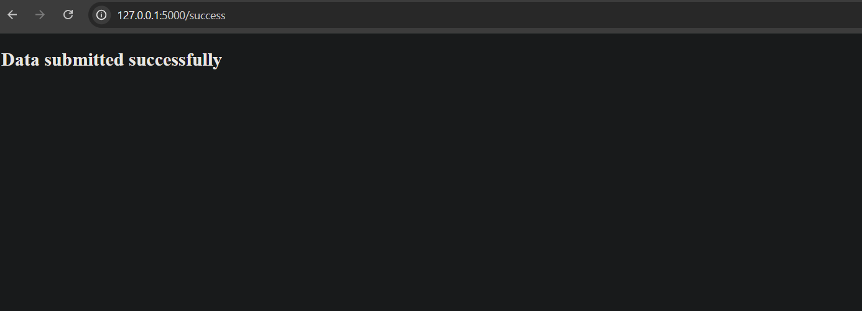
MongoDB Atlas collection showing inserted data.
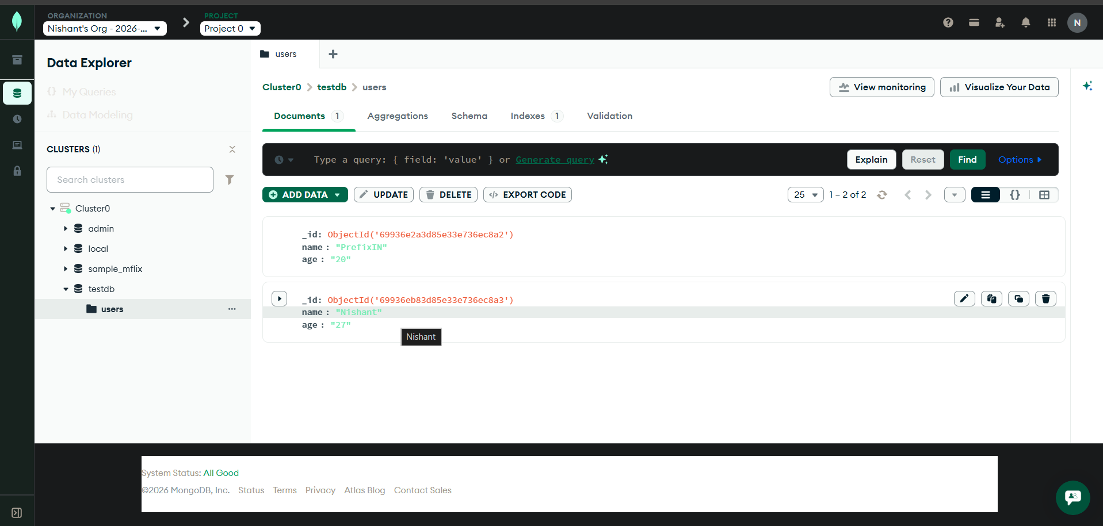
Terminal logs showing Flask app running and requests.
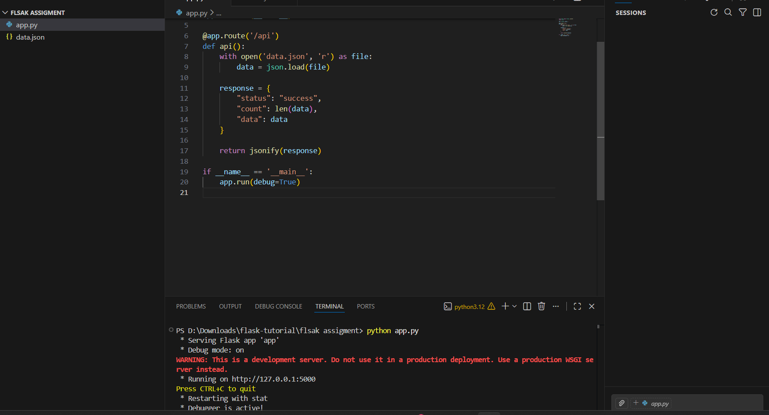

4. MongoDB Form Submission Flow
The frontend form sends a POST request to the /submit route. Flask receives the data, inserts it into MongoDB Atlas using PyMongo, and redirects the user to the success page. If any exception occurs, the error message is rendered on the same form page.

5. Commands Used
Run Flask App:
python app.py
Access API:
http://127.0.0.1:5000/api
Submit Form:
http://127.0.0.1:5000/

