Launched EC2
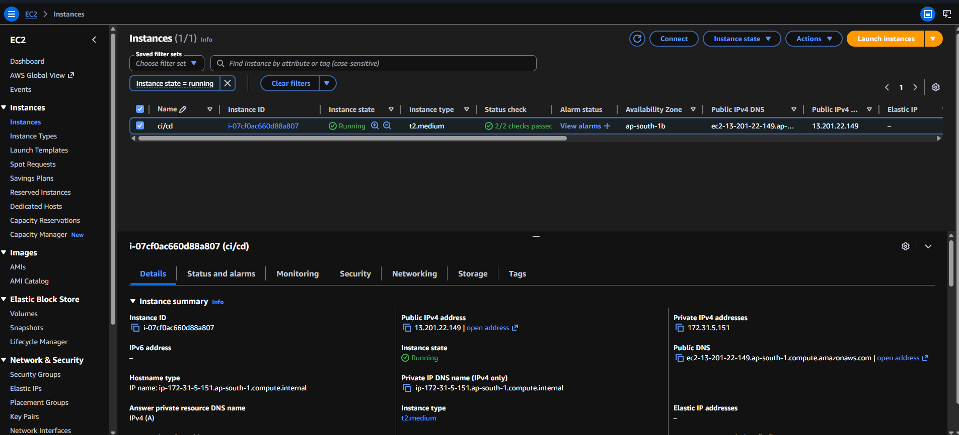

Install dependencies like pm2, npm, pip, flask and node etc….
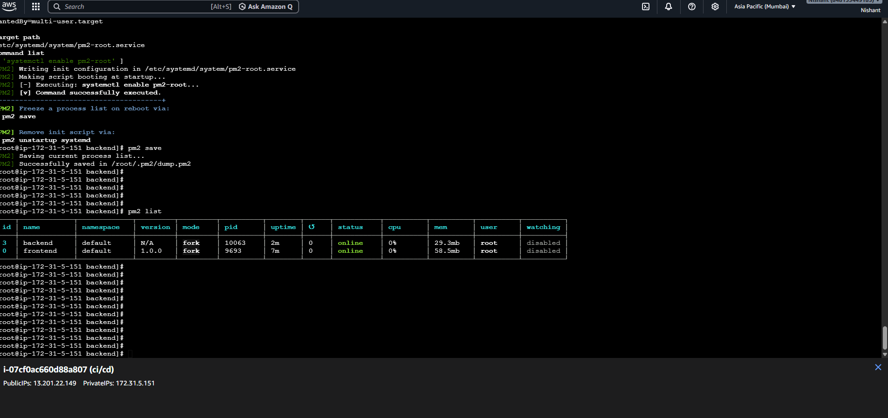

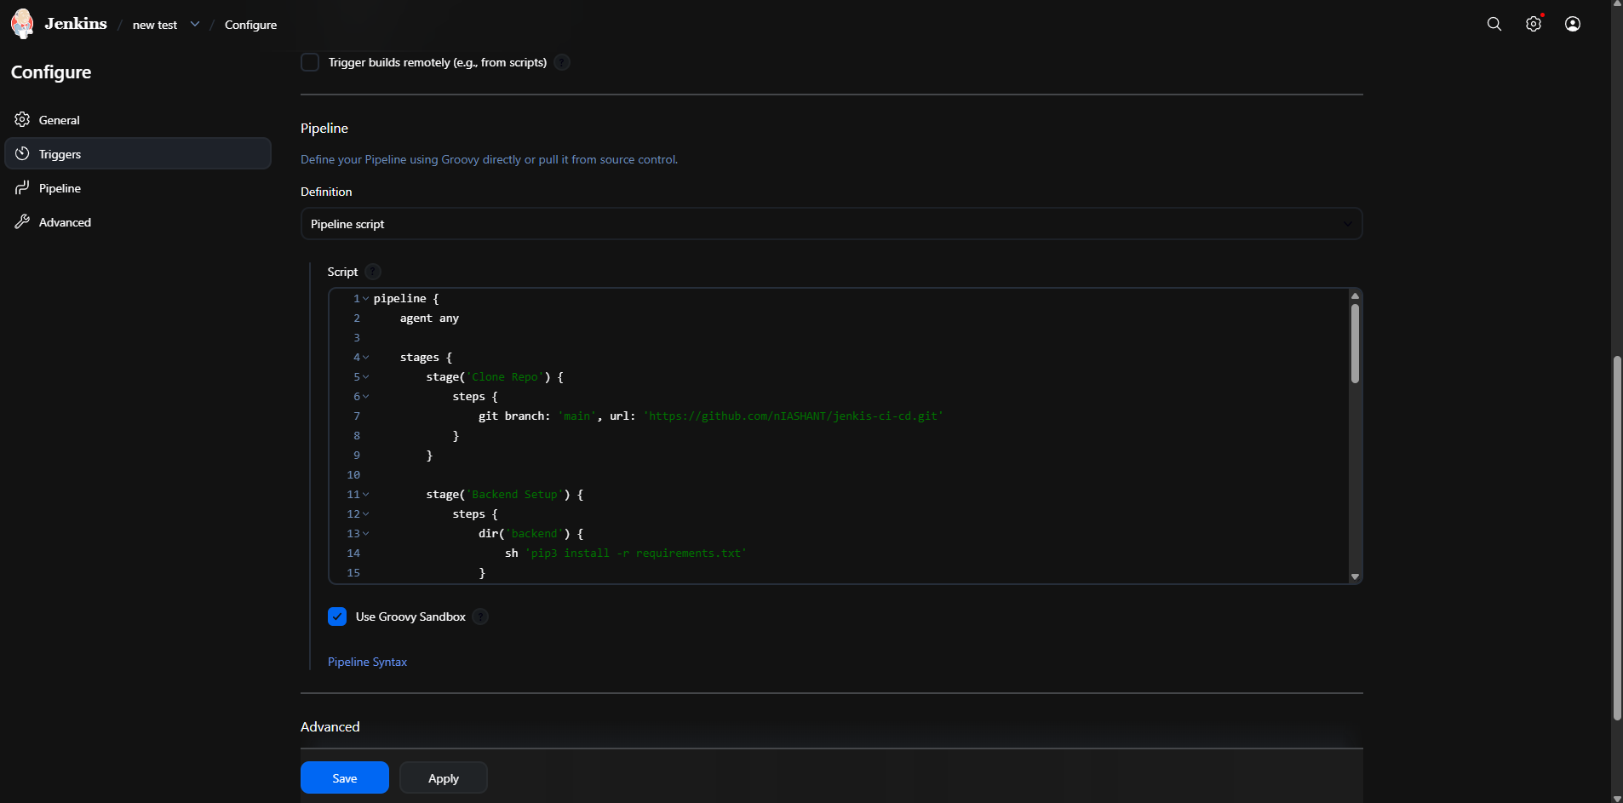
Making Builds at Jenkins

Build is created.
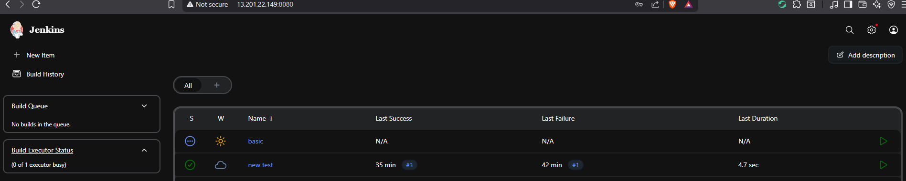

See repositories at github.
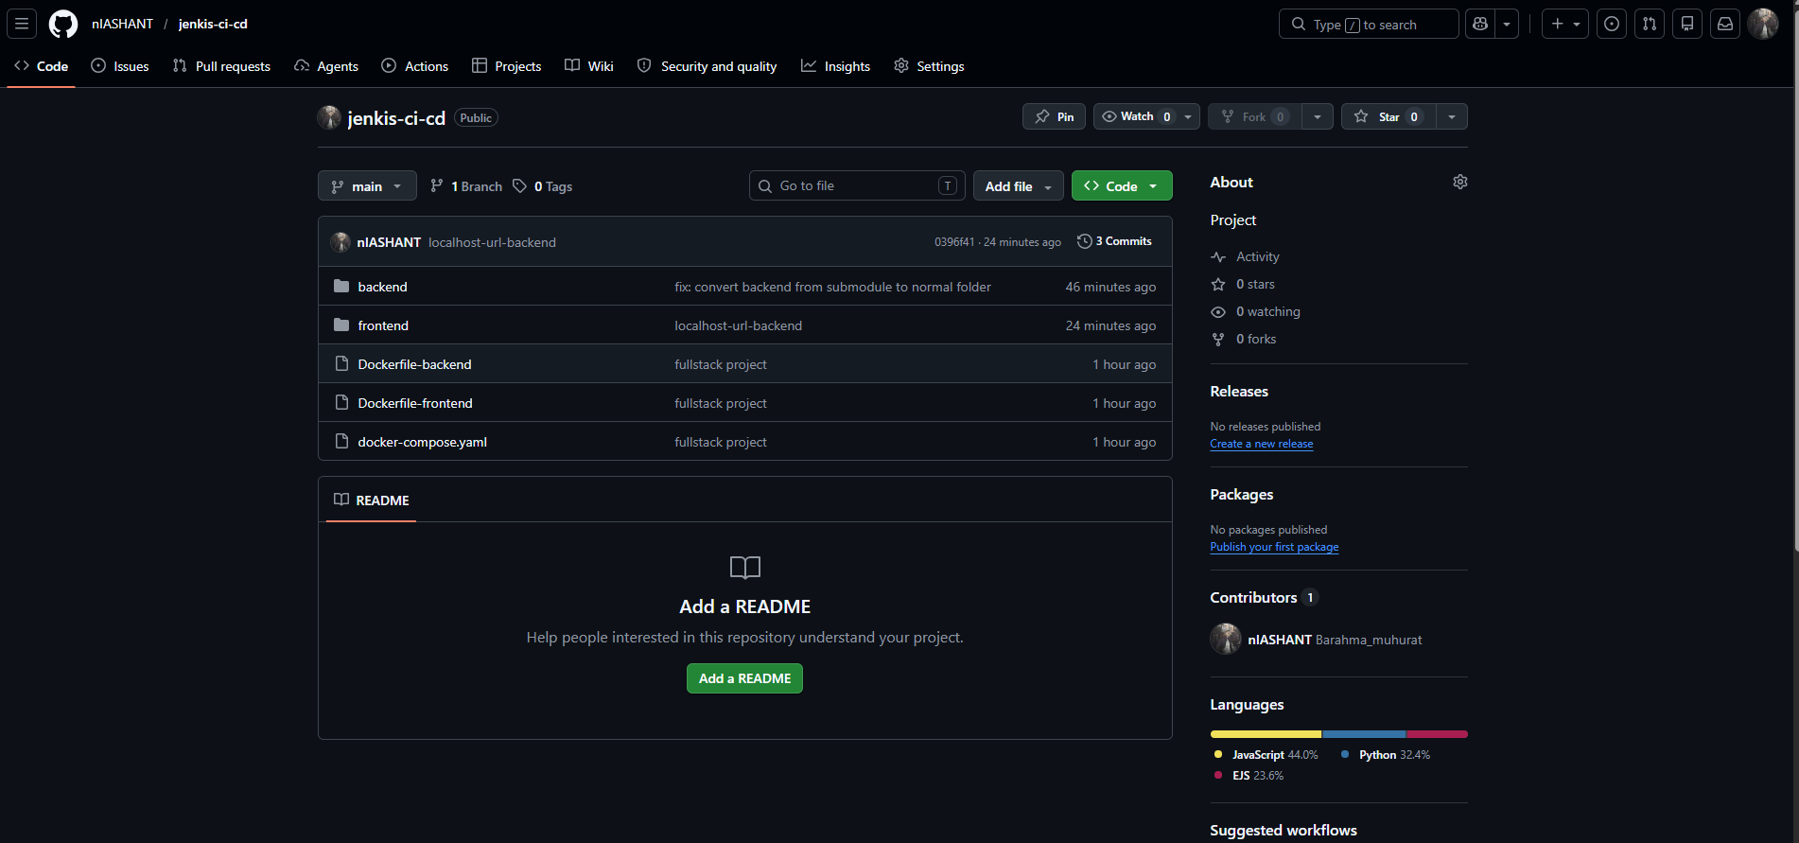

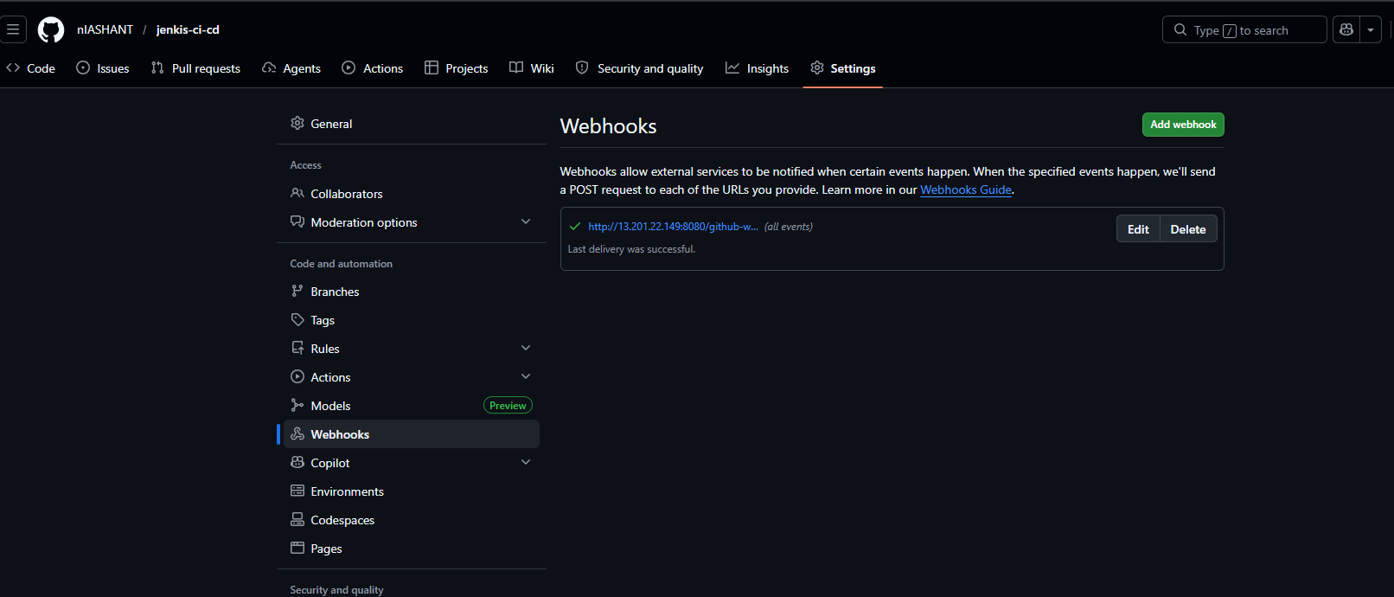
Add aws public Ip of GitHub webhooks
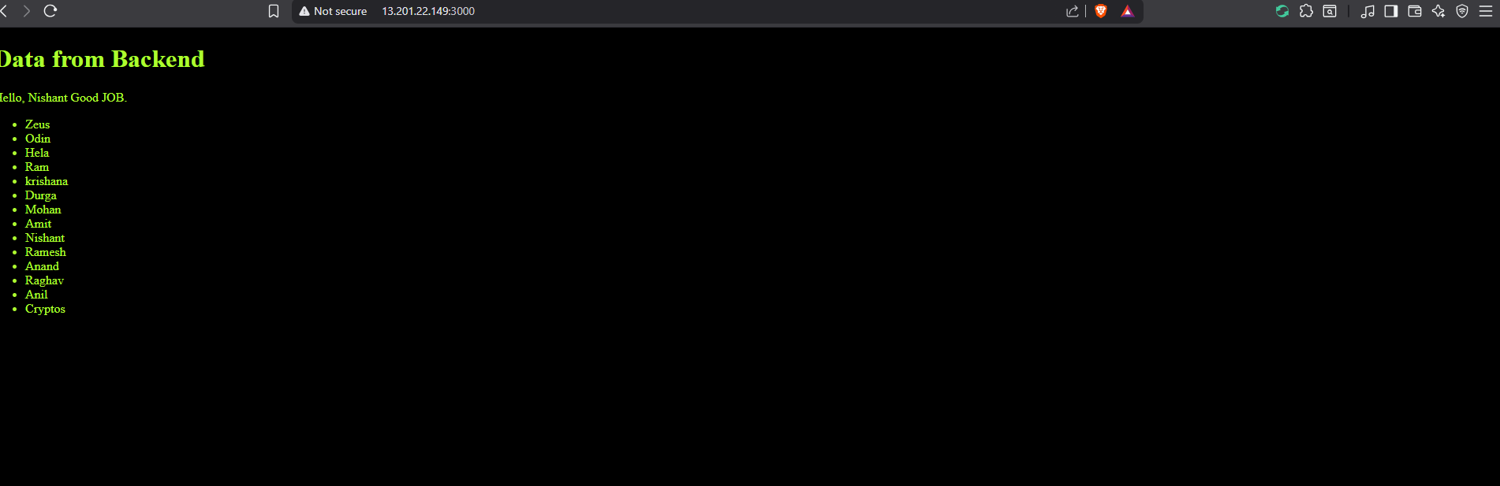
After that see frontend is accessible
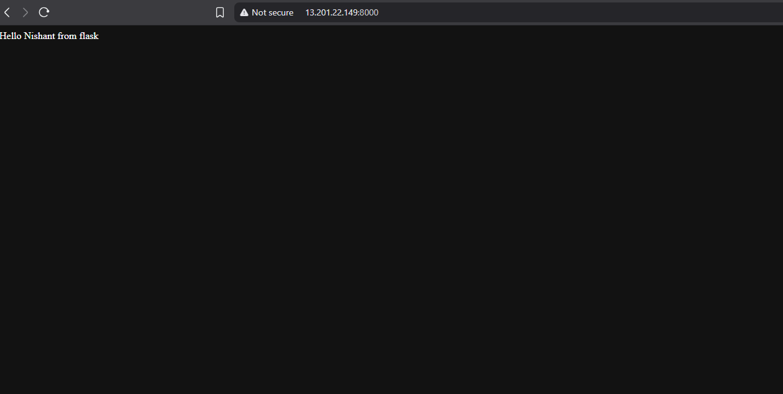
See backend is accessible through public ip.

URLS: http://13.201.22.149:3000/ ( for frontend)
http://13.201.22.149:8000/ (for backend)
http://13.201.22.149:8080/ (Jenkins url)

