Cluster running proof
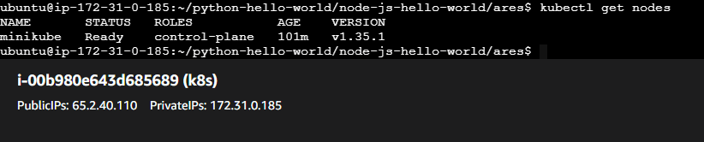

Pods running proof
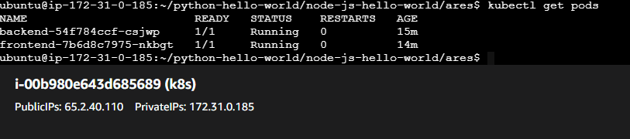

Services proof
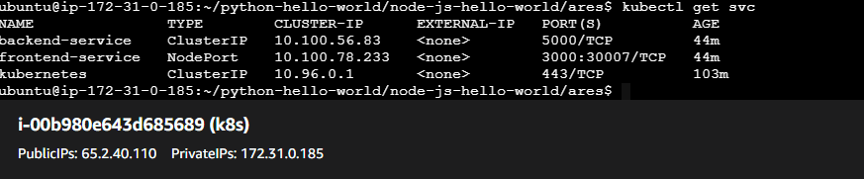

Docker images proof
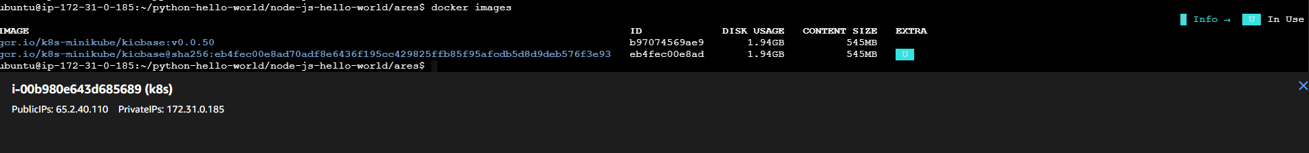

Backend working proof
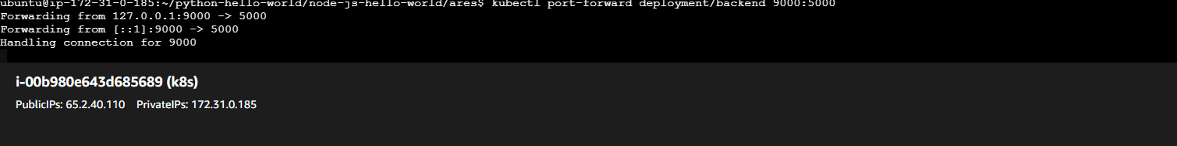
curl http://localhost:9000 Hello Nishant from flask
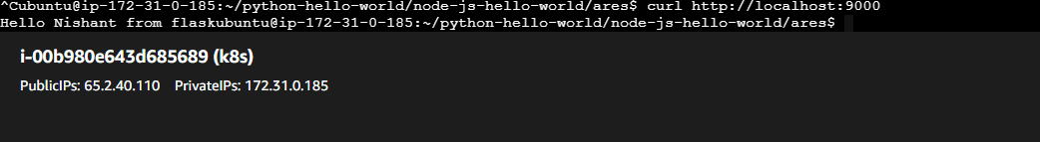

Frontend working proof
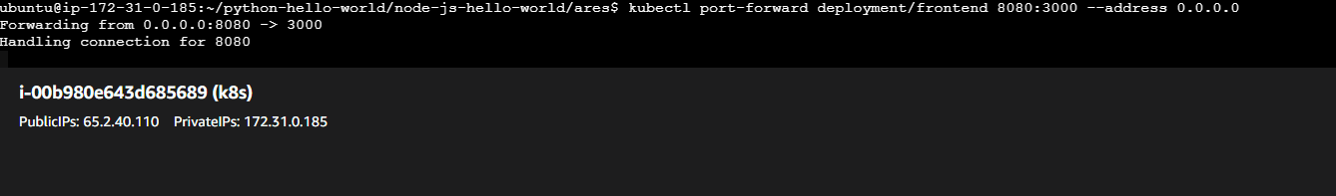

Browser: http://65.2.40.110:8080/ ( UI + data list)
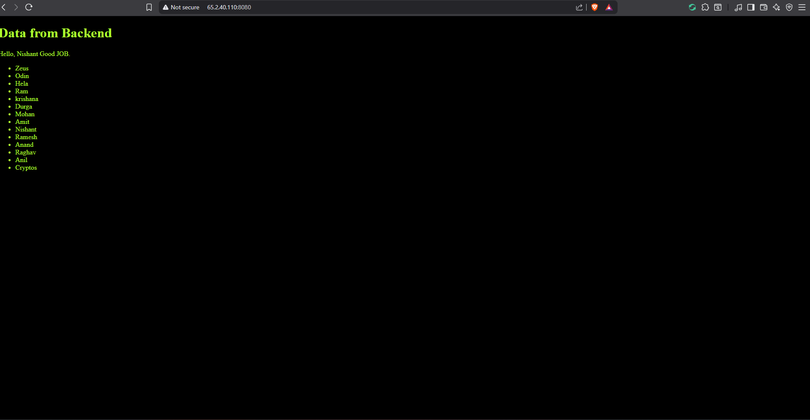

Logs proof:
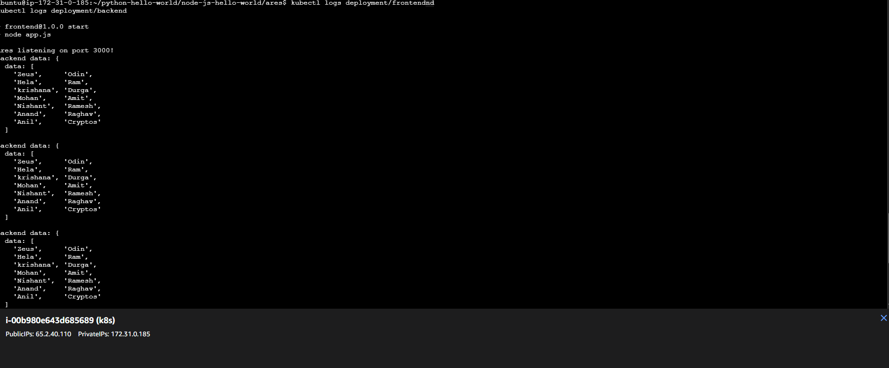

Logs proof:
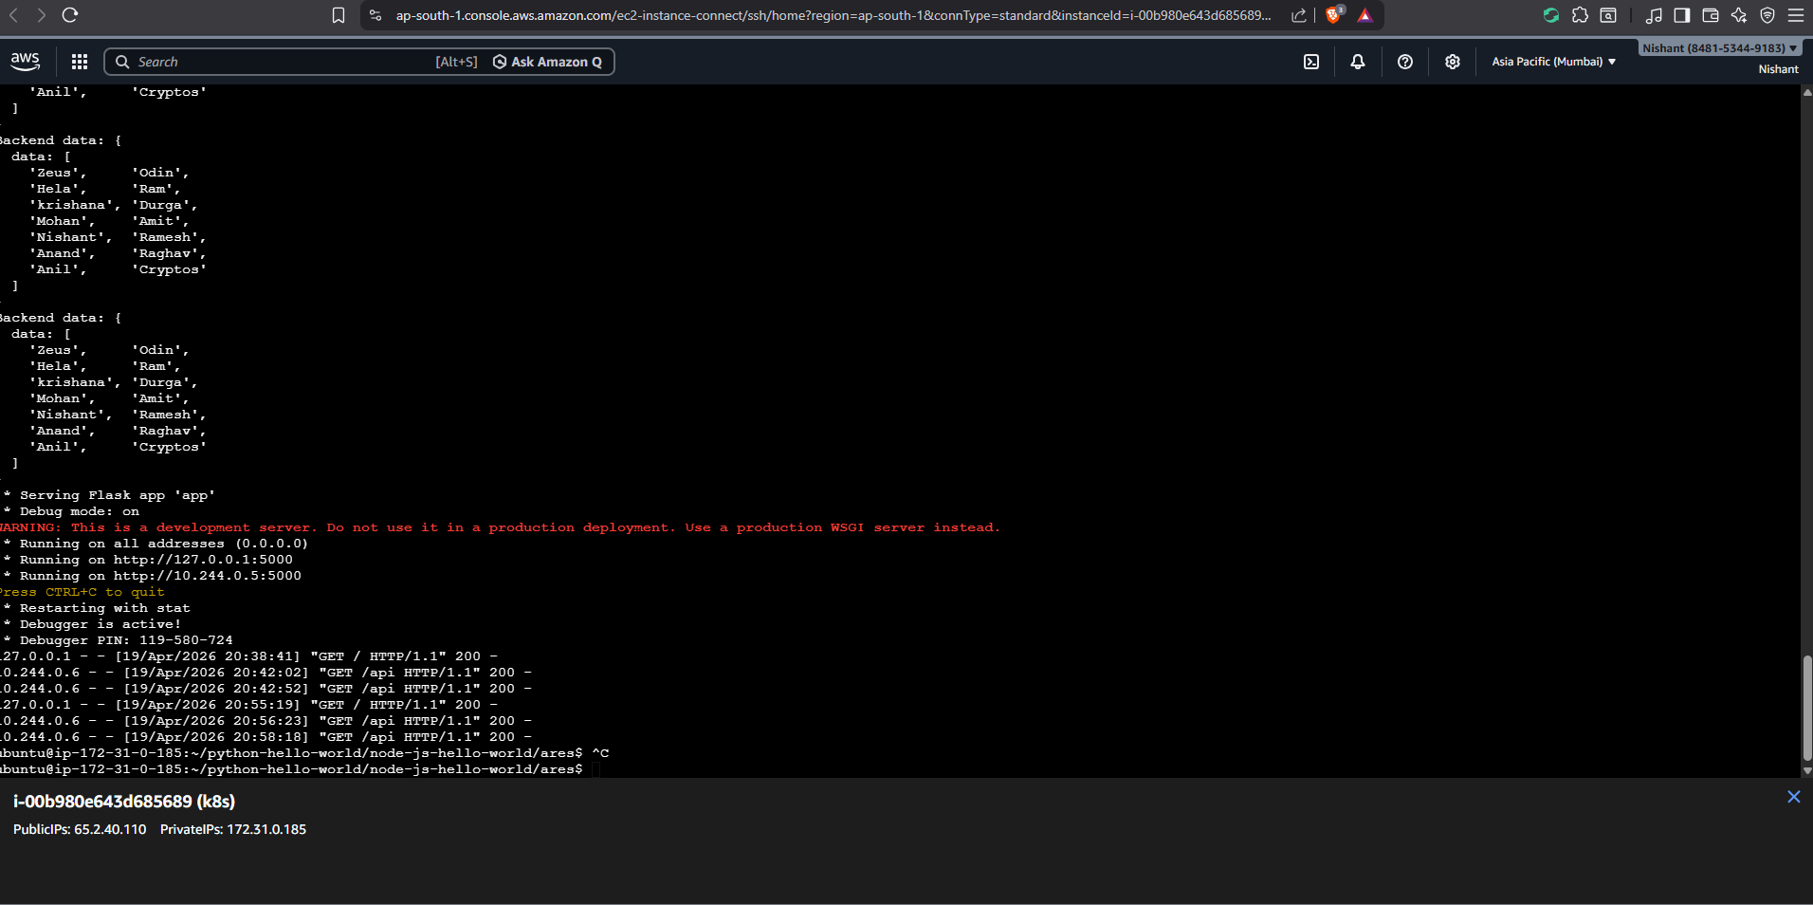

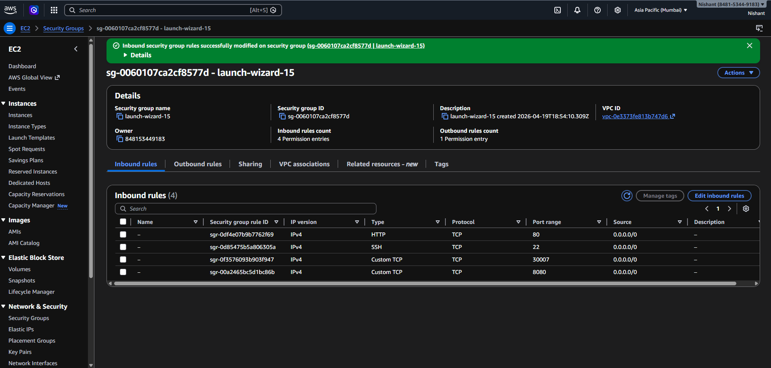

Flow diagram

User (Browser)
↓
EC2 Public IP: 8080
↓
Port Forward
↓
Frontend (Node.js - 3000)
↓
backend-service (ClusterIP)
↓
Backend (Flask - 5000)

This project demonstrates deployment of a multi-tier application using Kubernetes on Minikube (running on AWS EC2).
The frontend (Node.js) and backend (Flask) are containerized using Docker and deployed as separate Kubernetes deployments. The backend is exposed internally using a ClusterIP service, while the frontend is accessed externally via port-forwarding.
The frontend communicates with the backend using Kubernetes service DNS (backend-service). The application is verified using kubectl commands and browser access.
All components are successfully running and communicating within the Kubernetes cluster.

