Linux Basic Commands Assignment

1. Creating and Renaming Files/Directories
Command:
mkdir test_dir
Explanation:
Creates a directory named test_dir.
Command:
touch example.txt
Explanation:
Creates an empty file.
Command:
mv example.txt renamed_example.txt
Explanation:
Renames the file.

2. Viewing File Contents
Command:
cat /etc/passwd
Explanation:
Displays complete user account file.
Command:
head -n 5 /etc/passwd
Explanation:
Displays first 5 lines.
Command:
tail -n 5 /etc/passwd
Explanation:
Displays last 5 lines.

3. Searching for Patterns
Command:
grep root /etc/passwd
Explanation:
Searches for entries containing 'root'.

4. Zipping and Unzipping
Command:
zip -r test_dir.zip test_dir
Explanation:
Compresses directory.
Command:
unzip test_dir.zip -d unzipped_dir
Explanation:
Extracts zip file.

5. Downloading Files
Command:
wget https://example.com/sample.txt
Explanation:
Attempts to download file from URL.

6. Changing Permissions
Command:
chmod 444 secure.txt
Explanation:
Sets file as read-only for everyone.

7. Environment Variables
Command:
export MY_VAR="Hello, Linux!"
Explanation:
Creates environment variable.

Screenshots with Proof
Screenshot evidence
Screenshot evidence

Screenshot evidence
Screenshot evidence
Screenshot evidence
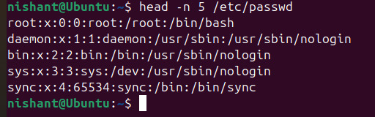
Screenshot evidence
Screenshot evidence
Screenshot evidence
Screenshot evidence
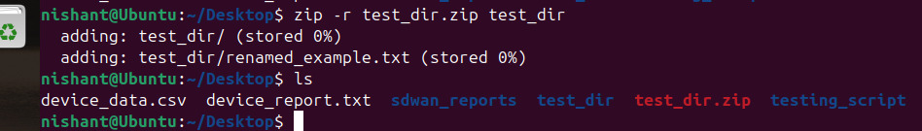
Screenshot evidence
Screenshot evidence
Screenshot evidence
Screenshot evidence
Screenshot evidence

