LAB 1 - MATLAB FUNCTIONALITY FOR DIGITAL SPEECH PROCESSING

**Reading an Audio File into MATLAB and playing it back**

**MATLAB Code**

*[s,fs,nbits]=wavread('hunder.wav');*

*fprintf('The sampling rate = %i Hz \nBit resolution = %i bits per sample\n',fs,nbits);*

*fprintf('Playing sound with fs = %i Hz\n',fs);*

*soundsc(s,fs);*

*fprintf('Playing sound with fs = %i Hz\n',fs/2);*

*soundsc(s,fs/2);*

*fprintf('Playing sound with fs = %i Hz\n',fs*2);*

*soundsc(s,fs*2);*

**Output**

The sampling rate = 44100 Hz

Bit resolution = 16 bits per sample

Playing sound with fs = 44100 Hz

Playing sound with fs = 22050 Hz

Playing sound with fs = 88200 Hz

**Discussion**

For reading .wav file we can use wavread() function on matlab. Later we vary the frequency and play the sound using soundsc() function.

**Plotting the Signal Waveform**

**MATLAB Code**

[s,fs,nbits]=wavread('hunder.wav');

subplot(2,1,1);

plot(s);

xlabel('Number of samples');

ylabel('Amplitude');

title('Speech waveform for the word /obey/');

grid on;

xval=linspace(0,1,length(s));

xval = xval*length(s)/fs;

subplot(2,1,2);

plot(xval,s);

xlabel('Time in seconds');

ylabel('Amplitude');

grid on;

**Output**

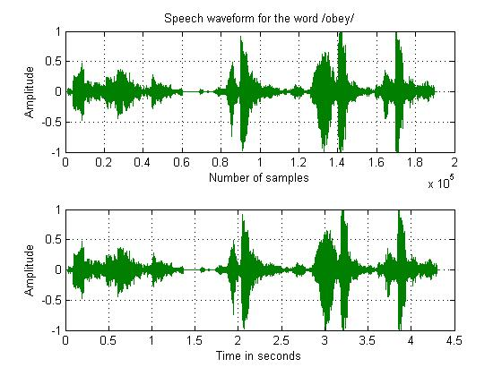

**Discussion**

In this exercise we plot the sample recorded sound using plot() function available at matlab *.* The maximum and minimum values of the signal are 1 and -1 respectively.

**Plotting the Spectrogram**

**MATLAB Code**

[s,fs,nbits]=wavread('hunder.wav');

framelen_samples = (20/1000)*fs;

noverlap = ceil(0.3* framelen_samples);

NFFT = 2^nextpow2(framelen_samples);

subplot(2,2,1);

plot(hamming(framelen_samples));

title('Hamming Window');

subplot(2,2,2);

spectrogram(s(:,1),hamming(framelen_samples),(noverlap),NFFT,fs);

title('Spectrogram of the speech signal');

SG = spectrogram(s(:,1),hamming(framelen_samples),(noverlap),NFFT,fs);

spectrum = SG(:,40);

magnitudespectrum = abs(spectrum);

subplot(2,2,3);

plot(20*log10(magnitudespectrum+eps));

title('Magnitude Spectrum of the signal');

freqvaluesHz = ((0:NFFT/2)/(NFFT/2+1))*(fs/2);

subplot(2,2,4);

plot(freqvaluesHz, 20*log10(magnitudespectrum+eps));

xlabel('Frequency [Hz]');

ylabel('Magnitude [dB]');

title('Magnitude Spectrum: dB vs Hz');

grid on;

**Output**

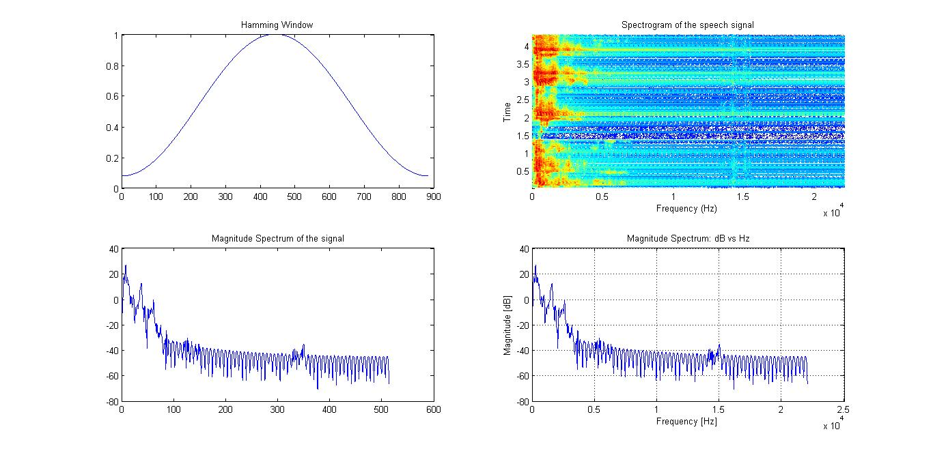

**Discussion:**

In this exercise we plot hamming window, spectrogram, magnitude spectrum of the signal and magnitude spectrum in db. Here noverlap value is in float so we have to ceil it to get output, as spectrogram need integer value.

**American English Phonetics**

Firstly, we synthesized the English word ‘speech’ using the Praat software and saved as speech.wav. Then, we then separated the voiced and unvoiced sounds from those word.

**For ‘speech’ word**

**MATLAB Code**

*[s,fs,nbits] = wavread('speech_default.wav');*

*t = 1/fs:1/fs:length(s)/fs;*

*start1 = 0.15;*

*finish1 = 0.23;*

*figure(1)*

*subplot(411) %plot of entire word*

*plot(t,s); grid on;*

*title('Plot of "speech" ')*

*xlabel('Time (sec)')*

*ylabel('Amplitude')*

*subplot(412) %plot of phoneme in examination*

*plot(t,s); grid on;*

*axis([start1 finish1 -.5 .5])*

*title('Plot of phoneme: /e/')*

*xlabel('Times (sec)')*

*ylabel('Amplitude')*

*subplot(413) %plot of voiced sounds obtained from Praat software*

*[s,fs,nbits] = wavread('speech_ default _voiced.wav');*

*t = 1/fs:1/fs:length(s)/fs;*

*plot(t,s); grid on;*

*title('Plot of voiced sound in /speech/ word ')*

*xlabel('Time (sec)')*

*ylabel('Amplitude')*

*subplot(414) %plot of unvoiced sounds obtained from Praat software*

*[s,fs,nbits] = wavread('speech_ default _unvoiced.wav');*

*t = 1/fs:1/fs:length(s)/fs;*

*plot(t,s); grid on;*

*title('Plot of unvoiced sound in /speech/ word ')*

*xlabel('Time (sec)')*

*ylabel('Amplitude')*

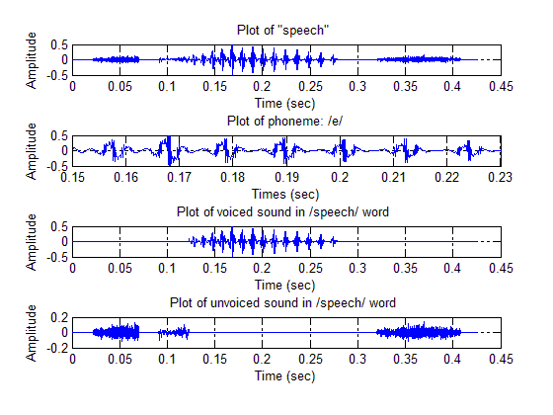**Output**

Now, I plotted the signal for the same word ‘speech’ but recorded my own voice. The result is shown below:

**MATLAB Code**

*[s,fs,nbits] = wavread('speech_v1.wav');*

*t = 1/fs:1/fs:length(s)/fs;*

*start1 = 1.30;*

*finish1 = 1.37;*

*figure(1)*

*subplot(411) %plot of entire word*

*plot(t,s); grid on;*

*title('Plot of "speech" ')*

*xlabel('Time (sec)')*

*ylabel('Amplitude')*

*subplot(412) %plot of phoneme in examination*

*plot(t,s); grid on;*

*axis([start1 finish1 -.05 .05])*

*title('Plot of phoneme: /e/')*

*xlabel('Times (sec)')*

*ylabel('Amplitude')*

*subplot(413) %plot of voiced sounds obtained from Praat software*

*[s,fs,nbits] = wavread('speech_v1_voiced.wav');*

*t = 1/fs:1/fs:length(s)/fs;*

*plot(t,s); grid on;*

*title('Plot of voiced sound in /speech/ word ')*

*xlabel('Time (sec)')*

*ylabel('Amplitude')*

*subplot(414) %plot of unvoiced sounds obtained from Praat software*

*[s,fs,nbits] = wavread('speech_v1_unvoiced.wav');*

*t = 1/fs:1/fs:length(s)/fs;*

*plot(t,s); grid on;*

*title('Plot of unvoiced sound in /speech/ word ')*

*xlabel('Time (sec)')*

*ylabel('Amplitude')*

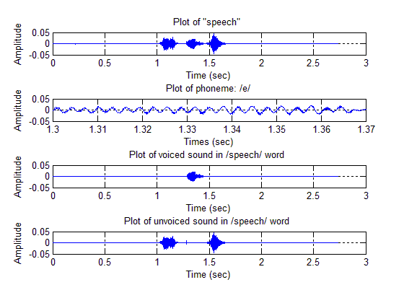**Output**

# CONCLUSIONS

After completing this lab, we become familiar with basic read function, plot function available in matlab for speech processing.