Speech Processing [Lab 2 – Report]

Submitted By: - Narayan Kandel [066BCT520]

## Objectives

* To become familiar with the time domain methods for speech processing.
* To calculate

*Short-time energy*

*Average magnitude*

*Short-time average zero crossing rate*

*Short-time autocorrelation function*

* To check the effect of windowing in the calculation of different functions.

## Observation

1. **Plotting Different Window functions: Rectangular & Hamming**

Outputs:-

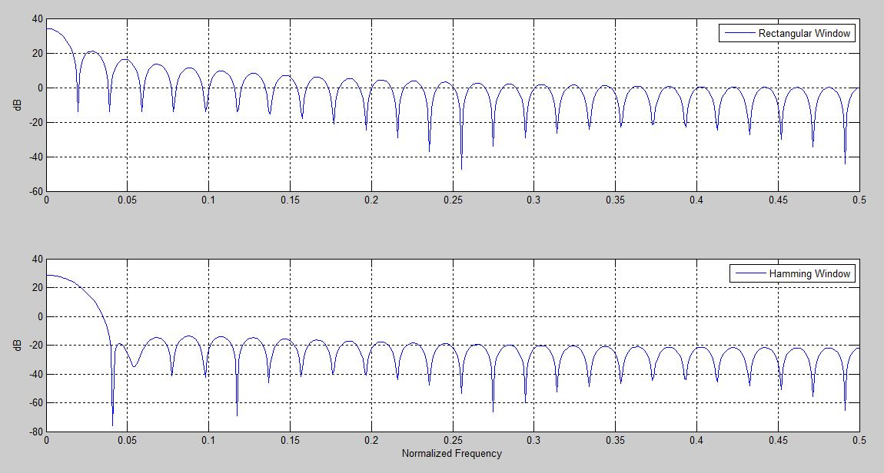

Comment: -

The choice of the window in short-time speech processing determines the nature of the measurement representation. A long window would result in very little changes of the measurement in time whereas the measurement with a short window would not be sufficiently smooth. We’ve plotted two representative windows namely, Rectangular and Hamming. The latter has almost twice the bandwidth of the former, for the same length. Furthermore, the attenuation for the Hamming window (below - 20 dB) outside the passband is much greater than that of the Rectangular window (approx. -14 dB).

1. **Short-time Energy Calculation**

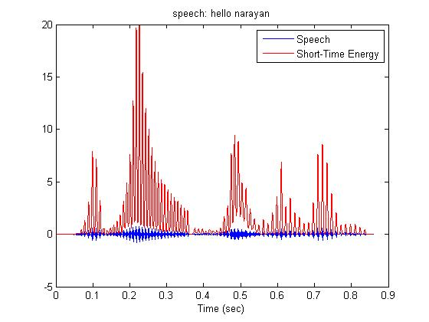

Comment: -

From this problem, we can say that voice signal can be separated from unvoiced signal on the basis of the short time energy as voice signal has significant higher energy than that of unvoiced signals.

1. **Short-time Average Magnitude Calculation**

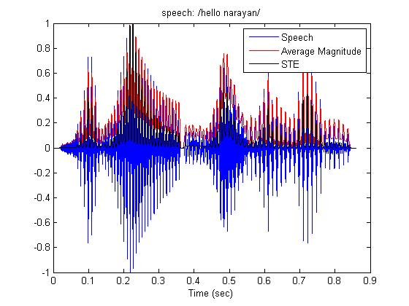

Comment: -

Average magnitude don’t emphasize the separation between voice and unvoiced signal as short time energy.

1. **Short-time Average Zero-crossing Rate Calculation**

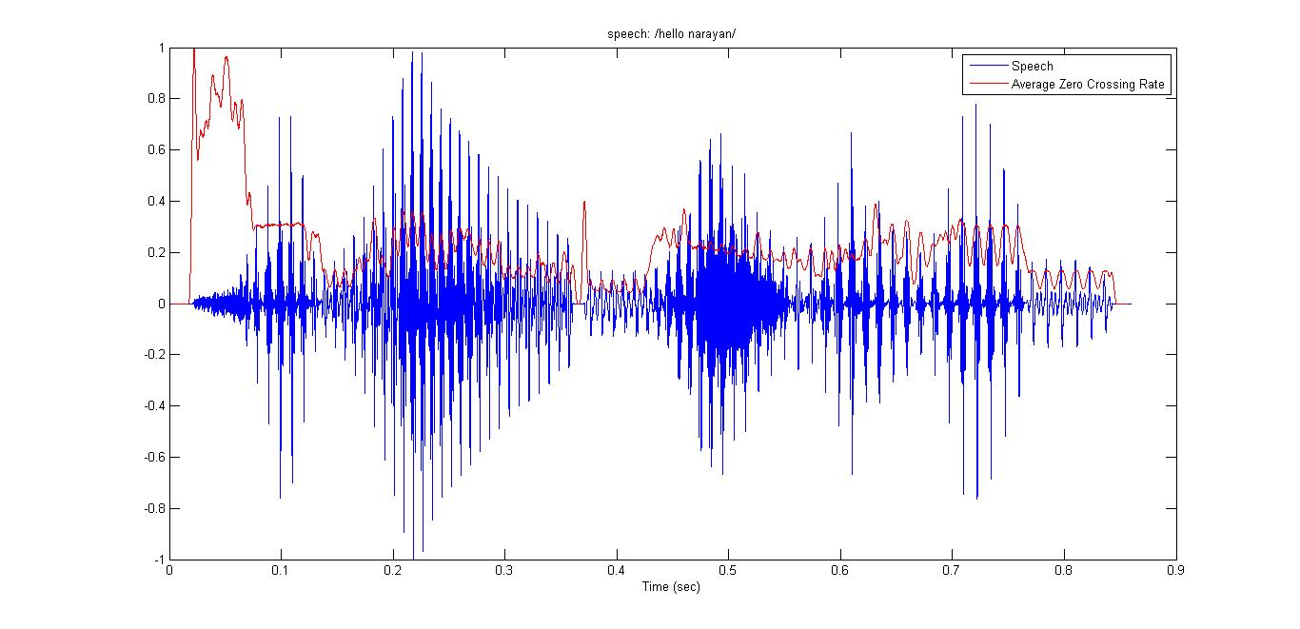

Comment:-

Unvoiced signal has high zero crossing than that of voiced signal as large number of noise are present on unvoiced signal. So zero crossing can also be taken as parameter in separating voiced and unvoiced signal.

1. **Short-time Autocorrelation Calculation**

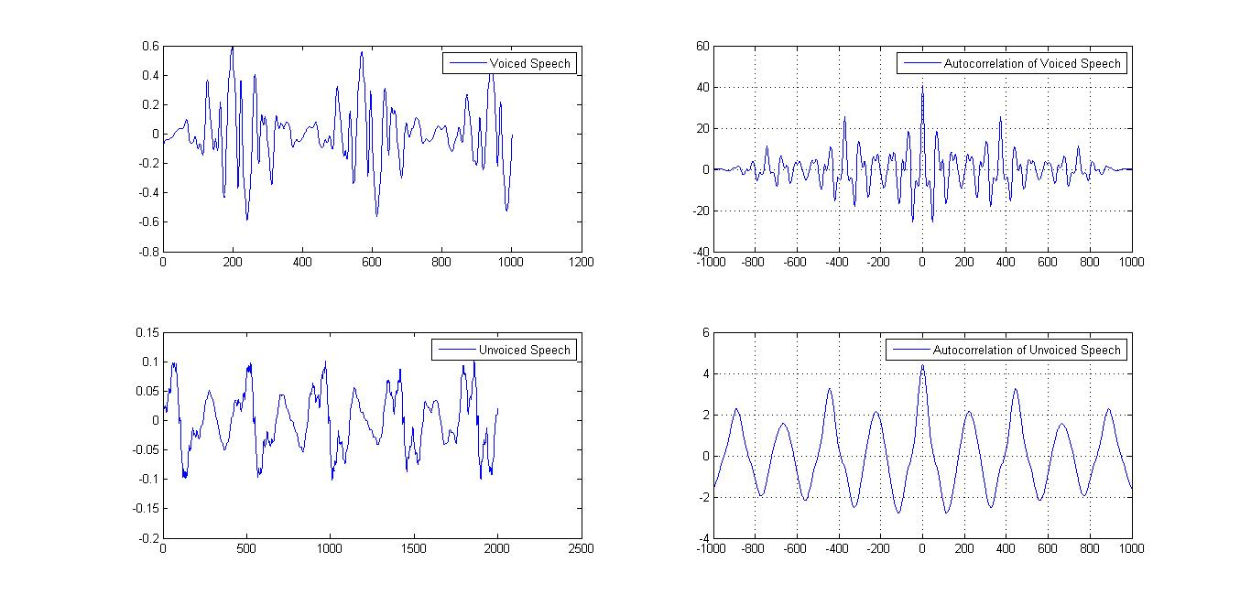

Comment: -

Voice signal has high autocorrelation coefficient that that of unvoiced signal i.e autocorrelation of unvoiced signal is looked more like noise.

1. **Short-time Energy Calculation for Hamming Window of Variable Length**

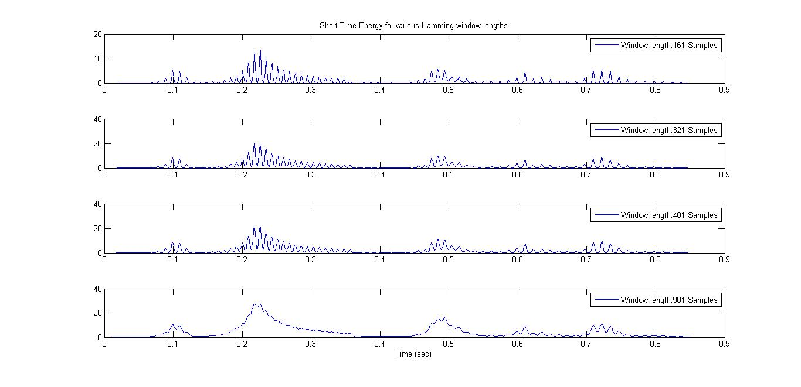

Comment: -

This problem demonstrate the effect of hamming window length on short time energy of the signal. As window length increased, short time energy become smother and smother i.e. give less information.

1. **Short-time Energy Calculation for Rectangular Window of Variable Length**

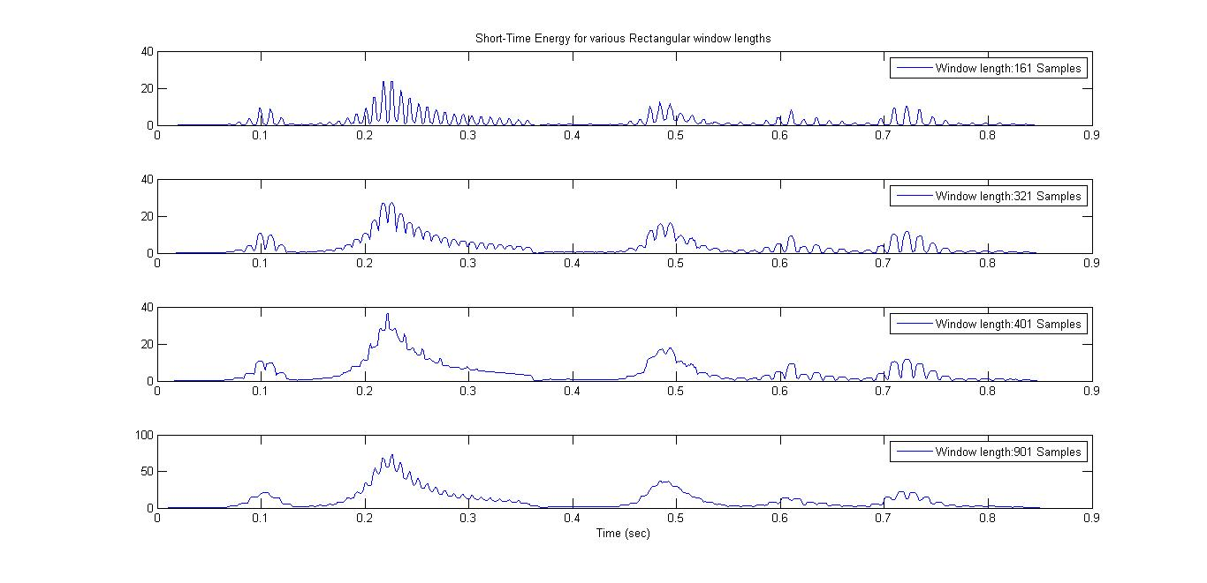

Comment: -

As like hamming window, short time energy become smother with increase in window length. This is because rectangular window has smaller bandwidth for same length compare to the hamming window.

1. **Short-time Average Magnitude Calculation for Hamming Window of Variable Length**

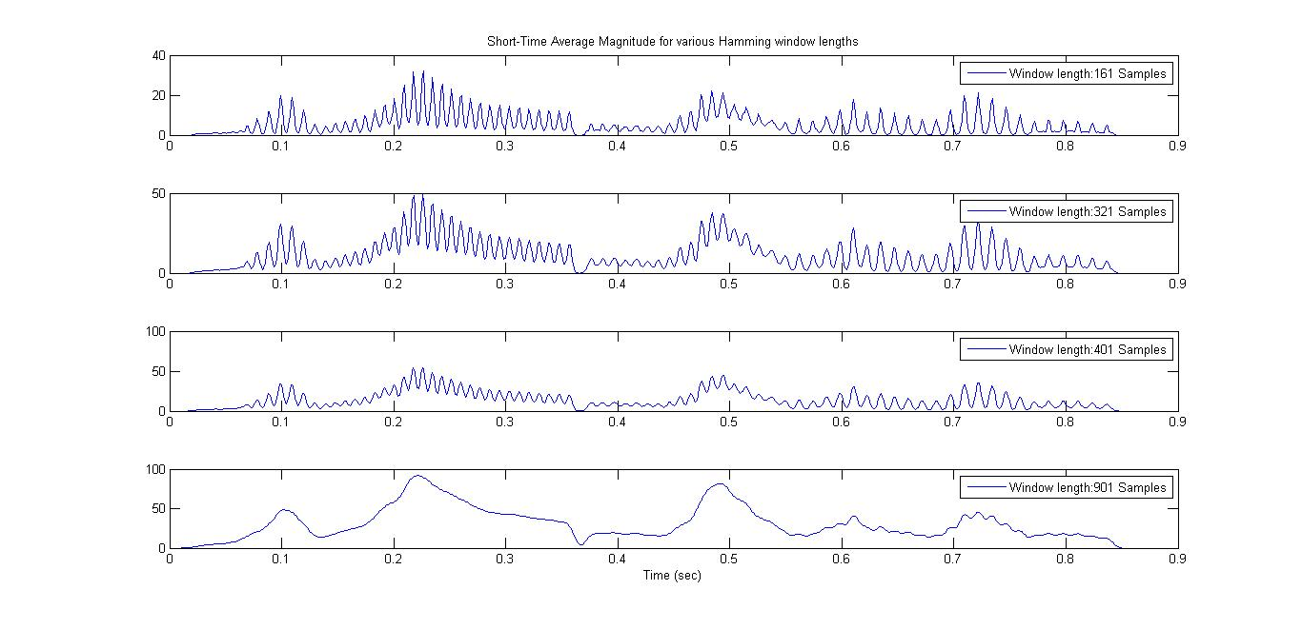

Comment: -

As like short time energy, short time average magnitude is also become smother with increase in window length.

1. **Short-time Average Zero-crossing Rate for Hamming Window of Variable Length**

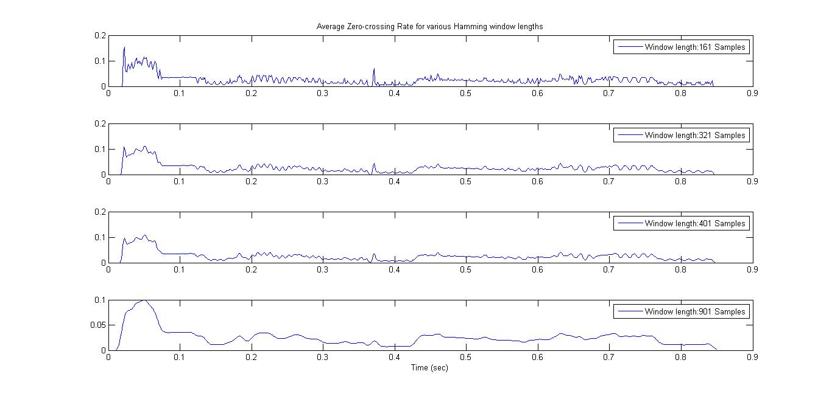

Comment:-

As like short time energy and short time average magnitude, short time average zero crossing also become smooth with increase of the window length.

1. **Short Time Autocorrelation Calculation for Rectangular Window of Variable Length**

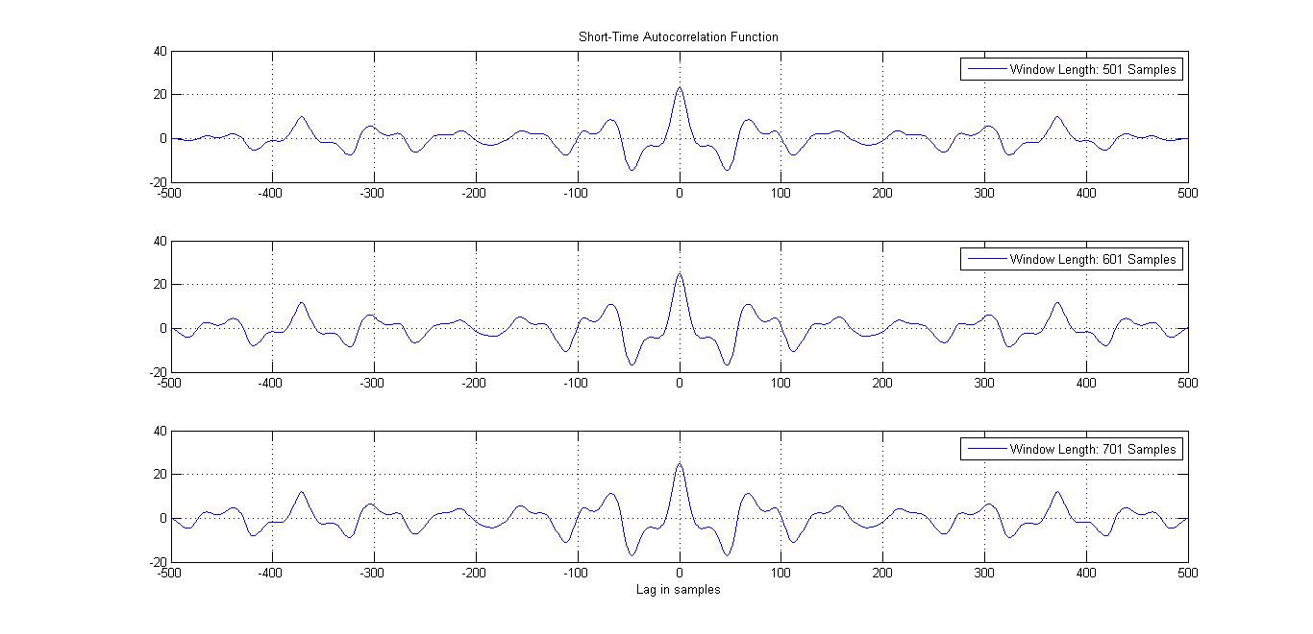

Comment: -

Attenuation of the autocorrelation become smother with increase in window length, but the effect is less detectable than that of short time energy, short time average magnitude and short time correlation.

**2.3.11 Pitch Period Estimation at Voiced Region**

Estimated Pitch period over the voiced region: 0.045351 ms

Comment: -

The autocorrelation function can be applied for the estimation of pitch period over the voiced locations. With this method, the pitch is estimated with the point having maximum correlation coefficient. As shown above, the pitch period is 0.045 ms,

## Conclusion

After completing this lab we become familiar with time domain analysis of speech signal and also separating voice signal from unvoiced signal with help of zero-crossing plot, autocorrelation plot, and short time energy plot.

Code of this lab is available at: - <https://github.com/nKandel/speechlab/tree/master/lab02>