Lab 3 Report by 066BCT520

# Objective:

* To understand the development of short-term Fourier transform(STFT) representation and plot the STFT of a speech signal
* To understand the difference among the spectra of voiced & unvoiced regions of speech
* To understand the effect of frame size on short term spectral analysis
* To understand the Narrowband and Wideband spectrograms

# Observations

## 1. Short Time Fourier Transform of Speech

Output:

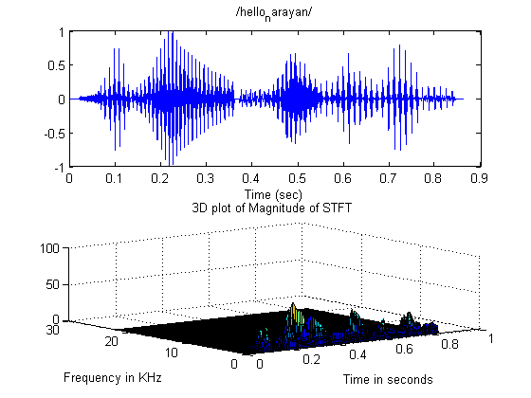

Comment:

3D plot of STFT gives variation of amplitude with respect to time and frequency. Also we can observe the variation of amplitude with variation of time keeping frequency constant and variation of the amplitude with frequency keeping time constant, which help us to have better insight of given sound spectrum.

## 2. Short Time Fourier Transform of Voiced & Unvoiced Sound & Effect of Window

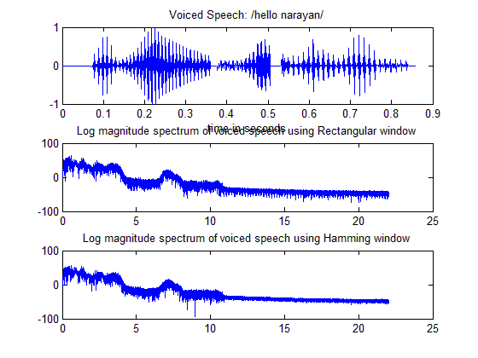

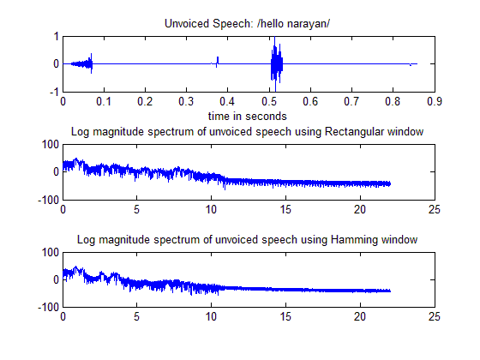

Comment:

It has to be observed that, the STFT using the rectangular spectra is found to be more noisy compared to STFT spectra due to hamming window. This is due to the higher spectral leakage in rectangular window compared to hamming window.

## 3. Short Time Fourier Transform for Varying Window Size

## 

Comment:

Figure above shows a short term log magnitude spectra of voiced segment using a frame size of 100 ms, 200 ms and 300 ms. Here we can observe that the poor spectral resolution due to smaller window size in case of 100 ms window. Also poor time resolution can be observed in case of 300 ms window. The log magnitude spectrum of the 200 ms windowed speech segment shows vocal tract spectral envelope and excitation information in terms of pitch and its harmonics.

## 4. Wideband & Narrowband Spectrograms

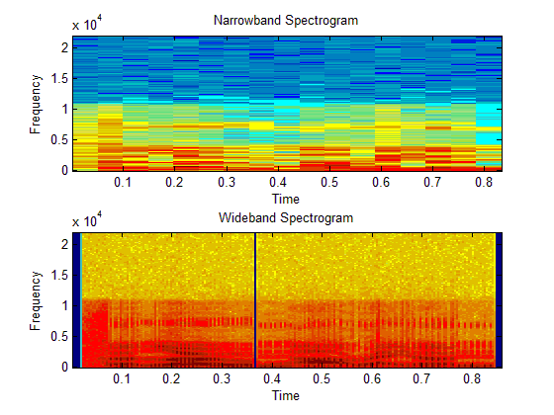

Comment:

It has been observed that the narrowband spectrogram provides good frequency resolution but poor temporal resolution, while the wideband spectrogram resolves pitch pulses in time but not in frequency. In unvoiced region, both the spectrograms show no strong structures.

# Conclusion

After completing this lab, we were able to perform analysis of the speech signal using short time spectral analysis, comparing the effect of rectangular and Hamming window functions on short term spectral analysis on both voice and unvoiced sounds and comparative spectrographic display of given sound signal.

Code available at :- <https://github.com/nKandel/speechlab/tree/master/lab03>