Bibliography

"Myanmar". Encyclopædia Britannica. Encyclopædia Britannica Online.  
Encyclopædia Britannica Inc., 2016. Web. 05 Jun. 2016  
<<http://www.britannica.com/place/Myanmar>>.

Haney, Elissa. "Myanmar." *Infoplease*. Infoplease, 2000-2015. Web. 06 June 2016. <http://www.infoplease.com/country/myanmar.html?pageno=1>.

Biography.com. "Aung San Suu Kyi." *Bio.com*. A&E Networks Television, 2014. Web. 06 June 2016. <http://www.biography.com/people/aung-san-suu-kyi-9192617#arrest-and-election>.

Saw Myint, Shwe Yee. "Myanmar Times." *Our Growing Air Pollution Problem*. Myanmar, 06 June 2016. Web. 06 June 2016. <http://www.mmtimes.com/index.php/national-news/yangon/1050-our-growing-air-pollution-problem.html>.

Advameg. "Burma." *Everyculture.com*. Advameg, 2016. Web. 5 June 2016. <http%3A%2F%2Fwww.everyculture.com%2FBo-Co%2FBurma.html>.

Myanmar (Burma)

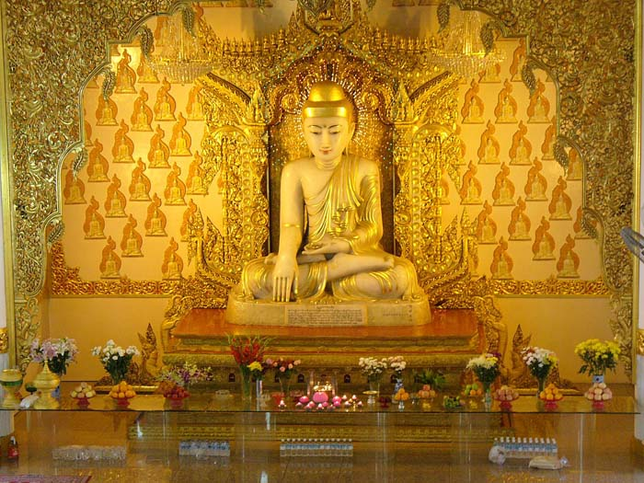

Nir Levin, period 3, 5 June 2016

Contents:

←Speech

Culture and Social Structure

History

Politics

Economics

Geography

Achievements

Aung San Suu Kyi biography

General Summary

Appendix

Bibliography