In this assignment we aimed to analize different frameworks across the embeded world and see the difference between them. We have Proteus, Altium, STM, Atmel etc. There are a lot of different companies and frameworks.

First and easy framework to use is Arduino’s framework. It uses C language but has some different features like strings etc. It based on C language but a little bit different. Secondly, I have CubeIDE for STM32. This framework also uses C language but it uses pure C. But this framework gives us a lot of control on the actual microcontroller which is STM32. Such as we can change osilation timing in the cristal or we can use an external osilator as a clock. This framework a little bit harder to use because we have to know which STM32 family we are using to be able to control the pins of the microcontroller. For example, STM32f103c6t6a is a little bit different than STM32f407. We need to know the microcontroller that we are using but in Arduino we dont need to. That makes Arduino easy to use for me. Intel edison also uses Arduino framework. When it comes to pcb frameworks we have a lot of options. Firstly, I have proteus which is a pcb desing framework but it has a lot of compabilities along pcb desing. Secondly, I have altium which similar to proteus. Finally, I have KiCad which is again another pcb desing framework. Proteus is a good pcb design frameworks and it also a good simulation tool which we can simulate a lot of real time components and also microcontrollers such as Arduino uno or Arduino nano. I have used proteus as a simulator framework. I have simulated a floating messages on some leds using Arduino and C language. Altium also has that simulation feature. We can install specific libraries to use certain microcontrollers. KiCad also has that features similar to others. I dont have enough experience to tell the difference between them but they uses different routing algorithms for pcb desing and that makes the most difference between them.

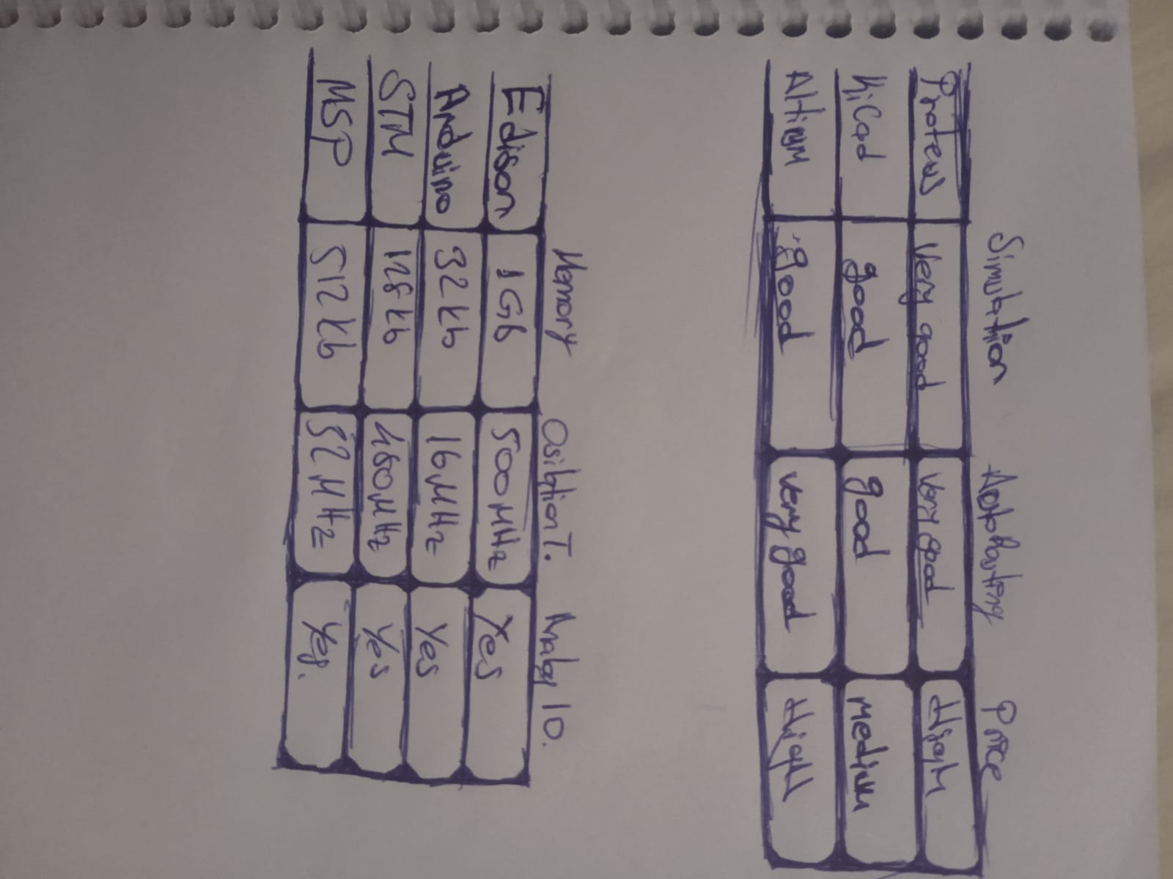 As a conclution we have discussed different frameworks in different perspective. The obvious perspective is price and pcb desing frameworks have similar prices. But Arduino and CudeIDE is free.