1**.Main Page**

Terms Button = goes to the Terms List or Terms Page.

Menu

1. Sample Term Data = creates sample data for all lists.

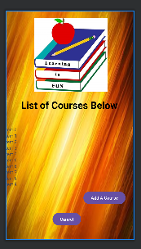**

Courses Button = goes to Courses or Course List Page.

Cancel Button = from Courses Page goes back to Main/Home Page.

Cancel Button = from Assessments Page goes back to Main/Home Page.

Assessments Button = goes to Assessments or Assessment List Page.

Cancel Button = from Terms Page goes back to Main/Home Page.

Menu

1.Course Page = goes to Courses or List of Courses

Add A Term Button = goes to Term Details page.

Cancel Button = from Terms page goes back to Main/ Home Page.

Menu

1. Delete Term = gets rid of Term and goes back to Terms Page.
2. Save Term = saves the term and goes back to Terms Page.
3. Cancel = does not go anywhere.

**4. Courses Page**

Cancel Button = from Courses goes back to Main Page/ Home Page.

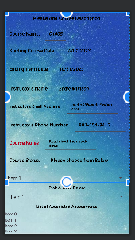 6. Assessment Page

Menu

1. Assessments Page = goes to the Assessments Page.

Add A Course Button = goes to Course Details. Page.

Menu

1. Save Course = adds the course to the Course List page and goes back to Courses or the Course List page.
2. Share Note = shares the notes via email or text but does not go anywhere.
3. Alert Me Start Date = sends an alert to the phone but does not go anywhere.
4. Alert Me End Date = sends an alert to the phone but does not go anywhere.
5. Delete Course = removes the course from Courses and goes back to Courses or Course List.
6. Cancel = does not go anywhere.

Add A Assessment = goes to the Assessment Detail Page.

Cancel Button = goes from the Assessments Page back to the Main/ Home Page.

**No Menu for this Activity.**

Menu

1.Delete Assessment = gets rid of Assessment and goes back to Assessments page.

2. Alert Me Start Date = alerts the phone but does not go anywhere.

3. Alert Me Start Date = alerts the phone but does not go anywhere.

Save Test = saves the test and goes back to Assessments page.

Cancel Button = goes from Assessment Detail Page back to Assessments page.