

**Green University of Bangladesh**

**Department of Computer Science and Engineering (CSE)**

**Faculty of Sciences and Engineering**

**Semester: (Fall, Year:2022), B.Sc. in CSE (Day)**

**Course Title: Computer Networking Lab**

**Course Code: CSE 312 Section: 202 D1**

**Lab Project Name: Campus Network Scenario**

**Student Details**

|  |  |
| --- | --- |
| **Name** | **ID** |
| Nur Ahmed | 201002398 |
| *Zobayer Arman Nadim* | 202002039 |

**Submission Date : 13/09/2022**

**Course Teacher’s Name : *MS. TANPIA TASNIM***

**[For Teachers use only: Don’t Write Anything inside this box]**

|  |
| --- |
| **Lab Project Status**  **Marks: ………………………………… Signature: .....................**  **Comments: .............................................. Date: ..............................** |

Table of Contents

Chapter 1 Introduction 3

1.1 Introduction 3

1.2 Objectives 3

Chapter 2 Design 4

2.1 Network Design 4

2.2 Device Used 9

Chapter 3 Performance Evaluation 10

3.1 Simulation Environment 10

3.2 Results and Discussions 11

Chapter 4 Conclusion 12

4.1 Introduction 12

References 13

# Chapter 1 Introduction

## Introduction

This Campus Network Scenario is about designing a hybrid topology of a network that is a Local Area Network for our university city campus in which various computers of different buildings are set up. So that they can interact and communicate with each other by sharing data.

In this mini-project, We defined a simulation of campus networks based on wireless networking. The major aim of this project is to show the wireless connectivity that is used in universities to make the network efficient and mobile at the same time. Mobility is the major concentration of this project. In order to provide equal functionality to all the users (college staff and students),

Hence the campus network provides different services such as connecting the user to the internet, data sharing among users (students, teachers, and different university members), accessing different web services for different functionalities, so it needs wireless networking for smooth processing.

## Objectives

The main objective of the proposed network is:

* To update the existing network.
* Also enhance its capabilities and increase the flexibility of the network.
* To provide good security.
* Connecting the user to the internet,
* Data sharing among students, teachers, and different university members.

# Chapter 2 Design

## Network Design

We have designed the network by building and floor wise. Every building has a same network design. There is one floor which contains the office rooms. Some floor has faculty rooms and class rooms. And other floor has Lab classes.

* + 1. **Design**

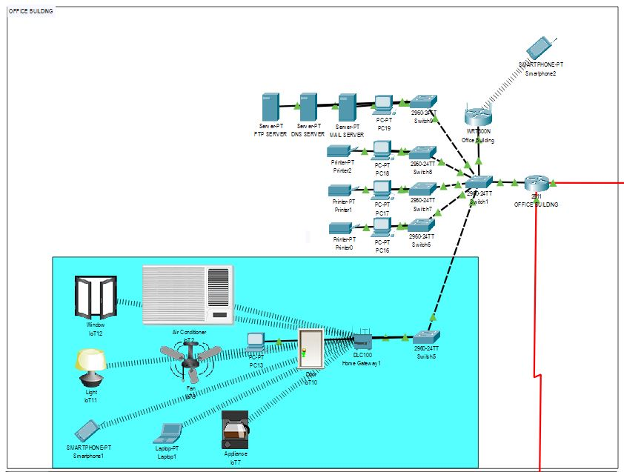

Figure 2.1.1.1 – Office Building design

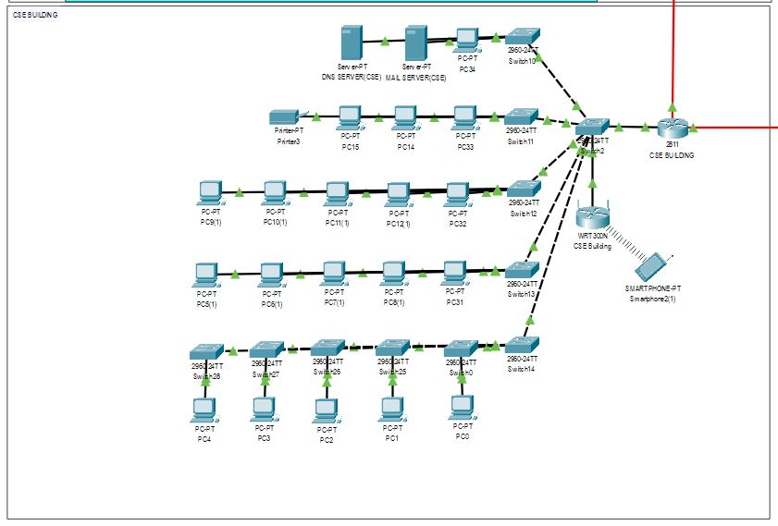

Figure 2.1.1.2 – Department Building design

* + 1. **Configuration**

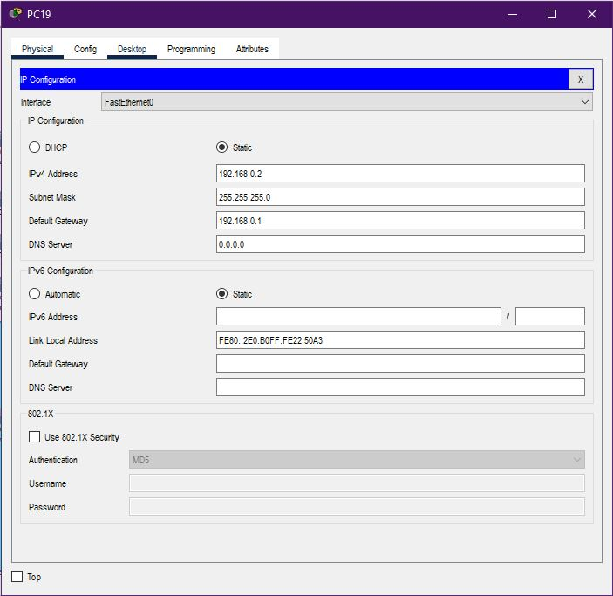

Figure 2.1.2.1 – PC configuration

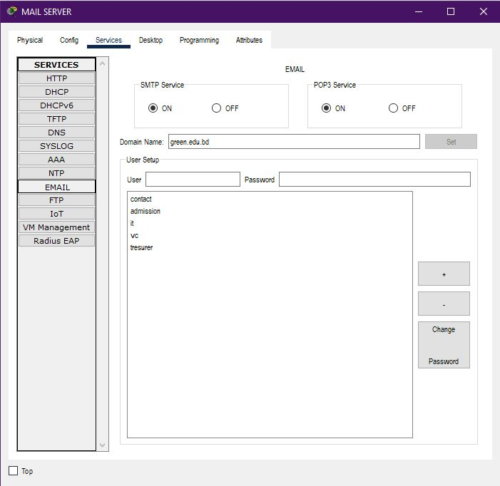

Figure 2.1.2.2 – Email service configuration

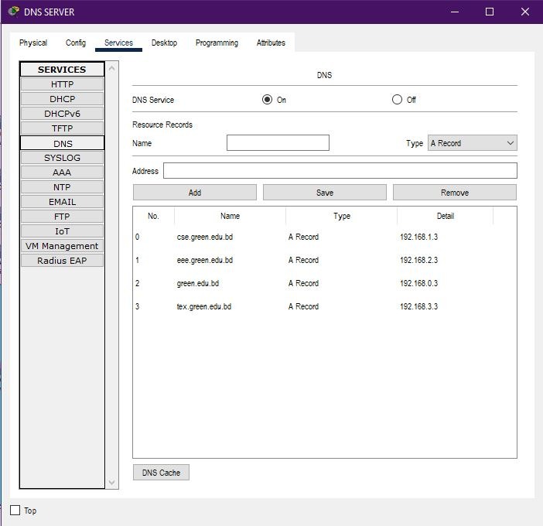

Figure 2.1.2.3 – DNS service configuration

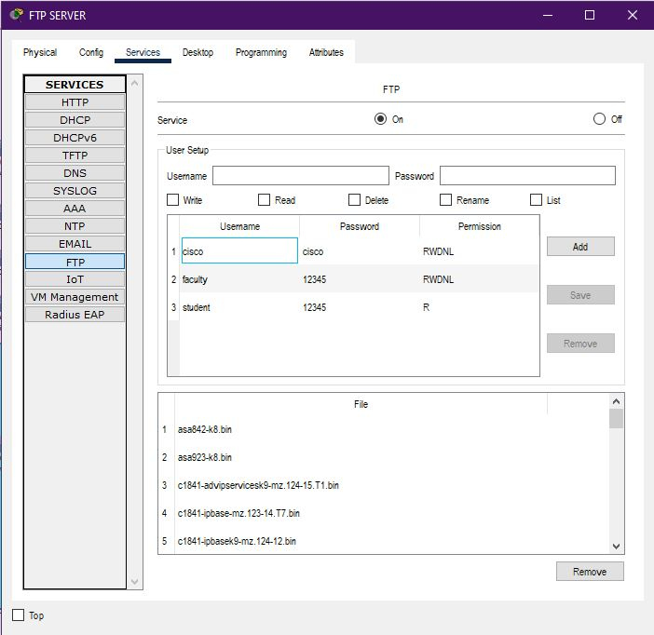

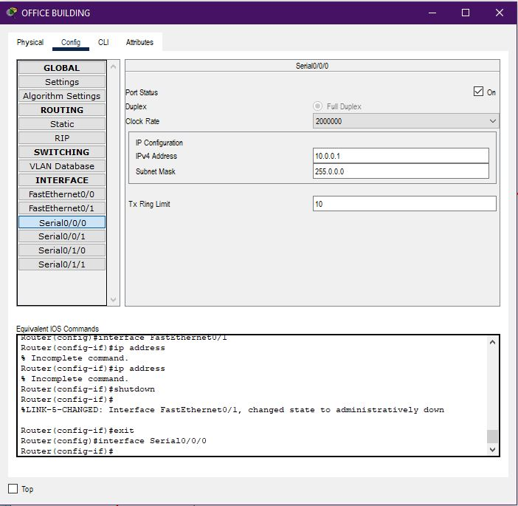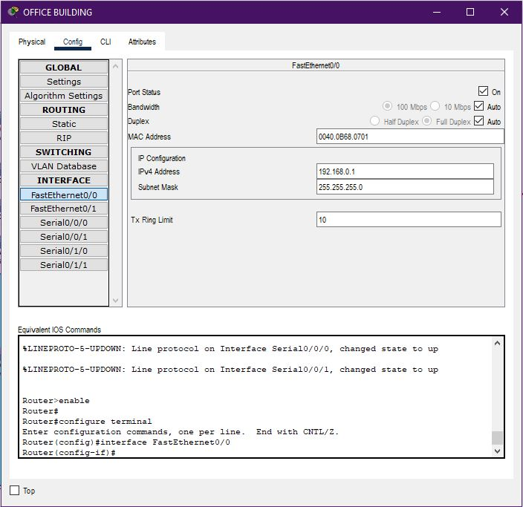Figure 2.1.2.4 – FTP service configuration

Figure 2.1.2.5 – Router configuration

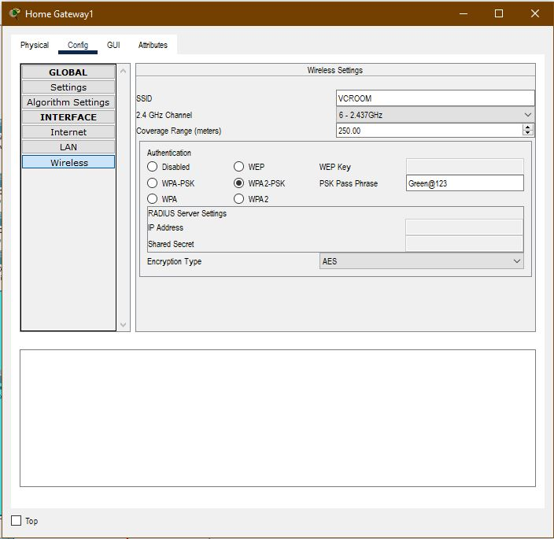

Figure 2.1.2.6 – Home Gateway configuration

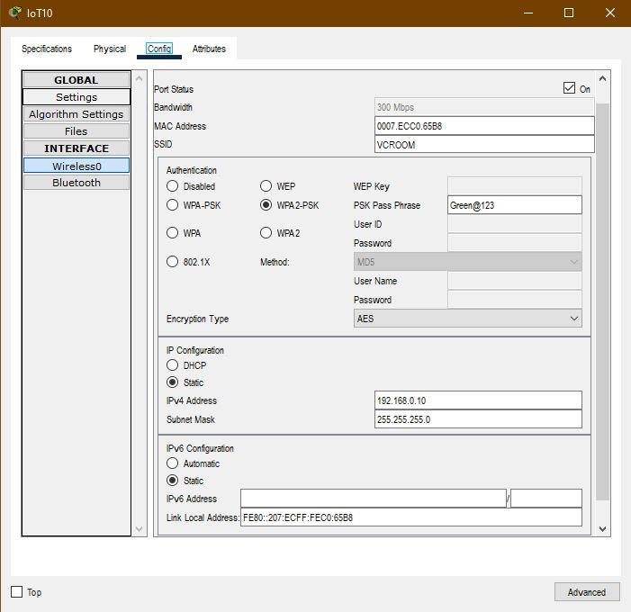

Figure 2.1.2.7 – IOT device configuration

## Device Used

|  |  |
| --- | --- |
| Sl. | Name |
| 1 | PC |
| 2 | Laptop |
| 3 | Smart Phone |
| 4 | Router 2811 |
| 5 | WRT300N |
| 6 | Switch 2960 |
| 7 | Home Gateway |
| 8 | IOT devices (AC ,Fan ,Light ,Appliance , Door, Window) |
| 9 | Printer |

## 

## 

# Chapter 3 Performance Evaluation

## Simulation Environment

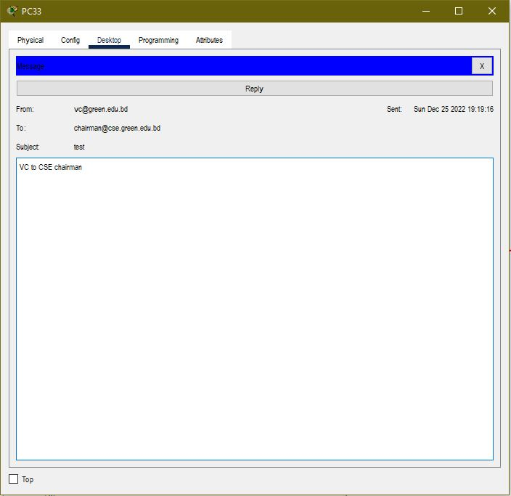

Figure3.1.1: Mail server Simulation

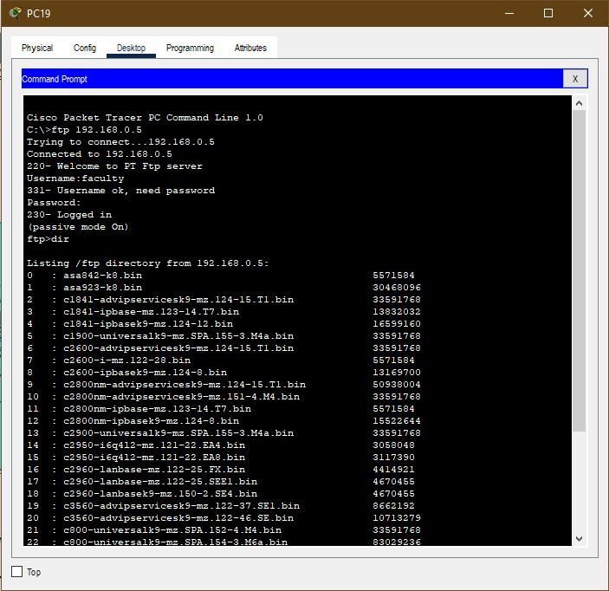

Figure3.1.2: FTP server Simulation

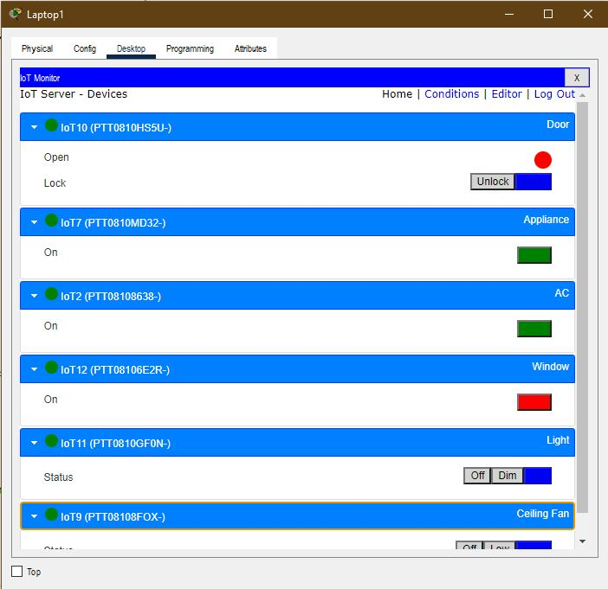

Figure3.1.3: IOT devices Simulation

## Results and Discussions



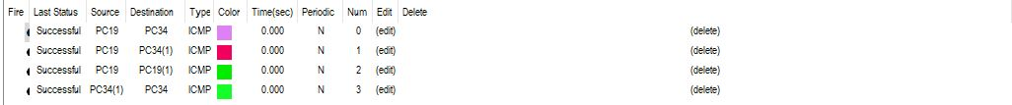

Figure 3.2.1 – Some simulation result

Our main purpose of the project to connect all the device. So, we build a network where every device is connected to each other. We also added the IOT in our project to make the project more complex. We have used dynamic routing for making the connection between a network to another.

# Chapter 4 Conclusion

## Introduction

The outcome of the proposed system will be a fail-safe backbone network infrastructure which meets the requirements for readily available access to information and security of the private network, and also ensures optimized productivity when telecommunication services are accessed. The installed equipment allowed to organize high-speed wired and wireless Internet access throughout the whole complex of hospital buildings as well as providing transfer of all types of data throughout the single optimized network.

We started our discussion with the word “digitalization” and in order to achieve it, we aimed to start with an educational institute, and finally, we designed a network for a university, which is wireless. As we mentioned, mobility and efficiency are the key aspects of wireless networks, which were our main goal, and hence, we decided to shift to a wireless network instead of a wired one, making our network clean and less chaotic.

In this project, we designed a University Network using Cisco Packet Tracer that uses a networking topology implemented using routers, switches, and end devices in a multiple area network. We have covered all the necessary features that are required for a network to function properly.

# References

1. Sun, L., Wu, J., Zhang, Y., & Yin, H. (2013, April). “Comparison between physical devices and simulator software for Cisco network technology teaching”. In Computer Science &Education (ICCSE), 2013 8th International Conference on (pp. 1357-1360). IEEE
2. Roberto Minerva AbiyBiru, "Towards a Definition of the Internet of Things” IEEE IOT Initiative white paper.
3. “Design and Simulation of Local Area Network Using Cisco Packet Tracer”. The International Journal of Engineering and Science (IJES) || Volume || 6 || Issue || 10 || Pages || PP 63- 77 || 2017 || ISSN (e): 2319 – 1813 ISSN (p): 2319 – 1805.
4. Qin, X. U. E. "Simulation Experimental Teaching of Computer Network Based on Packet Tracer [J]." Research and Exploration in Laboratory 2 (2010): 57-59.
5. Current, John R., Charles S. ReVelle, and Jared L. Cohon. "The hierarchical network design problem." European Journal of Operational Research 27.1 (1986): 57-66.