HR_C6000 User Manual

DISCLAIMER
NO IMPLICIT OR EXPLICIT WARRANTY GIVEN WITH THIS TRANSLATION. THE TRANSLATOR TAKES NO RESPONSIBILITY FOR ANY INACCURACY OF THIS DOCUMENT AND FOR ANY DAMAGE FOLLOWING AN INAPPROPRIATE USE OF DEVICES NOT FOLLOWING THE ORIGINAL MANUFACTURER INSTRUCTIONS. IF YOU DON’T UNDERSTAND SOMETHING, LOOK AT THE ORIGINAL DOCUMENT AND ASK SOMEONE THAT SPEAKS CHINESE.

Characteristics
DMR
- Protocol design in accordance with ETSI TS102 361 (DMR) Tier I/II/III standard
- Support physical layer, data link layer and call control layer independent control
- Support true dual-slot sync header detection
- Supports full-duplex, half-duplex voice, data communication and simultaneous digital messaging services using TDMA technology
- Support IP data services
- Support single frequency, dual frequency relay
- Support 4.8Kbps and 9.6Kbps data transmission
- Support digital-analog intelligent detection
- Support for relay voice and data functions
- Support voice encryption
Modem and channel codec
- High performance 4FSK modem
- Channel codec specified by the integration protocol
Vocoder support
- Support HR_V3000 (Hongrui AMBE+2), SELP vocoder (Tsinghua), AVDS vocoder (712)
- Wait for the SPI interface vocoder to provide an interface for digital recording, playback and prompt input
- Seamless docking AMBE3000, AMBE1000, WT3000 and other vocoders, automatically by HR_C6000
- Complete the configuration of the vocoder and control the data exchanged with the vocoder
- Support for digital voice encryption
RF interface
- Transmit RF interface with single-ended output, support baseband IQ, intermediate frequency, two-point modulation
- Receive RF interface with differential input, supporting baseband IQ, IF and AF
- Send two signal offsets, the amplitude can be adjusted independently
- Support user configuration GPIO control RF channel
Analog FM
- Support 12.5KHz/25KHz channel communication
- Support aggravation, de-emphasis
- Support compression, decompression
- Support CDCSS/CTCSS sub-tone processing
- Support 2-tone/5-tone processing
- Support for DTMF processing
- Support for analog squelch
- Support MSK modulation and demodulation
Built-in high performance IP
- High performance ADC/DAC
- DC-DC, powered by 3.3V
- High performance PLL
- High-performance Codec with differential or single-ended Mic input and Line_out output
- Support for external Codec 2 I S interface
- With low power design, the typical power consumption of the chip is less than 40mW
- Available in LQFP-80 package

Application block diagram
OMISSIS

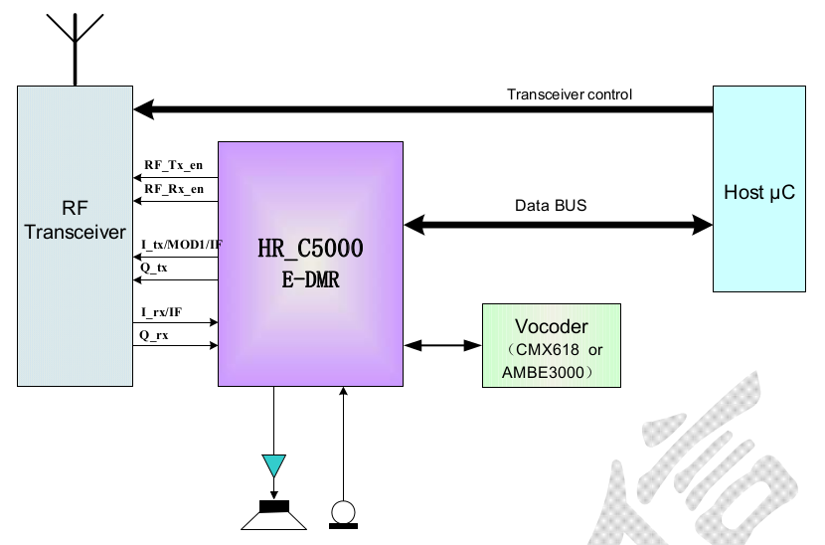
Introduction

The HR_C6000 chip independently developed by Hongrui complies with the ETSI TS102 361 (DMR) digital intercom standard, while supporting digital PDT cluster intercom, analog intercom and analog cluster intercom application is a terminal chip for high-end applications.
The chip integrates a high-performance 4FSK modem, MSK modem, analog intercom channel, sub-audio, DTMF, 2-Tone, 5-Tone and other analog functions, channel coding code, protocol processor, physical layer, data link layer and call control layered design, users can directly use the three-layer protocol to develop DMR-compliant digital walkie-talkies, greatly reduced the development workload and shorten the development time; users can also perform PDT based on the HR_C6000 Layer 2 protocol.
Development of protocols, DMR TierIII or custom protocols to meet the needs of high-end users. The chip is suitable for digital intercoms, dedicated cluster terminals, as well as low-speed data and voice transmission terminal applications, support relay and terminal applications in a centralized mode.
The chip has built-in AD/DA, CodeC, DC-DC and other IP to effectively reduce the user's peripheral devices. At the same time, it can sewing and docking AMBE3000, WT3000, AMBE1000, HR_V3000, SELP, AVDS and other vocoders, two-point modulation transmission, low IF reception, compatible with the original analog walkie-talkie RF channel, reducing the workload of user RF development.
The chip is powered by 3.3V and has a built-in power management module for low power design.
The product is available in the LQFP-80 package.
Table of Contents
Characteristics 2
Application block diagram 3
Introduction 3
1Chip block diagram 5
2Chip pin 6
2.1Pin map 6
2.2Pin list 6
2.3Package size 10
3Chip characteristic 11
3.1Static characteristic 11
3.2Dynamic characteristics 11
3.3Power consumption parameter 11
3.4Performance parameter 11
4Application note 12
4.1Chip reset 12
4.1.1Power-on reset 12
4.1.2Software reset 12
4.2Chip power supply 12
4.3Chip working clock block diagram and description 13
4.3.1Clock circuit 13
4.3.2Clock configuration 13
4.4Chip parameter configuration interface 14
4.5Use of Codec 17
4.5.1Built-in Codec 17
4.5.2Use external Codec 17
4.6Vocoder 18
4.6.1Interface definition with Hongrui HR_V3000 vocoder 18
4.7Transmitter module 20
4.7.1Baseband IQ modulation 21
4.7.2Two-point modulation 21
4.7.3IF IQ modulation 21
4.7.4IF modulation 21
4.8Receiving module 21
4.8.1Baseband IQ 21
4.8.2IF mode 21
5Hierarchical function description 21
5.1Interrupt use instructions 22
5.1.1Interrupt use description 22
5.2Interface read and write instructions 25
5.3HR_C6000 RAM allocation definition 26
5.4Support frame type 28
5.4.1Time slot framing 28
5.4.2Framing mode 34
5.4.3Frame definition and use 34

Chip block diagram
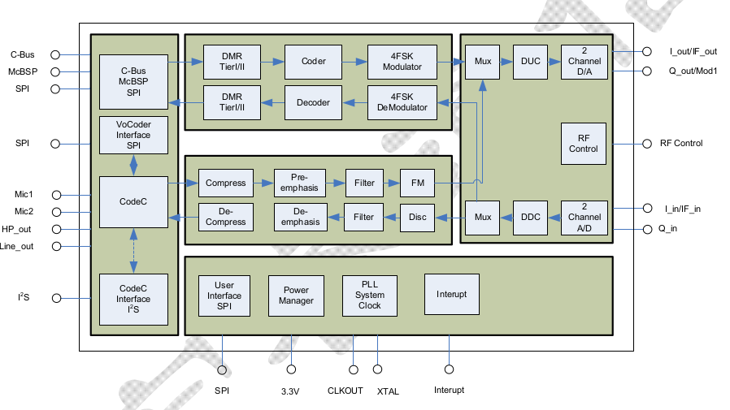
OMISSIS

Chip pin

Pin map
OMISSIS

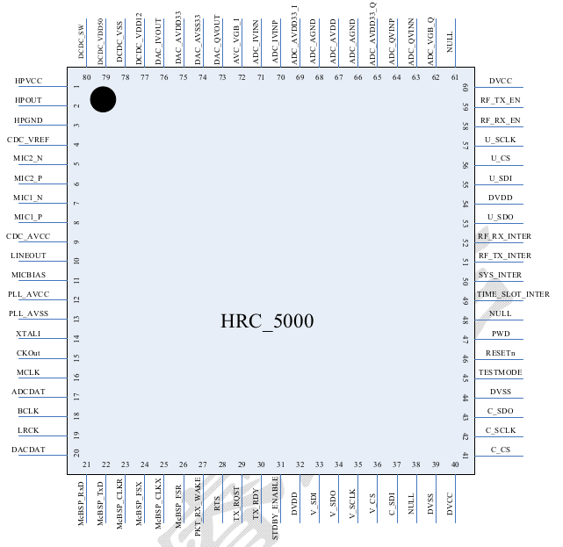

HR_C6000 pin diagram picture is missing

Pin list
Table 2.1 Pin Arrangement Diagram
Pin Number | Name | Type | Pin Description
1 | HPVCC | AP | The headphone output amplifier simulates a 3.3V power supply.
2 | LINEOUT1 | AO | Headphone output.
3 | HPGND | AG | Built-in Codec analog ground.
4 | CDC_VREF | AO | Built-in Codec reference power supply.
5 | MIC_P | AI | The positive side of the differential input of the microphone.
6 | MIC_N | AI | The negative side of the differential input of the microphone.
7 | LINEIN1 | AI | Microphone single-ended input 1.
8 | LINEIN2 | AI | Microphone single-ended input 2.
9 | CDC_AVCC | AP | Codec simulates a 3.3V power supply.
10 | LINEOUT2 | AO | Line-out output, need to add external amplifier drive.
11 | VREFL | AG | The external reference of the microphone is connected to the analog ground.
12 | PLL_VDD33 | AP | The PLL simulates a 3.3V supply.
13 | PLL_VSS33 | AG | The PLL simulates ground.
14 | XTALI | DI | System clock, active crystal input.
15 | CLKOUT | DO | HR_C6000 output clock, when output by PLL clock divider is obtained, the division ratio is matched by reg0xBB Set. Available for external Codec or external vocoder use.  External Codec interface working clock, which is clocked by CLKOUT is provided if the external Codec is not used CLKOUT, the clock needs to be external Codec's working clock; also multiplexed as a radio The digital control of the sender is enabled.
16 | MCLK/RF_ANT_EN | DIO | Codec's working clock; also multiplexed as a radio digital control of the sender is enabled.
17 | LRCK/RF_3TC_EN | DO | External Codec left and right channel selection enable; multiplexing  Digital control is enabled as the RF transmitter.
18 | BCLK/RF_3RC_EN | DO | External Codec bit clock; multiplexed as RF  Receiver digital control is enabled.
19 | ADCDAT/RF_5TC_EN | DIO | External Codec audio ADC sampling data; multiplexing As the RF transmitter is digitally enabled, this time For output characteristics.
20 | DACDAT/RF_5RC_EN | DO | External Codec audio DAC data; reuse as  Digital control at the RF receiver is enabled.
21 | VSS12 | G | The kernel is digitally ground.
22 | McBSP_Rxd/CHS_DI | DO | AMBE3000: HR_C6000 by McBSP  The data sent by the interface to the AMBE3000;  AMBE1000: HR_C6000 through CHS string  The frame input data sent to the AMBE1000 by the port.
23 | McBSP_TxD/CHS_DO | DI | AMBE3000: HR_C6000 by McBSP  The interface receives data sent by the AMBE3000;  AMBE1000: HR_C6000 through CHS string  The port receives the frame output data of the AMBE1000.
24 | McBSP_CLKR/CHS_O_CLK | DO | AMBE3000: McBSP connection of HR_C6000  Port output clock;  AMBE1000: CHS interface clock of AMBE1000.
25 | McBSP_FSX | DI | AMBE3000: HR_C6000 by McBSP Interface receives synchronization of AMBE3000 output data signal.
26 | McBSP_CLKX | DI | AMBE3000: McBSP connection of HR_C6000 Port input clock.
27 | McBSP_FSR/CHS_I_STRB | DO | AMBE3000: HR_C6000 by McBSP The data synchronization letter sent by the interface to the AMBE3000 number;  AMBE1000: CHS_DI port data is valid Enable.
28 | PKT_RX_WAKE/CHS_O_STRB | DO | AMBE3000: Invert McBSP_FSR, Used to wake up the McBSP interface;  AMBE1000: CHS_DO port data is valid Enablement.
29 | RTS/DPE | DI | AMBE3000 : AMBE3000 is allowed to pass  The McBsp interface writes data, which is low effective;  AMBE1000: AMBE1000 decoding packet is empty.
30 | TX_RDY/EPR | DI | AMBE3000: AMBE3000 sends a packet Ready to complete, high effective;  MBE1000: AMBE1000 encoding standard Ready.
31 | STDB_ENB/RESET_AMBE1000 |  | AMBE3000: AMBE3000 Standby Mode Enable, active high;  AMBE1000: AMBE1000 RESET, Low effective.
32 | VDD12 | P | Core digital 1.2V power supply.
33 | VSS12 | G | The kernel is digitally ground.
34 | (C_SDI/I2S_RX) – supposed | DI | As an SPI interface: the vocoder SPI port Serial data input to HR_C6000, SPI operation In the main mode.
35 | C_SDO/I2S_TX | DO | As an I2S interface: can work in master/slave mode formula. If working in master mode, read from the vocoder Take PCM serial data to HR_C6000; if Working in slave mode, the vocoder will write PCM data Go to HR_C6000.  As an SPI interface: HR_C6000 will Output voice data from CodecADC to vocoding SPI port.
36 | C_SCLK/I2S_CK | DO/DI | As an I2S interface: can work in master/slave mode formula. If working in master mode, if working in Main mode, the I2S master that is provided to the vocoder Clock; if working in slave mode, for vocoder When working with the I2S interface of the HR_C6000 bell As an SPI interface: a slice of the vocoder SPI port selected.
37 | C_CS/I2S_FS | DO/DI | As an I2S interface: can work in master/slave mode formula. If working in master mode, provide vocoding Read and write I2S left and right channel data enable; Fruit work is provided from the mode, the vocoder HR_C6000 reads and writes the left and right channels of serial data  Enable.
38 | TEST_MODE | DI | Test mode configuration pin, 1 is test mode, 0 for normal working mode.
39 | RESETn | DI | System reset signal, active low.
40 | VSS33 | P | Digital IO 3.3V power supply.
41 | V_SDI | DI | Universal vocoder SPI port serial data input.
42 | V_SDO | DO | Universal vocoder SPI port serial data output.
43 | V_SCLK | DI | Universal vocoder SPI port serial clock.
44 | V_CS | DI | Universal vocoder SPI port chip select
45 | DBIST_IN | DI | NC. Connect to ground.
46 | DBIST_OUT | DO | NC
47 | PWD | DI | Chip PowerDown control pin, high level activates the PowerDown state.
48 | TIME_SLOT_INTER | DO | 30ms time slot interrupt.
49 | SYS_INTER | DO | System control is interrupted.
50 |  | DO | The radio end sends related parameters to configure interrupts, such as sending the mixer frequency configuration.
51 |  | DO | The radio end receives the relevant parameter configuration interrupt, such as receive the mixer frequency configuration.
52 | VSS12 | G | The kernel is digitally ground.
53 | VDD12 | P | Core digital 1.2V power supply.
54 | VDD33 | P | Digital IO 3.3V power supply.
55 | U_SDO | DO | MCU accesses HR_C6000 register or RAM  SPI data output from the memory area.
56 | U_SDI | DI | MCU accesses HR_C6000 register or RAM  SPI data input for the bank.
57 | U_SCLK | DI | MCU accesses HR_C6000 register or RAM  The SPI serial clock for the bank.
58 | U_CS | DI | MCU accesses HR_C6000 register or RAM  SPI chip select for the bank.
59 | RF_RX_EN | DO | Control the RF receiving switch to enable, when receiving status,  Output high level. The signal will not be  RF_TX_EN is valid at the same time.
60 | RF_TX_EN | DO | Control the RF transmit switch enable, when sending status,  Output high level. The signal will not be  RF_RX_EN is valid at the same time.
61 | ADC_VBG_Q | AIO | Q-channel ADC channel external decoupling bandgap voltage
62 | ADC_QVINN | AI | Q The negative side of the ADC channel differential input.
63 | ADC_QVINP | AI | Q Positive side of the ADC channel differential input.
64 | ADC_AVDD12_Q | AP | The Q-channel ADC channel simulates a 1.2V power supply.
65 | ADC_AGND_Q | AG | Q-channel ADC channel analog ground.
66 | ADC_AVDD33_Q | AP | ADC Analog 3.3V Power Supply
67 | ADC_AVDD33_I | AP | ADC Analog 3.3V Power Supply
68 | ADC_AGND_I | AG | I-channel ADC channel analog ground
69 | ADC_AVDD12_I | AP | The I-channel ADC channel simulates a 1.2V power supply.
70 | ADC_IVINP | AI | I-channel ADC channel differential input positive terminal, or medium  Signal access terminal in frequency receiving mode.
71 | ADC_IVINN |  | I-channel ADC channel differential input negative terminal, intermediate frequency.  The port is grounded or other fixed in receive mode  Pressure.
72 | ADC_VBG_I |  | The bandgap voltage of the external decoupling of the I-channel ADC channel.
73 | DAC_AVSS33 | AG | The DAC simulates ground.
74 | DAC_QVOUT/MOD2 | AO | Q channel DAC channel output signal.  Two-point modulation MOD2 port in send mode.
75 | DAC_IVOUT/MOD1 | AO | I DAC channel output signal.  MOD1 port in two-point modulation transmit mode.
76 | DAC_AVDD33 | AP | The DAC simulates a 3.3V power supply.
77 | DCDC_VDD12 | AO | DC-DC 1.2V output.
78 | DCDC_VSS | G | DC-DC digital ground.
79 | DCDC_VDD33 | P | DC-DC 3.3V power supply.
80 | DCDC_SW | O | DC-DC internal switch.

Package size
OMISSIS

Chip characteristic

Static characteristic
Table 3.1 HR_C6000 Static Parameters

OMISSIS

Dynamic characteristics

OMISSIS

Power consumption parameter

OMISSIS

Performance parameter

OMISSIS

Application note

Chip reset

Power-on reset
The HR_C6000 can be powered on and reset using resistors and capacitors. The reference circuit is as follows.
OMISSIS
Figure 4.1 Chip Power-on Reset Reference Circuit
To ensure a successful power-on reset, the reset time is required to be kept to a minimum of 0.1μs. As shown, 0-0.8V is stable low power flat voltage range, 2.0-3.3V is a stable high-level voltage range.
OMISSIS
Figure 4.2 Chip power-on reset timing diagram
It is recommended to use the same reset chip as the CPU or the GPIO of the CPU as the reset pin.

Software reset
In addition to the automatic reset process during power-on, the HR_C6000 can also pass the MCU according to the actual application needs.
Software reset the chip. The software reset operation is implemented by Bit7 of the configuration register Reg0x00. Will be Reg0x00
After Bit7 is configured as 0, a soft reset of HR_C6000 is completed, and the reset time is a Sys_Clk pulse width, that is, 1/9.8304 uS. After this bit is configured as 0, it is not necessary to reconfigure to 1 to resume normal operation mode through the MCU. The HR_C6000 automatically sets Bit to 1.
OMISSIS
Figure 4.3 Chip Software Reset Timing Diagram

Chip power supply
The HR_C6000 requires 3.3V power supply and the built-in DCDC module outputs 1.2V for digital and analog cores. By outside The circuit separates the analog 3.3V, digital 3.3V and analog 1.2V, digital 1.2V power supplies. Digital 1.2V and digital 3.3V
The power supply shares digital ground; all analog 3.3V common ground; all analog 1.2V common ground.
The power supply network is shown in the figure, where VCC33 provides the total power supply for the system and AVDD33 is the chip to simulate the 3.3V power supply.
The DVDD33 is a chip digital 3.3V power supply. AVDD33 provides on-chip DCDC module for conversion of output chip 1.2V analog power supply AVDD12 and digital power supply DVDD12.
OMISSIS
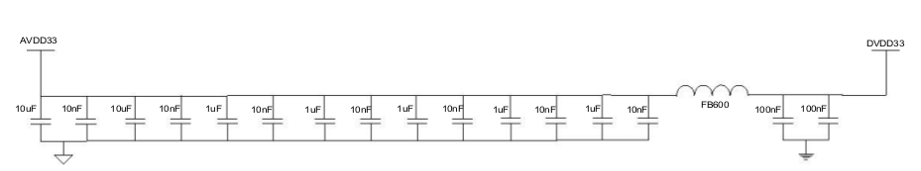

Figure 4.4 HR_C6000 power reference circuit

Chip working clock block diagram and description

Clock circuit
The HR_C6000 requires an optimum bias of 1.5V for the crystal. At this bias, the crystal output requires Vpp ≥ 2V. Chip The clock is input by the XTALI pin.
OMISSIS
Figure 4.5 HR_C6000 clock reference circuit

Clock configuration
Configure the relevant registers of the built-in PLL of the chip, so that the input clock is locked to CLK via PLL (recommended value is 49.152MHz), and the internal frequency of the chip is Sys_clk, Clk_codec, CLKOUT. The Sys_clk is the system working clock. Configuration register 0xB9 is obtained, Sys_clk is 9.8304MHz; Clk_codec is the built-in Codec working clock, which is configured by register 0xBA and has a frequency of 12.288MHz. CLKOUT can provide working clock for external Codec or vocoder. The clock frequency can pass 0xBB register. Configure and additionally configure bit 0 (ClkOut_enb) of Register 0x0A to control whether to output the CLKOUT clock and output a valid clock when high.
When the HR_C6000 is powered on, the internal working clock is directly provided by the external crystal oscillator by default, that is, bit7 of 0x0A is 1. After changing the configuration reg0x0B and reg0x0C, it needs to wait for more than 500μs. Wait for the PLL output to be stable enough before switching the internal clock back from the crystal oscillator. PLL output.
OMISSIS
Figure 4.6 Chip Operating Clock Block Diagram
The built-in PLL of the chip is configured through the 0x0B, 0x0C registers. The specific calculation formula is as follows:
CLK=XTALI×PLLM / PLLN / NO;
among them:
NO=2 PLLDO
1M<XTAL/ PLLN<25MHz;
200MHz<CLK×NO<1000MHz;
PLLM>1;PLLN>1;
By setting bit 7 of the 0x0C register to 1, the PLL can be bypassed. At this time, the PLL output is CLK=XTALI;
Configure bit 0 of 0x0C to 1 or the PWD pin of the chip is pulled high to put the PLL into sleep state. At this time, the PLL has no clock output.
Configure bit 7 (Clk_in_sel) of Register 0x0A as 1, and CLK does not select the output clock of the PLL. Instead, choose XTALI directly, which is CLK=XTALI.
Table 4.1 recommends two typical PLL output clock configuration parameters
XTALI | PLL configuration parameters | PLL output  clock | System clock configuration  parameter | System output clock
12.288M | Reg0x0B = 0x40  Reg0x0C = 0x32 | 49.152M | Reg0xB9 = 0x05  Reg0xBA = 0x04  Reg0xBB = 0x02 | Sys_clk=9.8304  Clk_codec=12.288M  CLKOUT=24.576M
29.4912M | Reg0x0B = 0x28  Reg0x0C = 0x33 | 49.152M | Reg0xB9 = 0x05  Reg0xBA = 0x04  Reg0xBB = 0x02 | Sys_clk=9.8304  Clk_codec=12.288M  CLKOUT=24.576M

Chip parameter configuration interface
The MCU uses the U_SPI port to perform parameter configuration, status control information, and write/receive data to and from the HR_C6000, and performs corresponding interrupt processing according to the TIME_SLOT_INTER, SYS_INTER, RF_TX_INTER, and RF_RX_INTER interrupts given by the HR_C6000. The MCU can also control the Sleep state of the chip through the GPIO pins. Its interface is shown below.
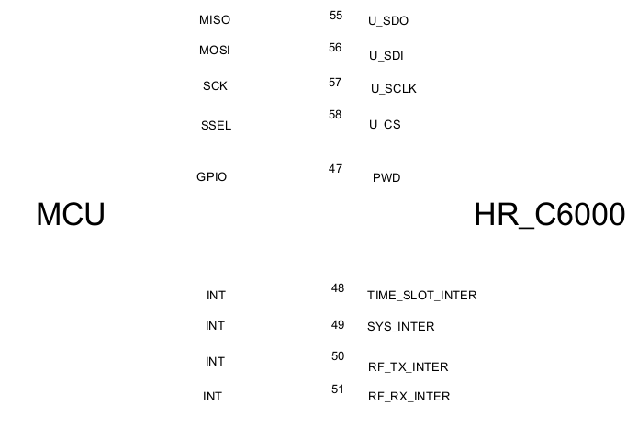
OMISSIS
Figure 4.7 Interface between MCU and HR_C6000
The chip's U_SPI interface operates in Slave mode, and the interface timing is shown in the figure below.
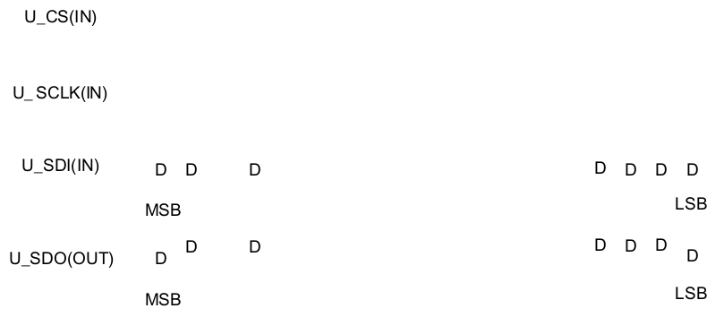
OMISSIS
Figure 4.8 U_SPI Interface Read and Write Timing
SCLK supports up to 4MHz clock rate.
The MCU can control the Sleep state of the HR_C6000 through the GPIO pin. When the GPIO is pulled high, the chip is in the Sleep state, and all clocks in the HR_C6000 are turned off.
When the GPIO is pulled low again, the chip is in normal operation mode. In this case, the ByPass internal PLL needs to be used to provide the clock through the crystal XTALI direct HR_C6000. After waiting for more than 500μs, switch to the internal PLL to provide the HR_C6000 working clock.
As shown in the figure, XTALI is the crystal input clock signal, PWD is the sleep signal of HR_C6000, Sys_clk is the working clock of HR_C6000; PLL_Sys_clk is the clock obtained by dividing the frequency of HR_C6000 after the PLL output.
The MCU configuration PWD is high, and the PWD is stable after 100ns. At this time, the HR_C6000 internal clock is all cleared. After the PWD is pulled low again, the working clock needs to be switched to XTALI. After waiting for the PLL to stabilize the output of the divided PLL_Sys_clk, switch to the PLL. The divided output clock has a settling time greater than 500μs.

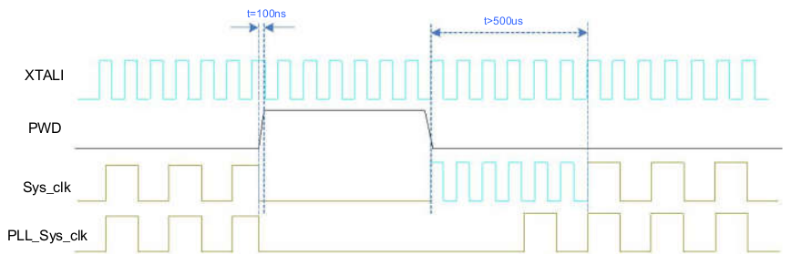
Figure 4.9 Schematic diagram of PWD control timing and working clock switching requirements
HR_C6000 provides 4 interrupt pins, the interrupt low pulse is valid, the pulse width is 3 system working clocks (Sys_clk, 9.8304MHz), SYS_INTER is to receive the indication interrupt of the system receiving and transmitting information, and the sending process and receiving process prompt the MCU status or control. TIME_SLOT_INTER is a 30ms time slot interrupt. This interrupt is generated cyclically after the HR_C6000 establishes a synchronization time slot. It is used to establish a TDMA time slot structure for the MCU. RF_TX_INTER and RF_RX_INTER are RF transceiver switching control interrupts. It is generated during the switching process to facilitate accurate and timely control of the RF channel by the MCU. RF_TX_INTER and RF_RX_INTER are alternately generated according to the period of 30ms. In order to facilitate the early start of the RF transmission control, register Reg0x12 can be set to control RF_TX_INTER and register Reg0xC0 to control RF_RX_INTER. The advance of 0ms can be configured with respect to the 30ms boundary.
OMISSIS
Figure 4.10 Schematic diagram of RF_TX_INTER and RF_RX_INTER generation
Table 4.2 RF_TX_INTER Interrupt Control Register Address Description
address | function
0x12 | Bit[5:0] configures the RF transceiver switching interrupt RF_TX_INTER relative to the 30ms boundary advance, in increments of 100μs. Bit[5:0] configures the RF transceiver switching interrupt RF_RX_INTER relative to the 30ms boundary advance, in increments of 100μs.

Use of Codec
HR_C6000 built-in CodeC for Mic input and LINEOUT output, Mic gain control and LINEOUT
The volume control effectively reduces the user's peripheral devices. At the same time, the standard I2S interface is configured for the external CodeC, and the user can also select the appropriate Codec according to his own needs.

Built-in Codec
OMISSIS

Use external Codec
OMISSIS
Figure 4.13 Interface circuit with external Codec
When the HR_C6000 uses an external Codec, data is exchanged with Codec through the I2S interface. The interface timing is as follows.
OMISSIS
Figure 4.14 I2S Interface Timing
among them:
- The LRCK clock frequency is determined by the Codec clock frequency and registers 0x32, 0x33. By default, the LRCK clock frequency is 8KHz.
LRCK clock frequency = Codec clock frequency / [2 * (parameter value + 1)], where the parameter value is derived from {register 0x32 value, register 0x33 value}.
- The BCLK clock frequency is determined by the Codec clock frequency and registers 0x30, 0x31.
BCLK clock frequency = Codec clock frequency / [2 * (parameter value + 1)], where the parameter value is derived from {register 0x30 value, register 0x31 value}.
- If the default external Codec (ALC5621) is used, LRCK is 8KHz and BCLK is 512KHz. At the same time, the chip CLKOUT pin needs to be connected to the chip MCLK pin, and CLKOUT outputs a 24.576MHz clock for the internal I2S operation of the chip. Connect the CLKOUT pin of the chip to the working clock input pin of Codec. When using the chip built-in Codec, the chip CLKOUT pin is not connected to the chip MCLK pin.
All pins of the external Codec can be reused as digital IO output, which can be used to control the high and low switching of the RF and the main control chip. The high and low switching time can be configured with reference to the delay of 30ms slot boundary or within 6ms in advance. The step size is 100us.
Table 4.4
Address | Function
0xC7/C8 | Control LRCK pin multiplexing, where Bit7 of C7 is multiplexed control enabled, Bit6 confirms high level with respect to 30ms slot boundary advance or delay, 0 is advanced, 1 is delayed; Bit5-0 is controlled early or delayed Quantity, the step size is 100us. Bit8 of C8 confirms that the low level is ahead or delayed relative to the 30ms time slot boundary, 0 is advanced, 1 is delayed; Bit5-0 is controlled early or delayed, and the step is 100us
0xC9/CA | Control ADCDAT pin multiplexing. The definition is the same as LRCK multiplexing.
0xCB/CC | Control MCLK pin multiplexing. The definition is the same as LRCK multiplexing.
0xCD/CE | Control BCLK pin multiplexing. The definition is the same as LRCK multiplexing.
0xCF/D0 | Control DACDAT pin multiplexing. The definition is the same as LRCK multiplexing.

As shown in the figure below, the control of the LRCK pin is taken as an example to illustrate the control diagram of the high and low levels. The other pin control methods are the same as this.
OMISSIS
Figure 4.15 LRCK pin multiplexing for general IO control interface timing

Vocoder
HR_C6000 can seamlessly interface with vocoder chips such as AMBE3000 and AMBE1000 with McBSP and CHS serial interface, and provide standard SPI and IS interfaces, and with Macro Rui HR_V3000 vocoder, Tsinghua SELP vocoder, 712 factory AVDS vocoder. Splicing docking, support for encrypted voice, data interface, and provide interface for digital voice recording, playback and prompt tone input.

Interface definition with Hongrui HR_V3000 vocoder
HR_V3000 and HR_C6000 transmit the compression-encoded digital voice stream or the digital voice stream to be decoded through V_SPI, and transmit PCM data through the I 2 S interface and the vocoder. The 2 IS interface of HR_C6000 works in the master mode; the MCU passes the UART interface. Transfer the voice encryption/decryption key or voice frame synchronization information with HR_V3000. The interface timing of the V_SPI port is shown in the figure below.
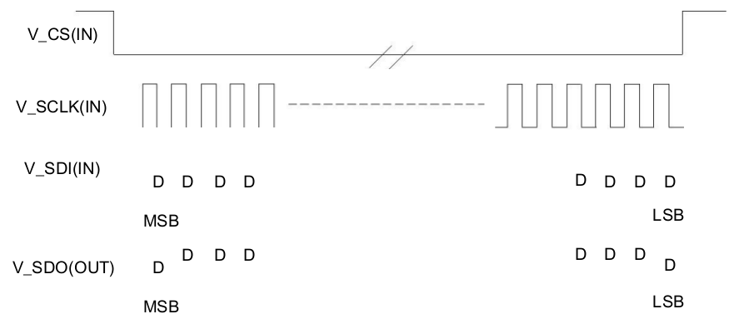
Figure 4.16 Using the V_SPI Interface to Read (Write) Timing
The SCLK supports up to 4MHz clock rate.
The frame format of V_SPI is shown below. What needs to be explained is:
The V_SPI interface can only perform one operation at a time, read or write.
When performing a read operation, Cmd=0x83, Addr=0x00, and read 27 individual Data(byte).
When writing, Cmd=0x03, Addr=0x00, and write 27 individual Data(byte).
OMISSIS
Cmd Addr Data0 Data1… Datan
Figure 4.17 V_SPI frame format
To communicate with the Hongrui HR_V3000 vocoder via the V_SPI interface HR_C6000, simply configure the HR_C6000 register reg0x06 to 0x24. The connection diagram of HR_V3000 and HR_C6000 and MCU is shown in the figure.
OMISSIS
Figure 4.18 HR_V3000 vocoder and HR_C6000 connection block diagram
OMISSIS
Figure 4.19 shows the interface timing of I2S.
I2S operates in master mode and needs to configure the I2S_CK_M clock frequency via Register 0x2F, calculated as codec operating frequency / (2* (Register 0x2F value + 1)). The I2S_FS_M clock frequency is configured by Register 0x32, 0x33 (the configured I2S_FS_M clock frequency must be 8KHz), calculated as codec operating frequency / (2 * ({Register 0x32 value, 0x33 value} +1)). At the same time, the I2S_CK_M frequency is >34* I2S_FS_M frequency, and the codec clock frequency is >=6*I2S_CK_M frequency.
When I2S is operating in Master mode, the I2S_CK_M, I2S_FS_M signals can be turned off via Register 0x36[6]. When 0x36[6]=0, these two signals are turned on, otherwise the two signals are turned off.
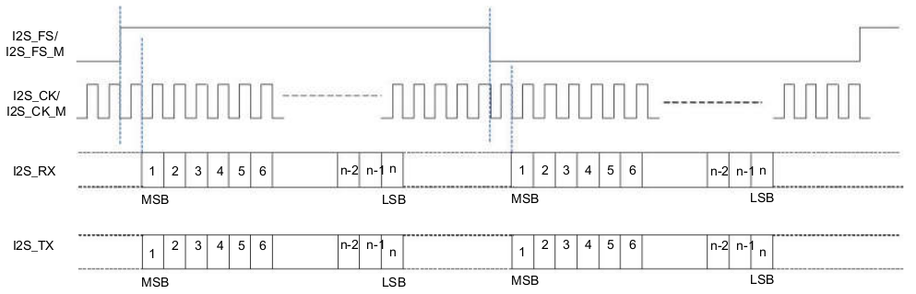
Figure 4.19 I2S Interface Timing
For details on the use of the HR_V3000 vocoder, please refer to the HR_V3000 vocoder instructions doc.

Transmitter module
The HR_C6000 has two high-performance DACs with single-ended output and supports RF interfaces such as baseband IQ, intermediate frequency and two-point modulation. The amplitude and offset of the two signals are adjustable.
The user can select the corresponding transmit interface through the configuration register, the two output signal offsets and the amplitude of the two output signals.
In addition, to control the power consumption of the chip, the user can turn it off when the DAC is not working by setting the 0x25 register. Bit3 and Bit2 of 0x25 can be selected by HR_C6000 to automatically control the DAC according to the transmission time slot, or the MCU can control the working state of the DAC by configuring Bit5 and Bit4.
Table 4.5HR_C6000 Baseband Transmit Control Register Address
Address | Function
0x01 | Bit7 selects the correspondence between the HR_C6000 transmit port and the RF transmit port; Bit[5:4] selects one of the four transmit modes. 2'b00 means to send the intermediate frequency mode, 2'b10 means to send the baseband IQ mode, and 2'b11 means to send the two-point modulation mode.
0x02 | The offset value of the baseband transmit output I path.
0x04 | The baseband transmits the offset value of the output Q path.
0x07 | IF frequency word height 8bit
0x08 | IF frequency word 8bit
0x09 | IF frequency word low 8bit
0x12 | Bit7 configuration smoothing enable; bit6 configures two-point modulation test square wave output  Can; bit[5:0] radio frequency interrupt advance, the incremental step size is about 100μs.
0x25 | DAC work control word.
0x2E | Send the advance configuration value. Because the RF channel delay is different, to ensure that the airborne DMR signal is strictly corresponding to the slot boundary transmission, configuring this register can offset the delay amount, and the step is 100μs. The internal channel has a fixed delay of 400μs, so this register should be configured as 0x04 when there is no delay on the RF side.
0x45 | Adjust the amplitude of the two-point modulation MOD2 (DAC_IVOUT)
0x46 | Adjust the amplitude of the two-point modulation MOD1 (DAC_QVOUT)
0x47 | Define two-point modulation offset adjustment value, a total of 10bit, where the high 2bit is defined in the lower 2bit of reg0x48.
0x48 | Bit[1:0] defines two-point modulation offset adjustment value, a total of 10bit, of which the lower 8bit is defined in reg0x47

Baseband IQ modulation
OMISSIS

Two-point modulation
OMISSIS

IF IQ modulation
OMISSIS

IF modulation
OMISSIS

Receiving module
OMISSIS

Baseband IQ
OMISSIS

IF mode
OMISSIS

Hierarchical function description
HR_C6000 adopts a flexible layered design model to flexibly open different levels for users to meet different user needs.
The layered design uses a three-tier architecture as shown.
Control and data services Voice service
- Call control layer
- Data link layer
- Physical layer
OMISSIS
Figure 5.1 HR_C6000 three-tier open architecture
The one-layer mode mainly solves the channel filtering of the baseband or low-IF signal and the modulation and demodulation process of the signal, as defined in the green dotted box in the above figure. The user needs to solve the channel codec and the processing of all communication protocol stacks by using one layer mode, which has the greatest development flexibility and development workload.
The second layer mode is mainly based on the opening of one layer of all content, completes the coding and decoding of the channel, and interleaves, deinterleaves and checksums, etc., as defined in the gray dashed box in the above figure. The user only needs to solve the processing flow of the communication protocol stack, and has greater development flexibility and moderate development workload.
The three-layer mode refers to all the application functions defined by the HR_C6000 according to the DMR protocol, and completes the modulation and demodulation, codec, and protocol stack design of all standardized application functions, all the functions defined in the blue dotted box in the above figure.
Users use these application functions, and only need to configure the corresponding function registers, so that all DMR protocol customized voice and data services can be quickly and conveniently used.
The HR_C6000 is mainly developed based on the Layer 2 mode. The user does not need to pay attention to the codec interleaving of the channel and the underlying modulation and demodulation process.

Interrupt use instructions

Interrupt use description
The corresponding interrupt of the three-layer function is sys_inter. The interrupt consists of two sub-interrupts. After receiving the interrupt, the MCU reads the interrupt status register 0x82. The corresponding interrupt can be masked by register 0x81, and the corresponding interrupt is cleared by register 0x83. A list of bit interrupt signals that yields 8 types of interrupts, including:
Bit7: In DMR mode: indicates that the transmission request rejects the interrupt without a sub-status register.
In DMR mode, it indicates that this transmission request is rejected because the channel is busy;
Bit6: In DMR mode: indicates the start of transmission; in MSK mode: indicates that the ping-pong buffer is half-full interrupted. In DMR mode, the sub-status register 0x84 is transmitted at the beginning, and the corresponding interrupt can be masked by 0x85. The sub-status registers indicate seven interrupts that initiate the transmission, including:
Bit7: Voice transmission starts
Bit6: OACSU requests to send interrupts, including first-time send and resend requests.
Bit5: End-to-end voice enhanced encryption interrupt, including EMB72bits update interrupt and voice 216bits key update interrupt, which are distinguished by Bit5~Bit4 of Register 0x88, where 01 indicates EMB72bits update interrupt and 10 indicates voice 216bits key update interrupt.
Bit4: The Vocoder configuration returns an interrupt (this interrupt is sent by the HR_C6000 to the MCU when the MCU manually configures the AMBE3000). This interrupt is only valid when using the external AMBE3000 vocoder.
Bit3: Data transmission starts
Bit2: Data partial retransmission
Bit1: Data retransmission
Bit0: The vocoder is initialized to an interrupt. This interrupt is only valid when using an external AMBE3000 or AMBE1000 vocoder.
In MSK mode, there is no sub-interrupt status.
Bit5: In DMR mode: indicates the end of transmission; in MSK mode: indicates the end of transmission.
In DMR mode, there is a sub-status register 0x86 at the end of the transmission, and the corresponding interrupt can be masked by 0x87. The sub-status register indicates six interrupts that generate the end of the transmission, including:
Bit7: indicates that the service transmission is completely terminated, including voice and data. The MCU distinguishes whether the voice or data is sent this time. Confirming that the data service is received is the response packet that receives the correct feedback.
Bit6: Indicates that a Fragment length confirmation packet is sent in the sliding window data service without immediate feedback.
Bit5: Voice OACSU wait timeout
Bit4: The Layer 2 mode handles the interrupt. The MCU sends the configuration information to the last processing timing of the chip to control the interrupt. If after the interrupt, the MCU has not written all the information to be sent in the next frame to the chip, the next time slot cannot be Configured to send time slots. This interrupt is only valid when the chip is operating in Layer 2 mode.
Bit3: indicates that a Fragment that needs to be fed back confirms the completion of the data packet transmission. The interrupt is mainly applied to the acknowledgment message after all the data packets have been sent or the data packet that needs to be fed back in the sliding window data service is sent to the MCU to start waiting for the timing of the Response packet. Device.
Bit2 : ShortLC Receive Interrupt
Bit1: BS activation timeout interrupt
In MSK mode, there is no substate interrupt.
Bit4: In DMR mode: indicates the access interruption; in MSK mode: indicates that the response response is interrupted. In DMR mode, the access interrupt has no sub-status register. After receiving the interrupt, it indicates that the access voice communication mode is post-access. the way.
In MSK mode, this interrupt has no substatus registers.
Bit3: In DMR mode: indicates that the control frame parsing completion interrupt; in MSK mode: indicates the receive interrupt.
In DMR mode, this interrupt has no sub-status register, but the error and receive type of its received data is given by the 0x51 register. The DLLRecvDataType, DLLRecvCRC are used to indicate the received data type and the error status, and the MCU accordingly performs the corresponding status. Display, you can also block the corresponding interrupt.
In MSK mode, this interrupt has no substate interrupts.
The FMB frame's EMB information parsing completion prompt is also the completion of the interrupt, which is distinguished by judging the 0x51 register SyncClass=0.
Bit2: In DMR mode: indicates service data reception interrupt; in FM mode: indicates FM function detection interrupt.
In DMR mode, this interrupt has sub-status register 0x90, which has three types:
- 0x80 indicates that the entire information is received and verified. After the service data is verified, the MCU extracts the data after the address 0x30 in the RX terminal 1.2KRAM through the SPI port. The length of the data is defined by the corresponding field of the received frame header.
- 0x00 indicates the entire information reception check error;
- 0x40 indicates that a non-confirmed SMS abnormal interrupt is generated;
In FM mode, the interrupt has sub-status register 0x90, and the sub-status register has 1 type:
- 0x10 indicates that the FM function detection interrupt is matched. When the FM interrupt is detected in the FM mode, the corresponding analog sound output is turned on.
Bit1: In DMR mode: indicates that the voice is abnormally exited;
In DMR mode, the cause of the abnormality in DMR mode is the unexpected abnormal voice interrupt generated inside the state machine. The corresponding voice exception type is obtained through Bit2~Bit0 of register address 0x98.
Bit0: physical layer separate work reception interrupt
The physical layer works independently to receive interrupts without a sub-status register. The interrupt is generated in the physical layer single working mode. After receiving the data, the interrupt is generated, and the MCU is notified to read the corresponding register to obtain the received data. This interrupt is typically tested in bit error rate or other performance in physical layer mode.
The system interrupt is handled as follows. The specific response tree is shown below (the FM mode is not included):
Waiting for interruption
Received a system outage
Read 0x82
Send request rejection | Send start | End of sending | Post access | Receive data | Receive information | Abnormal exit | Physical layer alone
Bit7 | Bit6 | Bit5 | Bit4 | Bit3 | Bit2 | Bit1 | Interrupt Bit0
 | Read 0x84 to get 7 kinds of content | Read 0x86 to get 6 kinds of end content |  | Read 0x51 to get the status of received data | Read 0x90 to get the receiving result

Write 0x83 corresponding bit clear interrupt
Waiting for interruption
OMISSIS
Figure 5.2 Interrupt Response Tree
The Time_slot_inte interrupt is a TDMA time slot interrupt. When the synchronization time slot of HR_C6000 is established, the interrupt is continuously given at intervals of 30ms. Until the synchronization is lost.

Interface read and write instructions
The user accesses through the general U_SPI includes the register system parameter table, register schedule, TX side 1.2KRAM and RX end 1.2KRAM. The access frame format is:
Cmd | Addr | Data0 | Data1... | Datan
OMISSIS
Figure 5.3 U_SPI Access Frame Format
Table 5.1 Cmd indicates the read and write status of the SPI port and the corresponding address space.
Cmd | W | IsRead | Bit7 | 1 means the operation is read, 0 means the operation is write
 |  | Read and write initial address extension | Bit6 | 0 does not expand, 1 expands
 |  |  | Bit5-Bit3 | Reserved
 |  | OPMode | Bit2-Bit0 | 000 reserved  001 indicates the operation auxiliary parameter configuration table.  010 means to write the write end RAM, read the receive end RAM,  100 represents the operating system parameter table,  101 means to configure the AMBE3000 register  110 means the operation writes the RAM, reads the RAM,  111 means to configure the AMBE1000 register

The Cmd highest bit selects whether this is a read operation or a write operation, and the lower 3 bits selects the category of this read/write operation.
Addr is the starting address of this read/write. The data that is subsequently written (or read) will start from the starting address and will be accumulated one by one. It will continue to accumulate every time CS is valid.
When Cmd[6]=1'b0, Addr represents 8bits (high order first), and the read/write start address is Addr;
When Cmd[6]=1'b1, Addr indicates 16bits (high order first), and the read/write start address is {Addr[2:0], Addr[15:8]}.
1. Write 0x01 to register 0x80 of the register system parameter table. The format is:
Cmd | Data
8’b 0 0000 100 | 8’b1000 0000

2, read the end 1.2KRAM from 0x30 2 bytes of data (data content is 0x01, 0x02) format:
Cmd | Addr | Data0 | Data1
8’b 1 0000 010 | 8’b0011 0000 | 8’b0000 0001 | 8’b0000 0010

In addition, the OPMode bit of Cmd is 101, 111 is configured for different types of external vocoder registers, and 011 is for reading and writing tones or other prompts.

HR_C6000 RAM allocation definition
Table 5.2 Space allocation definition of TX side 1.2KRAM in the second layer working mode
Frame type | Address | Description
Voice LC Header | 0x00~0x0b | 0x00~0x08: A total of 72bit is the control letter;
 |  | 0x09~0x0b: A total of 24 bits is the check information, and the MCU is optional.
Voice PI Header | 0x00~0x0b | 0x00~0x09: A total of 80 bits is the control information;
 |  | 0x0a~0x0b: A total of 16 bits is the check information, and the MCU is optional.
Voice EMB | 0x00~0x09 | 0x00~0x08: A total of 72bit is the control letter;
 |  | 0x09: bit7-bit3 A total of 5 bits is the check information, and the MCU is optional.
 |  | The information here is prepared at the same time as the speech frame A is to be sent.
Voice A | 0x30~0x4a | A total of 216 bits is voice frame information.
Voice B | 0x30~0x4a | A total of 216 bits is voice frame information.
Voice C | 0x30~0x4a | A total of 216 bits is voice frame information.
Voice D | 0x30~0x4a | A total of 216 bits is voice frame information.
Voice E | 0x30~0x4a | A total of 216 bits is voice frame information.
Voice F | 0x30~0x4a | A total of 216 bits is voice frame information.
RC Frame | 0x00~0x01 | 0x00, bit7-bit5 of 0x01, total 11bit information
Voice Terminator | 0x00~0x0b | 0x00~0x08: A total of 72bit is the control letter;
 |  | 0x09~0x0b: A total of 24 bits is the check information, and the MCU is optional.
CSBK | 0x00~0x0b | 0x00~0x09: A total of 80 bits is the control information;
 |  | 0x0a~0x0b: A total of 16 bits is the check information, and the MCU is optional.
MBC Header | 0x00~0x0b | 0x00~0x09: A total of 80 bits is the control information;
 |  | 0x0a~0x0b: A total of 16 bits is the check information, and the MCU is optional.
MBC Intermedia | 0x00~0x0b | 0x00~0x0b: A total of 96 bits is the control information;
MBC Last | 0x00~0x0b | 0x00~0x0b: A total of 96 bits is the control information;
DataHeader | 0x00~0x0b | 0x00~0x09: A total of 80 bits is the control information;
 |  | 0x0a~0x0b: A total of 16 bits is the check information, and the MCU is optional.
DataRate1_2 | 0x00~0x0b | 0x00~0x0b: A total of 96 bits is data information;
DataRate3_4 | 0x00~0x11 | 0x00~0x11: A total of 144 bits is data information;
DataRate1 | 0x00~0x17 | 0x00~0x17: A total of 192 bits is data information;
Idle | 0x18~0x23 | 0x18~0x23: A total of 96 bits is the control information;
Short LC | 0x24~0x28 | 0x24~0x26, bit7-bit4 of 0x27: total 28bit control information;
 |  | 0x28 : A total of 8bit check information.
Voice F frame EMB | 0x29~0x2C | Voice F frame fill information
 |  | Or 0x29 stores the superframe number (KeyID), 0x2A high 3bit stores the encryption serial number (ALOG ID)
Data control frame EMB RC | 0x4b~0x50 | Data control frame embedded 48bit RC information or 0x4b, 0x4c
 |  | High 11bit RC encoder input
C_RC frame (PDT) | 0x00~0x0a | 0x00, bit7-bit5 of 0x01: total 11bit RC information;
 |  | 0x02~0x08: Total 56 bit control information;
 |  | 0x09~0x0a: Total 16 bit check information;
196 message/information | 0x30~0x48 | 196bit control information
Test send | 0x00~0x48 | Send mode test to store data address
FM data address 1 | 0x030~0x22f | A total of 512 bytes of data information. You can send voice data for externally written FM or internally send voice data from Codec
FM data address 2 | 0x230~0x42f | A total of 512 bytes of data information. You can send voice data for externally written FM or internally send voice data from Codec
Encryption key stream data storage | 0x495~0x4af | A total of 216bit, 27 bytes

Table 5.3 Space allocation definition of RX terminal 1.2KRAM in the two-layer working mode
OMISSIS

Support frame type

Time slot framing
For slot framing, there are three modes: voice slot packets, data slot packets, and RC packets.
SYNC(48) Voice(108)
27.5ms
OMISSIS
Figure 5.3 Voice Slot Packet with Sync Head
CC PI LCSS
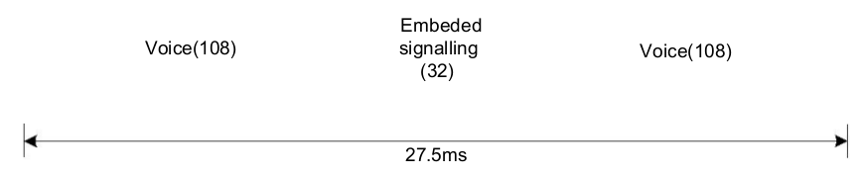
OMISSIS
Figure 5.4 Voice Slot Packet with EMB Data
1. Support six voice slot group group frames, and according to the superframe rule, determine the synchronization header or LC or Null in the voice frame, and set A (SYNC), B (LC), C (LC), D according to the standard. LC), E (LC), F (Null) superframe. Details include:
- Support sync header opt-in;
- Support EMB 7bit join, QR (16,7,6) encoding for EMB;
- Supports LC 72bit join, adds 5bit CS code, performs variable length BPTC encoding, interleaving, and joins into 4 time slots (128bit);
Table 5.3 Group Call 72bit LC Information Sheet
Information element | Length | Remark
Protect Flag (PF) | 1
Reserved | 1 | This bit shall be set to 0
Full Link Control Opcode (FLCO) | 6 | Shall be set to 000000
Feature set ID (FID) | 8 | Shall be set to 00000000
Service Option | 8
Group address | 24
Source address | 24

Table 5.4 Call 72bit LC Information Sheet
Information element |  | Remark
Protect Flag (PF) | 1
Reserved | 1 | This bit shall be set to 0
Full Link Control Opcode (FLCO) | 6 | Shall be set to 000011
Feature set ID (FID) | 8 | Shall be set to 00000000
Service Option | 8
Group address | 24
Source address | 24

- Support for Null time slot join;
CC | DataType
FEC Parity
FEC Parity

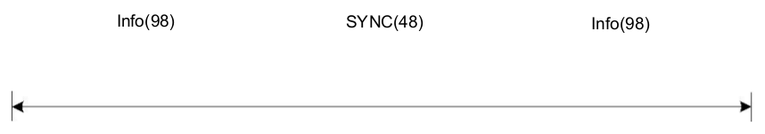
---missing figure
Figure 5.5 Data and control frame structure
2. Support for LC packet
- Support to join 72bit LC, CRC24bit check, and add CRC mask (Header and Terminator difference), BPTC (196,96) encoding, set up voice Head frame;
- Supports the construction of ShortLC packets with 72bitLC information for embedding into the EMB area of voice;
- Support for dynamic update of LC packages;
3. CSBK packages, MBC packages, and data packets are supported; detailed internals include:
- Support to join Slot Type (20bit), including CC, DataType, for Golay (20, 8) encoding;
- Support SYNC to join;
- Supports adding 80bit CSBK, CRC16bit checksum and adding CRC mask for BPTC (196,96) encoding and interleaving;
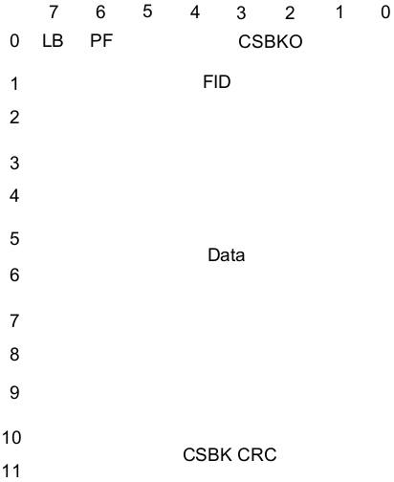

Figure 5.6 CSBK 80bit infographic
- Support to join 96bit Idle for BPTC (196, 96) encoding and interleaving;
- Supports adding 80bit MBC header, CRC16bit check, adding CRC mask, performing BPTC (196, 96) encoding and interleaving;
- Supports the addition of 96bit MBC data for BPTC (196, 96) encoding and interleaving;
- Support for adding 80bitMBC lastBlock, performing CRC16bit check, BPTC (196, 96) encoding and interleaving;
- Support data packet header, add 80bit data, perform CRC16bit check, add CRC mask, perform BPTC (196, 96) encoding and interleaving;
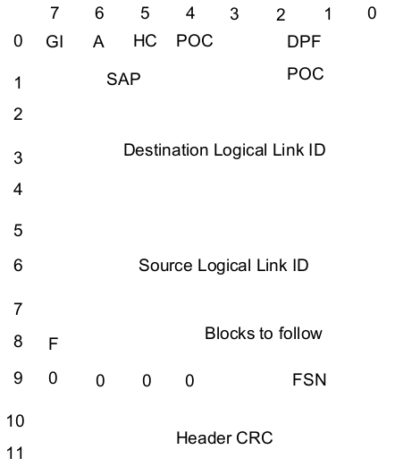

Figure 5.7 Unconfirmed packet header

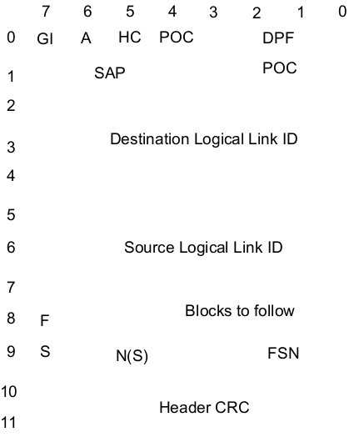

Figure 5.8 Confirm Packet Header
- Support for rapid generation based on application needs Unconfirmed data header, Confirmed data header, Response data header, Proprietary data header, Status/Precoded short data header, Raw short data header, Defined short data header with Unified Data transport data header;
- Supports the data format of the Rate 1/2 mode, adds 96-bit data, and performs BPTC (196, 96) encoding and interleaving;
- Supports the last slot data of Rate 1/2 mode, adds 64-bit data, performs 32-bit CRC check (checks all data), performs BPTC (196, 96) encoding and interleaving;
- Supports the data format of Rate 3/4 mode, adds 96-bit data, performs Trellis encoding and interleaving;
- Supports the last slot data of Rate 3/4 mode, adds 64-bit data, performs 32-bit CRC check (checks all data), performs Trellis encoding and interleaving;
- Supports the data format of Rate 1 mode and adds 96-bit data;
- Supports the last slot data of Rate 1 mode, adds 64-bit data, and performs 32-bit CRC check (checksum contains all data);
- Supports three types of confirmed data transmission, joins 7bit SN, performs 9-bit CRC check, adds masks (different rates, different masks), encodes and interleaves at different rates, and adds 32-bit CRC to the data;
- Support feedback packet data time slot, add 1-2 data feedback packets, perform overall 32-bit CRC check, perform BPTC (196, 96) encoding and interleaving;
- Support UDT's last block, perform 16-bit CRC check on data, perform BPTC (196, 96) encoding and interleaving;
CC | PI | LCSS
RC Info + FEC Parity
RC Info + FEC Parity
SYNC
SYNC
SYNC
SYNC
SYNC
SYNC
RC Info + FEC Parity
RC Info + FEC Parity
EMB Parity
SYNC(48)
10ms
30ms

---image missing
Figure 5.9 Independent RC frame structure
4. Supports RC signals for time slots RC and EMB;
- Support for adding 7bitEMB for QR (16, 7, 6) encoding;
- Support for adding 11bit RC signals, performing variable length BPTC, interleaving 32bit, and adding to RC unit;
5. Receiving the content type of the frame determined according to SYNC, determining the type of the received frame according to Slot Type, FLCO, CSBKO, LB, DPF, and then performing deinterleaving, decoding, and verifying corresponding to the transmission according to the received frame type.

Framing mode
Continuous mode:
OMISSIS
Slot mode:
- Supports voice superframe framing, which can be set to LC Header, PI Header or PI Header mode only, and automatically constitutes a superframe and joins LC Terminator;
- Support 4.8kbps framing for various data types, adding data LC Header, data and LC Terminator;

Frame definition and use
The configuration register reg0x10 is 0x68, and the system works in Layer 2 mode; the configuration register reg0x40 is 0x43, and reg0x41 is 0x40. The system is configured in the passive receive state by default. Other configurations are OK by default.
The transmit frame type configuration is specified by the reg0x50 register.
Table 5.5 Frame Type Coding Correspondence
Slot frame type | LocalDataType | Whether voice
Voice LC Header | 0001 | 0
Voice PI Header | 0000 | 0
Voice A | 0000 | 1
Voice B | 0001 | 1
Voice C | 0010 | 1
Voice D | 0011 | 1
Voice E | 0100 | 1
Voice F | 0101 | 1
RC Frame | 0110 | 1
Voice Terminator | 0010 | 0
CSBK | 0011 | 0
MBC Header | 0100 | 0
MBC Intermedia | 0101 | 0
MBC Last | 0101 | 0
DataHeader | 0110 | 0
DataRate1_2 | 0111 | 0
DataRate3_4 | 1000 | 0
DataRate1 | 1010 | 0
Idle | 1001 | 0
Reserved | 1011 | 0
 | 1100 | 0
 | 1011 | 0
 | 1110 | 0
 | 1111 | 0

To transmit data in Layer 2 mode, the user needs to prepare the content of the data frame to be sent in the next time slot according to the type of the transmitted frame. If it is the frame type already defined in the above table, the user can determine the user to complete the verification process corresponding to these frame types or the check digit generation process of the frame automatically by HR_C6000 through the bit 3 of the configuration register Reg40. If it is automatically completed by HR_C6000, the checksum generation process is strictly in accordance with the DMR protocol standard; if the user performs verification in the MCU, the HR_C6000 does not need to care about the verification mode and the check code content, but directly according to the original data. The next step is encoding. For example, if the user needs to have an MCU to complete a CSBK verification process, it needs to first generate 80bit CSBK data information, and then generate a 16-bit parity bit according to a self-defined verification method, and write a total of 96 bits of information to the address of the transmission RAM of the HR_C6000. - Address 11, then HR_C6000 takes this data directly for BPTC encoding and subsequent framing. If it is a user-defined frame type, the verification information bits generated by the verification are stored in the specified location of the RAM space of the transmitting end, and the HR_C6000 uses the verification information as part of the transmission information bit to enter the subsequent encoding and Framing processing. The schematic diagram of the sending process is shown below.

 | Idle |  |  |  | Configuration completed waiting
 | send request |  | Waiting to send |  | Sys_inter
Configure the send frame type and send the data to the RAM space. | Send enable open time slot establishment |  | Time_slot_  inter |  | Identification interruption | By reading Reg0x82 information
 | Send configuration preparation |  | sending |  | Send start interrupt
 | Configuration completed |  | Time_slot_  inter |  | Identify subinterrupt type | By reading Reg0x86 information
 | Configuration completed waiting | Correct | Send completed | Deny | Layer 2 mode transmission preparation interrupt
 |  | Idle |  | Send configuration preparation | Enable the next time slot transmission enable

Figure 5.10 Flow chart of the Layer 2 sending process

Working mode description
Working in Layer 2 mode, the synchronization time axis of the 30ms time slot required in the whole machine is provided by HR_C6000, while the HR_C6000 provides 30ms time axis. There are two modes, one is generated by HR_C6000 own clock, which provides 30ms stably. Interrupt, called active mode, the other is that the 30ms interrupt provided by HR_C6000 will continuously adjust its 30ms (approximate) interrupt output according to the signal received by HR_C6000 (including the sync head signal), which is called passive mode.
Active mode: CPU setting HR_C6000 Active mode (Register reg0x40 Bit5 is configured to 1, 1 of Bit6 and Bit7 must be 1), establish a time slot, and provide 30ms interrupt to the MCU.
Passive mode: CPU setting HR_C6000 register reg0x40 Bit5 is configured as 0 (where Bit6 and Bit7 must have one). HR_C6000 enters the receiving state. The system starts to establish synchronization according to the synchronization information of the received signal, and continues to receive synchronization information according to the received information. To adjust the synchronization timeline to provide a 30ms (approximate) interrupt to the MCU.
After the complete time axis is established, the chip has the conditions for sending and receiving. On this basis, the chip will provide the CPU time slot interrupt Time_slot_inter, which is used to inform the CPU of the middle position of the time slot of the entire time axis. The CPU plans the corresponding according to the time axis. Receive, send, and perform correct control and data transmission.
Bit 7 of Register 0x40 is the transmission, and Bit6 is the reception. This is the control signal that the CPU tells the chip to transmit or receive. Only when one of the two signals is valid, the time axis will be established, but these two signals will not be independently controlled. The transmission and reception of time slots is enabled, and the control of time slot transmission and reception is Bit 7 (send) and Bit 6 (receive) in register 0x41.
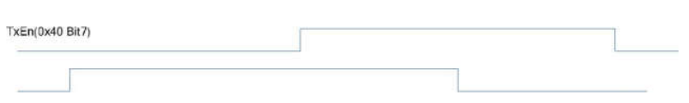
Figure 5.11 Schematic diagram of Layer 2 interrupt distribution

