Part A: Create Django project

1. Create Django project

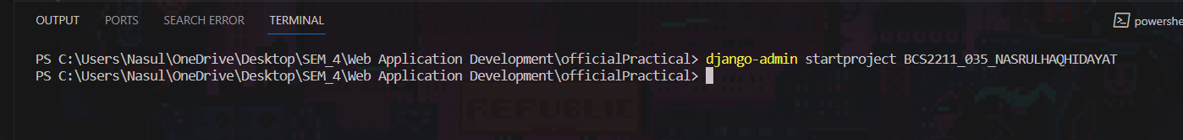

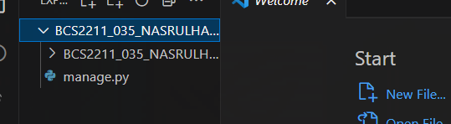

1. Create application named ‘MyKorea’

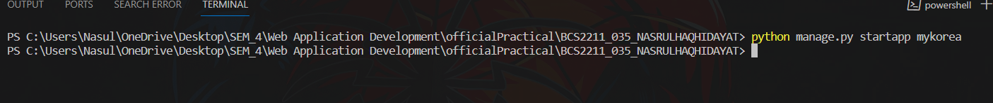

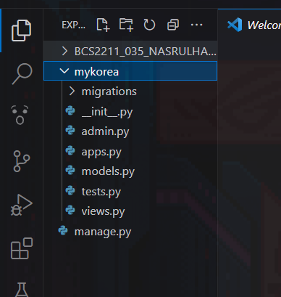

1. Add application into project setting

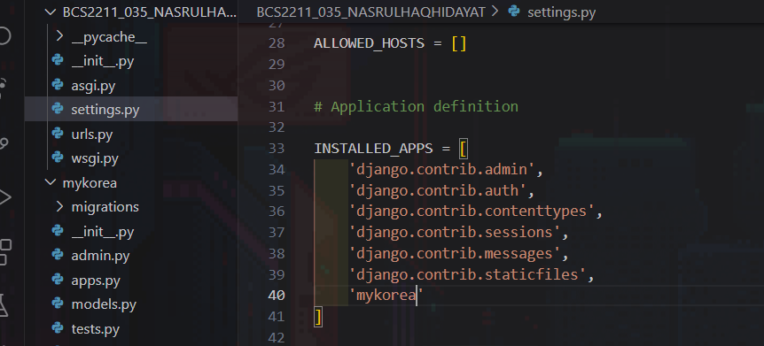

Part B: define Models

1. Create all models based on the tables

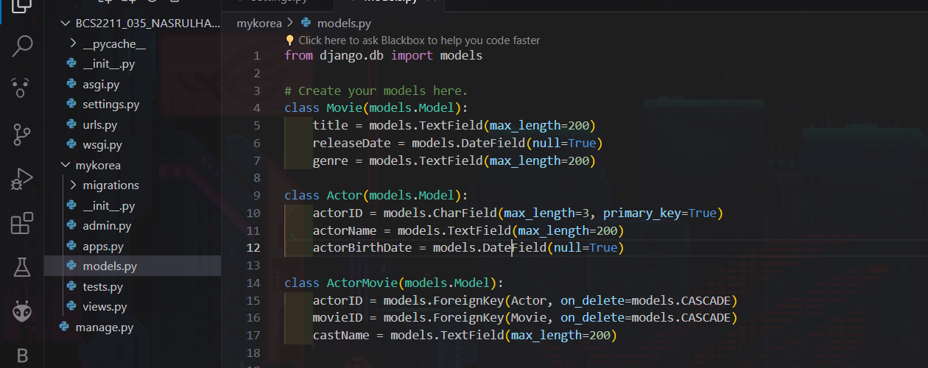

Part C: Create and apply migrations

1. Create initial migration

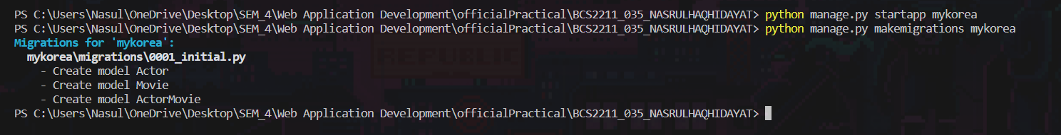

1. Apply migrations

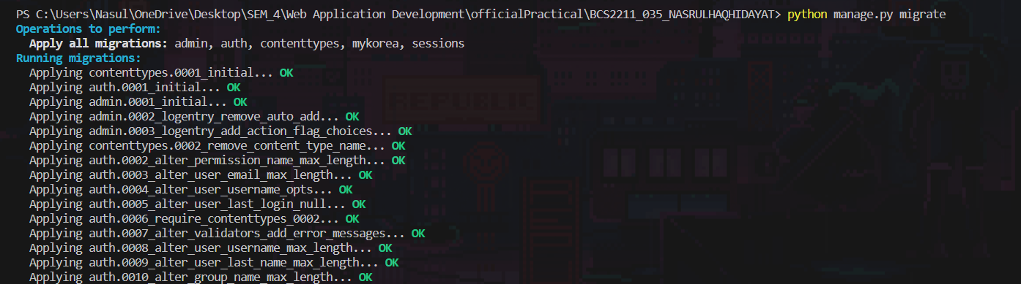

1. Show migrated fields

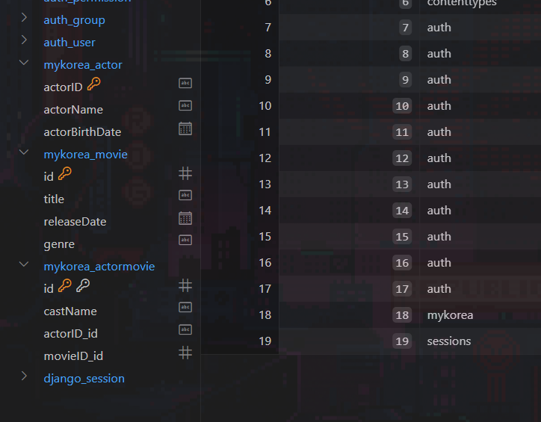’

Part D: Implement CRUD

1. Open interactive Console

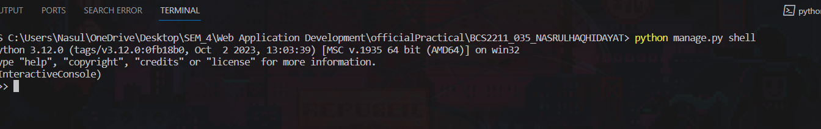

1. Import models

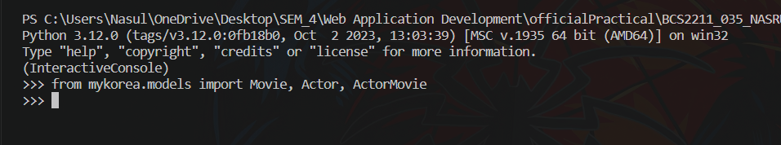

1. Insert All object into database

Movie

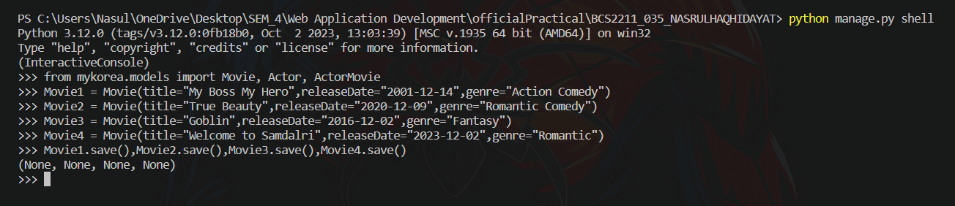

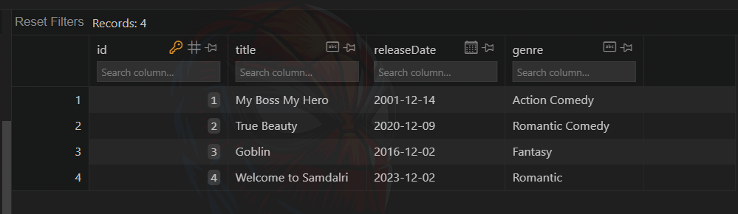

Actor

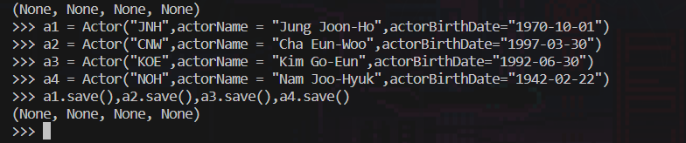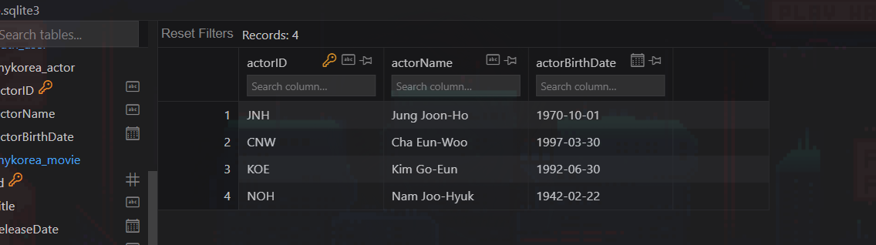

ActorMovie

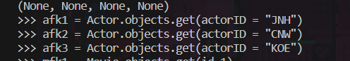

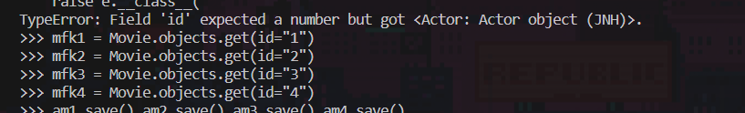

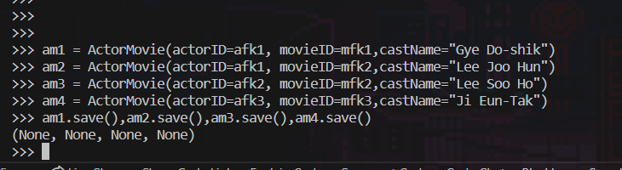

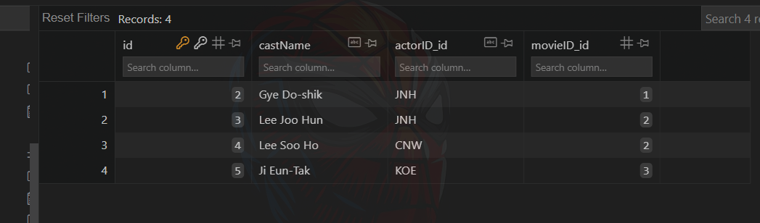

1. Display objects for all models using cmd

Movie

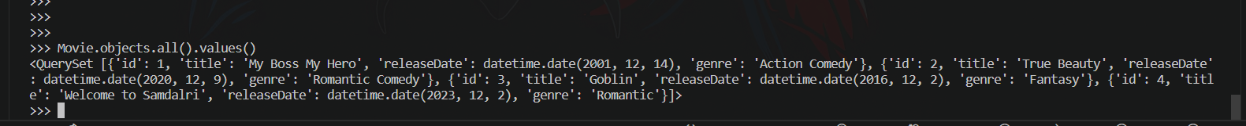

Actor



ActorMovie



1. Display all tables in VS Code

Actor

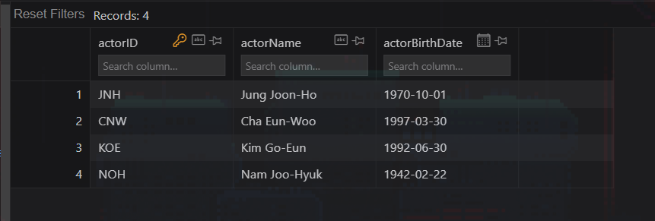

Movie

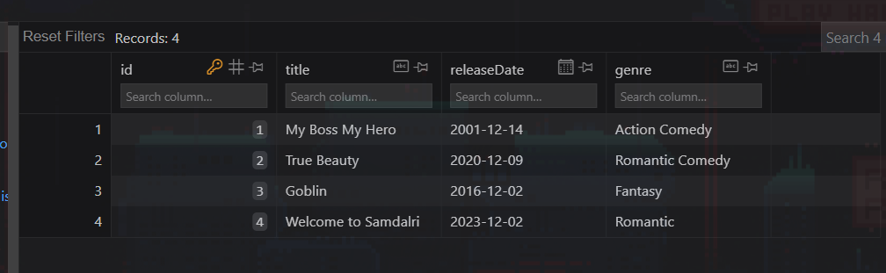

ActorMovie

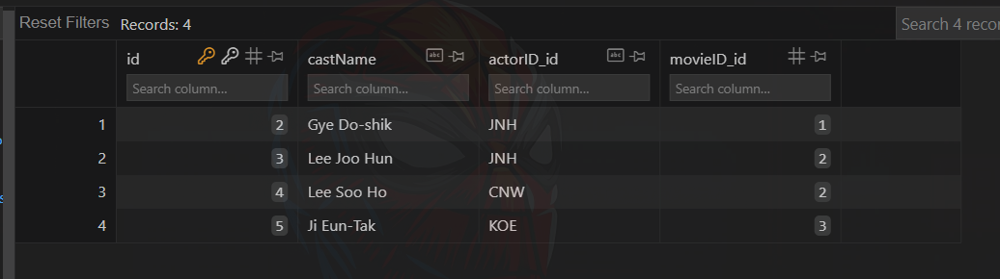

1. Terminate interactive console.



1. Add new field rating and set default value = 6

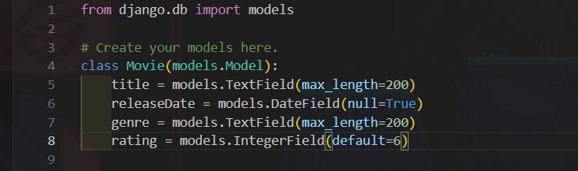



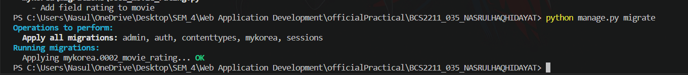

1. Update actorbirthdate for Kim Go Eun to 1992-07-02

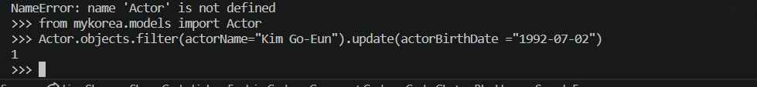



1. Delete object welcome to samdalri in movie

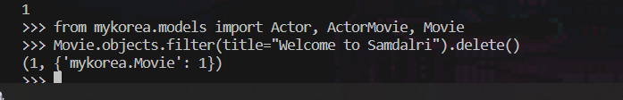

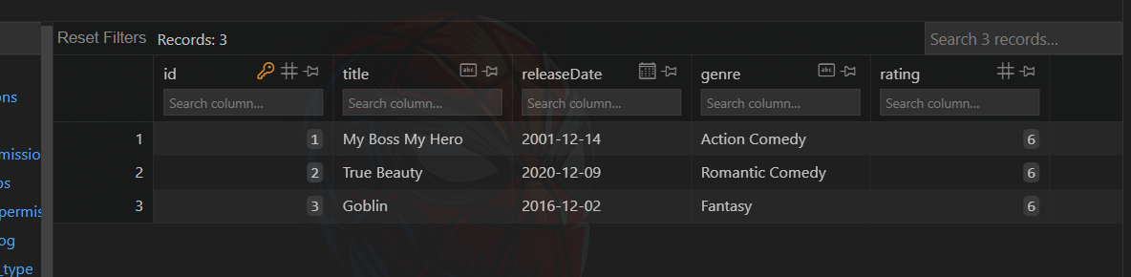

1. Display only JNH from table Actor Movie



1. Display All objects

ActorMovie

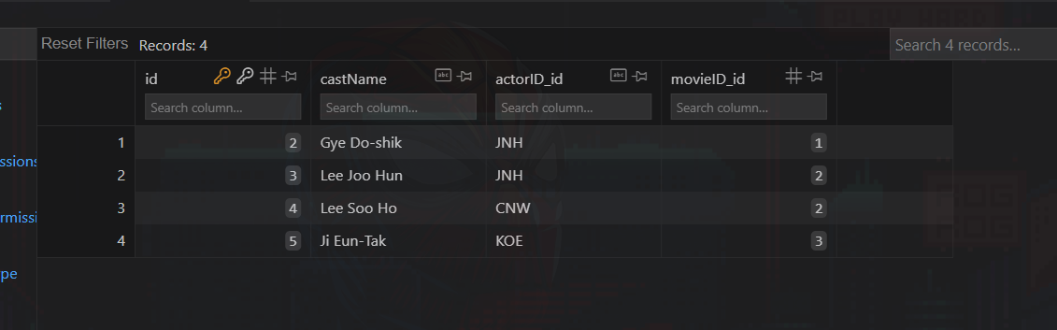

Movie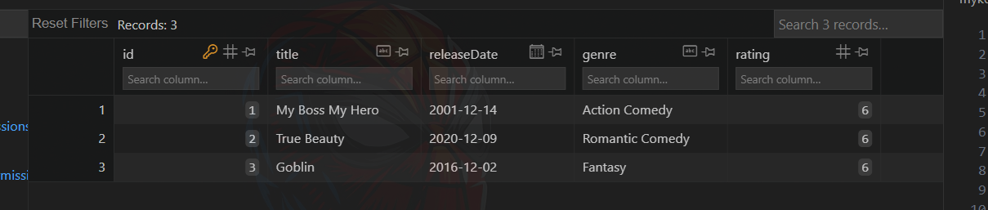

Actor

