Workshop Web Server
(TIF330805)

LAPORAN



ACARA 6

NAAFI’U MU’IZZ
NIM E41250371

TEKNIK INFORMATIKA KAB. NGANJUK
JURUSAN TEKNOLOGI INFORMASI
POLITEKNIK NEGERI JEMBER
TAHUN 2026

ACARA 6 Middleware, Auth Sederhana, dan Struktur Folder Lengkap
Studi Kasus
Halaman dashboard, form tambah mahasiswa, dan halaman edit hanya boleh diakses user yang sudah login. Tanpa proteksi, siapa pun yang tahu URL bisa masuk. Middleware Auth mengecek session sebelum Controller dijalankan. Jika belum login, user diarahkan ke halaman login.
Tujuan
Mahasiswa menyusun struktur folder lengkap, membuat AuthController (login/logout), dan melindungi beberapa route dengan AuthMiddleware.
Langkah
- Susun folder sesuai struktur berikut.
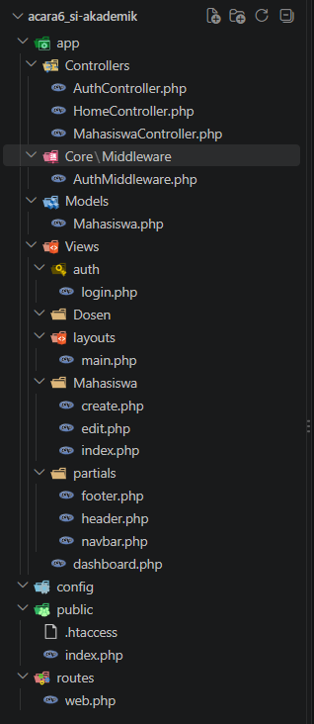

- Buat AuthController dengan method loginForm, login, logout.
<?php

namespace App\Controllers;

class AuthController
{
public function loginForm(): void
{
if (session_status() === PHP_SESSION_NONE) {
session_start();
}

if (!empty($_SESSION['logged_in'])) {
header('Location: ' .
app_url('/dashboard'));
exit;
}

$pageTitle = 'Login | SI Akademik';
$error = $_SESSION['login_error'] ?? null;
unset($_SESSION['login_error']);
require __DIR__ .
'/../Views/auth/login.php';
}

public function login(): void
{
if (session_status() === PHP_SESSION_NONE) {
session_start();
}

$username = trim($_POST['username'] ?? '');
$password = $_POST['password'] ?? '';
$validPassword = password_hash('admin123',
PASSWORD_DEFAULT);

if ($username !== 'admin' ||
!password_verify($password,
$validPassword)) {
$_SESSION['login_error'] = 'Username
atau password salah.';
header('Location: ' .
app_url('/login'));
exit;
}

session_regenerate_id(true);
$_SESSION['user_id'] = 1;
$_SESSION['user_name'] = 'Admin';
$_SESSION['logged_in'] = true;
$_SESSION['flash'] = ['type' => 'success',
'message' => 'Selamat datang, Admin.'];

header('Location: ' .
app_url('/dashboard'));
exit;
}

public function logout(): void
{
if (session_status() === PHP_SESSION_NONE) {
session_start();
}

$_SESSION = [];
session_destroy();
session_start();
$_SESSION['flash'] = ['type' => 'success',
'message' => 'Anda telah logout.'];

header('Location: ' . app_url('/login'));
exit;
}
}

- Buat form login sederhana.
app/Views/auth/login.php:
<?php include __DIR__ . '/../partials/header.php';
?>

<main class="container py-5">
<div class="row justify-content-center">
<div class="col-md-5 col-lg-4">
<div class="card shadow-sm border-0">
<div class="card-body p-4">
<h1 class="h3 mb-4">Login</h1>
<?php if (!empty($_SESSION['flash'])): ?>
<div
class="alert alert-<?=
htmlspecialchars($_SESSION['flash']['type'],
ENT_QUOTES, 'UTF-8'); ?>"
role="alert">
<?=
htmlspecialchars($_SESSION['flash']['message'],
ENT_QUOTES, 'UTF-8'); ?>
</div>
<?php unset($_SESSION['flash']); ?>
<?php endif; ?>
<?php if ($error): ?>
<div class="alert alert-danger"
role="alert"><?=
htmlspecialchars($error, ENT_QUOTES,
'UTF-8'); ?></div>
<?php endif; ?>
<form action="<?= app_url('/login'); ?>"
method="POST">
<div class="mb-3">
<label for="username"
class="form-label">Username</label>
<input type="text"
class="form-control" id="username"
name="username" required autofocus>
</div>
<div class="mb-3">
<label for="password"
class="form-label">Password</label>
<input type="password"
class="form-control" id="password"
name="password" required>
</div>
<button type="submit"
class="btn btn-primary
w-100">Login</button>
</form>
<p
class="text-muted small mt-3 mb-0">Demo:
admin / admin123</p>
</div>
</div>
</div>
</div>
</main>

<?php include __DIR__ . '/../partials/footer.php';
?>

- Simulasikan login sukses dengan hardcode username/password dulu (nanti diganti database).
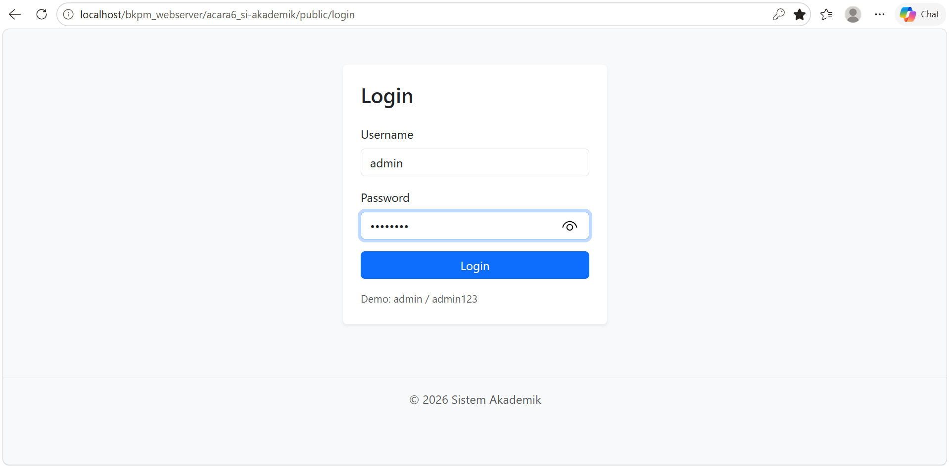
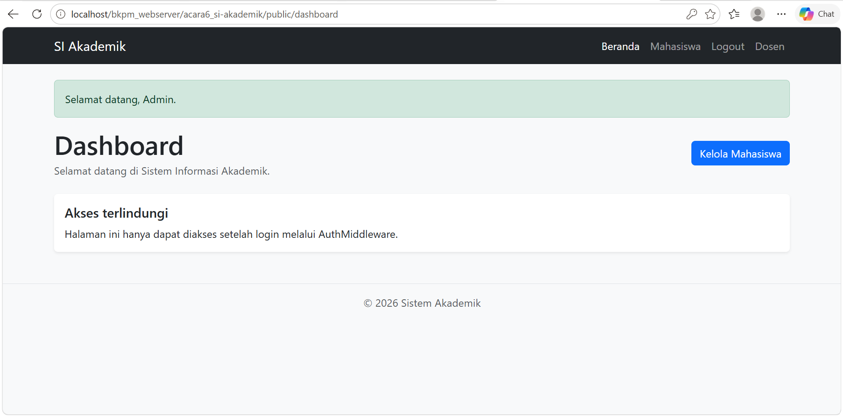
Pada method login() di AuthController, login dianggap sukses jika username 'admin' dan password 'admin123'. Setelah sukses, session logged_in diisi true dan user diarahkan ke /dashboard.

- Pasang AuthMiddleware pada route /dashboard dan /mahasiswa.
app/Core/Middleware/AuthMiddleware.php:
<?php

namespace App\Core\Middleware;

class AuthMiddleware
{
public function handle(): void
{
if (session_status() === PHP_SESSION_NONE) {
session_start();
}

header('Cache-Control: no-store, no-cache, must-revalidate, max-age=0');
header('Pragma: no-cache');
header('Expires: 0');

if (empty($_SESSION['logged_in']) || $_SESSION['logged_in'] !== true) {
$_SESSION['flash'] = ['type' => 'warning', 'message' => 'Anda harus login terlebih dahulu.'];
header('Location: ' . app_url('/login'));
exit;
}
}
}

routes/web.php:
<?php

return [
'GET' => [
'/' => ['HomeController', 'index'],
'/login' => ['AuthController', 'loginForm'],
'/logout' => ['AuthController', 'logout'],
'/dashboard' => ['HomeController',
'dashboard',
['App\\Core\\Middleware\\AuthMiddleware']],
'/mahasiswa' => ['MahasiswaController',
'index',
['App\\Core\\Middleware\\AuthMiddleware']],
'/mahasiswa/create' =>
['MahasiswaController', 'create',
['App\\Core\\Middleware\\AuthMiddleware']],
'/mahasiswa/edit' => ['MahasiswaController',
'edit',
['App\\Core\\Middleware\\AuthMiddleware']],
],
'POST' => [
'/login' => ['AuthController', 'login'],
'/mahasiswa' => ['MahasiswaController',
'store',
['App\\Core\\Middleware\\AuthMiddleware']],
'/mahasiswa/update' =>
['MahasiswaController', 'update',
['App\\Core\\Middleware\\AuthMiddleware']],
],
];

public/index.php:
<?php

require_once __DIR__ .
'/../app/Controllers/MahasiswaController.php';
require_once __DIR__ .
'/../app/Controllers/HomeController.php';
require_once __DIR__ .
'/../app/Controllers/AuthController.php';
require_once __DIR__ .
'/../app/Core/Middleware/AuthMiddleware.php';

$uri = parse_url($_SERVER['REQUEST_URI'] ?? '/',
PHP_URL_PATH) ?: '/';
$basePath = rtrim(dirname($_SERVER['SCRIPT_NAME'] ??
'/'), '/');

if (!function_exists('app_url')) {
function app_url(string $path): string
{
global $basePath;

return $basePath . '/' . ltrim($path, '/');
}
}

if ($basePath !== '' && $basePath !== '/' &&
str_starts_with($uri, $basePath)) {
$uri = substr($uri, strlen($basePath)) ?: '/';
}

$uri = '/' . trim($uri, '/');
$method = $_SERVER['REQUEST_METHOD'] ?? 'GET';
$routes = require __DIR__ . '/../routes/web.php';
$route = $routes[$method][$uri] ?? null;
$parameters = [];

if ($route === null && $method === 'GET' &&
preg_match('#^/mahasiswa/([^/]+)/edit$#', $uri,
$matches)) {
$route = ['MahasiswaController', 'edit',
['App\\Core\\Middleware\\AuthMiddleware']];
$parameters = [$matches[1]];
}

if ($route === null && $method === 'GET' &&
preg_match('#^/mahasiswa/([1-9]\d*)$#', $uri,
$matches)) {
$route = ['MahasiswaController', 'show',
['App\\Core\\Middleware\\AuthMiddleware']];
$parameters = [$matches[1]];
}

if ($route === null) {
http_response_code(404);
echo '<h1>404 - Halaman tidak ditemukan</h1>';
exit;
}

[$controllerName, $action, $middleware] =
array_pad($route, 3, []);

foreach ($middleware as $middlewareClass) {
(new $middlewareClass())->handle();
}

$controllerClass = 'App\\Controllers\\' .
$controllerName;
$controller = new $controllerClass();
$controller->$action(...$parameters);

- Uji: akses /mahasiswa tanpa login harus redirect ke /login.
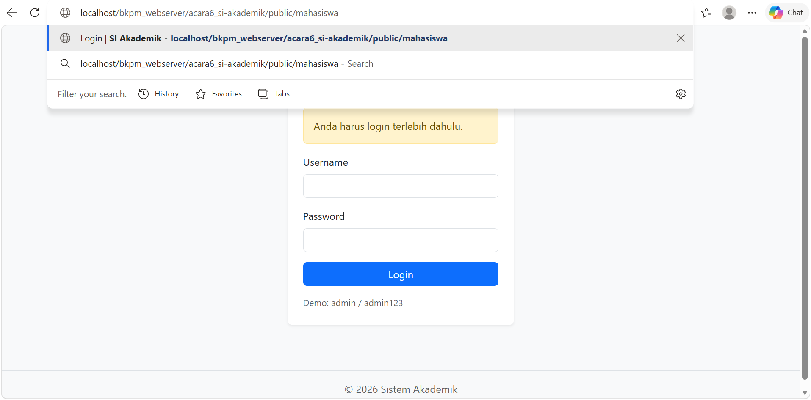
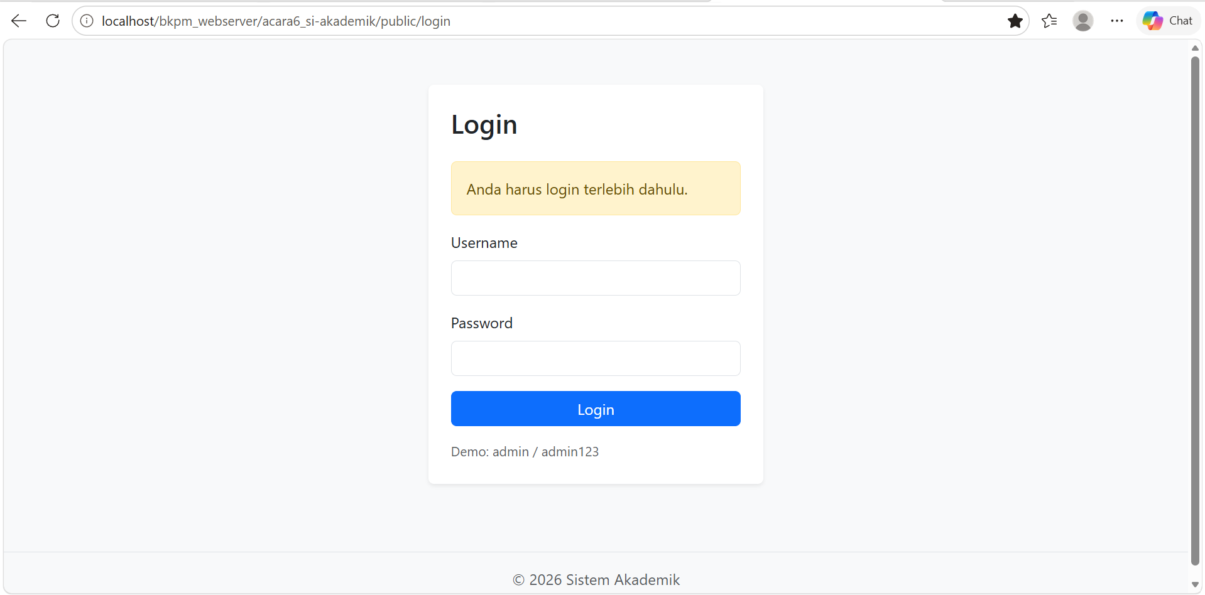
Saat /mahasiswa dibuka tanpa login, AuthMiddleware menemukan session logged_in kosong, menyimpan flash message 'Anda harus login terlebih dahulu.', lalu mengarahkan user ke /login. Setelah login dengan admin / admin123, user diarahkan ke /dashboard dan halaman /mahasiswa dapat dibuka.
Dengan demikian halaman /dashboard dan /mahasiswa terlindungi oleh AuthMiddleware, sedangkan flash message pada Tugas Mandiri tampil setelah login dan setelah logout.

Tugas Mandiri
Tambahkan flash message: setelah login sukses, tampilkan alert "Selamat datang, Admin" di dashboard. Setelah logout, tampilkan "Anda telah logout".
