Workshop Web Server
(TIF330805)

LAPORAN



ACARA 7

NAAFI'U MU'IZZ
NIM E41250371

TEKNIK INFORMATIKA KAB. NGANJUK
JURUSAN TEKNOLOGI INFORMASI
POLITEKNIK NEGERI JEMBER
TAHUN 2026

Studi Kasus
Sistem Informasi Akademik membutuhkan data Mahasiswa, Program Studi, dan Mata Kuliah. Data ini harus tersimpan permanen, bisa dicari, diubah, dan dihapus. File teks atau array PHP tidak cocok untuk data yang besar dan sering berubah. Database relasional (MySQL) adalah solusinya.
Tujuan
Mahasiswa membuat database si_akademik, tiga tabel, data awal, dan Model sederhana yang bisa mengambil semua data.
Langkah
- Buka phpMyAdmin, buat database si_akademik.
- Jalankan semua perintah CREATE TABLE.
- Jalankan INSERT data awal.
- Buat config/database.php.
<?php

return [
'host' => '127.0.0.1',
'dbname' => 'si_akademik',
'username' => 'root',
'password' => '',
'charset' => 'utf8mb4',
];

- Buat class Model dasar dan MahasiswaModel yang punya method all().
app/Core/Database.php:
<?php

namespace App\Core;

use PDO;
use PDOException;

class Database
{
private static ?PDO $connection = null;

public static function connection(): PDO
{
if (self::$connection !== null) {
return self::$connection;
}

$config = require __DIR__ .
'/../../config/database.php';
$dsn = sprintf(
'mysql:host=%s;dbname=%s;charset=%s',
$config['host'],
$config['dbname'],
$config['charset']
);

try {
self::$connection = new PDO($dsn,
$config['username'],
$config['password'], [
PDO::ATTR_ERRMODE =>
PDO::ERRMODE_EXCEPTION,
PDO::ATTR_DEFAULT_FETCH_MODE =>
PDO::FETCH_ASSOC,
PDO::ATTR_EMULATE_PREPARES => false,
]);
} catch (PDOException $exception) {
throw new PDOException('Koneksi database
gagal: ' . $exception->getMessage(),
(int) $exception->getCode(),
$exception);
}

return self::$connection;
}
}

app/Models/Model.php:
<?php

namespace App\Models;

use App\Core\Database;
use PDO;

require_once __DIR__ . '/../Core/Database.php';

abstract class Model
{
protected static function connection(): PDO
{
return Database::connection();
}
}

app/Models/Mahasiswa.php:
<?php

namespace App\Models;

require_once __DIR__ . '/Model.php';

class Mahasiswa extends Model
{
private static ?bool $hasStatusColumn = null;
private ?int $id;
private string $nim;
private string $nama;
private string $email;
private string $prodi;
private int $prodiId;
private int $angkatan;
private string $status;

public function __construct(
string $nim,
string $nama,
string $prodi,
string $email = '',
int $prodiId = 0,
int $angkatan = 0,
string $status = 'aktif',
?int $id = null
)
{
$this->id = $id;
$this->nim = strtoupper(trim($nim));
$this->nama = trim($nama);
$this->email = trim($email);
$this->prodi = trim($prodi);
$this->prodiId = $prodiId;
$this->angkatan = $angkatan;
$this->status = $status;
}

/** @return list<static> */
public static function all(): array
{
$statement = static::connection()->query(
'SELECT ' . static::selectColumns() . '
FROM mahasiswa m
INNER JOIN prodi p ON p.id = m.prodi_id
ORDER BY m.id'
);

return array_map(fn (array $row): static =>
static::fromRow($row),
$statement->fetchAll());
}

public static function find(int $id): ?static
{
$statement = static::connection()->prepare(
'SELECT ' . static::selectColumns() . '
FROM mahasiswa m
INNER JOIN prodi p ON p.id = m.prodi_id
WHERE m.id = :id'
);
$statement->execute(['id' => $id]);
$row = $statement->fetch();

return $row === false ? null :
static::fromRow($row);
}

private static function selectColumns(): string
{
if (self::$hasStatusColumn === null) {
$columns =
static::connection()->query('SHOW
COLUMNS FROM mahasiswa LIKE
\'status\'')->fetch();
self::$hasStatusColumn = $columns !==
false;
}

$statusColumn = self::$hasStatusColumn ?
'm.status' : "'aktif' AS status";

return
"m.id, m.nim, m.nama, m.email, m.prodi_id,
m.angkatan, {$statusColumn}, p.nama AS
prodi";
}

public static function create(string $nim,
string $nama, string $email, int $prodiId, int
$angkatan): void
{
$statement = static::connection()->prepare(
'INSERT INTO mahasiswa (nim, nama,
email, prodi_id, angkatan)
VALUES (:nim, :nama, :email, :prodi_id,
:angkatan)'
);
$statement->execute([
'nim' => $nim,
'nama' => $nama,
'email' => $email,
'prodi_id' => $prodiId,
'angkatan' => $angkatan,
]);
}

public static function update(int $id, string
$nim, string $nama, string $email, int
$prodiId, int $angkatan): void
{
$statement = static::connection()->prepare(
'UPDATE mahasiswa
SET nim = :nim, nama = :nama, email =
:email, prodi_id = :prodi_id,
angkatan = :angkatan
WHERE id = :id'
);
$statement->execute([
'id' => $id,
'nim' => $nim,
'nama' => $nama,
'email' => $email,
'prodi_id' => $prodiId,
'angkatan' => $angkatan,
]);
}

private static function fromRow(array $row):
static
{
return new static(
$row['nim'],
$row['nama'],
$row['prodi'],
$row['email'],
(int) $row['prodi_id'],
(int) $row['angkatan'],
$row['status'],
(int) $row['id']
);
}

public function getNim(): string
{
return $this->nim;
}

public function getNama(): string
{
return $this->nama;
}

public function getProdi(): string
{
return $this->prodi;
}

public function getId(): ?int
{
return $this->id;
}

public function getEmail(): string
{
return $this->email;
}

public function getProdiId(): int
{
return $this->prodiId;
}

public function getStatus(): string
{
return $this->status;
}

public function getAngkatan(): string
{
return $this->angkatan > 0 ? (string)
$this->angkatan : '-';
}
}

app/Models/MahasiswaModel.php:
<?php

namespace App\Models;

require_once __DIR__ . '/Model.php';
require_once __DIR__ . '/Mahasiswa.php';

class MahasiswaModel extends Mahasiswa
{
/** @return list<static> */
public static function all(): array
{
return parent::all();
}
}

- Tampilkan data mahasiswa di halaman /mahasiswa (masih sederhana).
app/Controllers/MahasiswaController.php (method index):
public function index(): void
{
$mahasiswa = MahasiswaModel::all();
$pageTitle = 'Data Mahasiswa | SI Akademik';
ob_start();
require __DIR__ .
'/../Views/Mahasiswa/index.php';
$content = ob_get_clean();
require __DIR__ .
'/../Views/layouts/main.php';
}

app/Views/Mahasiswa/index.php:
<div
class="d-flex justify-content-between
align-items-center mb-4">
<h1 class="mb-0">Daftar Mahasiswa</h1>
<a href="<?= app_url('/mahasiswa/create'); ?>"
class="btn btn-primary">Tambah Mahasiswa</a>
</div>

<div class="card shadow-sm border-0">
<div class="card-body p-0">
<table
class="table table-striped table-bordered mb-0
align-middle">
<thead class="table-dark">
<tr>
<th scope="col">NIM</th>
<th scope="col">Nama</th>
<th scope="col">Prodi</th>
<th scope="col">Angkatan</th>
<th scope="col">Status</th>
<th scope="col"
class="text-center">Aksi</th>
</tr>
</thead>
<tbody>
<?php foreach ($mahasiswa as $index =>
$item): ?>
<tr>
<td><?=
htmlspecialchars($item->getNim(),
ENT_QUOTES, 'UTF-8'); ?></td>
<td><?=
htmlspecialchars($item->getNama(),
ENT_QUOTES, 'UTF-8'); ?></td>
<td><?=
htmlspecialchars($item->getProdi(),
ENT_QUOTES, 'UTF-8'); ?></td>
<td><?=
htmlspecialchars($item->getAngkatan(),
ENT_QUOTES, 'UTF-8'); ?></td>
<td><?=
htmlspecialchars($item->getStatus(),
ENT_QUOTES, 'UTF-8'); ?></td>
<td class="text-center">
<a
href="<?= app_url('/mahasiswa/' .
$item->getId()); ?>"
class="btn btn-sm
btn-info">Detail</a>
</td>
</tr>
<?php endforeach; ?>
</tbody>
</table>
</div>
</div>

Halaman /mahasiswa menampilkan data mahasiswa yang diambil dari database melalui MahasiswaModel::all(), yaitu sebagai berikut.
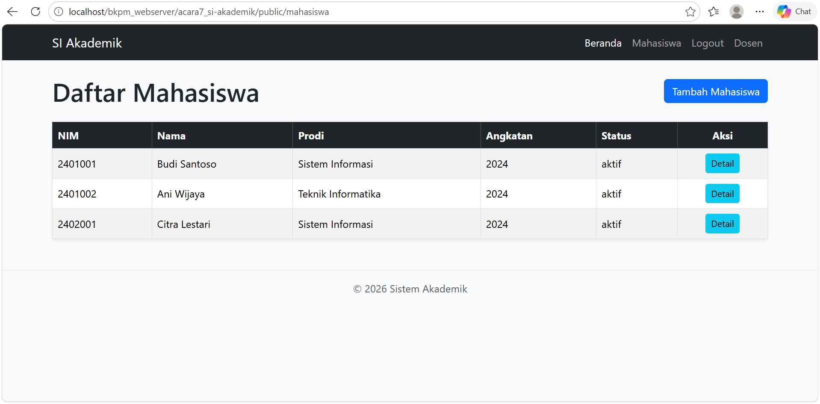
Setiap baris memiliki tombol Detail yang membuka halaman /mahasiswa/{id}. Kolom Prodi diambil dari tabel prodi melalui INNER JOIN, dan kolom Status bernilai aktif karena default pada tabel mahasiswa.

Tugas Mandiri
Tambahkan kolom 'status' (ENUM 'aktif','cuti','lulus') pada tabel mahasiswa, isi default 'aktif', lalu update data yang sudah ada.
ALTER TABLE mahasiswa
ADD COLUMN IF NOT EXISTS status ENUM('aktif', 'cuti', 'lulus')
NOT NULL DEFAULT 'aktif';

