**Impacts of Race and Age on Mental Health in Older Adults**

**Naail Chowdhury**



**Introduction**

**Objectives:**

Understanding any relationships that exist with the prevalence of mental health issues is an important tool for medical professionals when assessing and diagnosing patients. This study attempted to analyze if race and age had any effects on the frequency of mental health issues in older adults. I expect the data to reflect that Black Americans show a larger frequency of mental health issues, as they are the most marginalized minority group in America. I also expect to find that older patients suffer more from mental health issues than younger patients due to stressors which are associated with aging, such as the decline of functional ability. I was motivated to study this topic through my experiences as a research assistant for an Alzheimer’s Disease (AD) early detection lab. A massive focus in AD research is concerned with establishing causal links between several risk factors, such as obesity, depression, heart health, lifestyle, and mental health. As such, understanding these variables and how they relate to aging populations can provide more context to understanding chronic diseases such as AD.

**Research Questions:**

*Research Question 1 – Does the mean frequency of older adult people who suffer from a mental health issue differ based on race of the patient?*

*Research Question 2 – Does the mean frequency of older adult people who suffer from a mental health issue differ based on age of the patient?*

**Methods**

**Data Collection:**

This study analyzed a sample of 168 random and independent patient survey responses from a dataset which compiled results from numerous surveys on Alzheimer’s Disease (AD) and healthy aging carried out by the Behavioral Risk Factor Surveillance System (BRFSS).

**Measures:**

The numeric response variable being measured in this study was the mean frequency of older adults, measured in percents (%), who are experiencing a mental health issue. Both explanatory variables were categorical. The first variable specified which racial category an older adult identified as among three groups: Black (non-hispanic), White (non-hispanic), or Hispanic. The second variable specified which age group an older adult belonged to: ages 50 – 59 years or 60 years and older.

**Analysis Method:**

Utilizing RStudio, a programming software for statistical computing, a multi – factor ANOVA test with an interaction term between the two explanatory variables, age and race, was used to analyze the dataset.

**Descriptives**

**Response Variable:**

Table 1 – Descriptive Statistics for Frequency of Older Adults Suffering from a Mental Health (%) issue (n=168)

|  |  |  |
| --- | --- | --- |
|  | **Mean** | **Standard Deviation** |
| **Frequency of Older Adults Suffering from a Mental Health issue (%)** | 15.614 | 4.306 |

**Explanatory Variables:**

Table 2 – Frequency table for Race and Age of older adult patient (n=168)

|  |  |  |  |
| --- | --- | --- | --- |
|  | **Ages 50 – 59 years** | **Ages 60 years and older** | **Totals** |
| **Black (Non-Hispanic)** | 28 | 28 | 56 |
| **Hispanic** | 28 | 28 | 56 |
| **White (Non-Hispanic)** | 28 | 28 | 56 |
| **Total** | 84 | 84 | 168 |

**Results**

**Results table:**

|  |  |  |  |
| --- | --- | --- | --- |
| **Variable** | **Sums of Squares (SS)** | **F – Statistic** | **P-value** |
| **Race/Ethnicity** | 71.000 | 2.215 | 0.112 |
| **Age** | 354.000 | 22.103 | 5.496e-06 |
| **Race:Age** | 78.000 | 2.438 | 0.091 |

Table 3 – Model Results of Multi – Factor ANOVA.

**Adjusted R2 =** 0.1365418

An older person’s race and age account for 13.65% of the variation in the frequency of mental health issues.

**Interaction Plot**

Figure 1 – Interaction plot for Race and Age on the mean frequency of Mental Health issues in older Patients (%).

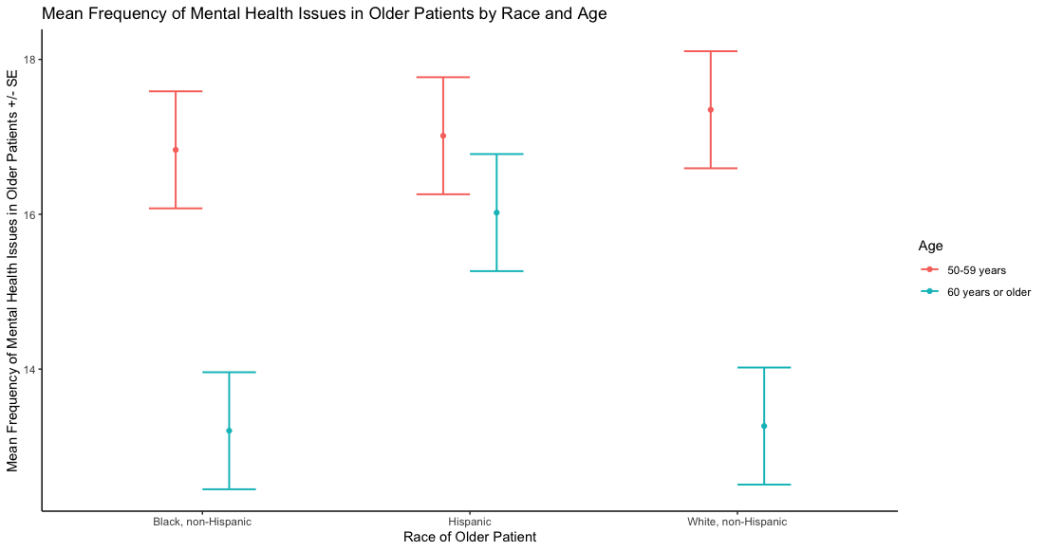

**Assumptions**

**Assumptions:**

1. This was a random sample carried out by the BRFFS through randomized telephone surveys to various people across the United States.
2. The sample had independent observations as there were no relationships between each individual survey carried out by the BRFSS.
3. While the two different age groups were normally distributed, when looking at the Race/Ethnicity factor, the “White, non – Hispanic” group was not normally distributed. No transformations could produce a normal distribution for the “White, non – Hispanic” group, and so the sample data failed the normality assumption for each group within each factor. Normality can be assessed visually through a box plot of the explanatory and response variables.

1. This data fails Levene’s test of equal variances for both factors. It was found that the three race groups within the race factor had significantly different variances from each other (p=0.003). Furthermore, it was also found that the two age groups within the Age category also had significantly different variances from each other (p=0.034).

**Discussion**

**Interpretation:**

While controlling for race, the mean frequency of mental illness in older adults significantly differs between the age group of the older adult (F = 22.103, df = (1, 162), p = 5.496e-06< 0.05). Also, while controlling for age, the mean frequency of mental illness in older adults did not significantly differ between the race of the older adult (F = 2.215, df = (2, 162), p = 0.112> 0.05). Race and age did not have a significant interaction on the mean frequency of mental illness in older adults (F = 2.438, df = (2, 162), p = 0.091> 0.05). A post – hoc analysis was performed on the only significant factor, age of the older adult. Older adults from ages 50 – 59 years experienced, on average, higher frequencies of mental health issues than older adults who were 65 years and older (p< 0.0001).

**Limitations:**

* The BRFSS conducts telephone surveys to gather their data. As such, all people who do not have telephones or are in institutions that do not allow the use of a telephone cannot be represented in this study. Furthermore, these survey responses are self – reported and cannot be confirmed by a healthcare provider.
* Both factors, Race and Age, failed the normality and equal variances assumption. This is another limitation to be considered when drawing conclusions from this study.
* One confounding variable in this study could be whether the older adult is suffering from a chronic illness or not. As people age, the symptoms from chronic illnesses typically worsen, which could result in a higher frequency of adults who could self – report mental health issues.

**Implications and Future Research:**

This study reveals that when considering the race and age of older adult patients, the patient’s age has a significant effect on the frequency of mental health issues in the older adult population. These two factors did not interact. Within the age groups, this study shows that the frequency of mental health issues is greater in the 50 – 59 age group compared to the 65 years and older group.

The consequences of this analysis have clinical applications. When assessing the mental health of an older adult patient, doctors should understand that older adult patients within the 50 – 59 year age group have higher frequencies of mental health issues compared to older patients. Knowing this, doctors can start advocating to their patients to take preventative measures to stop the onset of mental health issues sooner. By making older adults within this age range wary of their risk combined with the appropriate preventative measures to deter mental health issues, the frequency of mental health issues in older adults can reasonably decline. When expanding this research, considering other factors besides race and age, such as whether an older adult has heart disease or not, will be really useful in assessing the frequency of mental health in older adults. If given a chance to perform this study again, separating the two age groups into 4 ordinal age groups could give a better indication if the frequency of mental health issues increases with age.

**References**:

CDC - BRFSS - Survey Data & Documentation. (2019, August 27). Retrieved from https://www.cdc.gov/brfss/data_documentation/index.htm.

Centers for Disease Control and Prevention and National Association of Chronic Disease Directors. The State of Mental Health and Aging in America Issue Brief 1: What Do the Data Tell Us? Atlanta, GA: National Association of Chronic Disease Directors; 2008.