**Name: Naail Chowdhury**

**Lab day and time: Friday 2PM**

**Introduction (1 paragraph):**

Treatment options for mental health issues are better understood now then it’s ever been. As such, understanding any relationships that exist with the prevalence of mental health patients and the different types of patients who would experience mental health issues is an important tool for medical professionals when assessing and diagnosing patients. In this study, the mean percent of adults suffering from mental health issues were measured per race. This is important for doctors to know so that they can accurately predict whether a person of a certain race is more likely to develop a mental health complication compared to someone of a different race. Furthermore, this study also measures the difference in mean percent of adult mental health problems between age groups. This is also useful to understand at which age patients should start becoming wary of their mental health so that they can take the necessary steps to avoid mental health complications in the future.

**Research Question 1:**

Is there a difference between the mean percents of older adult people who suffer from a mental health issue between different racial/ethnic categories (White, Black, Hispanic)?

**Research Question 2:**

Is there a difference between the mean percents of older adult people who suffer from a mental health issue between different age groups?

**Data Collection Summary (1 paragraph):**

The data I compiled was from a dataset which compiled results from numerous surveys on Alzheimers Disease (AD) and healthy aging carried out by the Behavioral Risk Factor Surveillance System (BRFSS). There were over 46,000 datapoints describing different numeric response variables which related to healthy aging. My two explanatory variables were race, and age. Race data was not available for every data point, however, every entry came with an age group. After accounting for the points which included a race group and choosing the percentage of older adults who suffer from a mental health issue as my response variable, I was left with a dataset of 168 points. No transformations were needed for the numeric response variable as the data was already normally distributed.

**Descriptive Analysis of Response Variable (include graph(s) of distribution here):**

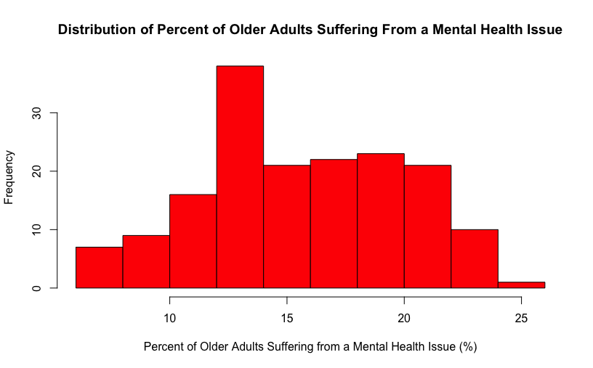

The distribution of percents of older adults suffering from a mental health issue was normally distributed with a slight left skew. The median percent of adults suffering from a mental health issue was 15.3% percent with an IQR of 6.6%.

**Investigation of Explanatory Variable #1 (include bivariate graph here):**

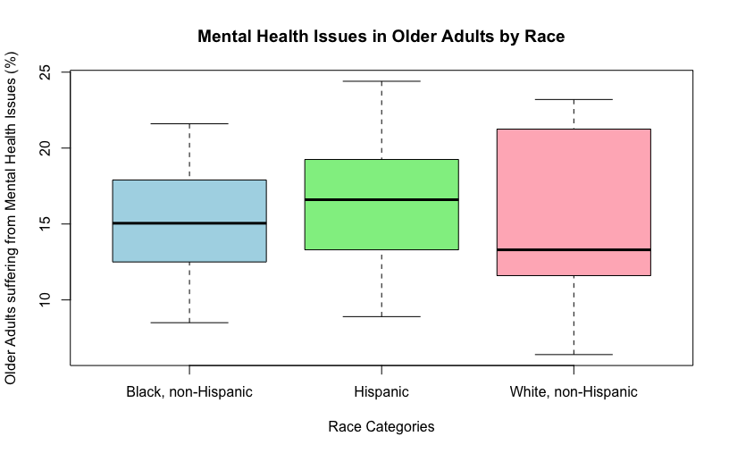

The mean number of older adult black people who are suffering from mental health issues is 15.02% with a standard deviation of 3.56%. The mean number of older adult Hispanic people who suffer from mental health issues was 16.52% with a standard deviation of 3.63%. Lastly, the mean number of older adult white people who suffer from mental health issues was 15.31% with a standard deviation of 5.39%.

**Investigation of Explanatory Variable #2 (include bivariate graph here):**

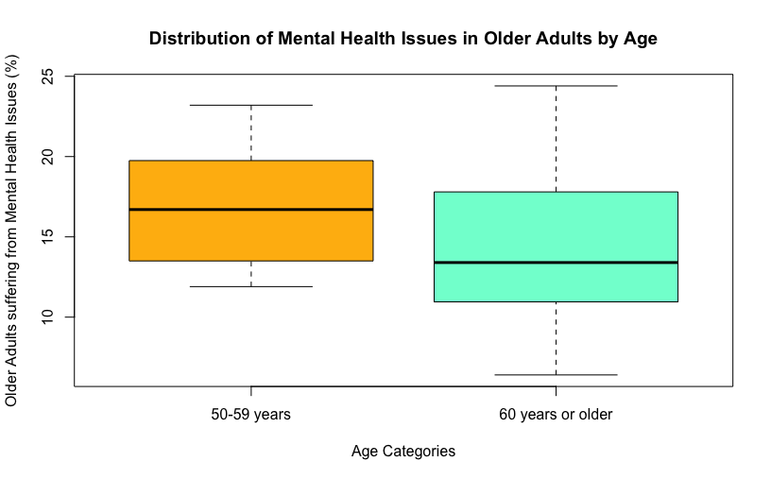

The mean number of older adults who suffer from mental health issues who are 50-59 years old was 17.07% with a standard deviation of 3.48%. Comparatively, the mean of older adults who suffer from mental health issues from ages 60 years or older was 14.16% with a standard deviation of 3.48%.

**R Code (organized by variable):**

Alzheimers<-read.csv("Final_Alzheimers.csv")

hist(Alzheimers$Percent_Mental_Distress, main = "Distribution of Percent of Older Adults Suffering From a Mental Health Issue", xlab = "Distribution of Older Adults Suffering from a Mental Health Issue (%)", right = F, col = "red")

fivenum(Alzheimers$Percent_Mental_Distress)#IQR Calculation: 19.3-12.7

boxplot(Alzheimers$Percent_Mental_Distress~ Alzheimers$Race, xlab = "Race Categories", ylab = "Older Adults suffering from Mental Health Issues (%)", main = "Mental Health Issues in Older Adults by Race", col = c("light blue", "light green", "light pink"))

Wht <- Alzheimers[Alzheimers$Race == "White, non-Hispanic",]

mean(wht$Percent_Mental_Distress)

sd(wht$Percent_Mental_Distress)

Blk <- Alzheimers[Alzheimers$Race == "Black, non-Hispanic",]

mean(Blk$Percent_Mental_Distress)

sd(Blk$Percent_Mental_Distress)

His <- Alzheimers[Alzheimers$Race == "Hispanic",]

mean(His$Percent_Mental_Distress)

sd(His$Percent_Mental_Distress)

boxplot(Alzheimers$Percent_Mental_Distress~ Alzheimers$Age, xlab = "Age Categories", ylab = "Older Adults suffering from Mental Health Issues (%)", main = "Distribution of Mental Health Issues in Older Adults by Age", col = c("darkgoldenrod1", "aquamarine"))

sixty_up <- Alzheimers[Alzheimers$Age == "60 years or older",]

mean(sixty_up$Percent_Mental_Distress)

sd(sixty_up$Percent_Mental_Distress)

fifty_fiftynine <-Alzheimers[Alzheimers$Age == "50-59 years",]

mean(fifty_fiftynine$Percent_Mental_Distress)

sd(fifty_fiftynine$Percent_Mental_Distress)