**Getting Started**

Before starting make sure npm and php is installed on your machine.

* Unzip the project folder.
* Navigate to the folder in terminal.
* Run the bash file named crawlWebsites.sh by entering the command “./crawlWebsites.sh” in the terminal window.
* Wait for the script to execute.
* Now type the command “cd angular-seed” in the terminal.
* Type “npm install” in the terminal and run it.
* Type “npm start” in the terminal and run it.
* Wait for the following output:

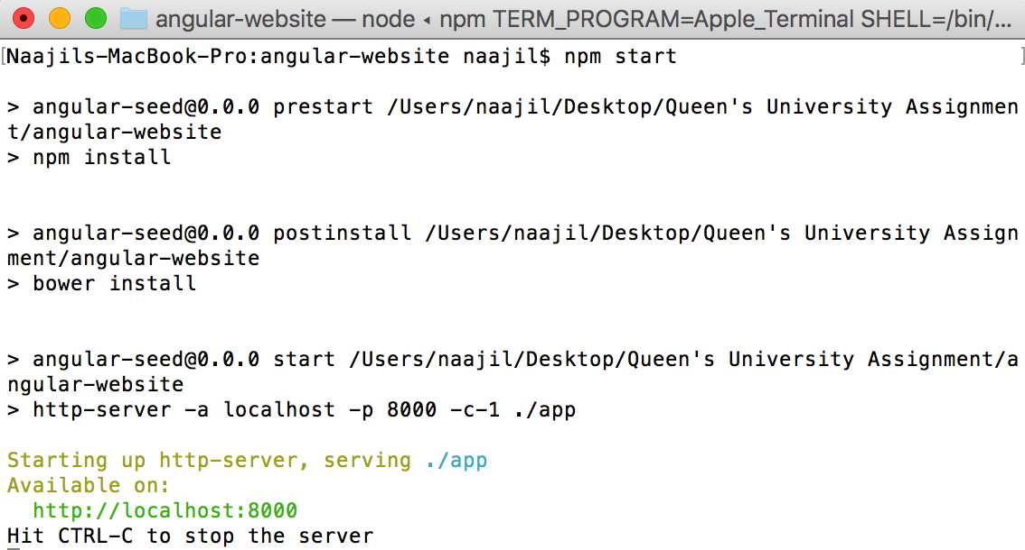

* Now Enter the following link in your web browser: “localhost:8000/index.html”.
* It should display Donald Trumps latest tweets and CNN news.

Note: In case of any package installation error on the terminal, google it. The code has been checkd on both OsX and Ubuntu.

**GitHub Repository**

The link to the github repository is <https://github.com/naajil-aamir/Queen-s-assignment.git>

It contains the both the crawlers, the bashfile and the core web app code. However, it does not contain the full Node and Bower dependencies required to run the website, therefore run the website with the procedure provided above.

**Crawlers**

I have modified an open-source php crawler that crawls the given websites for the specific information. I have modified its code to crawl both CNN and twitter and to output any information related to Donald trump in a JSON format which is required by the angular application.

**AngularJS Application**

To display the results, I have written a single page web application using angularJS. This takes the JSON files, generated by the crawlers and displays the results in an easy to read manner. Furthermore, it limits the number of news and tweets to 25, if more than 25 are found. In order to view any news or tweet, simply click on it, it will open that article or tweet in the original website

**Salient Features**

The application is coded in angularJS which is a state of the art framework used by many huge websites. It gives a responsive and fast experience to the user. The application also highlights the already visited links by changing the color to grey. In order to refresh the data, rerun the bashfile and once it has completed use the blue refresh button in the app to refresh the list, no need of refreshing the whole website.

**Future Improvements:**

The current implementation can be improved by hosting the php files on a server. This way the angular website will send an http get request to the server (when the refresh button is clicked) and the server will send the reply containing the JSON response.