Trương Ngọc Hân

MSSV: N21DCDT028

5.2) Controll Leds with GPIO Zero

*Control Led:

-Cách 1:

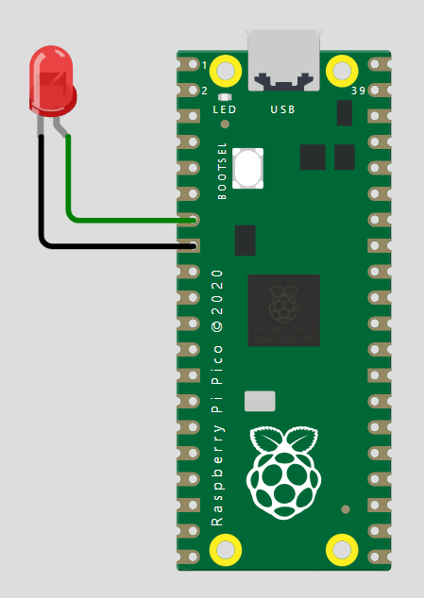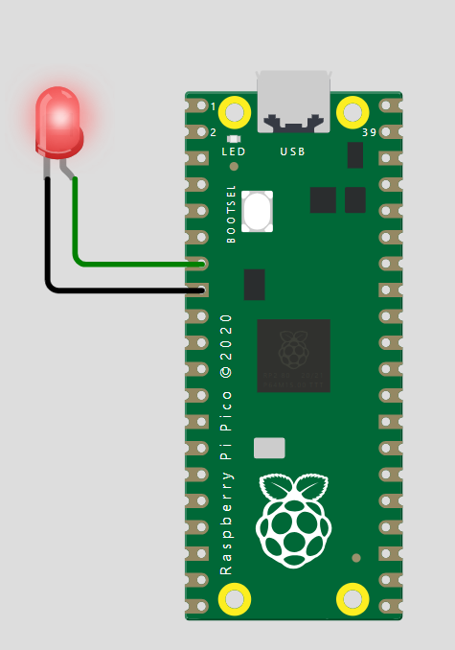

from machine import Pin

from utime import sleep

led = Pin(5, Pin.OUT)

while True:

    led.on()

    sleep(1)

    led.off()

    sleep(1)

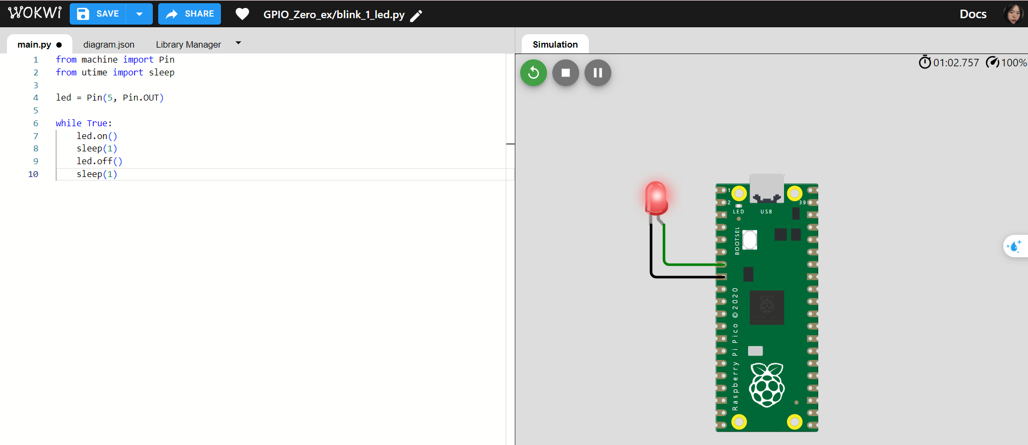

-Cách 2:

from machine import Pin

from utime import sleep

led = Pin(5, Pin.OUT)

while True:

  led.toggle()

  sleep(1)

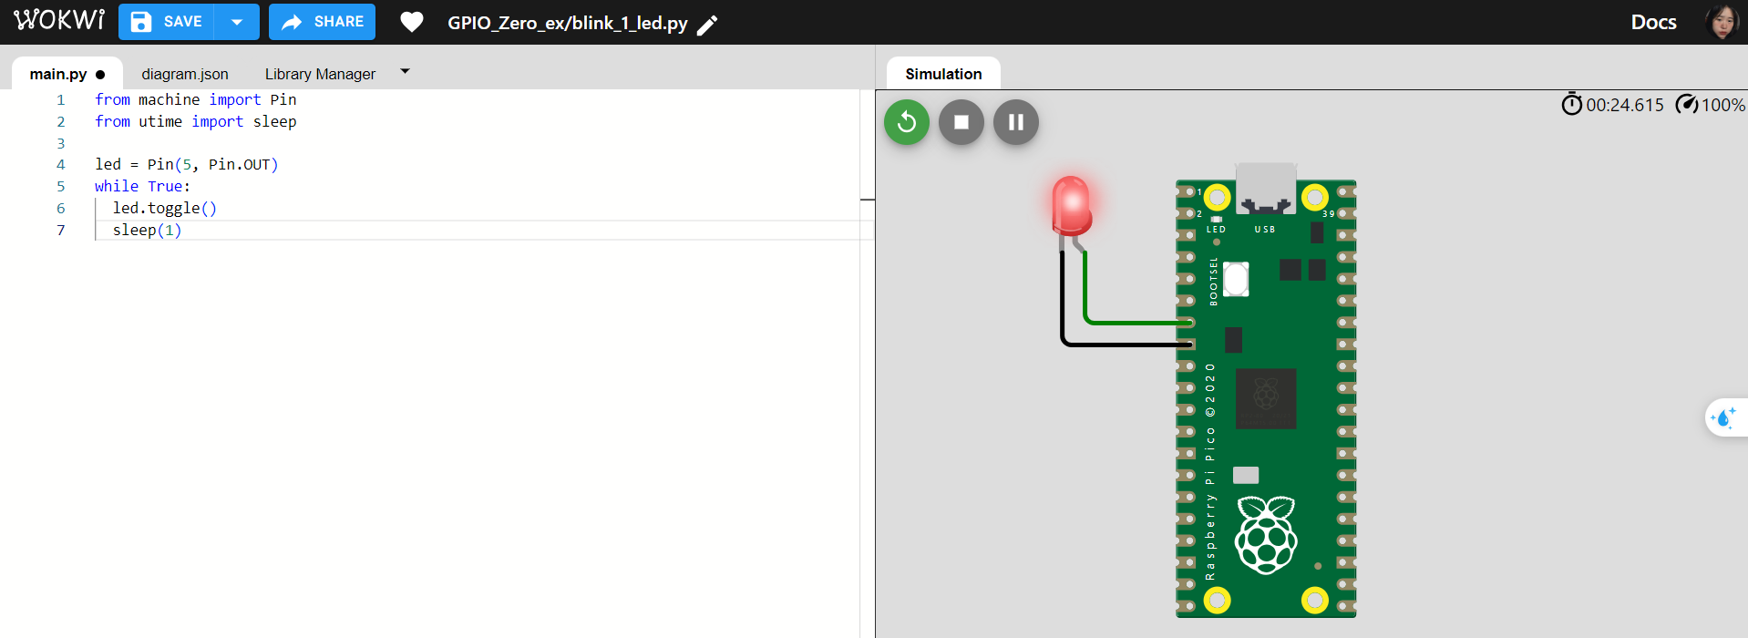

*Control Leds:

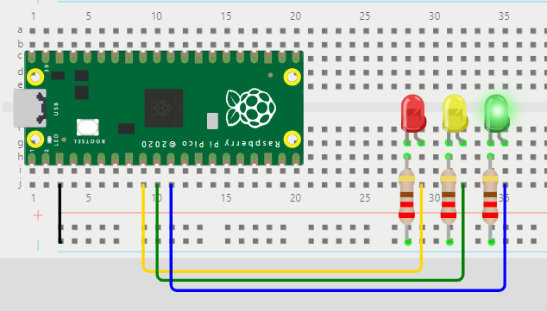from machine import Pin

from time import sleep

red = Pin(6, Pin.OUT)

amber = Pin(7, Pin.OUT)

green = Pin(8, Pin.OUT)

green.on()

amber.off()

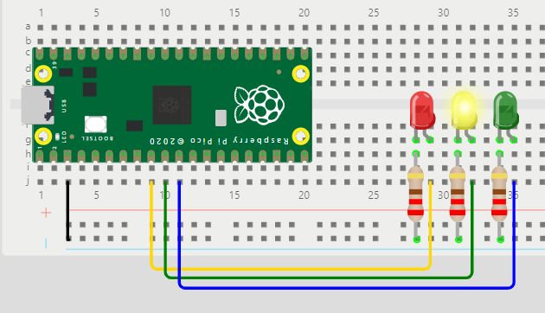red.off()

while True:

    sleep(3)

    green.off()

    amber.on()

    sleep(3)

    amber.off()

    red.on()

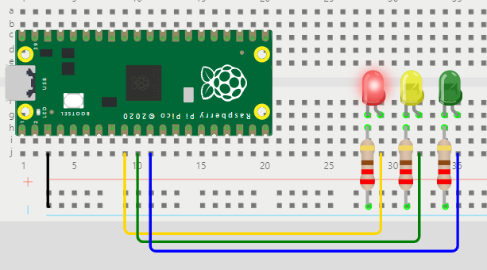    sleep(2)

    red.off()

    amber.on()

    sleep(3)

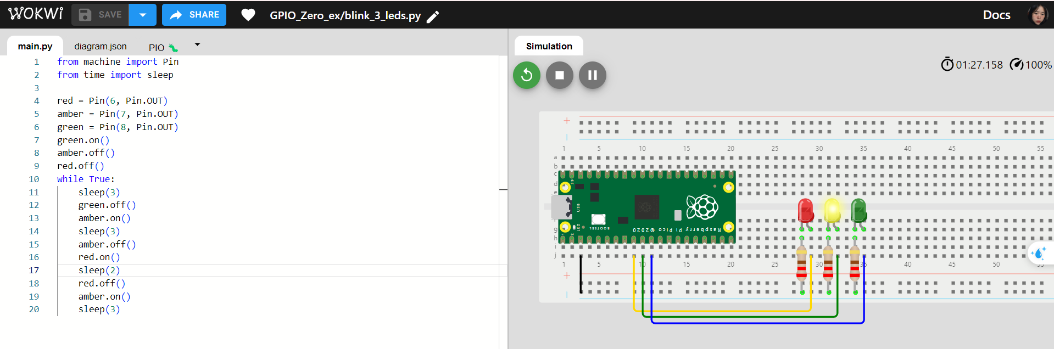

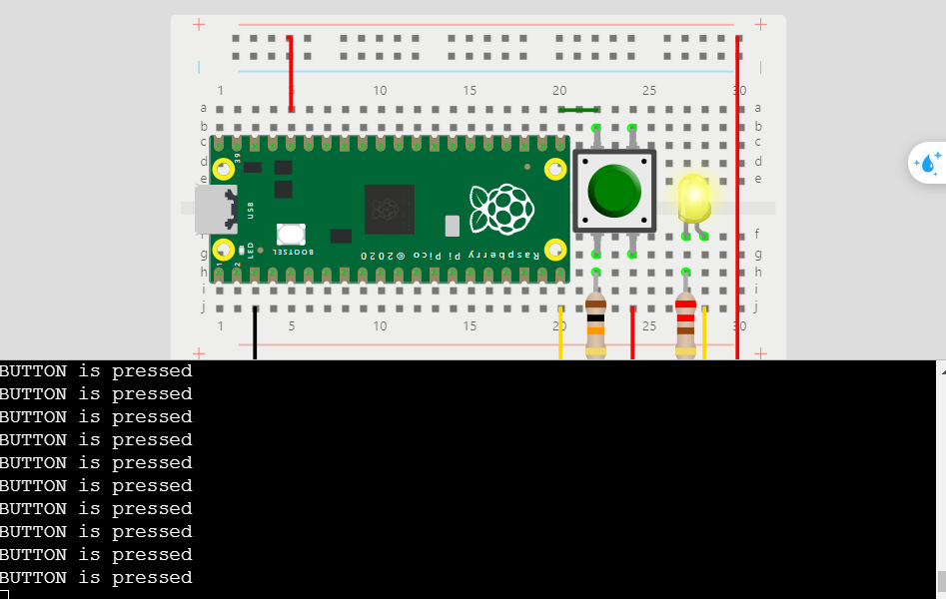5.3) Using Buttons with GPIO Zero

*Make Button:

from machine import Pin

from time import sleep

LED = Pin(15, Pin.OUT)

BUTTON = Pin(16, Pin.IN)

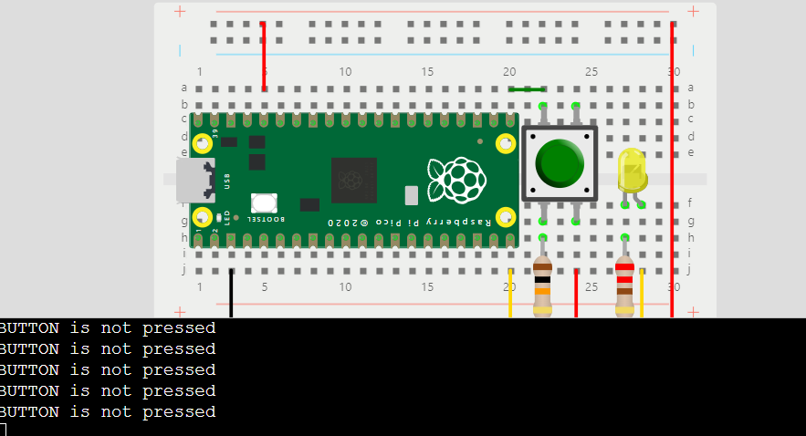

while True:

    if BUTTON.value() == 1:

        LED.on()

        print("BUTTON is pressed")

        sleep(3)

    else:

        LED.off()

        print("BUTTON is not pressed")

        sleep(3

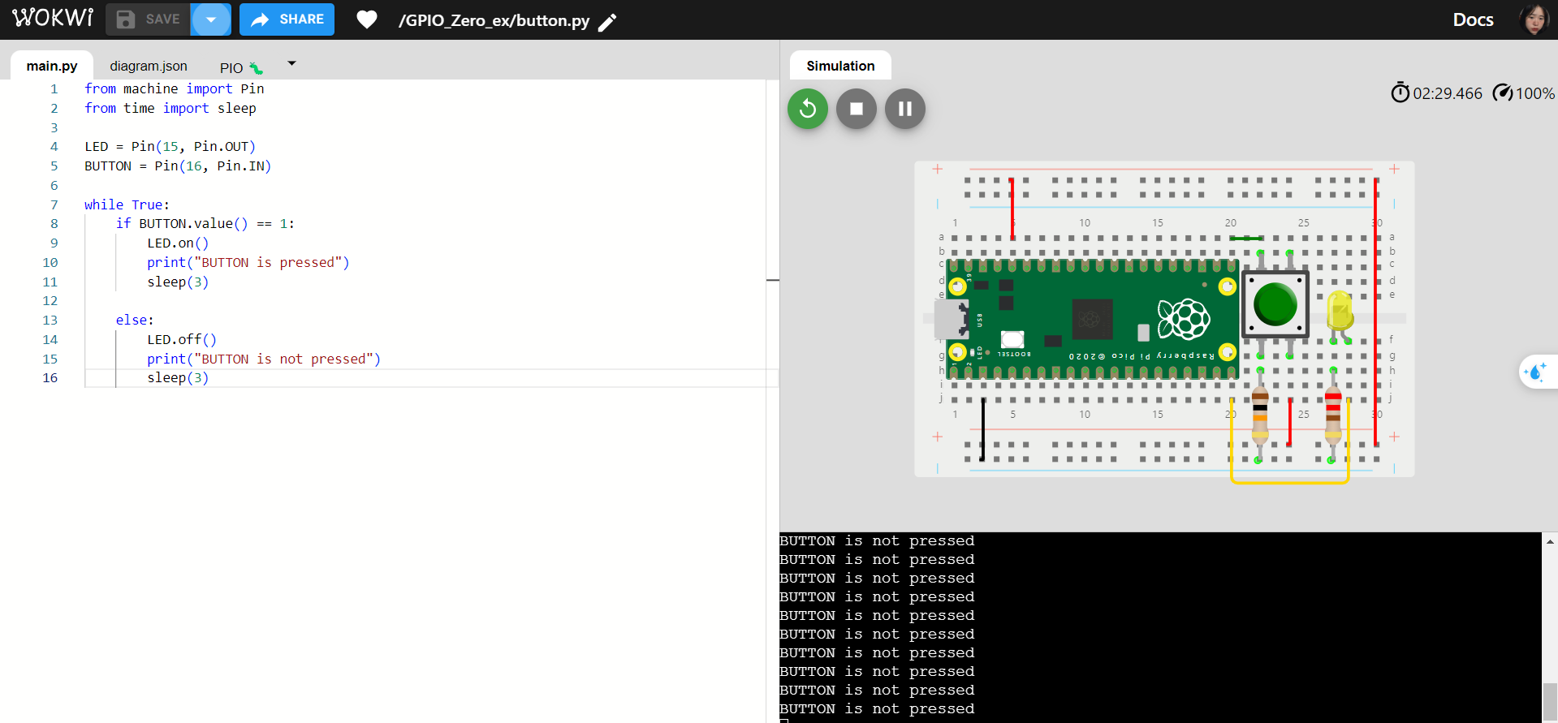

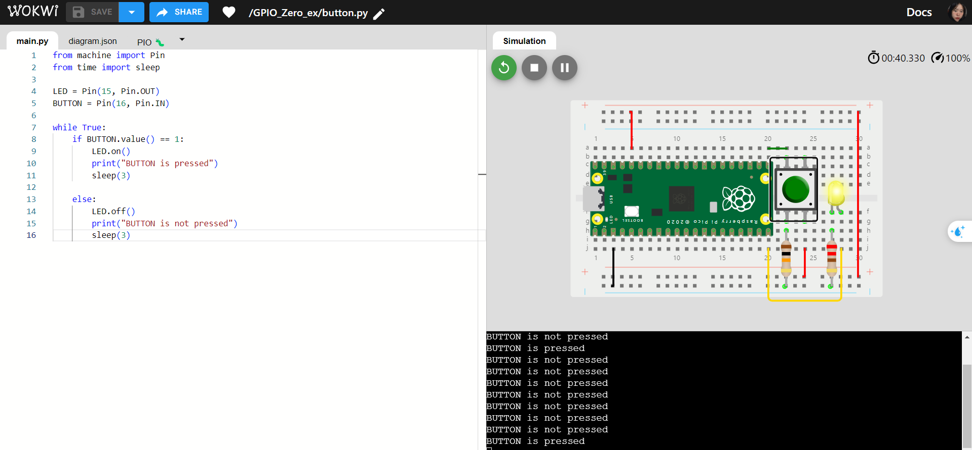

*Make Simple Game with Buttons:

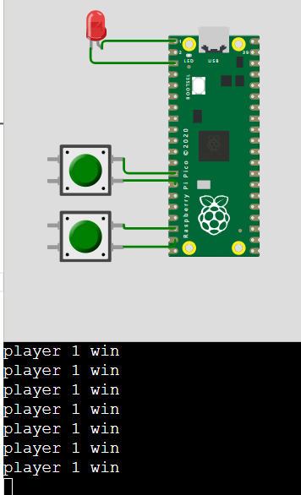

from machine import Pin

from time import sleep

import random

led = Pin(0, Pin.OUT)

player_1 = Pin(10, Pin.IN)

player_2 = Pin(14, Pin.IN)

while True:

    time = random.uniform(3,5)

    sleep(time)

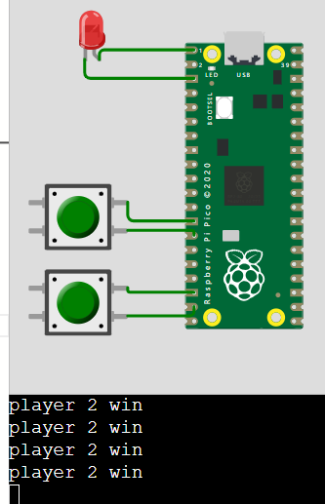    led.on()

    while True:

        if player_1.value()==1:

            print("player 1 win")

            break

        if player_2.value()==1:

            print("player 2 win")

            break

    led.off()

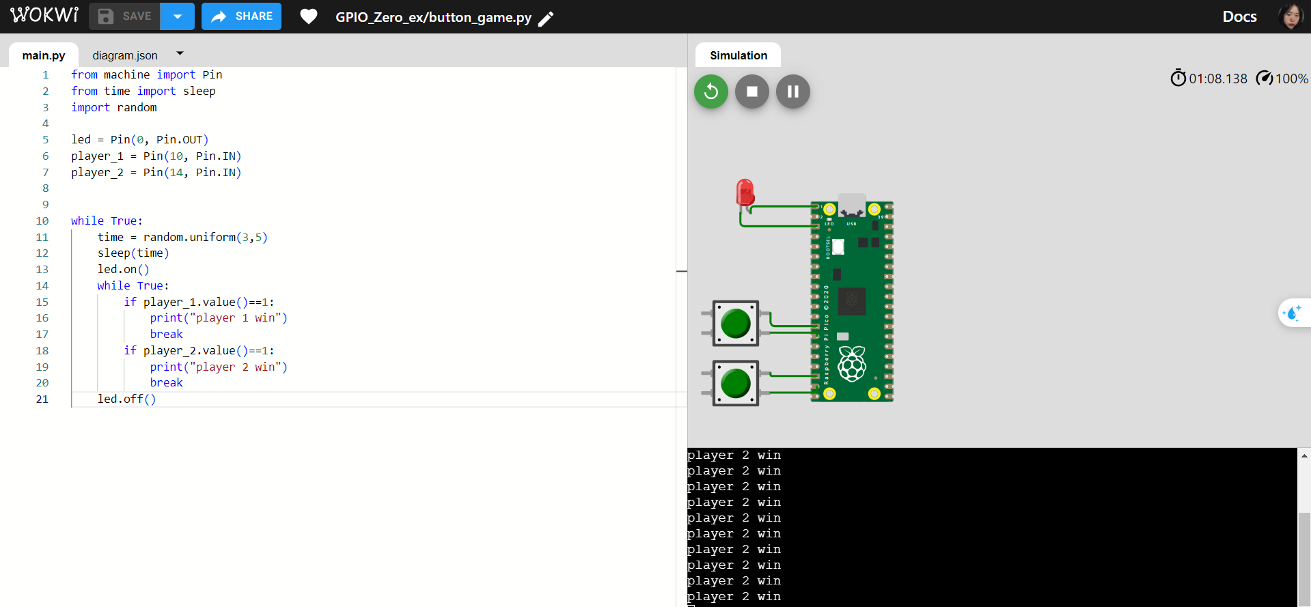

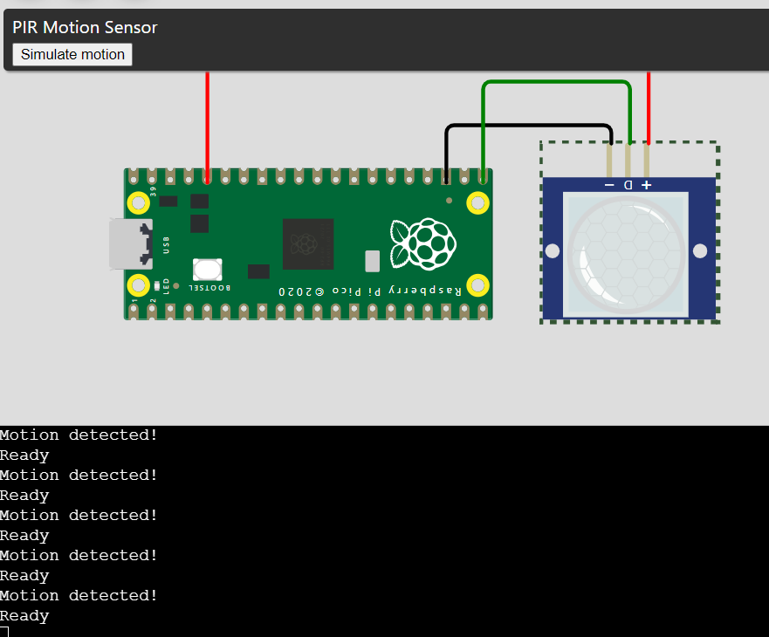5.4) Sensors with GPIO Zero:

*Motion Sensor:

from machine import Pin

from time import sleep

pir = Pin(16, Pin.IN)

while True:

   print("Ready")

   if pir.value() == 1:

       print("Motion detected!")

   sleep(1)

