MODULE HTML-5

**• What are the new tags added in HTML5?**

ans: There are several new tags added in html 5 such as <video>,

<iframe>, <nav>, <section>, etc..

<iframe src="https://www.youtube.com" title="Youtube"></iframe>

<nav>

<a href="/html/">HTML</a>

<a href="/css/">CSS</a>

<a href="/js/">JavaScript</a>

<a href="/python/">Python</a>

</nav>

**• How to embed audio and video in a webpage?**

ans: To add audio and video we can simply use <audio> & <video>

tags.

Code: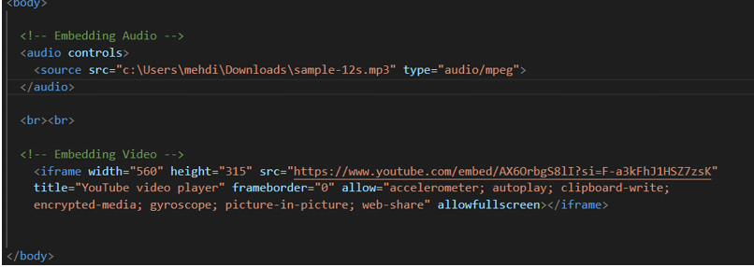

(zoom in to have a clear view)

Output:



**• Semantic element in HTML5?**

ans: Semantic elements in HTML5 are tags that give meaning to the content , making it easier to understand both for humans and machines. Instead of just telling how content should look, semantic elements describe what the content represents. They help organize web pages into sections. Examples of semantic elements are <header>, <nav>, <main>, <article>, <section>, <footer>, and <aside>.

**• Canvas and SVG tags.**

ans: Both <canvas> and <svg> are HTML5 elements used for drawing graphics on web pages, but here's the diffrence:

-> Canvas (<canvas>):

1. This element allows you to draw shapes, images and custom graphics dynamically.

2. The drawing is done using a scripting language that interacts with the canvas .

3. It is primarily used for animation purpose,making it suitable for gaming graphics.

-> SVG(<svg>):

1. The <svg> element is a vector graphics format. It defines graphics in XML format.

2. SVG graphics are created using XML tags that describes shapes,paths and text, this makes good charts and graphs.

3. Elements inside SVG can be customize uisng CSS and animated using javascript.

