Module (JQuery Basic, Effects & Advanced) – 5

**• What is jQuery?**

ans: jQuery is a JavaScript library that makes it easier to write code for websites. It helps developers manipulate web page elements, handle events like clicks and scrolls, create animations, and interact with servers to update web content without refreshing the page. In simple terms, jQuery simplifies web development by providing shortcuts and tools to make common tasks quicker and easier to implement.

**• How to Apply CSS Using JQuery, How to Add Class and Remove Class in Jquery ,JQuery Animation?**

ans:

Applying CSS:

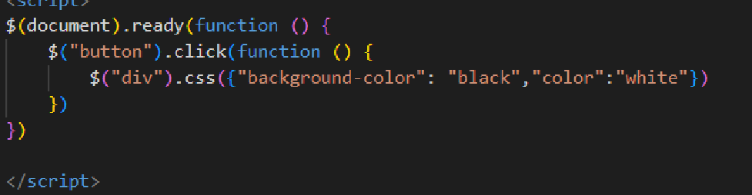

Add and Remove class:

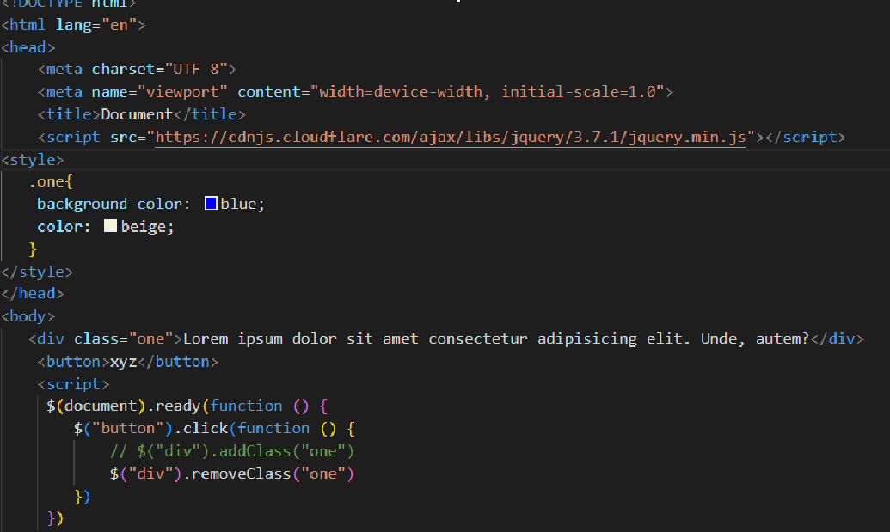

(zoom for clear vision)*

Animation:

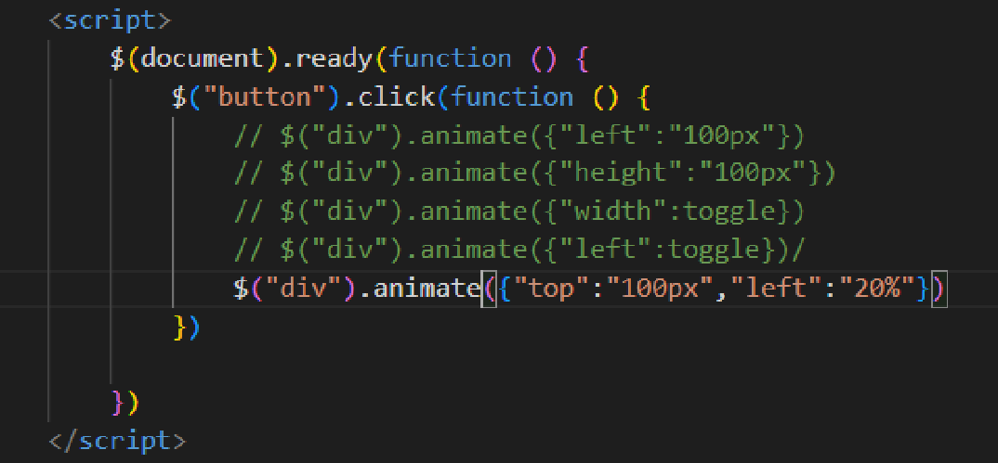

**• How to create slider with animation?**

ans:

<!DOCTYPE html>

<html lang="en">

<head>

<meta charset="UTF-8">

<meta name="viewport" content="width=device-width, initial-scale=1.0">

<title>Document</title>

<script src="https://cdnjs.cloudflare.com/ajax/libs/jquery/3.7.1/jquery.min.js"></script>

<style>

.slider {

width: 100%;

overflow: hidden;

}

.slides {

display: flex;

transition: transform 0.5s ease-in-out;

}

.slides img {

width: 100%;

}

</style>

</head>

<body>

<div class="slider">

<div class="slides">

<img src="https://prod-img.thesouledstore.com/public/theSoul/storage/mobile-cms-media-prod/banner-images/web-banner_12.jpg?format=webp&w=1500&dpr=1.0" alt="Slide 1">

<img src="https://prod-img.thesouledstore.com/public/theSoul/storage/mobile-cms-media-prod/banner-images/Homepage-.jpg?format=webp&w=1500&dpr=1.0" alt="Slide 2">

<img src="https://prod-img.thesouledstore.com/public/theSoul/uploads/catalog/category/catban-020240226121409.jpg?format=webp&w=1500&dpr=1.0" alt="Slide 3">

</div>

</div>

<script>

$(document).ready(function() {

slideWidth = $('.slides img').width();

numSlides = $('.slides img').length;

currentSlide = 0;

setInterval(slideNext,1000); // Change slide every 3 seconds

});

</script>

</body>

</html>

Output:

