GLS UNIVERSITY
Faculty of Computer Applications & Information Technology
iMSc(IT) / iMCA — Semester IX
221601907 — Capstone Project – II

AI-Powered Multimodal Healthcare Diagnosis &
Clinical Risk Prediction System
("MediAI Diagnostics")

Submitted By
Shah Khush Prakashbhai (Enrollment No: 202201619010082, A-84)
Trivedi Naman Ravikumar (Enrollment No: 202201619010107, A-110)

Guided By
____________________________

Academic Year 2026–27

CERTIFICATE
This is to certify that Mr. Shah Khush Prakashbhai (Enrollment No: 202201619010082) and Mr. Trivedi Naman Ravikumar (Enrollment No: 202201619010107), students of iMSc(IT) / iMCA Semester IX, Faculty of Computer Applications & Information Technology, GLS University, have satisfactorily completed the Capstone Project – II entitled "AI-Powered Multimodal Healthcare Diagnosis & Clinical Risk Prediction System" during the academic year 2026–27, in partial fulfilment of the requirements of the degree, under our guidance and supervision.
The work presented in this project is original and has been carried out by the above-named students themselves.

Internal Guide Head of Department

External Examiner Date: ___________

Place: ________________

Index
Index
Problem Statement
Objectives
Brief of System
Key Modules
Reliability Features
UML Diagrams
1. Use Case Diagram
2. Class Diagram
3. Activity Diagram (Swimlane)
4. Sequence Diagram
5. State Chart Diagram
Data Dictionary
Collection: users
Collection: predictions
All Screenshots with URL
7.1 Admin Side
7.2 Client Side
7.3 Reports
References
Datasets
Frameworks & Libraries
Conclusion

(Right-click the table above in Microsoft Word and choose "Update Field" to populate page numbers after opening this document.)

Problem Statement
Early and accurate diagnosis is critical for common conditions such as pneumonia, brain tumors, skin cancer, and diabetes, yet several practical barriers limit timely clinical decision-making in real-world healthcare settings:
- Specialist radiologists, dermatologists, and endocrinologists are not uniformly available, especially in smaller clinics and under-resourced regions, which delays diagnosis.
- Manual interpretation of X-rays, MRI scans, and dermatoscopic images is time-consuming and subject to inter-observer variability, even among experienced clinicians.
- Many existing AI-assisted diagnostic prototypes — including this project’s own earlier Capstone-I baseline — are trained on narrow, single-source datasets and present predictions with no indication of confidence, risking misleadingly confident results on unfamiliar, real-world images.
- Patient records and diagnostic history are often fragmented across paper records or disconnected systems, making longitudinal tracking difficult.
This project addresses these problems by building a single, consistent clinical decision-support system that screens four conditions using properly trained deep-learning models, visually explains its reasoning (Grad-CAM), flags low-confidence predictions instead of forcing a guess, generates a standardized clinical report, and keeps a structured, searchable history of every patient’s predictions.

Objectives
- Build and train four independent diagnostic models from properly sourced, larger public datasets using sound machine-learning methodology.
- Provide visual explainability for every image-based prediction via Grad-CAM.
- Add reliability safeguards — out-of-distribution rejection and confidence thresholds — so the system degrades gracefully instead of confidently guessing on invalid or unfamiliar inputs.
- Generate automated, standardized PDF clinical reports for each diagnosis.
- Persist patient and prediction history in a structured, queryable database.

Brief of System
MediAI Diagnostics is an AI-powered, multimodal clinical decision-support web application that assists healthcare professionals in screening four conditions from patient data: pneumonia from chest X-rays, brain tumors from MRI scans, skin lesions (including melanoma) from dermatoscopic photographs, and diabetes risk from clinical health indicators. The system is built as a capstone extension of an earlier prototype (Capstone-I), which covered only chest X-ray and brain MRI analysis with a basic web interface.
In this phase (Capstone-II), the system has been substantially re-engineered: all four diagnostic models were retrained from scratch on larger, better-sourced public medical datasets using proper machine-learning methodology (stratified train/validation/test splits, class-weighted loss to handle imbalanced disease classes, transfer learning from ImageNet-pretrained backbones, early stopping, and mixed-precision GPU training). A new Skin Lesion Detection module was added, Explainable AI (Grad-CAM) visual heatmaps were implemented for every image-based module, automated PDF diagnostic report generation was built, and a reliability layer was added so that the system can reject invalid/out-of-distribution images and flag low-confidence predictions as "Uncertain" instead of forcing a guess.
The application is a full-stack system: a React + Vite single-page frontend communicates with a Python FastAPI backend over a REST API; the backend runs four independent PyTorch deep-learning models for inference, generates Grad-CAM explainability heatmaps with OpenCV, produces downloadable PDF reports with ReportLab, and persists user accounts and every prediction record in MongoDB.

Key Modules
- User Management — secure registration/login for healthcare professionals
- Chest X-ray Analysis — pneumonia detection (ResNet-50)
- Brain MRI Analysis — 4-class brain tumor classification (EfficientNet-B3)
- Skin Lesion Detection — 7-class dermatoscopic lesion classification (EfficientNet-B3)
- Clinical Vitals Module — diabetes risk prediction from 21 health indicators (MLP)
- Explainable AI — Grad-CAM heatmaps for every image-based diagnosis
- Automated PDF Report Generation — downloadable clinical report per diagnosis
- Patient History & Database — MongoDB-backed prediction history per patient

Reliability Features
- Out-of-distribution input rejection — heuristic checks reject images that don’t statistically resemble the expected scan type
- Confidence-threshold gating — predictions below a 65% confidence threshold are reported as "Uncertain" rather than a forced diagnosis
- Checkpointed, resumable model training — resilient to interruptions during multi-hour GPU training runs

UML Diagrams

1. Use Case Diagram
Shows the Healthcare Professional actor interacting with the system’s core use cases — account management, patient data entry, uploading scans/photos for each of the four diagnostic modules, and the supporting "Run AI Diagnosis" use case that includes the four module-specific detections and extends to heatmap generation and PDF report download.
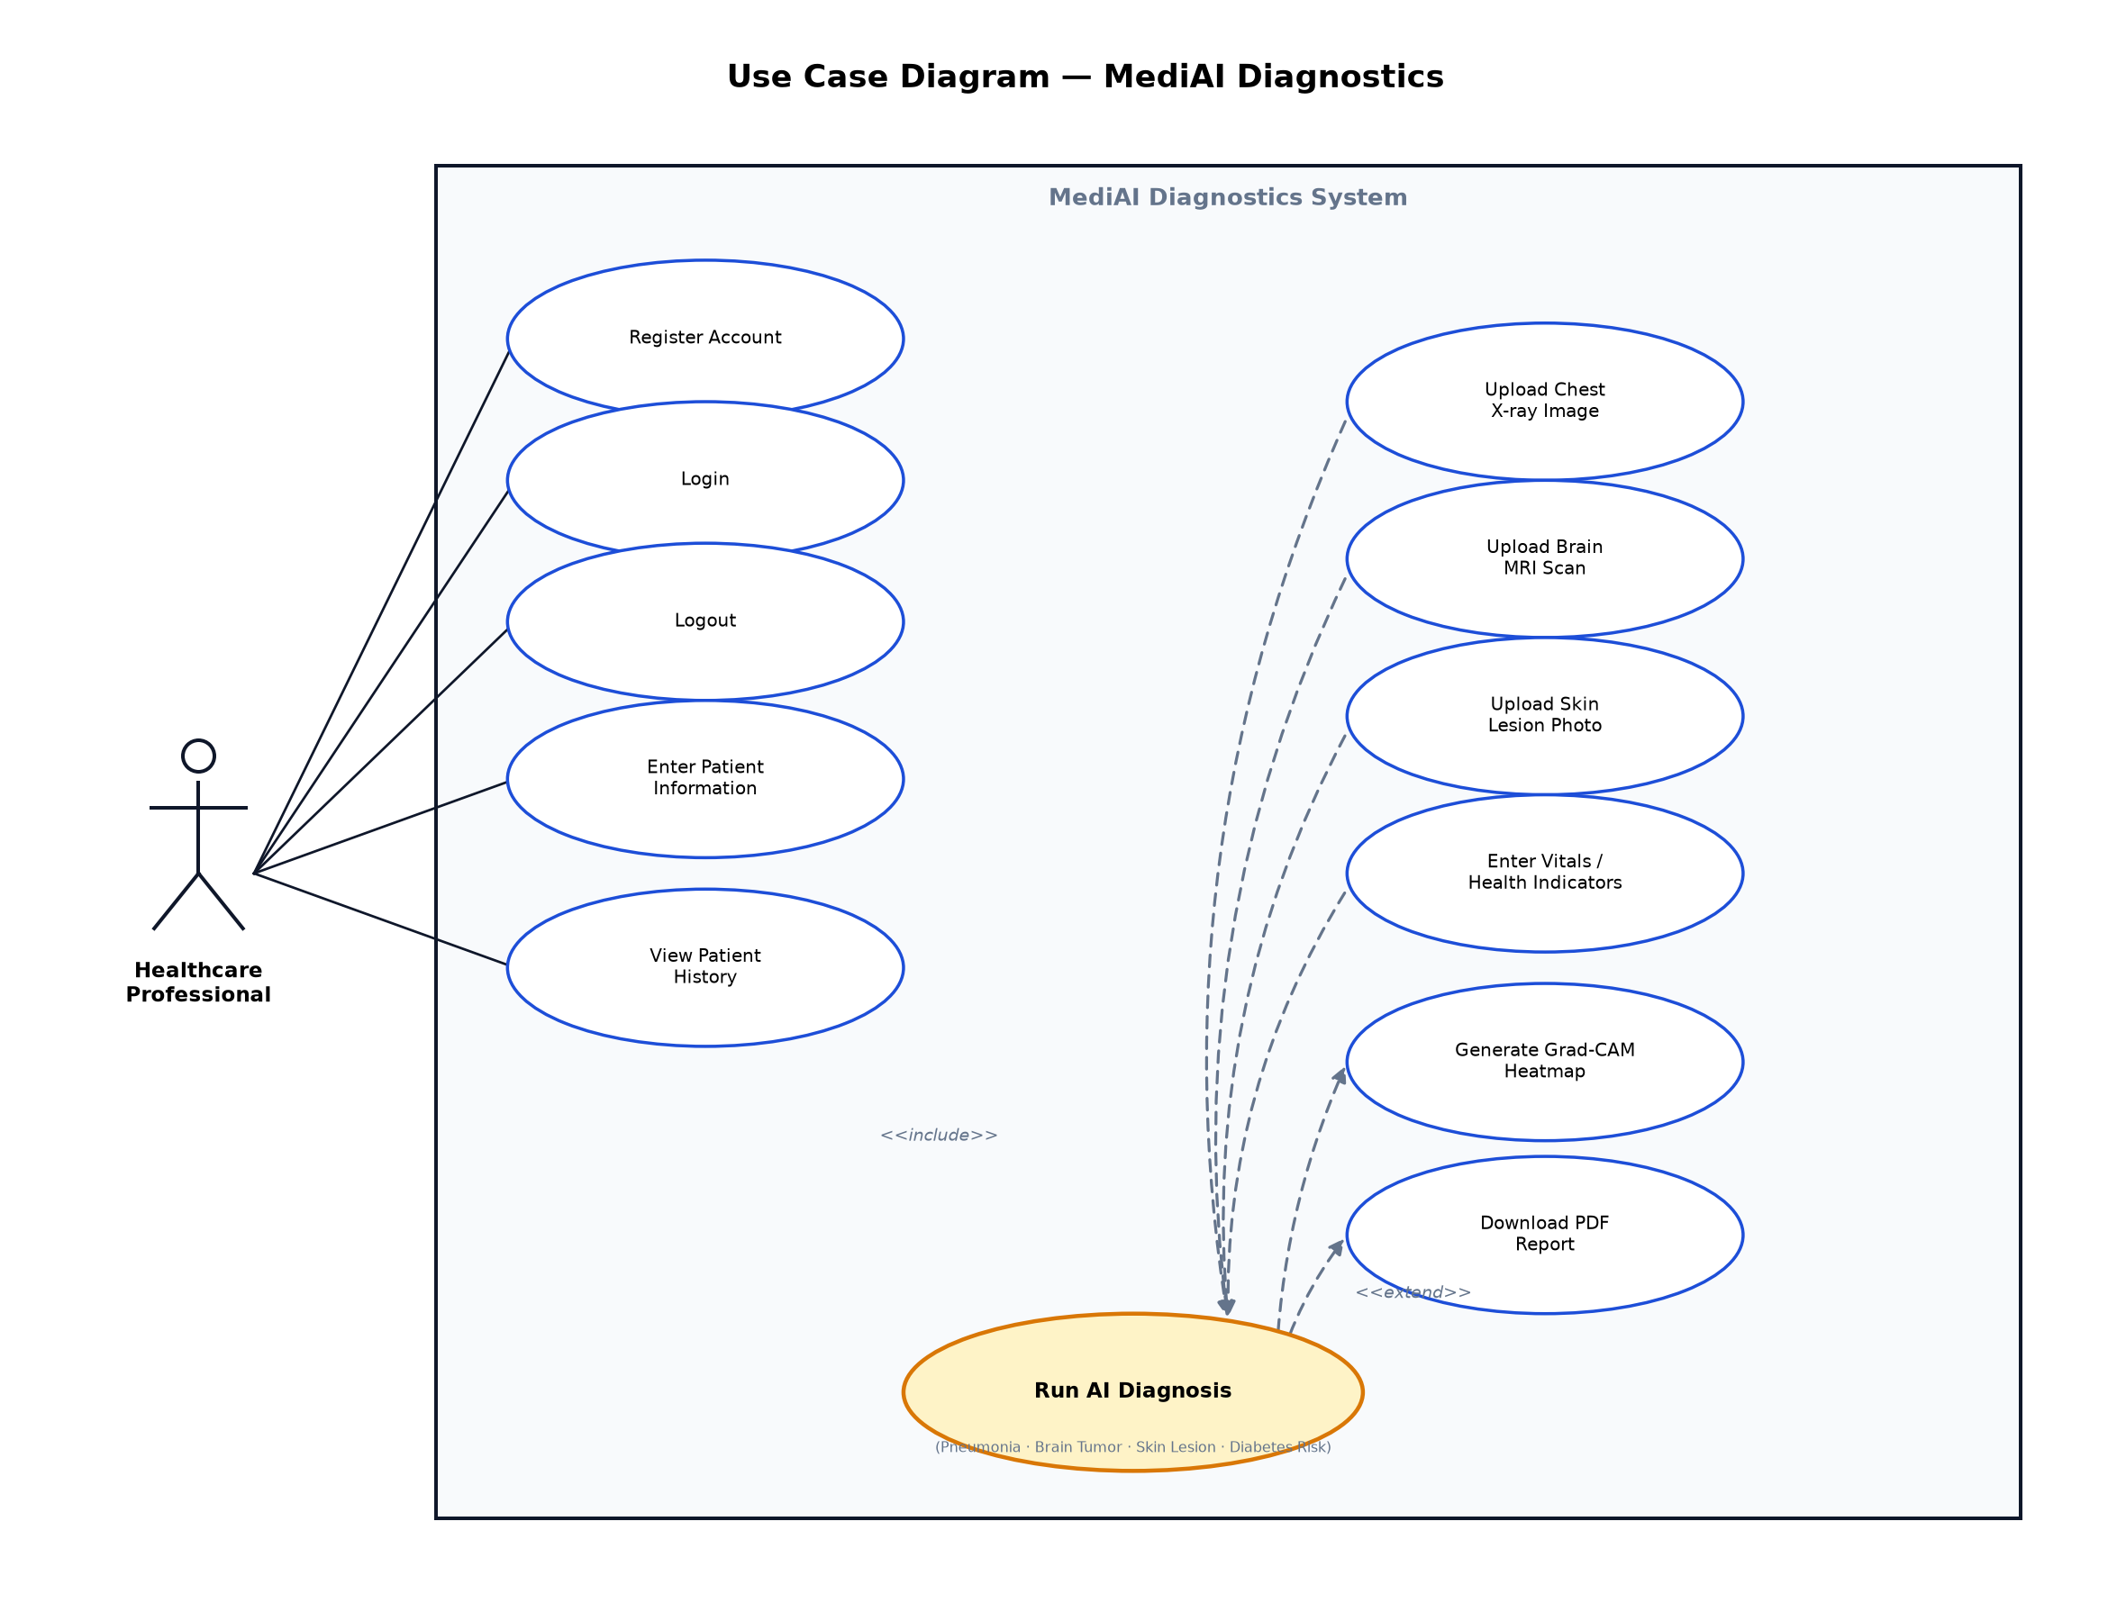
Fig. 5.1 — Use Case Diagram

2. Class Diagram
Models the system’s core domain classes: User and PredictionRecord (persisted in MongoDB), the abstract DiagnosisModel with its four concrete PyTorch model subclasses, and the supporting GradCAMGenerator and ReportGenerator service classes.
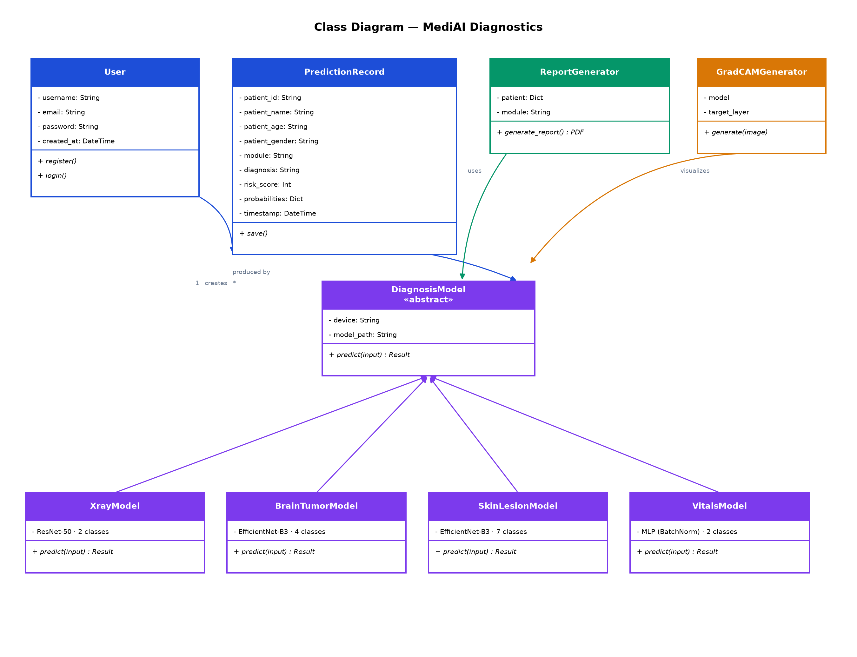
Fig. 5.2 — Class Diagram

3. Activity Diagram (Swimlane)
Traces the end-to-end "Run AI Diagnosis" flow across four responsibility lanes — User, Frontend (React), Backend (FastAPI), and AI Model/MongoDB — including both decision points (image validity and confidence-threshold checks) and their alternate paths.
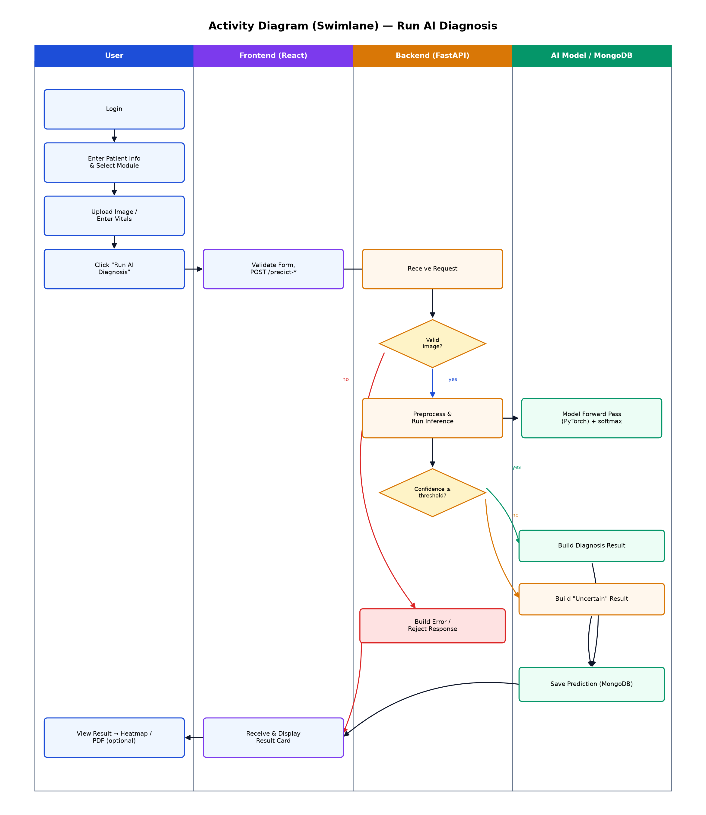
Fig. 5.3 — Activity Diagram (Swimlane)

4. Sequence Diagram
Details the object-level message flow for the Chest X-ray + Diabetes diagnosis flow, from the user’s click through the frontend, backend, prediction module, PyTorch model, and the final MongoDB save.
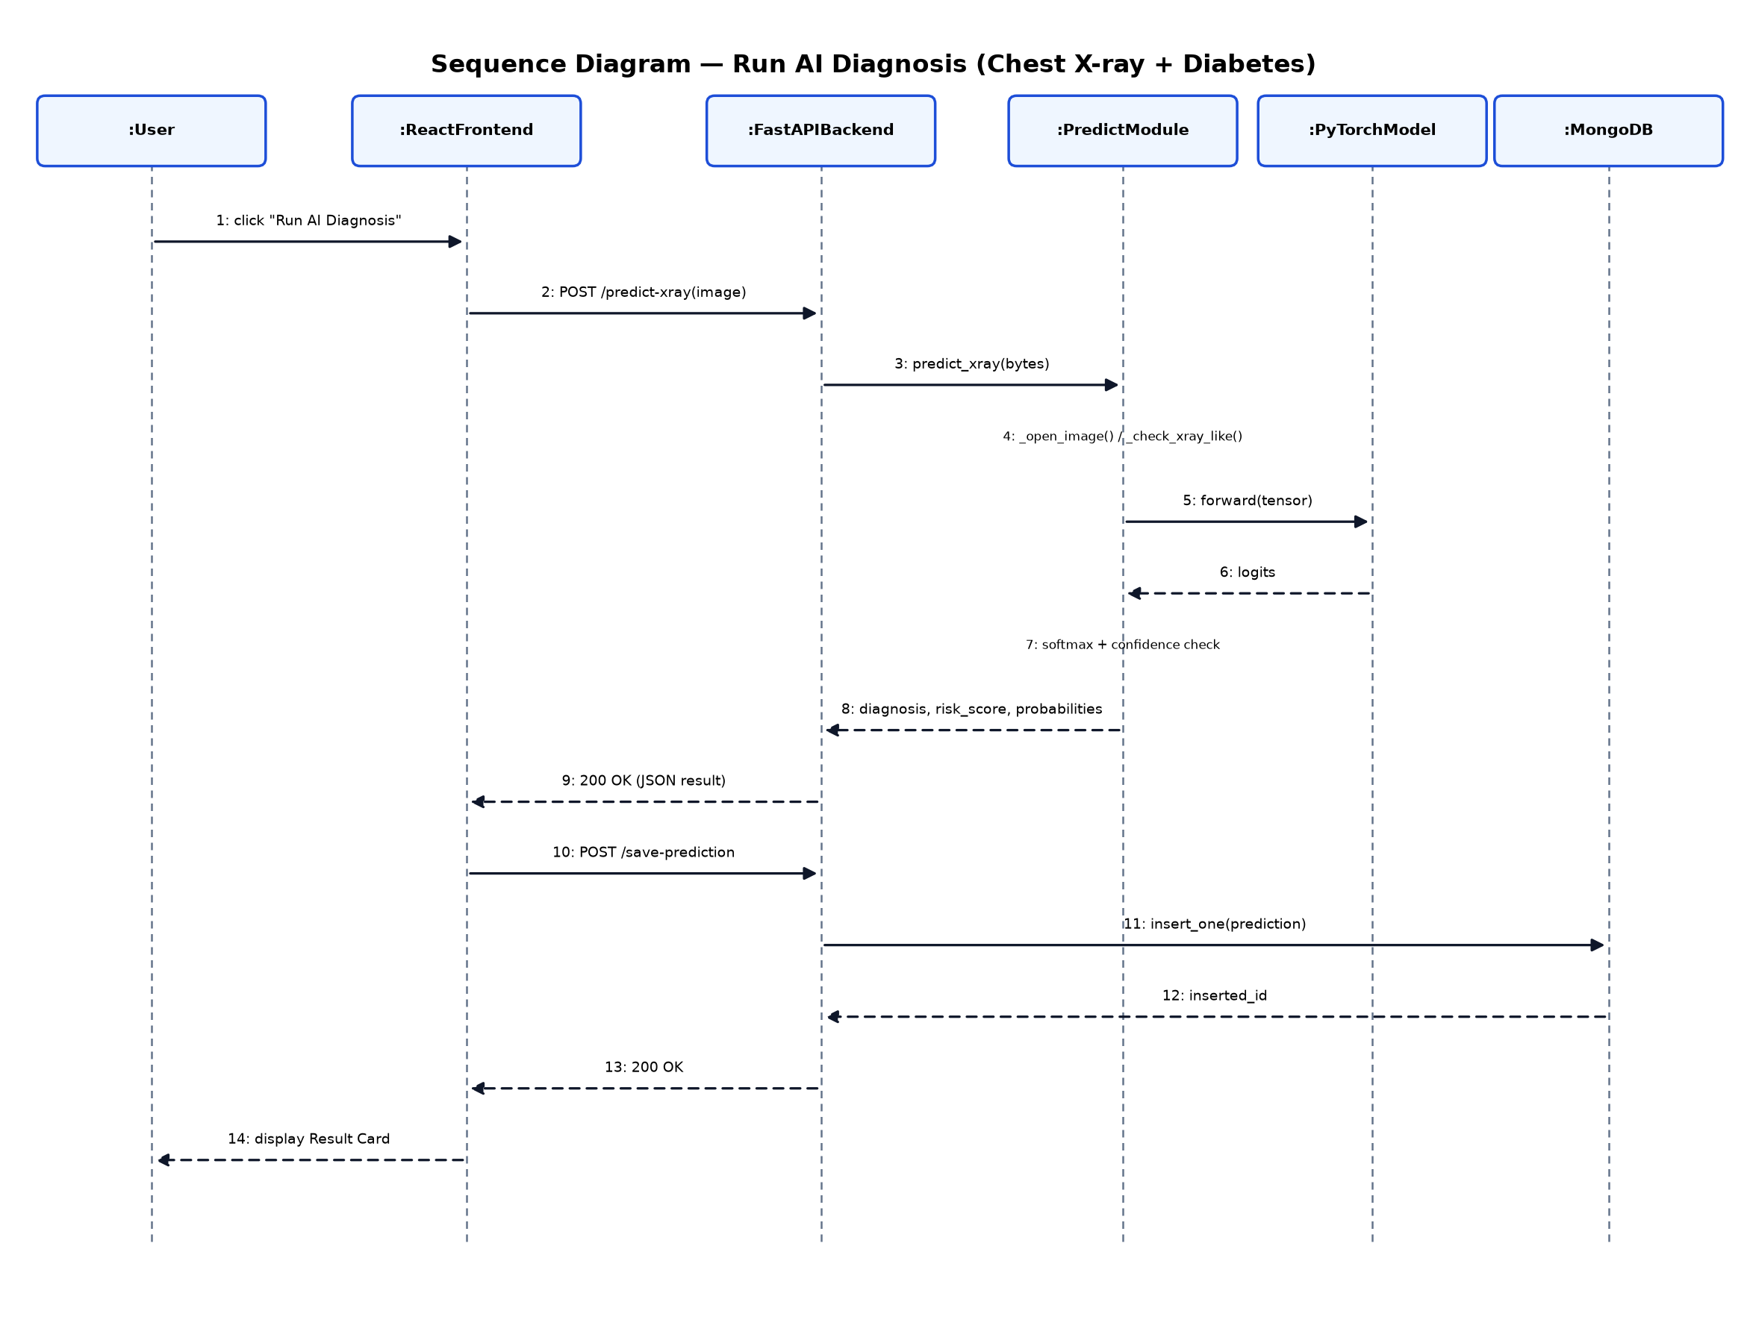
Fig. 5.4 — Sequence Diagram

5. State Chart Diagram
Models the lifecycle of a single diagnosis request, from Idle through patient-info entry, image upload, analysis, and its terminal states (ResultReady / Uncertain / Invalid), including the optional heatmap-generation and report-download transitions before the record is saved.
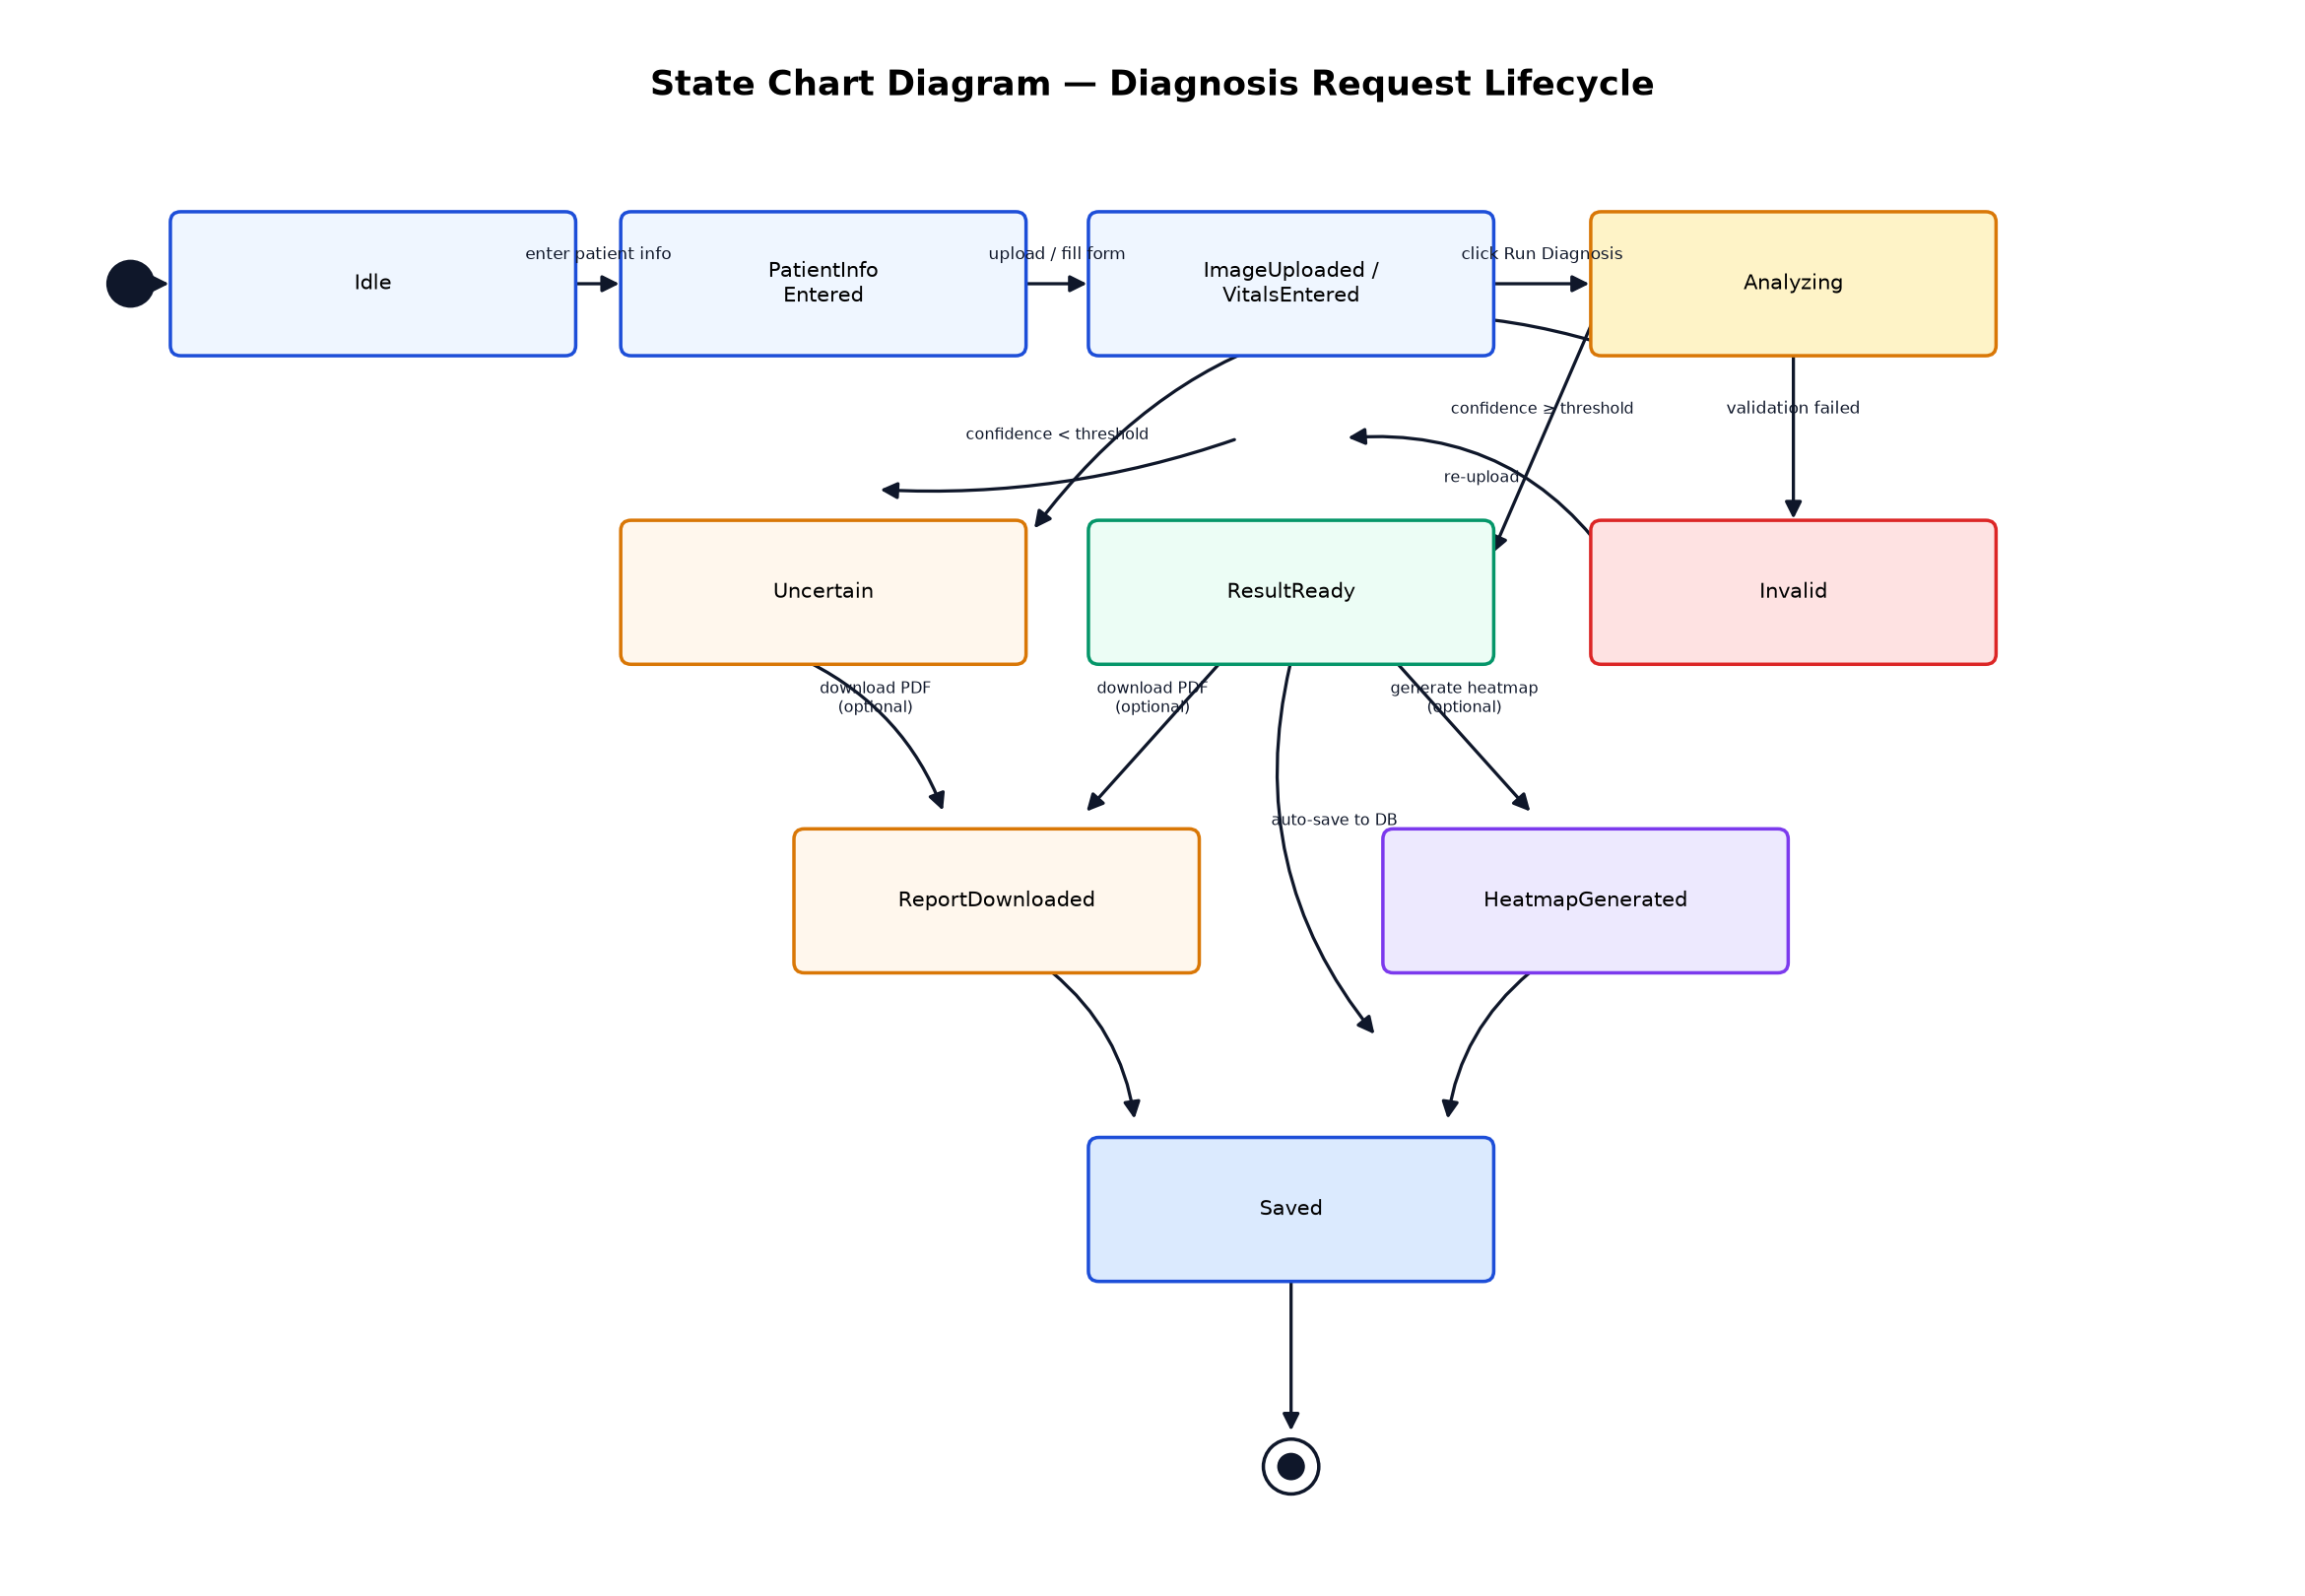
Fig. 5.5 — State Chart Diagram

Data Dictionary
The system uses MongoDB (a NoSQL document database) with two primary collections.

Collection: users
Field | Type | Description
_id | ObjectId | MongoDB-generated unique document identifier
username | String | Full name of the registered healthcare professional
email | String | Login identifier; must be unique
password | String | Account password (plain string field in the current schema)
created_at | DateTime | Account creation timestamp (UTC, auto-generated)

Collection: predictions
Field | Type | Description
_id | ObjectId | MongoDB-generated unique document identifier
patient_id | String | Clinician-entered patient identifier
patient_name | String | Patient full name
patient_age | String | Patient age
patient_gender | String | Patient gender (Male / Female / Other)
module | String | Diagnostic module used: "xray", "brain", "skin"
diagnosis | String | Predicted class label (or "Uncertain" if below confidence threshold)
risk_score | Integer | Computed risk score, 0–100
probabilities | Object (Dict) | Per-class predicted probability (%), one key per class
vitals_diagnosis | String | Diabetes prediction label (only present for module = "xray")
vitals_risk_score | Integer | Diabetes risk score, 0–100 (only present for module = "xray")
vitals_probabilities | Object (Dict) | Diabetes class probabilities (only present for module = "xray")
saved_by | String | Username of the healthcare professional who ran the diagnosis
timestamp | DateTime | Record creation timestamp (UTC, auto-generated)

All Screenshots with URL

7.1 Admin Side
MediAI Diagnostics has a single authenticated user role (Healthcare Professional) and no separate administrator interface in this release — all screens below fall under "Client Side".

7.2 Client Side
Application URL: http://localhost:5173/ (React/Vite development server) — all client-side screens below are views within this single-page application.
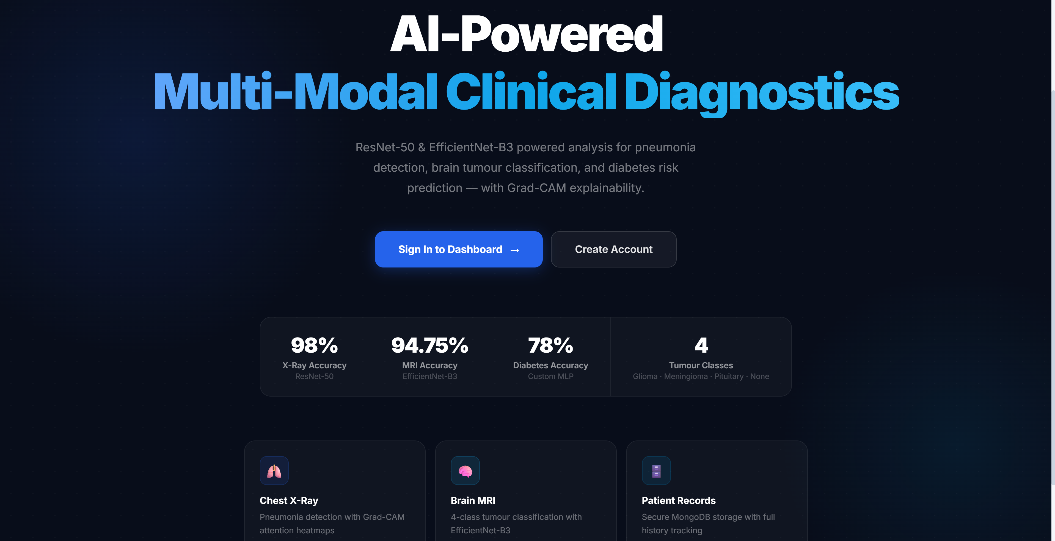
Fig. 7.1 — Landing / Welcome page with project overview and accuracy highlights (URL: http://localhost:5173/)
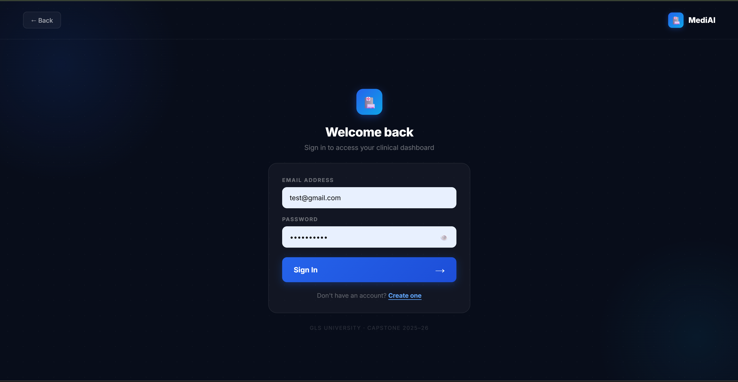
Fig. 7.2 — Login screen ("Welcome back") (URL: http://localhost:5173/)
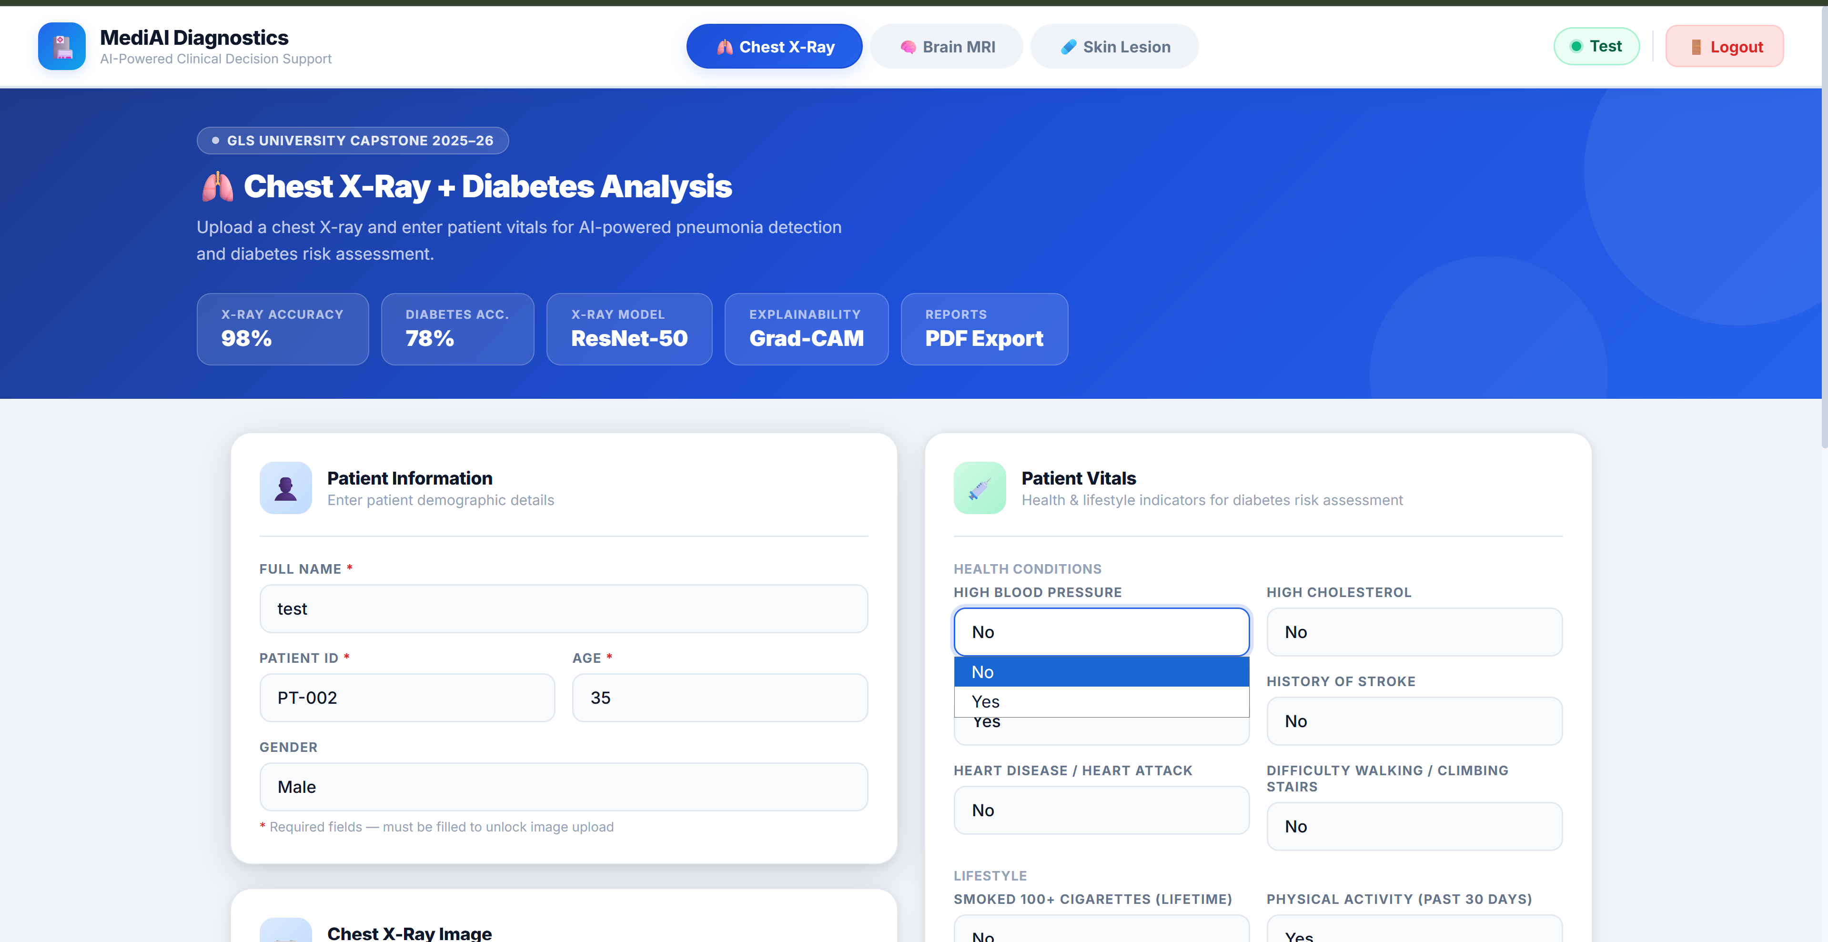
Fig. 7.3 — Chest X-Ray + Diabetes module — patient information and vitals input form (URL: http://localhost:5173/)
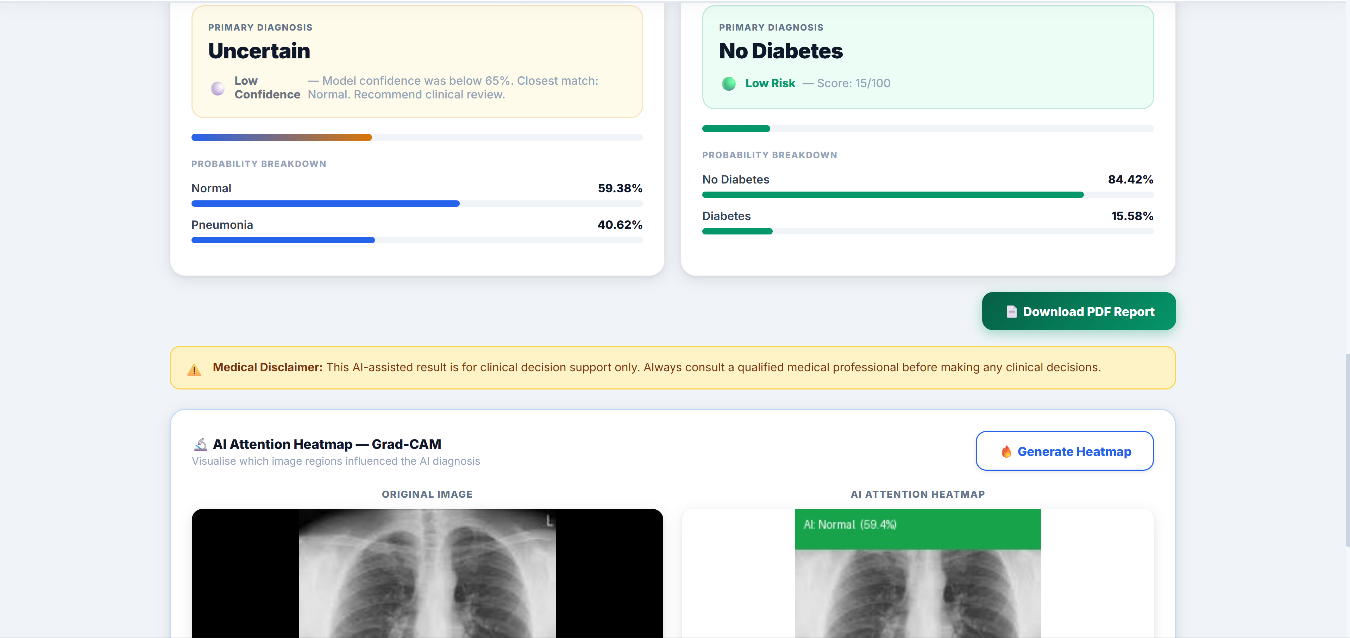
Fig. 7.4 — Chest X-Ray + Diabetes — diagnosis result cards with probability breakdown (URL: http://localhost:5173/)
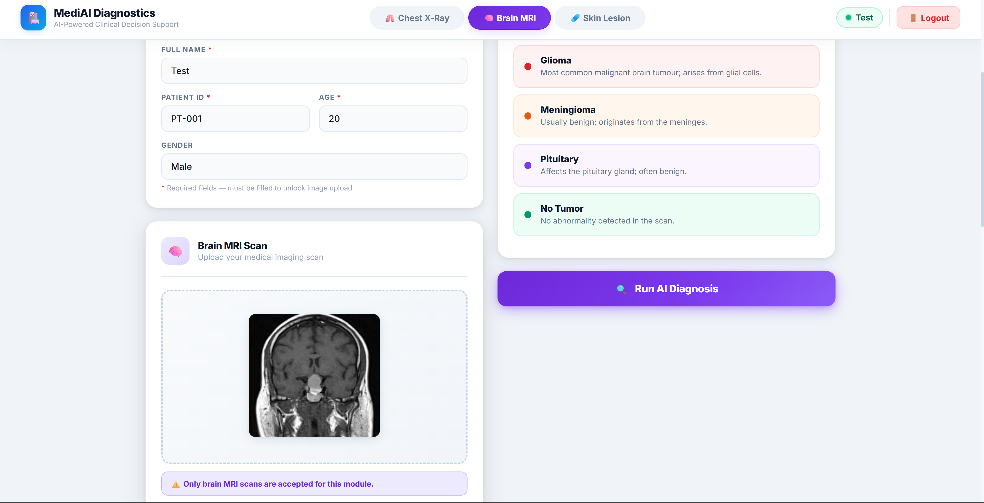
Fig. 7.5 — Brain MRI module — patient info, detectable conditions panel, and uploaded scan preview (URL: http://localhost:5173/)
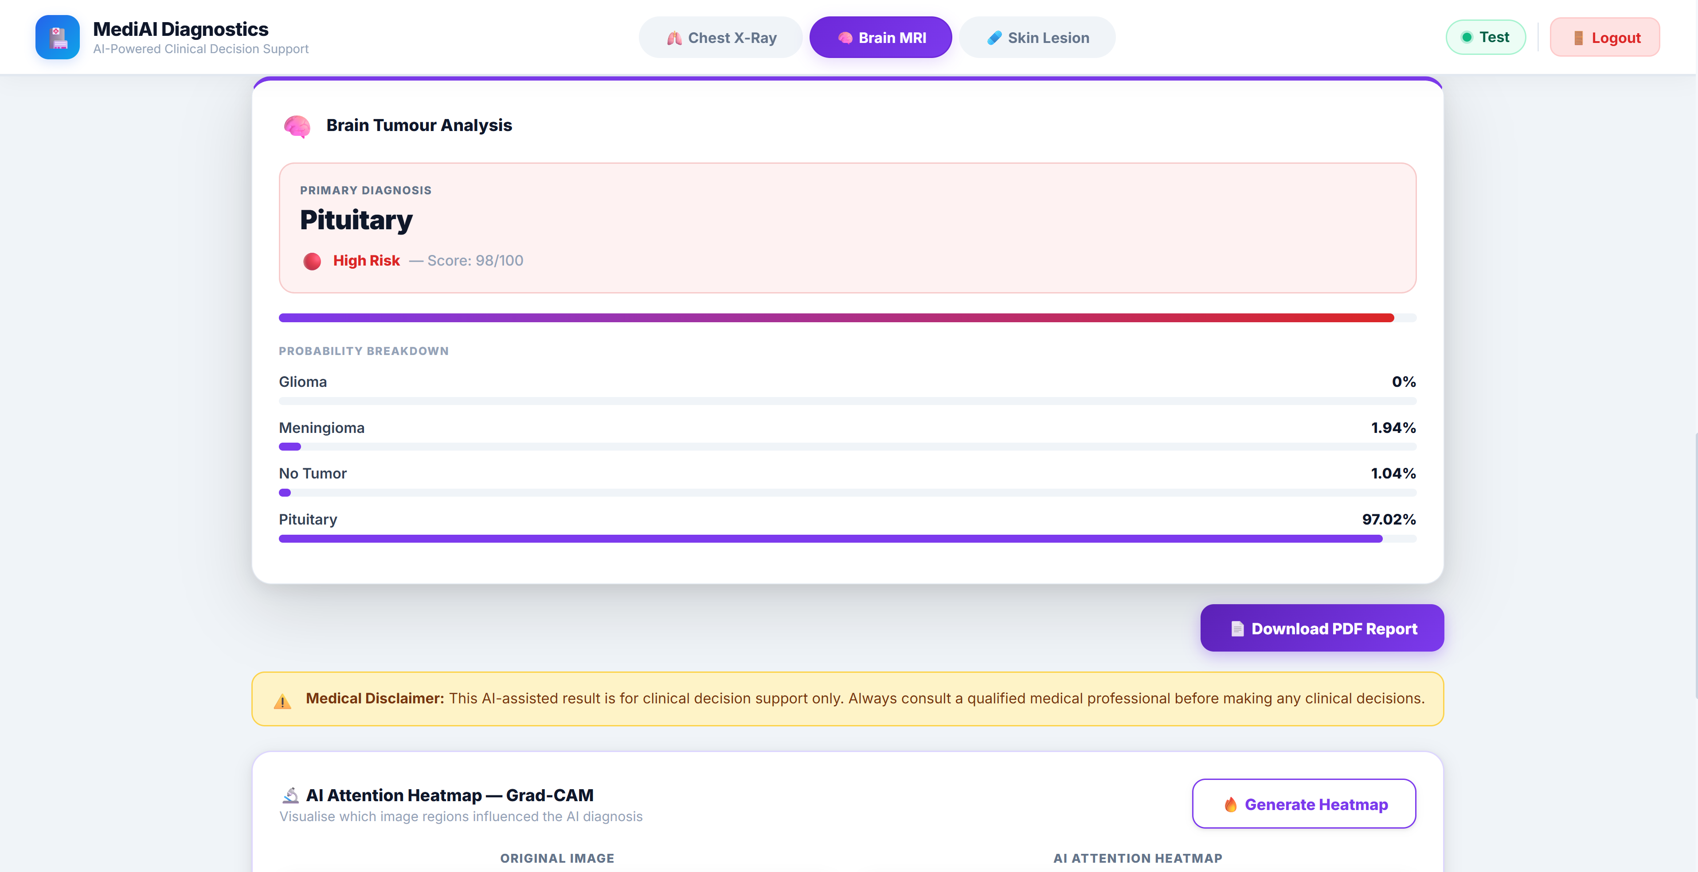
Fig. 7.6 — Brain MRI — diagnosis result with risk score and probability breakdown (URL: http://localhost:5173/)
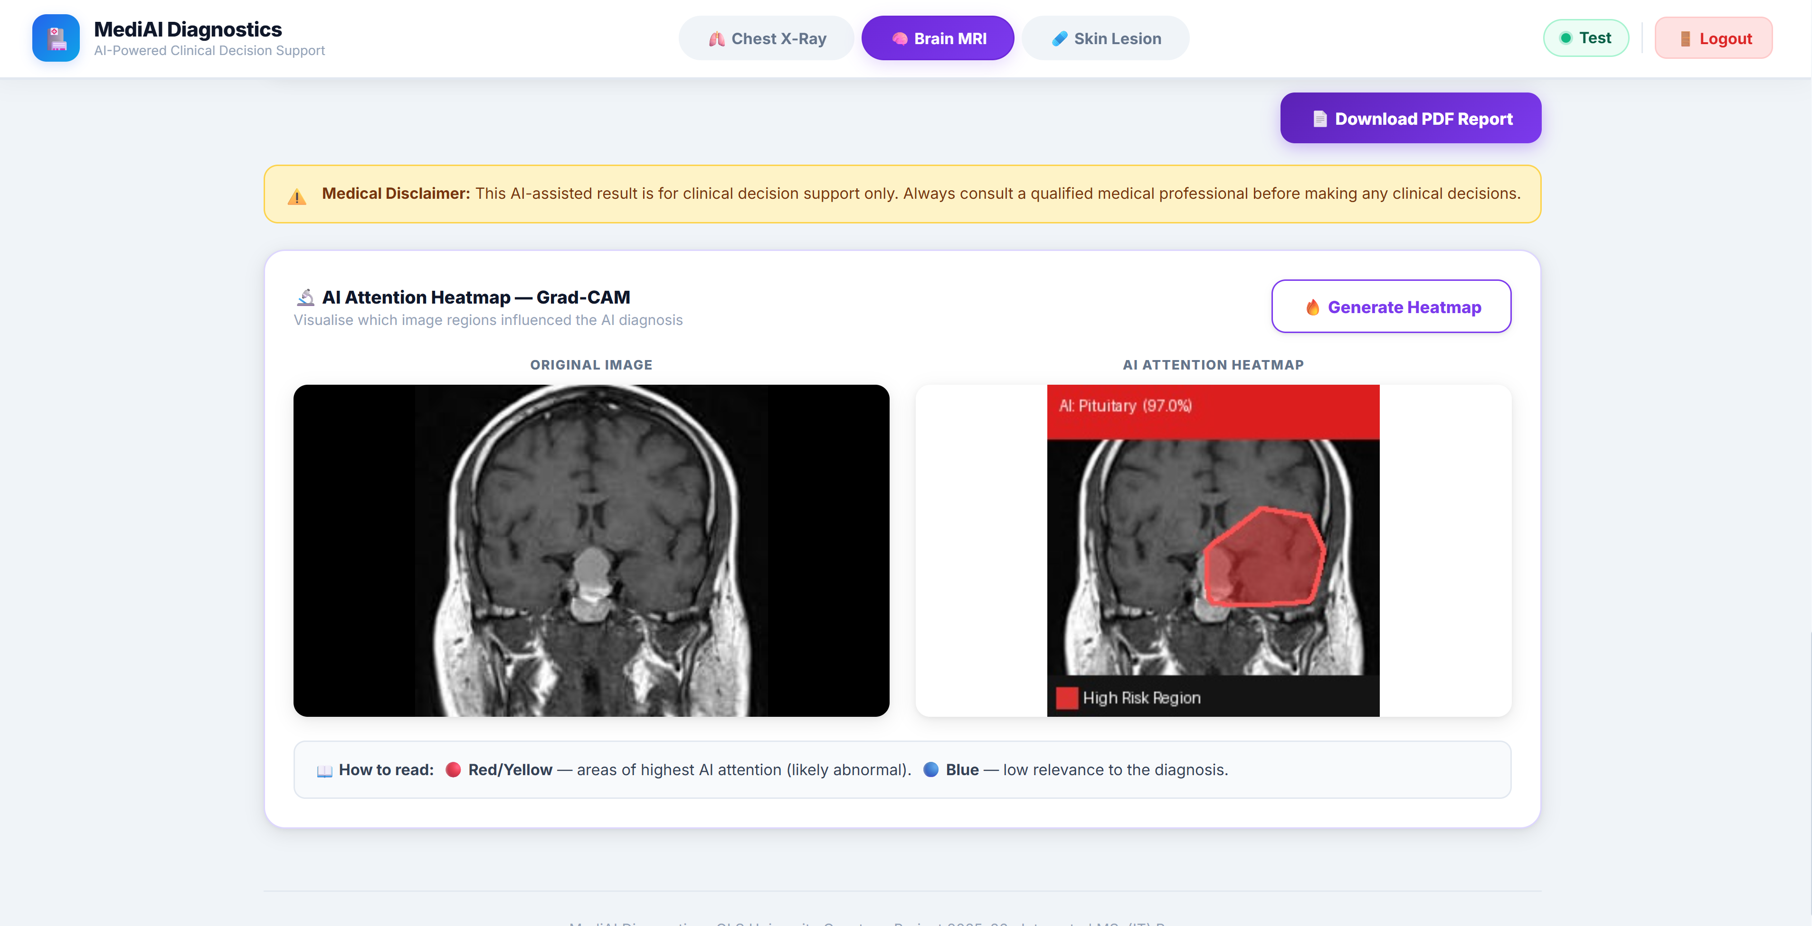
Fig. 7.7 — Brain MRI — Grad-CAM AI attention heatmap (original vs. heatmap overlay) (URL: http://localhost:5173/)
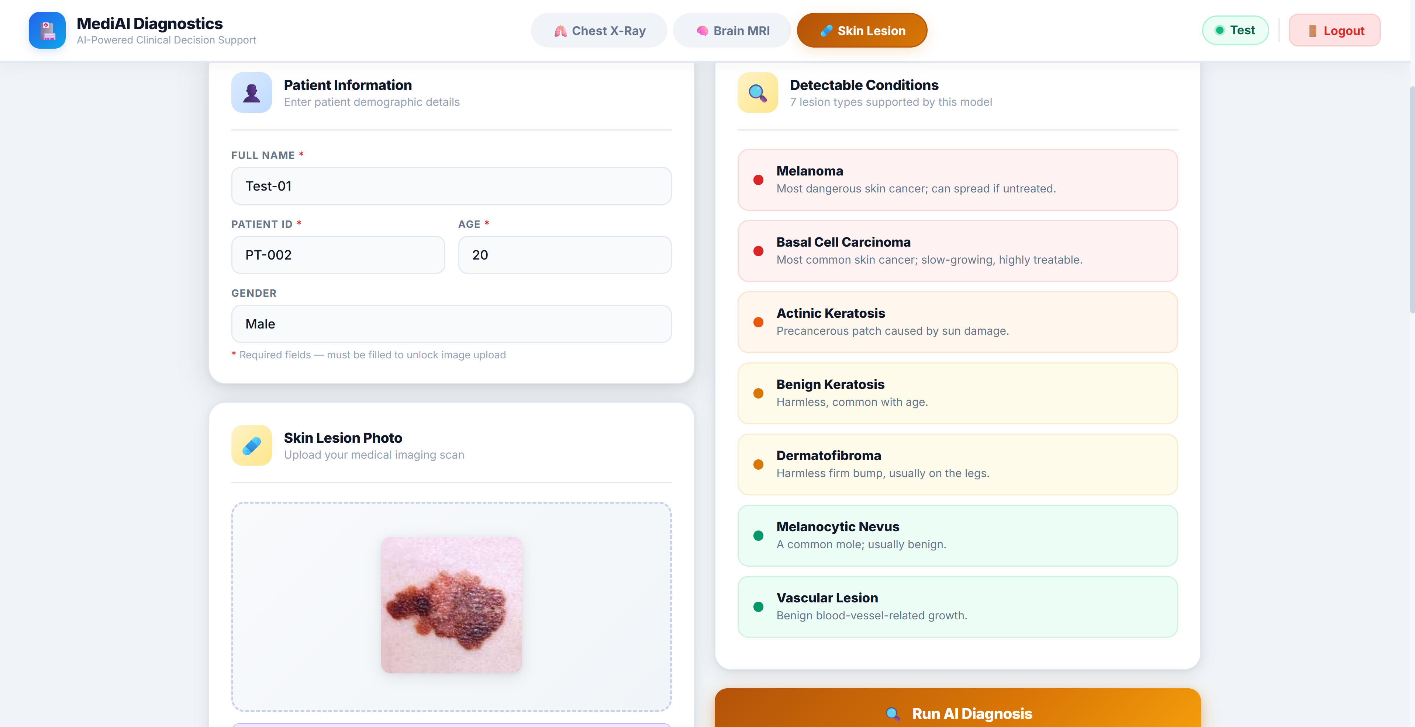
Fig. 7.8 — Skin Lesion module — patient info, 7 detectable lesion types, and uploaded photo (URL: http://localhost:5173/)
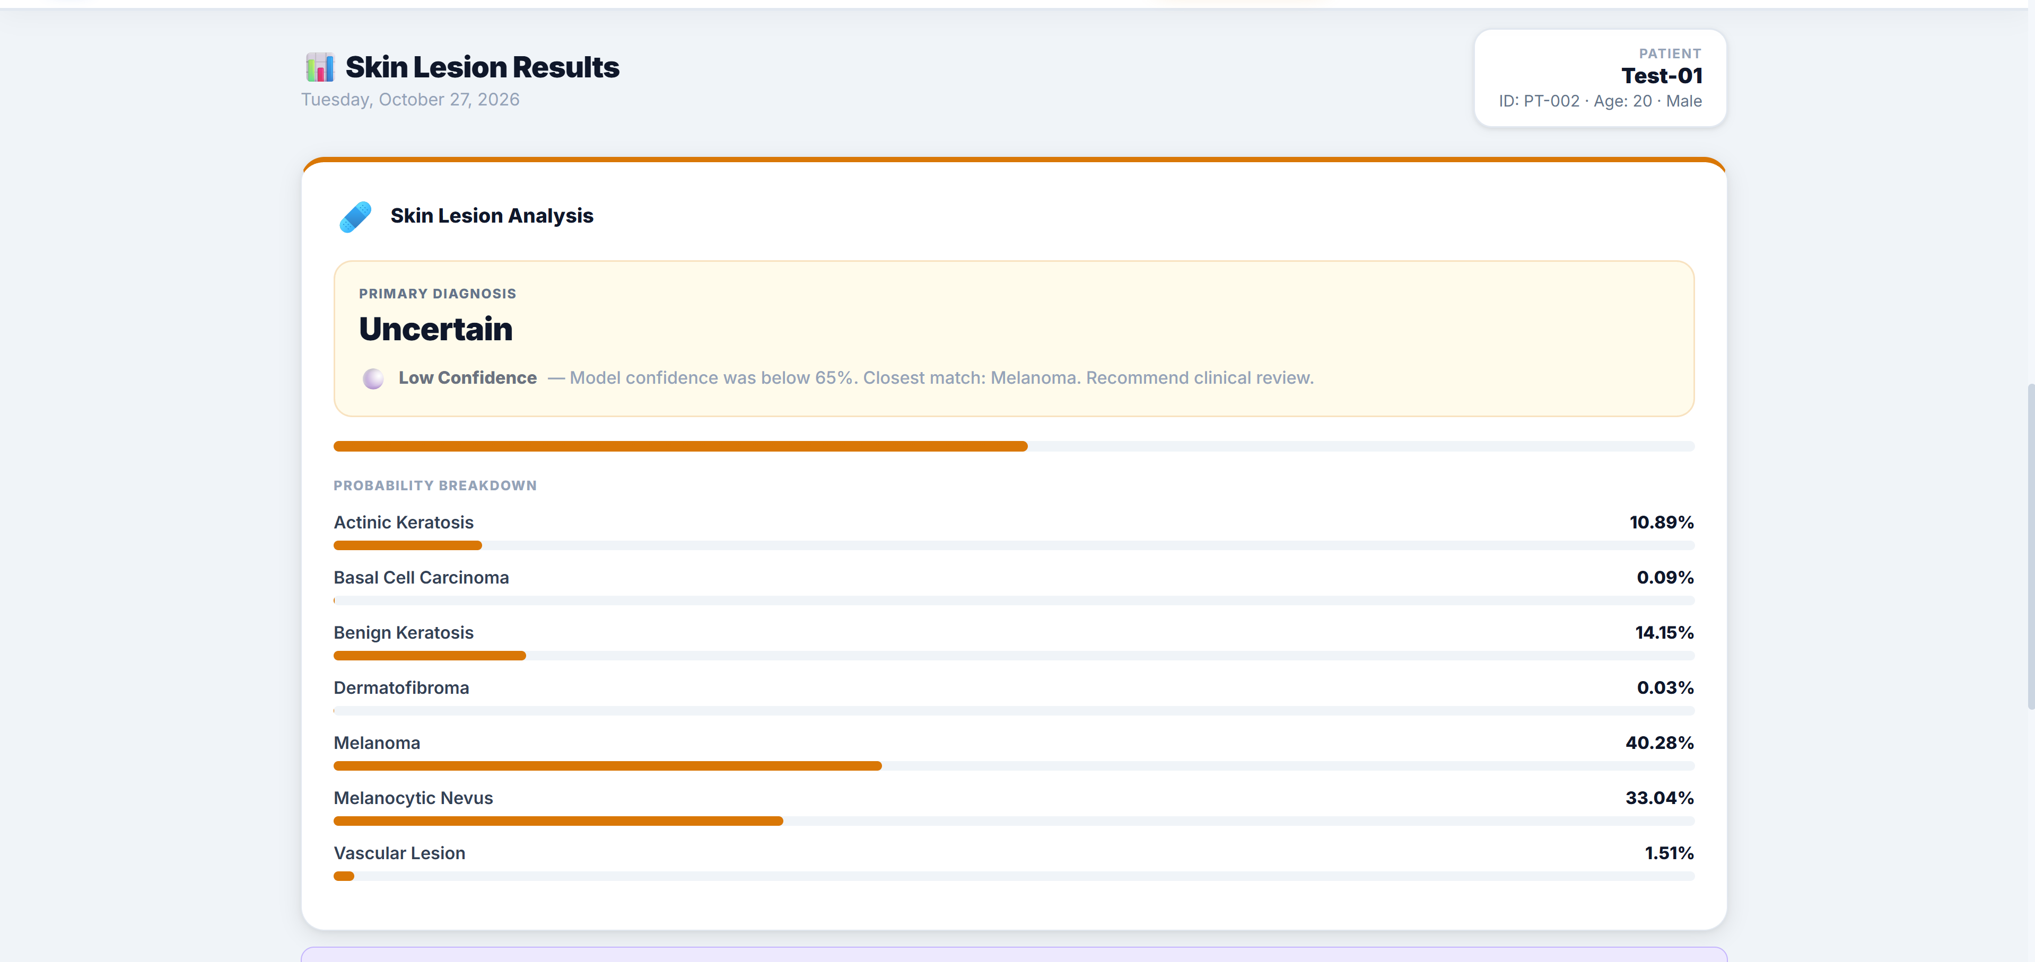
Fig. 7.9 — Skin Lesion — diagnosis result with 7-class probability breakdown (URL: http://localhost:5173/)
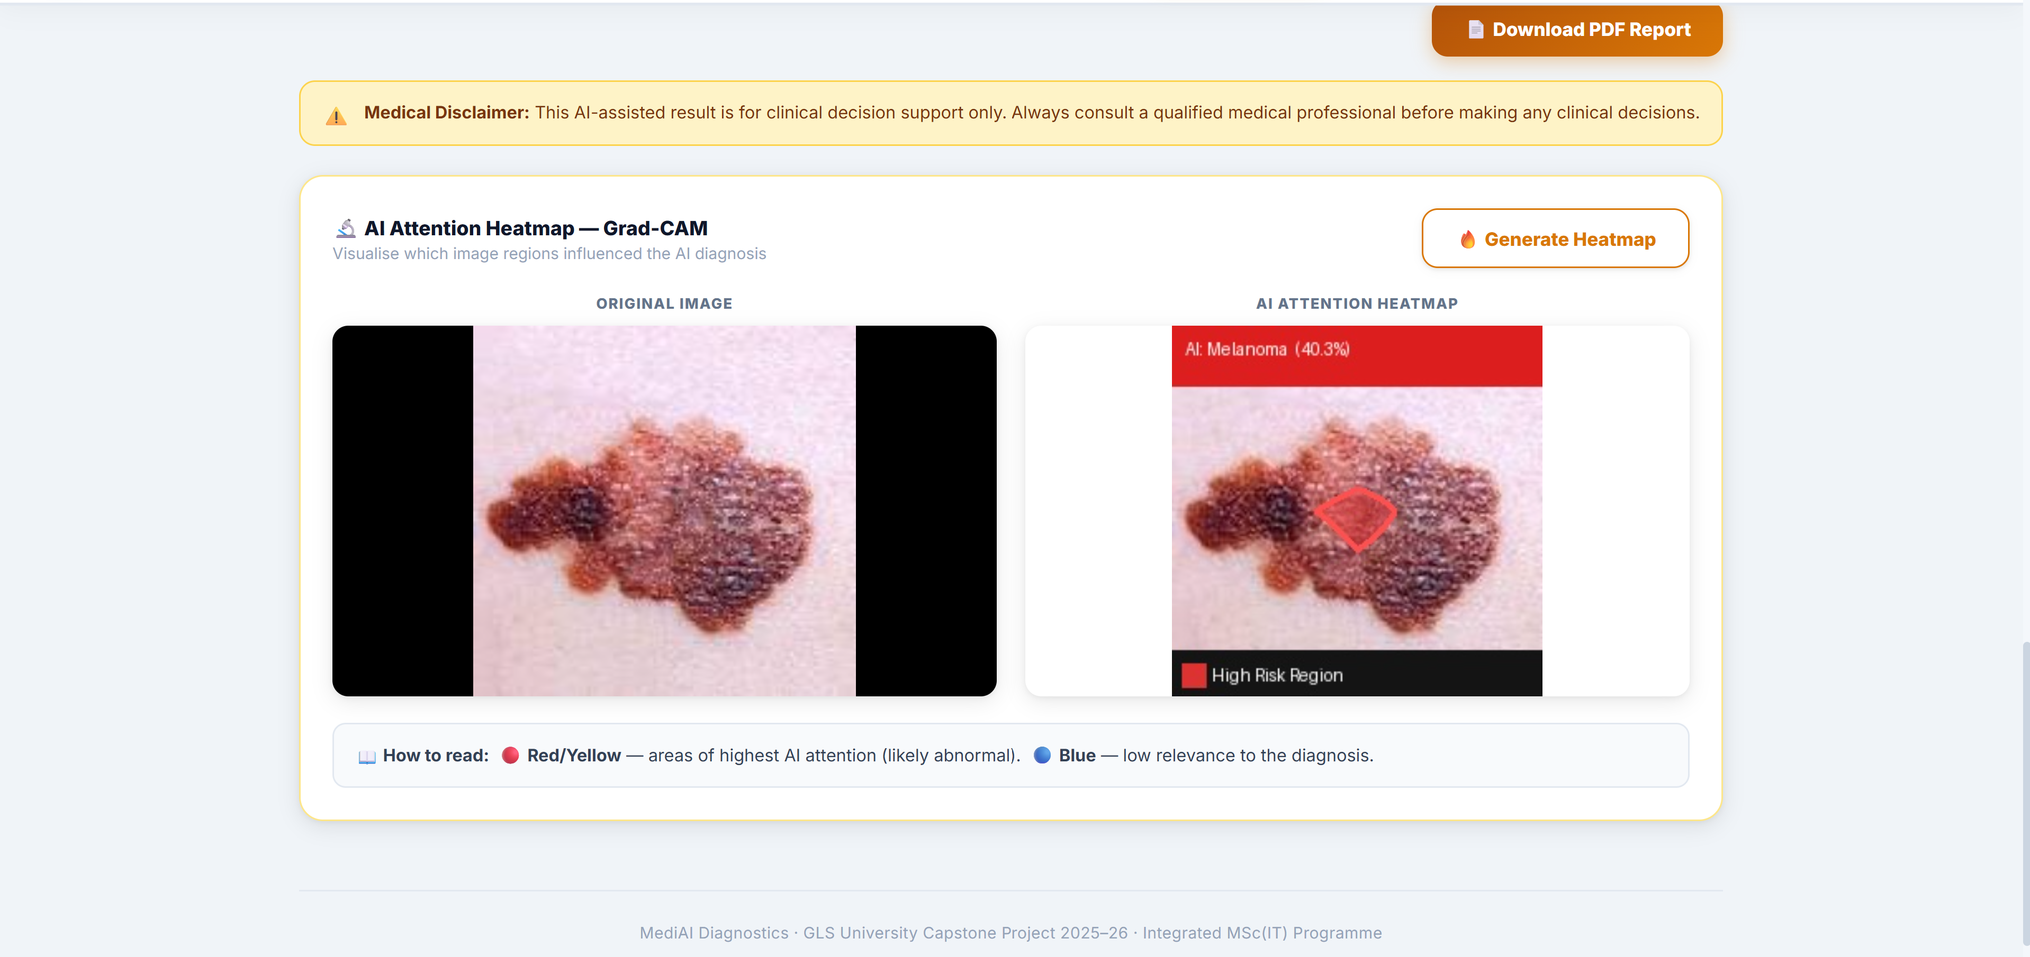
Fig. 7.10 — Skin Lesion — Grad-CAM AI attention heatmap (original vs. heatmap overlay) (URL: http://localhost:5173/)

7.3 Reports
Reports are generated on demand via POST http://127.0.0.1:8000/generate-report and downloaded as a PDF file by the browser.
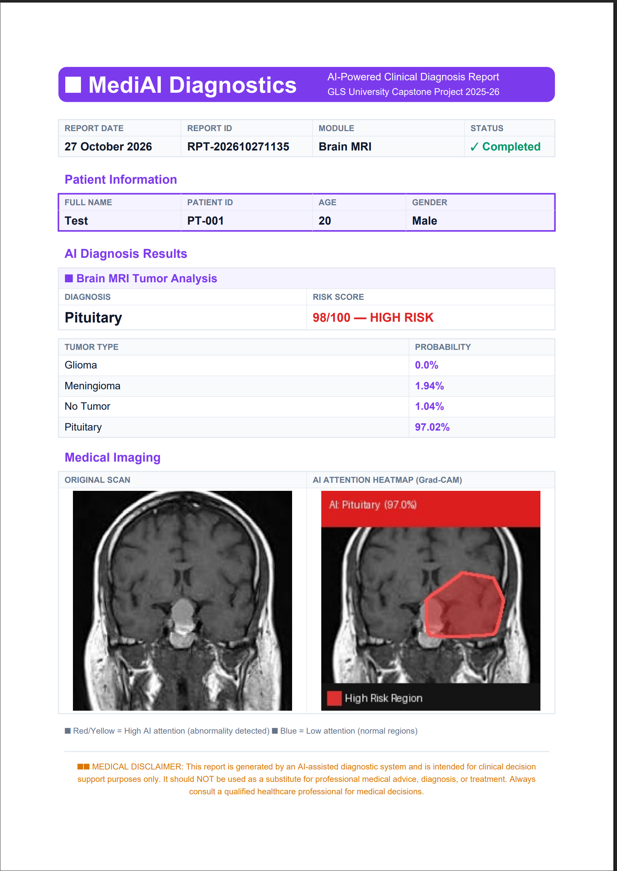
Fig. 7.11 — Generated PDF diagnostic report — Brain MRI module (Source: POST http://127.0.0.1:8000/generate-report)
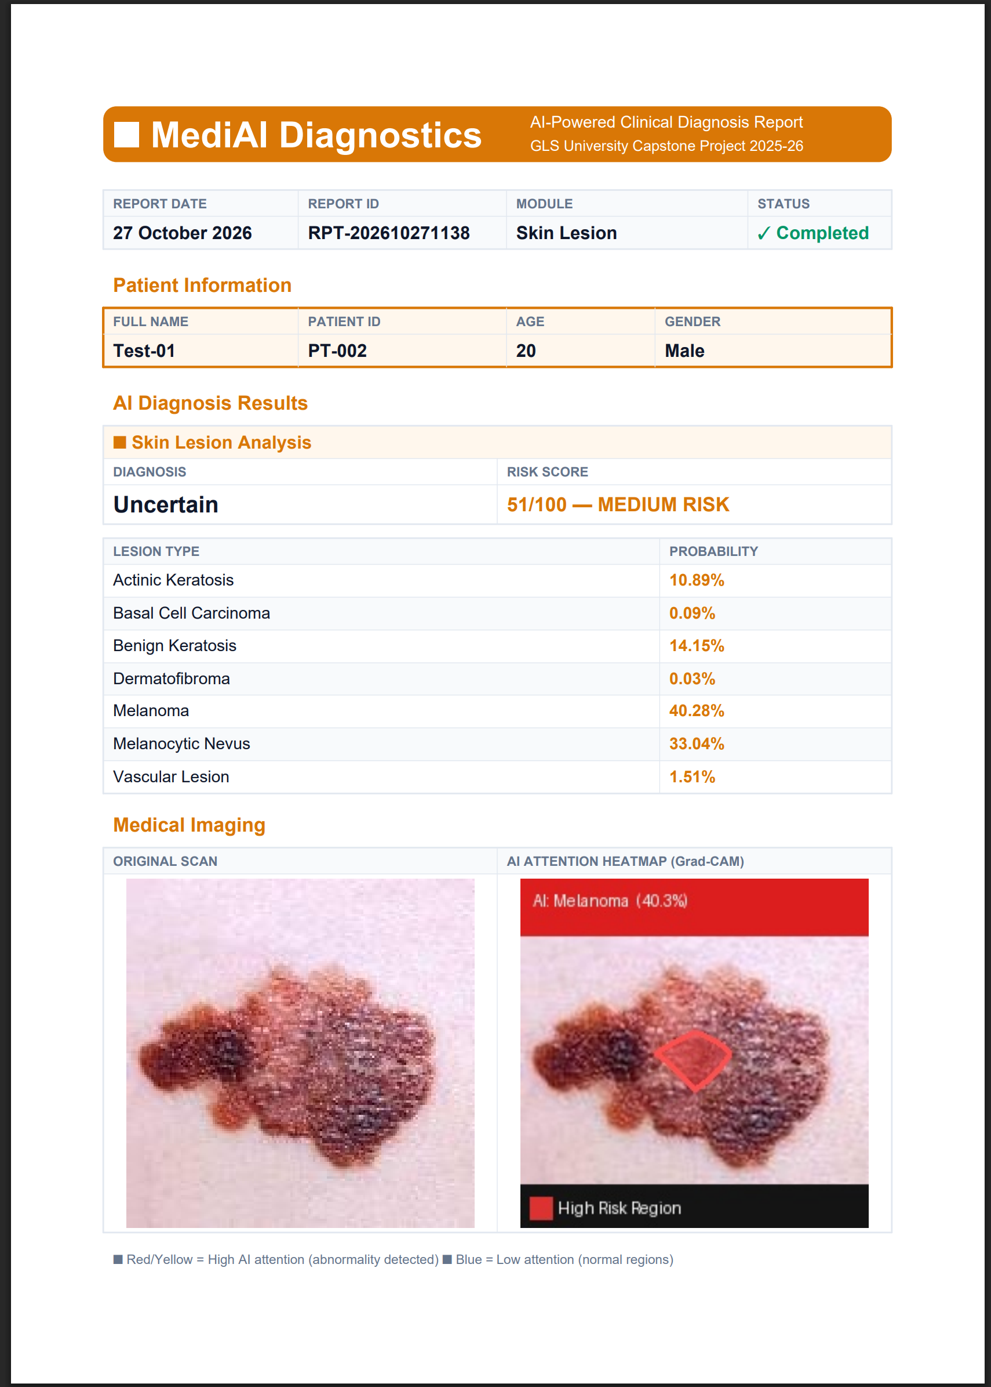
Fig. 7.12 — Generated PDF diagnostic report — Skin Lesion module (Source: POST http://127.0.0.1:8000/generate-report)

References

Datasets
- Brain Tumor MRI Dataset (deduplicated, 4-class: glioma / meningioma / pituitary / no tumor, 6,507 images) — sourced via Kaggle
- RSNA Pneumonia Detection Challenge Dataset — https://www.kaggle.com/c/rsna-pneumonia-detection-challenge
- CDC BRFSS 2015 Diabetes Health Indicators Dataset (Alex Teboul) — https://www.kaggle.com/datasets/alexteboul/diabetes-health-indicators-dataset
- HAM10000 ("Human Against Machine with 10000 training images") — https://www.kaggle.com/datasets/kmader/skin-cancer-mnist-ham10000

Frameworks & Libraries
- FastAPI — https://fastapi.tiangolo.com/
- PyTorch & Torchvision — https://pytorch.org/
- React — https://react.dev/
- Vite — https://vite.dev/
- MongoDB — https://www.mongodb.com/
- ReportLab (PDF generation) — https://www.reportlab.com/
- scikit-learn — https://scikit-learn.org/
- OpenCV — https://opencv.org/

Conclusion
MediAI Diagnostics successfully demonstrates an end-to-end, multimodal AI-assisted clinical decision-support application covering four distinct diagnostic tasks on a single, consistent platform. All four models were trained using sound machine-learning methodology — stratified data splits, class-weighted loss for imbalanced classes, transfer learning, early stopping, and mixed-precision GPU training — achieving strong held-out test performance (98% chest X-ray accuracy, 94.75% brain MRI accuracy, 74.7% skin lesion accuracy, and 78% diabetes risk accuracy). Beyond raw accuracy, the system was deliberately built with reliability in mind: Grad-CAM makes every image-based prediction visually explainable, out-of-distribution and confidence-threshold checks prevent the system from forcing a confident-sounding guess on invalid or unfamiliar inputs, and every diagnosis can be exported as a standardized, shareable PDF clinical report.
Testing the system against real-world images sourced outside the training datasets also surfaced an important, honest limitation: a single 2D-slice classifier trained on one curated dataset has a narrower generalization ceiling than a true multi-institutional clinical system, and occasionally misclassifies images that differ in acquisition style, framing, or scanner from its training source. This is a known, well-documented challenge in medical imaging AI rather than an implementation defect, and the project’s confidence-threshold and out-of-distribution safeguards exist specifically to make that limitation visible to the user instead of hiding it behind a falsely confident diagnosis.
Future work identified during this project includes: training on multi-source, multi-institutional datasets to further close the real-world generalization gap; adding test-time augmentation and model ensembling; expanding the Skin Lesion module with additional lesion classes such as squamous cell carcinoma; and integrating an LLM-based medical assistant to explain diagnostic reports in plain language and answer clinician questions, as outlined in the original project proposal. Overall, the project meets its stated objectives and delivers a genuinely usable, reliability-conscious foundation for AI-assisted multimodal clinical screening.

