**E-Medicare**

**Unit Testing**

**LoginServiceTest.java**

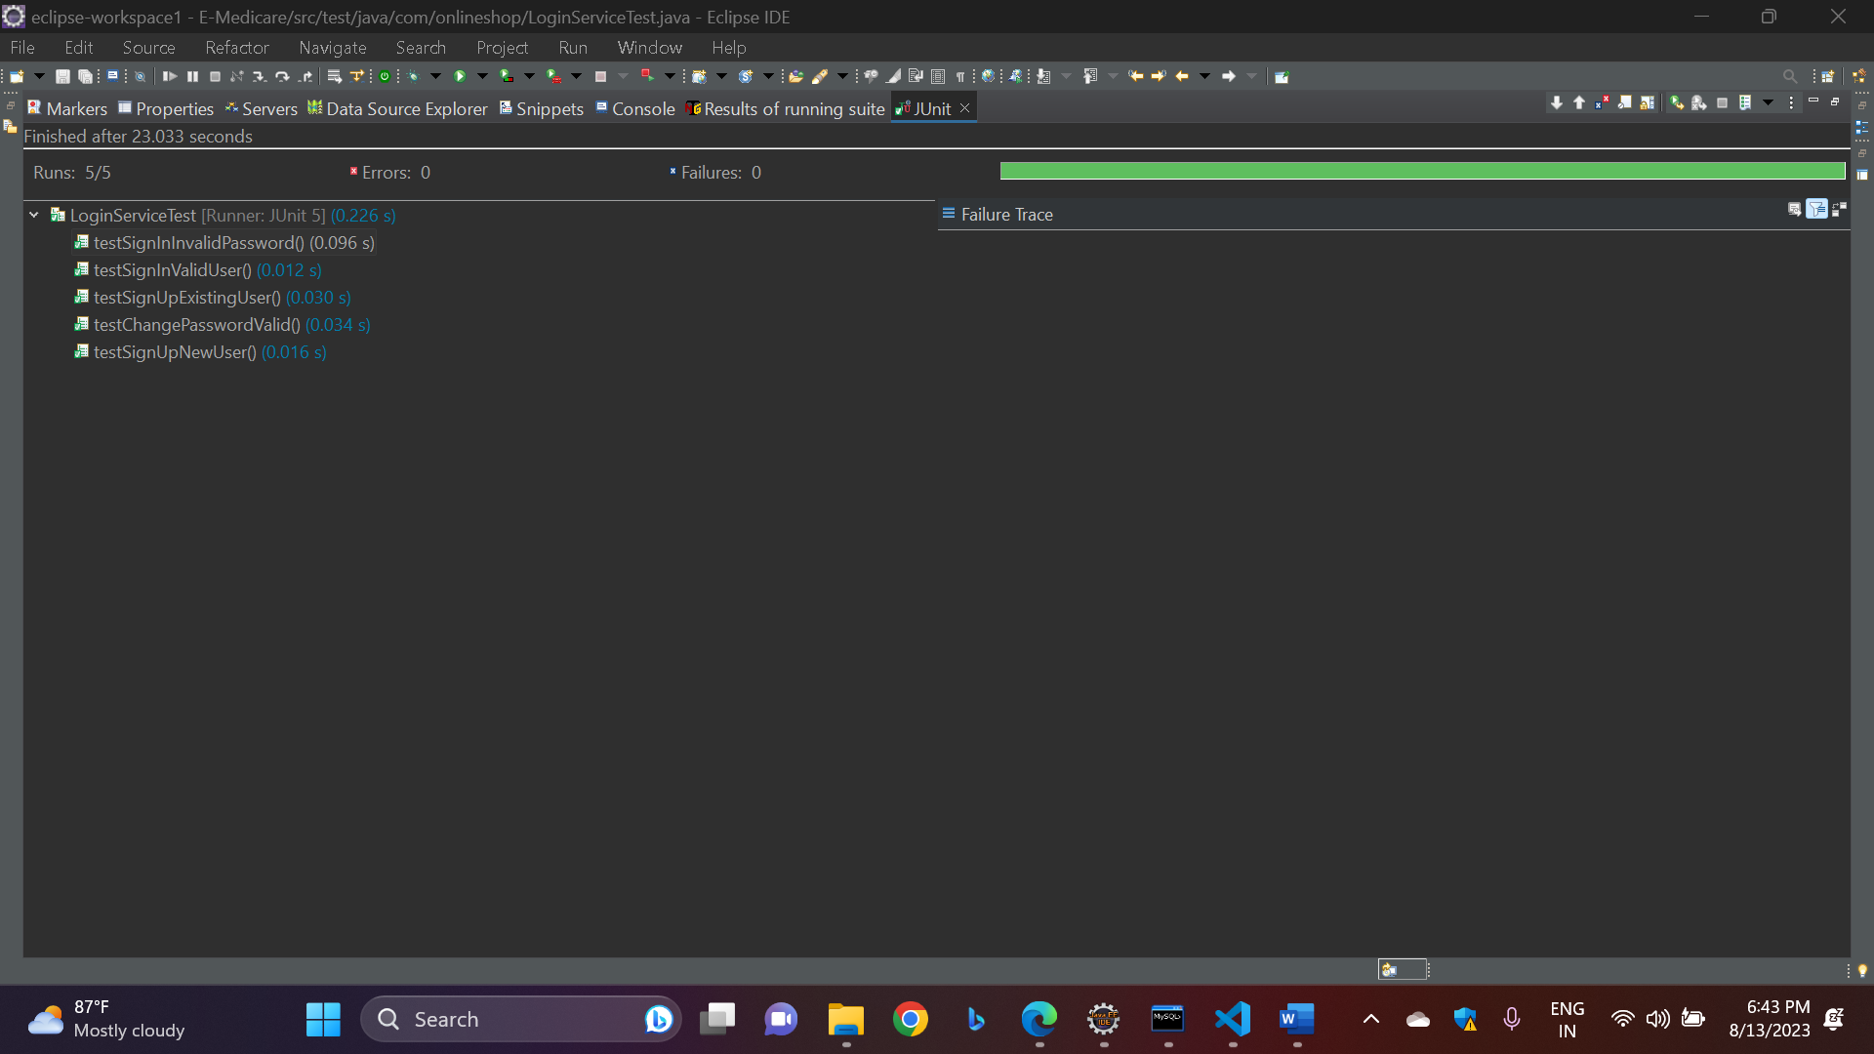

**ProductServiceTest.java**

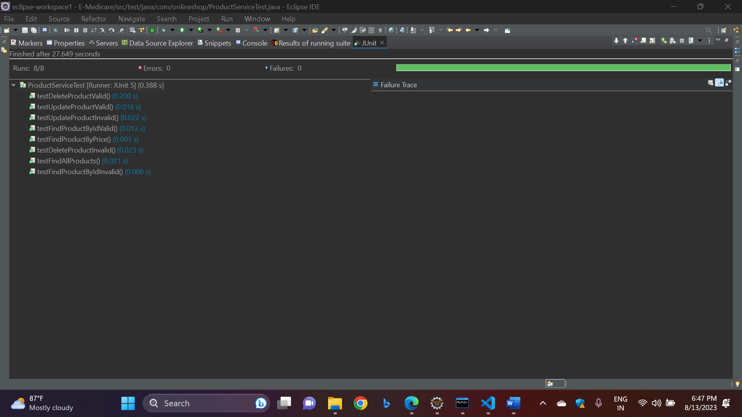

**All Test Cases**

