LinkedApply Pro — User Guide & Manual
Official Step-by-Step Instructions for New Users • Version 1.2.0
100% Client-Side Privacy • Zero Subscriptions (BYOK)

1. Quick Start & Installation
LinkedApply Pro is a Chrome extension built on Manifest V3. All code, settings, resumes, and API calls execute locally on your machine—no remote databases or middleman servers are involved.
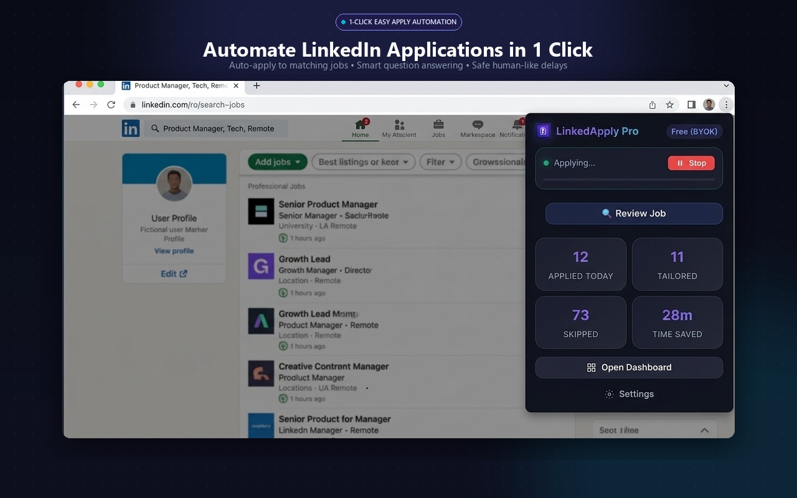
Fig 1.1: Extension popup running live on LinkedIn Easy Apply

Installation Steps (2 Minutes):
- 1. Open Chrome and navigate to chrome://extensions.
- 2. Enable Developer mode in the top-right corner.
- 3. Click Load unpacked and select the extension/dist folder.
- 4. Click the puzzle icon in Chrome and pin LinkedApply Pro to your toolbar.

2. Bring Your Own AI (BYOK) Configuration
LinkedApply Pro does not charge monthly subscription fees ($30–$50/mo). Instead, you connect your own API key directly to Google Gemini, OpenAI, or DeepSeek. Google Gemini Flash provides thousands of free requests daily, making all AI features completely free.
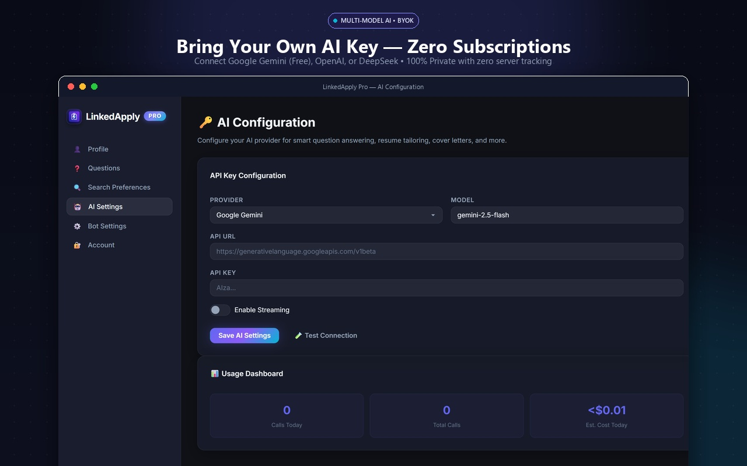
Fig 2.1: Multi-Model AI Settings page with usage metrics and cost tracker

Google Gemini Setup (60 Seconds):
- 1. Visit https://aistudio.google.com/app/apikey and create a free key.
- 2. Open LinkedApply Settings → AI Settings tab.
- 3. Select Google Gemini, keep model gemini-2.5-flash, and paste your key.
- 4. Click Test Connection to verify, then click Save AI Settings.

3. Profile & Auto-Fill Questions
Screening questions on LinkedIn Easy Apply forms (e.g., years of experience, sponsorship, notice period) are pre-filled from your profile settings. When an unlisted question appears, LinkedApply uses your AI key to draft a context-aware response based on your resume.
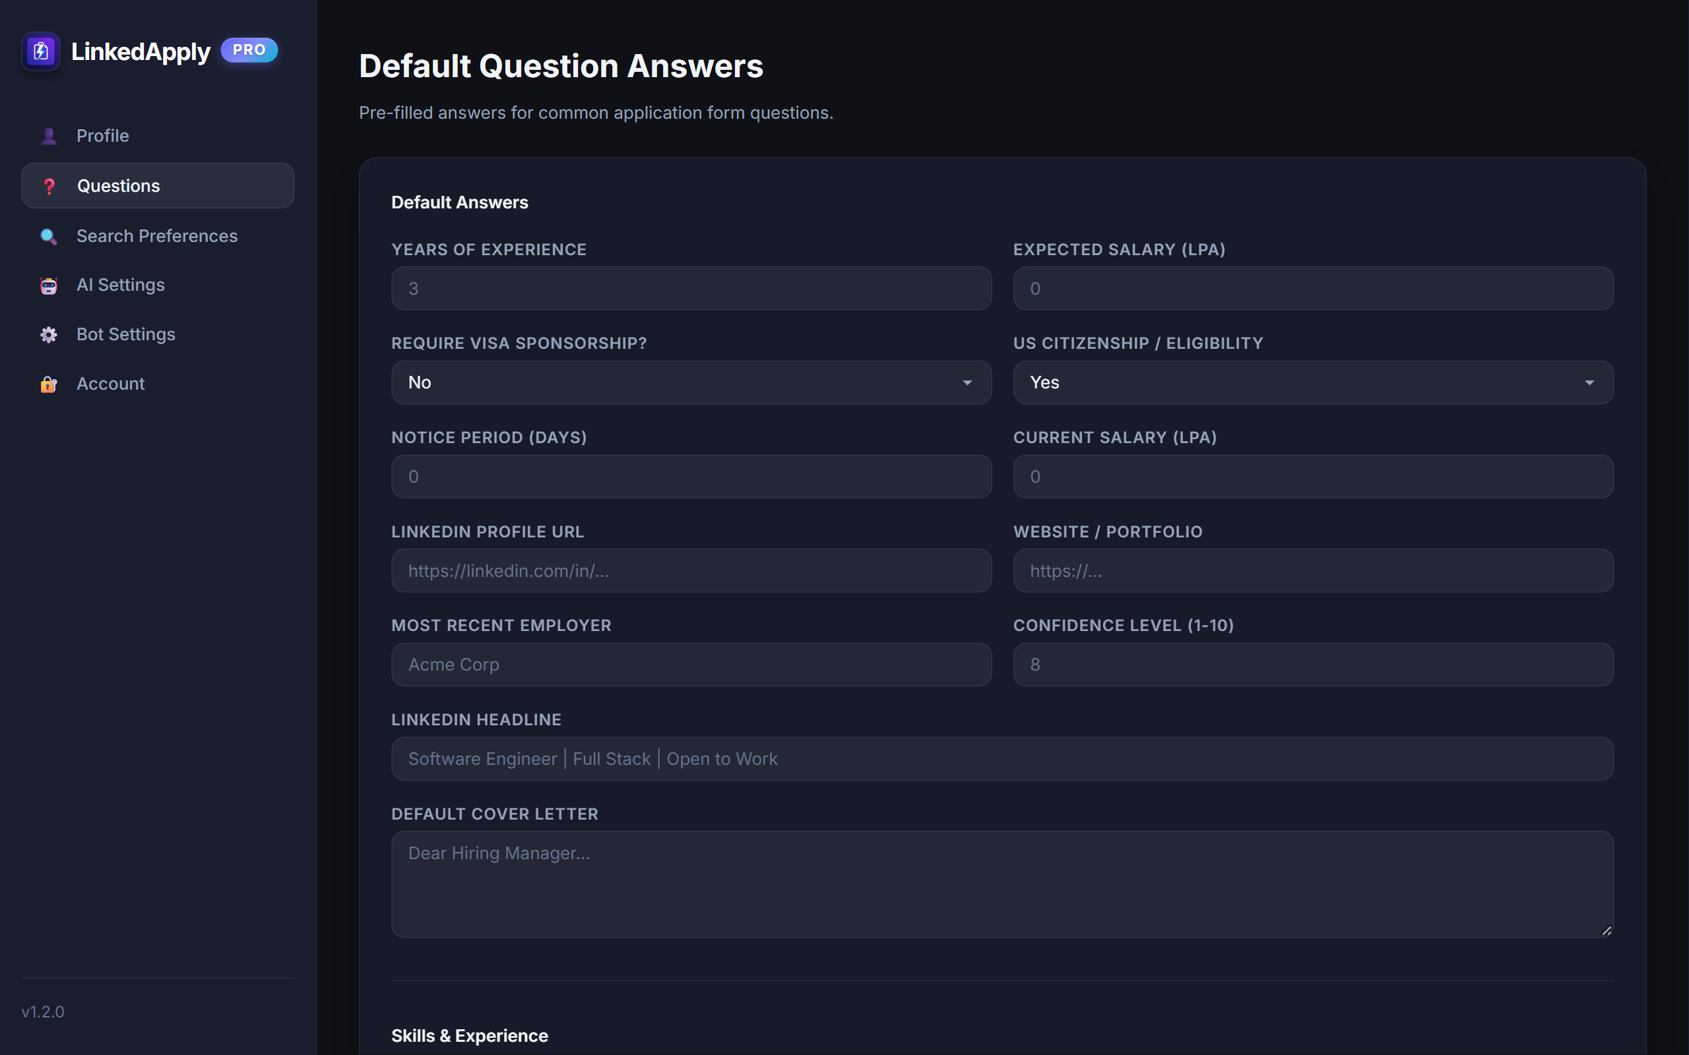
Fig 3.1: Pre-filled screening question answers

4. Visual Resume Builder
LinkedApply Pro includes an integrated, full-featured ATS resume builder. Choose from 11 recruiter-approved templates, customize section order with drag-and-drop, pick live color palettes, and download vector PDFs instantly.
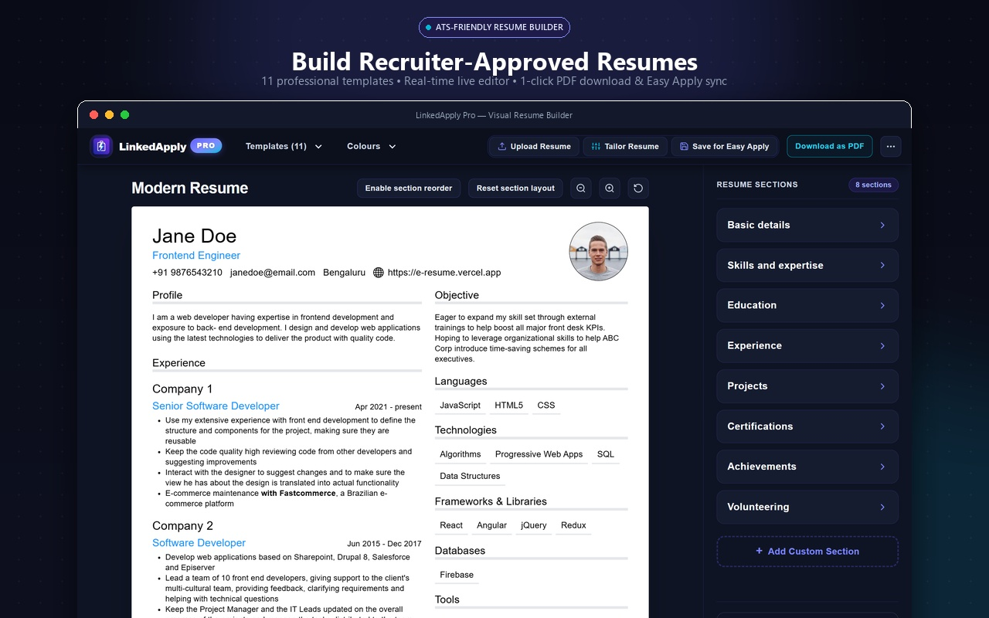
Fig 4.1: Visual Resume Builder editing the Modern Resume template

5. Job-Specific AI Resume Tailoring
A generic resume gets filtered by company ATS parsers. The Tailor engine extracts keywords from any job description, compares them against your resume, and optimizes your bullet points using Google's XYZ formula.
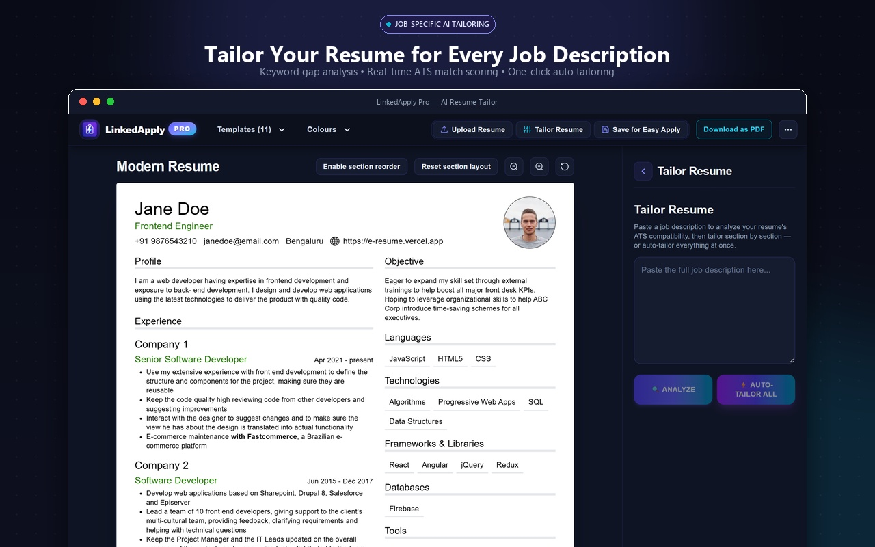
Fig 5.1: AI Resume Tailor drawer performing keyword gap analysis

6. Running the LinkedIn Auto-Apply Bot
Navigate to linkedin.com/jobs, search for your target role, toggle Easy Apply, and click Start in the LinkedApply popup. The bot emulates natural human reading intervals (2–5 second delays) to keep your account 100% safe.
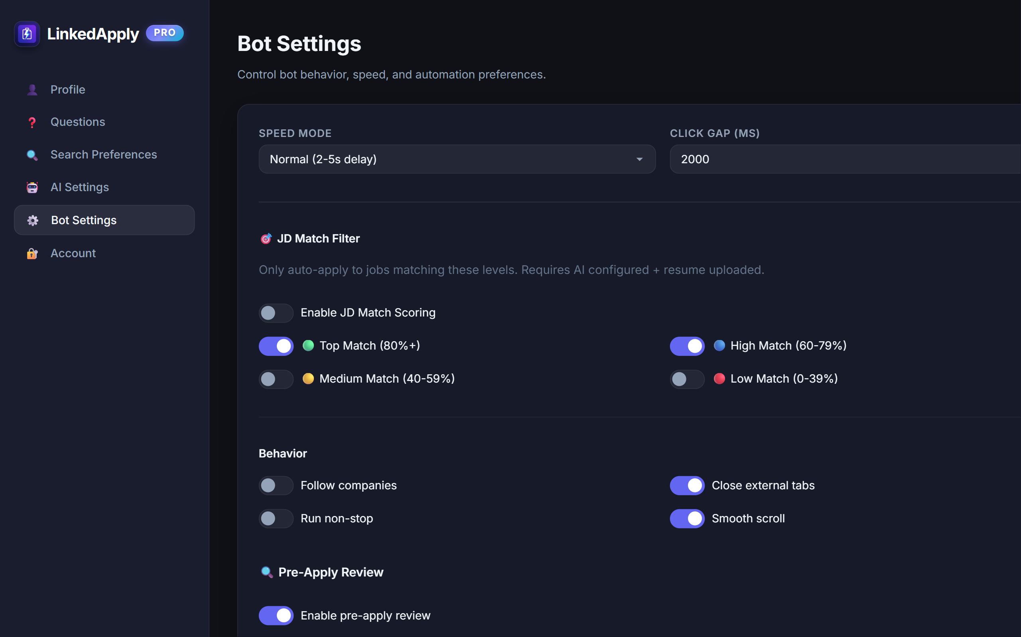
Fig 6.1: Bot Automation Settings

7. Sidepanel Dashboard & Tracking
The sidepanel dashboard runs alongside LinkedIn, giving you real-time visibility into applied jobs, daily goal progress, and interview pipeline stages.
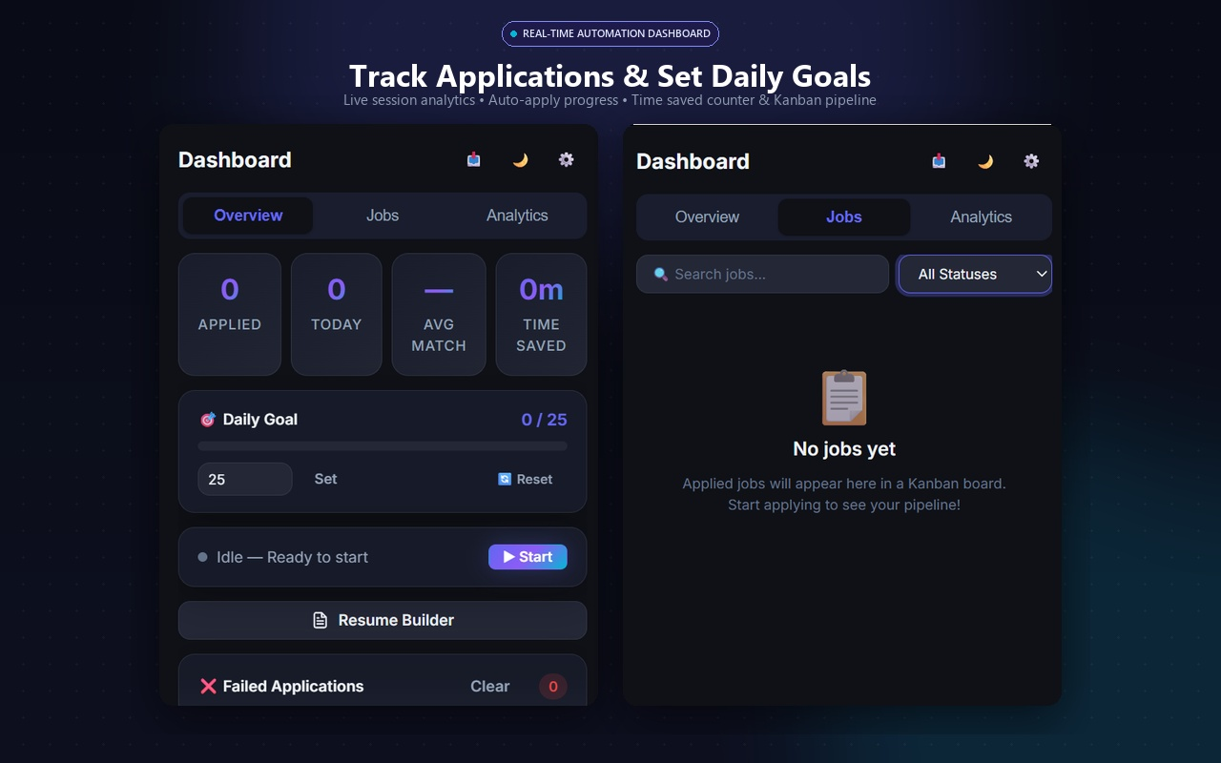
Fig 7.1: Sidepanel Dashboard Overview & Jobs pipeline tabs

8. Account Safety & Daily Limits
Safe application volume guidelines:
Account Age | Recommended Daily Limit | Pacing Setting
New Accounts (< 6 months) | 15–25 applications / day | Normal (2–5s delay)
Established (> 1 year) | 40–60 applications / day | Normal (2–5s delay)
Active Premium Accounts | Up to 75 applications / day | Normal (2–5s delay)

9. Frequently Asked Questions
Q: Does LinkedApply Pro collect my passwords?
A: Never. The extension operates entirely inside your active browser session and never touches passwords.
Q: How much does it cost to use?
A: $0.00. Software is free and Google Gemini Flash free tier provides thousands of requests daily at no cost.
Q: How do I back up my data?
A: Go to Settings → Account → Export Data to save a full JSON backup of your resumes and history.

