# Design

The block diagram below is a general design of our solution. We divide our design into four modules, including Power Supply, Control Unit, External Control, and Mechanical Unit. Details of each unit is presented in the diagram and described in the next section.

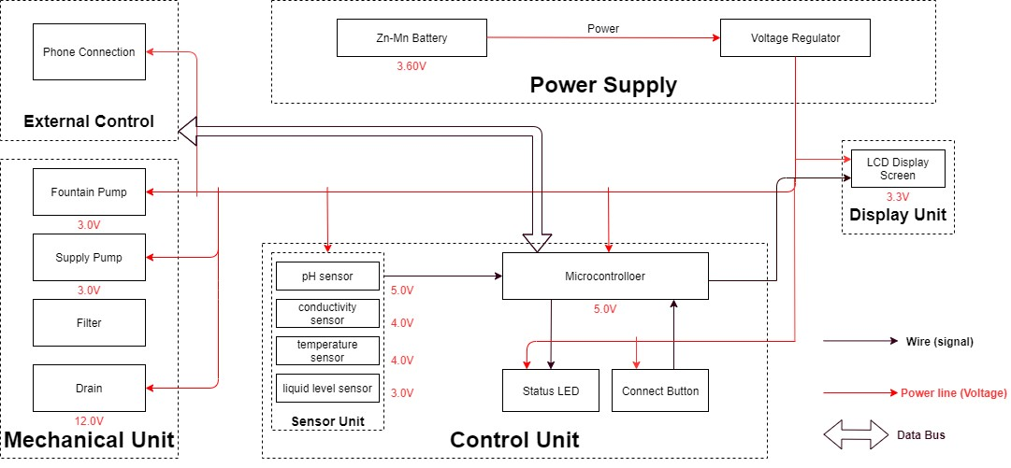

*Block Diagram of Smart Water Fountain*

***Sensor Unit***

This block contains the four sensors. The data acquired from the sensors will be transmitted to the control unit. Control unit will then have some logic designed to send corresponding signals to control other blocks of the water fountain. At the same time, the display screen on the water fountain will display the readings along with the determined water quality level and remaining water quantity.

For the PH-value sensor, temperature sensor and conductivity sensor, values will be retrieved and calculated to determine the overall water quality level. When poor water quality is determined, the water replacement procedures will take place. The weight sensor readings will be used to determine the amount of fresh water left in the water tank.

**Temperature Sensor:**

A water-proof temperature sensor is going to be used. Part number from spark fun is: DS18B20 [6]. This temperature sensor is compatible with a relatively wide range of power supply from 3.0V to 5.5V. The measured temperature ranges from -55 to +125 celsius degrees. Between -10 to + 85 degrees, the accuracy is up to +-0.5 degrees. This sensor can full fill all requirements needed for this project.

**PH-sensor:**

PH value is a valued indicator of water quality. This PH-sensor[7] works with 5V voltage, which is also compatible with the temperature sensor. It can 6measure the PH value from 0 to 14 with an accuracy of +- 0.1 at the temperature of 25 degrees.

**Conductivity sensor:**

Conductivity sensor is also part of the water quality assessment. The input voltage is from 3.0 to 5.0V. The error is small, +-5%F.S. The measurement value ranges from 0 to 20 ms/cm which is enough for water quality monitoring.

**Liquid Level Sensor:**

This sensor is responsible for reflecting how much freshwater is left in the water tank. When the water level is low, fresh water will be pumped to the water tank to ensure the water fountain keeps running with freshwater. This sensor is 0.5 Watts. For water level from 0 to 9 inches, the corresponding sensor outputs readings from 0 to 1.6. From that, the quantity of freshwater left can be determined.

***Display unit:***

**Screen:**

The screen will be used to display the readings from the sensors in a real-time manner. In addition, other necessary information will also be displayed. As described in the sensor part, the water quality and remaining water quantity will be displayed. The screen will be programmed so that it makes it easy for users to read information.

This 20*4 LCD display screen is going to be used to display the relevant information. After programming the screen, a conclusion of water quality(Good, Average, Poor) will be displayed along with the remaining water level.

***Power Supply Unit***

**Zn-Mn Battery**

The Zn-Mn battery must be able to continuously support the functioning of the circuit, display unit, and the mechanical unit.

Requirement: Commercial batteries will be used to maintain a continuous 3.60V power supply for at least 24 hours. If the chosen battery is not powerful enough, 120V power outlets will be considered.

**Voltage regulator**

The integrated circuit will regulate the power supply for each module to maintain their functionality. This chip must be able to handle the maximum voltage supplied by the battery (3.60V ± 0.5V) while ensuring the voltage at each module does not exceed their limit.

Requirement: Must maintain thermal stability below 100°C.

***Mechanical Unit***

**Fountain Pump**

The fountain pump must maintain a continuous water supply through the fountain mechanism. The pump must work 24 hours a day, 7 days a week unless the user manually turns off the power supply.

Requirement 1: The fountain pump must lift a cylindrical water stream of diameter 6mm for a height of 400mm.

Requirement 2: The fountain pump must serve for a duration of 2 years without maintenance or replacement under heavy workload.

Requirement 3: The fountain pump should have an operational condition around 3V, 200mA.

**Supply Pump**

The supply pump must function when a low water level alert is raised. While no water supply is requested, the pump must prevent water flow between the main supply and the fountain.

Requirement: The supply pump should have an operational condition around 3V, 200mA.

**Filter**

The filter must maintain the water quality through controlling the pH value and conductivity of the water.

Requirement 1: The filter must have a cost less than $5 each for frequent replacement. Each new filter must serve a duration no less than 3 month.

Requirement 2: The filter must be designed for easy removal and installation, while the connection mechanism must have a low degenerate rate when submerged in water.

**Drain**

The drain [13] must be able to hold and release water in the fountain. When water in the fountain should be replaced, the faucet should automatically drain the fountain once instruction is received from the integrated circuit.

***Control Unit***

This unit contains the control unit which does the following things:

* When the weight sensor reports a weight less than the minimum weight setting, the control unit will send an alert signal to the user and then control the water supply unit to refill the water fountain with a certain amount of water.
* Computes the water quality with data transferred from the three sensors in the water quality module and sends the result in terms of “Good”, “Average” or “Bad” to the user.
* If the water quality is “Bad”, the control unit will control the drain module to drain the water in the fountain and then control the water supply to refill.
* Water quality result is sent to the user with wireless connection and screen display as described above in the display unit.(unsure about keeping this function)

***Risk Analysis:***

**Control Unit Block:**

One of the most challenging points in this project is the precise control of the control unit between different blocks. To react accurately and promptly based on the results from the sensors is the key. The control unit needs to accommodate the mechanical and the electrical part so that the pumps, draining system can work collaboratively smoothly. From acquiring the data from sensors, analyzing the data, communicating and displaying the data to users, and then sending signals to activate the corresponding actions(drain or add fresh water), these are all to be performed by the control unit. Thus, it is the block that brings the greatest risk.

We will divide all the overall control unit functions into three parts: data retrieving, data manipulation, data delivering. Data retrieving is the logic used to read data from all sensors. Necessary algorithm is to be written to ensure successful and accurate data acquisition. Data manipulation is the process of calculating the water quality levels, and the formula to integrate all the data to produce a credible result. The data delivering is used to connect the control unit to the screen, displaying the necessary information as described above. This part will also be responsible for building the connection between the water fountain and the users’ phones through WIFI.

**Mechanical Unit Block:**

This is very challenging and extremely important. As most of the components will be exposed to water. Sensors, pumps, filters, draining system motors are all to be placed in the water tank. This means that we need to ensure no water can leak into the electrical-related mechanical parts. This puts pressure on the design and also the implementation. In addition, the motor-controlled valves used to drain the polluted water need to be firm when closed. Otherwise the fresh water will be leaking to the polluted water storage and the water consumption will be uncontrollable.

To achieve those points, we will make sure the designs are carefully implemented. The actual building process for the container should be proved before placing the electronic parts in.

**Safety and Energy Efficiency**

Discuss the implementation of safety features, like motion sensors and automatic shut-off.Highlight the importance of energy-efficient components and scheduling features.

**Testing and Quality Assurance**

Emphasize the need for thorough testing to ensure reliability and performance.Mention quality control procedures.

**Safety and Energy Efficiency**

Discuss the implementation of safety features, like motion sensors and automatic shut-off.Highlight the importance of energy-efficient components and scheduling features.

**Connectivity**

Explain how smart water fountains can connect to home automation systems or the internet. Mention remote control options and real-time status updates.

**Automation and Control**

Highlight the importance of automation for convenience and user experience.Discuss features like timers and motion sensors.

python

import RPi.GPIO as GPIO

import time

# GPIO pins for water pump and LED lights

pump_pin = 17

light_pin = 18

# Initialize GPIO

GPIO.setmode(GPIO.BCM)

GPIO.setup(pump_pin, GPIO.OUT)

GPIO.setup(light_pin, GPIO.OUT)

# Function to control the water pump

def control_pump(state):

if state == "on":

GPIO.output(pump_pin, GPIO.HIGH)

else:

GPIO.output(pump_pin, GPIO.LOW)

# Function to control LED lights

def control_lights(state):

if state == "on":

GPIO.output(light_pin, GPIO.HIGH)

else:

GPIO.output(light_pin, GPIO.LOW)

# Main program

try:

while True:

# Read sensor data and make decisions based on it.

# For example, turn on the water pump and lights if water level is low.

control_pump("on")

control_lights("on")

time.sleep(5) # Run the fountain for 5 seconds

control_pump("off")

control_lights("off")

time.sleep(60) # Wait for a minute before running again

except KeyboardInterrupt:

GPIO.cleanup() # Cleanup GPIO on program exit