**Space Shooter!**

# ***Introduction:***

In a galaxy far, far away, we find ourselves in the company of Dr. Potter, an astronaut who is studying extraterrestrial beings in his state-of-the-art rocket ship. Little does Dr. Potter know about the danger of his journey. While exploring the outer limits of our galaxy, Dr. Potter is caught in battle against several laser-shooting beasts! Can you help Dr. Potter defeat the many foes that he faces so that he can complete his research in the name of science? Let’s find out!

# How to Win:

All you need to do to win is to shoot down the enemies that appear on your screen by shooting them with your lasers. Clear through all five levels to win the game!

# Basic Controls

Arrow Keys: Control Rocket

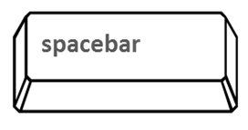

Space Bar: Shoot Lasers

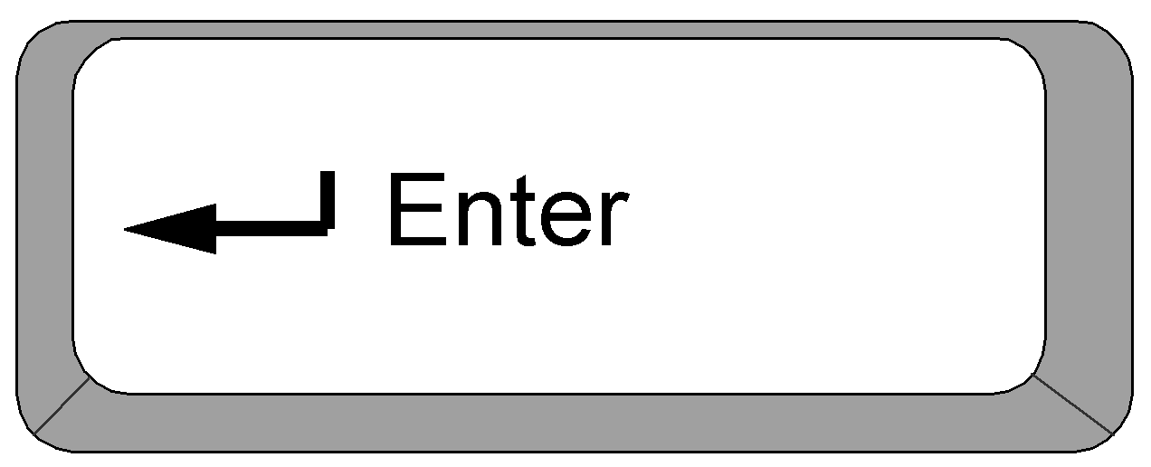

Enter Key: Shoot Charged Laser

(Only When Charge Meter is full)

# Hearts:

When you begin the game, you will have 10 hearts. If you lose all of your hearts, you will lose the game. You lose hearts by taking damage, which happens whenever an enemy shoots you with a laser or when you collide directly with an enemy. You can see all of your hearts in the health bar located in the top left corner of the screen.

# Charge Meter:

When you shoot a laser, you will normally shoot a yellow laser that deals 1 damage point to an enemy when it is struck. Every so often, you will have the opportunity to shoot a charged laser that will deal 3 damage points to an enemy if struck. You can do this by pressing the   
“enter” key when your charge meter is filled. The charge meter will fill up completely after a certain amount of time. This time CANNOT be sped up. The meter is ready to shoot when it completely fills to be all green, as shown below.

Meter is still Meter is fully charged.

charging: Press enter to shoot charged laser.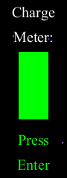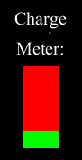

# Power Ups:

There are three power ups you can collect to help you defeat the enemies. All power ups will appear in the field, and you need to fly into them to activate their effects. After a certain amount of time, they will disappear from the playing field if not collected.



**Extra Heart:** Collect these to add an extra heart to your health bar (You can have no more than 10 hearts total).



**Charged Mode:** Collect this to temporarily power up your entire rocket! When you are in charged mode, you will shoot more powerful lasers that deal 2 damage to enemies. After a certain amount of time, the effects of the power up will wear off.



**Immunity Shield:** Collecting this will activate a shield around your rocket, protecting you from all potential damage for a short period of time.

# Tips and Tricks:

* To load the game, execute the “Play Space Shooter!.exe” execution file by double-clicking it. Be sure to save a copy of it to your desktop screen for a convenient shortcut!
* To close the game, press the “escape” button on your keyboard.
* When you take damage, you will reappear from the bottom of the screen and be granted a few frames of immunity in which enemies cannot hurt you.
* When you damage an enemy, it will appear stunned for a few frames. The enemy will not take further damage while it is stunned.
* You can move diagonally by holding down more than one direction key.
* Holding down the space bar DOES NOT allow you to continually shoot.
* See enemy guide below for information on how to approach each foe.
* Have fun!

# Enemies Guide:

|  | Name: UFO  HP: 3  Attack Power: 1  Appears in levels 1, 2 and 5  Notes: Generally will only move left and right. Occasionally, the UFO enemy will lock onto a specific spot and descend slowly over that area. |
| --- | --- |
|  | Name: Staring Steven  HP: 6  Attack Power: 1  Appears in level 3  Notes: Creates square shaped force fields that radiate off of its skin. You will need to carefully maneuver around them to not take damage. |
|  | Name: Octowen  HP: 15  Attack Power: 1  Appears in level 4  Notes: Shoots lasers in 8 directions! Octowens have a bad habit of showing you the attack order they are going to use on you. Watch the order that they flash their red lights to see where they will shoot the lasers next! |
|  | Name: Professor Doomsday (Boss)  HP: 30  Attack Power: 1 (Note that his super laser has an attack power of 2!)  Appears in level 5  Notes: Professor Doomsday is responsible for sending all of these enemies your way! It’s time to teach him a lesson! Notice that he shoots two lasers at once and will occasionally shoot supercharged lasers that deal 2 damage! Defeat him to win the game! |

# 

# Credits:

“Space Shooter” was written with Processing (Version 3.4) using the Java language. It is playable on Windows (32 + 64 bit) and MAC (Apple Silicon and Intel 64 bit). More information about processing can be found at their website: [processing.org](https://processing.org/)

The source code and data for this project was developed by Naaman Trumbull. Modifications and duplication of the source code is allowed by the creator, so long as credit is given to them for the original code.

See more of Naaman’s projects on his github: [github.com/naatrumbull](https://github.com/naatrumbull)

Naaman would like to thank all his High School Programming teachers for making him love programming and for giving him the freedom to make whatever he wanted to make. Naaman would also like to thank the RYB Trumpet section for being his guinea pigs by testing out this game for him.