Abakirov Nursultan

2 kurs

SE (english) 1-16

TASK 1

Lab work

1. Problem statement:

To find the minimum element of the array (5) and its sequence number

2. Input and Output data

input data:

arr[5] – array of real numbers

output data:

min – minimum element of the array

index – index of minimum element of the array

3. Algorithm

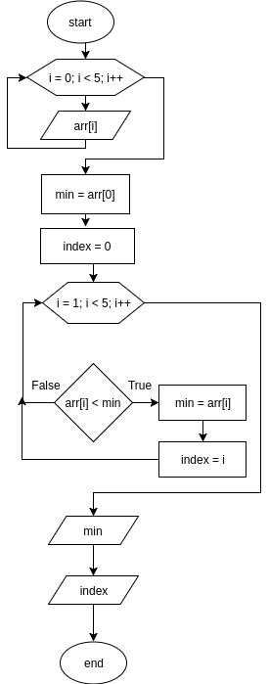#include <iostream>

using namespace std;

int main(){

cout << "input 5 elements of array: ";

float arr[4];

for (short i = 0; i < 5; i++) {

cin >> arr[i];

}

float min = arr[0];

short index = 0;

for (short i = 1; i < 5; i++) {

if (arr[i] < min) {

min = arr[i];

index = i;

}

}

cout << "min el: " << min << endl;

cout << "index: " << index;

cout << endl;

return 0;

}

Tests

|  |  |  |  |  |  |  |  |
| --- | --- | --- | --- | --- | --- | --- | --- |
| Test № | arr[0] | arr[1] | arr[2] | arr[3] | arr[4] | min | index |
| 1 | 5 | 6 | 9 | 8 | 6 | 5 | 0 |
| 2 | 3.6 | 0.3 | 1.9 | 9.5 | 4.5 | 0.3 | 1 |
| 3 | 99 | 126 | 596 | 450 | 22 | 22 | 4 |
| 4 | -9 | 56 | 36 | -99 | -7 | -99 | 3 |

Proof:

1

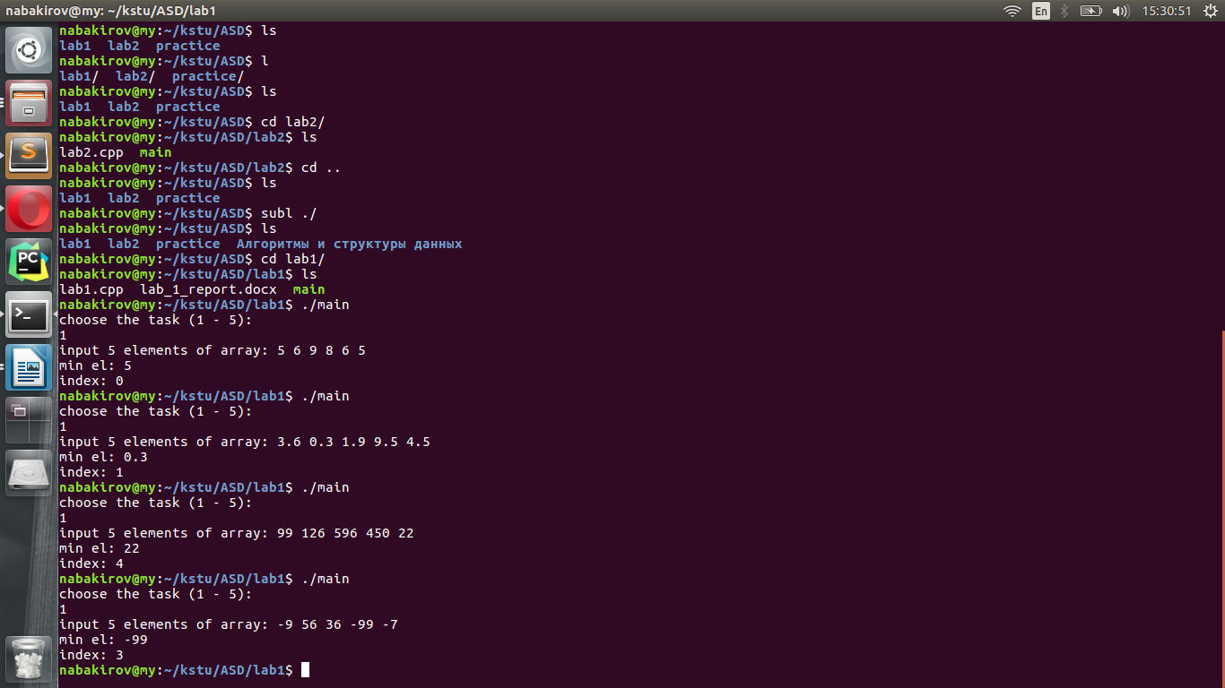

2



3



4



Task 2

Lab work

1. Problem statement:

To find quantity of elements in the array (A = 10), situated after the smallest element

2. Input and Output data

input data:

arr[10] – array of real numbers

output data:

index – integer, index of the smallest element

quantity – integer, quantity of number situated after the smallest element

3. Algorithm

#include <iostream>

using namespace std;

int main() {

cout << "input 10 elements of array: ";

float arr[10];

for (short i = 0; i < 10; i++) {

cin >> arr[i];

}

float min = arr[0];

short index = 0;

for (short i = 1; i < 10; i++) {

if (arr[i] <= min) {

min = arr[i];

index = i;

}

}

int result = 10 - (index + 1);

cout << "index of min: " << index << endl;

cout << "quantity: "<< result<< endl;

return 0;

}

Tests

|  |  |  |  |  |  |  |  |  |  |  |  |  |
| --- | --- | --- | --- | --- | --- | --- | --- | --- | --- | --- | --- | --- |
| Test № | arr[0] | arr[1] | arr[2] | arr[3] | arr[4] | arr[5] | arr[6] | arr[7] | arr[8] | arr[9] | Min  index | quantity |
| 1 | 5 | 6 | 9 | 8 | 6 | 5 | 3 | 1 | 4 | 5 | 7 | 2 |
| 2 | 3.6 | 0.3 | 1.9 | 9.5 | 4.5 | 1.2 | 6.3 | 5.4 | 2.6 | 40 | 1 | 8 |
| 3 | 0 | 0 | 0 | 0 | 0 | 0 | 0 | 0 | 0 | 0 | 9 | 0 |
| 4 | -9 | 56 | 36 | -99 | -7 | -9 | -8 | 4 | -6 | 4 | 3 | 6 |

Proof:

1

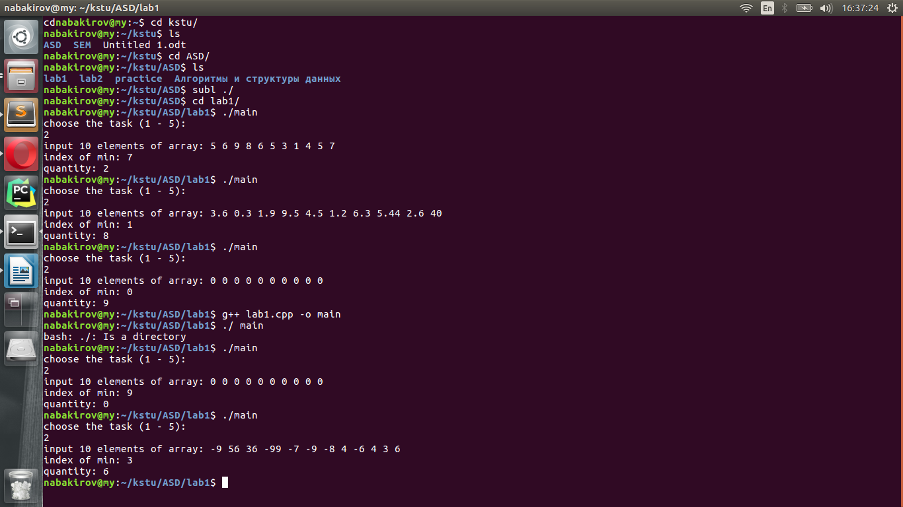

2



3



4



Task 3

1. Problem statement:

To swap lines containing a minimal element and a maximal element in the specified 2-dimensional array (A = 3x3)

2. Input and Output data

input data:

arr[3][3 – 2-dimensional array of real numbers

output data:

arr[3][3] – 2-dimensional array of real numbers

3. Algorithm