**Home Page:**  ’Supernova’ is the online shop portal name. Audio navigation is established to navigate the site to Product List Page with the help of key event and speech.

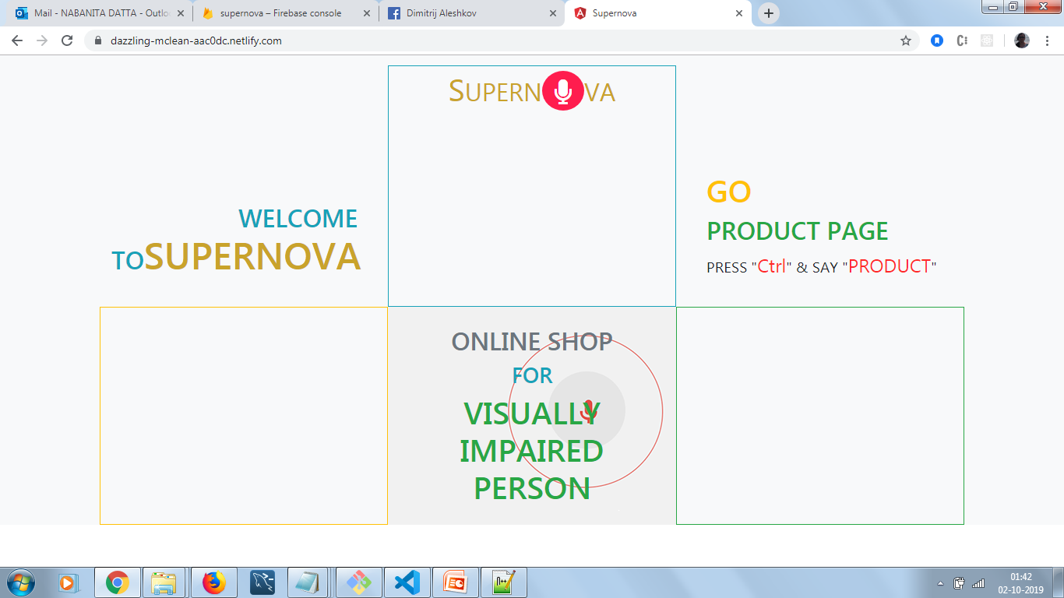

**Product list page:** Display the list of all available products visually and also clicking specified key. Audio navigation is established to navigate the site to Product Details Page**.**

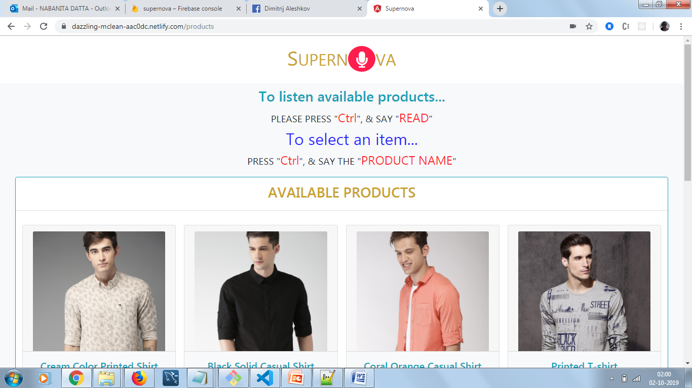

**Product Details page:** This page will describe the details of a particular product. Audio navigation is established to navigate the site to Shopping Cart Page Or Product List Page with the help of key event and speech .

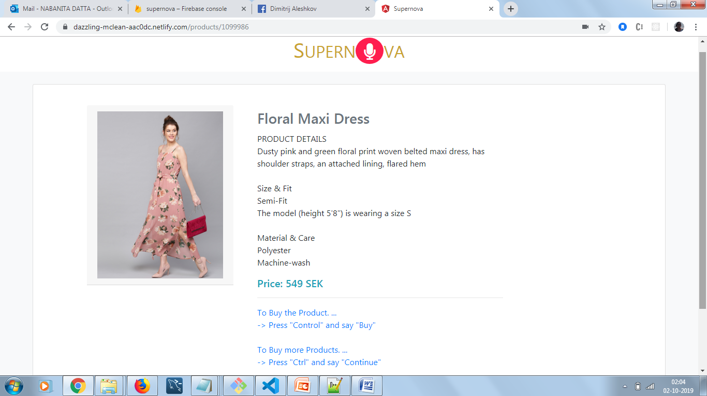

**Shopping cart page:** Shopping items will be stored in this page. Audio navigation is established to navigate the site to Check Out Page.

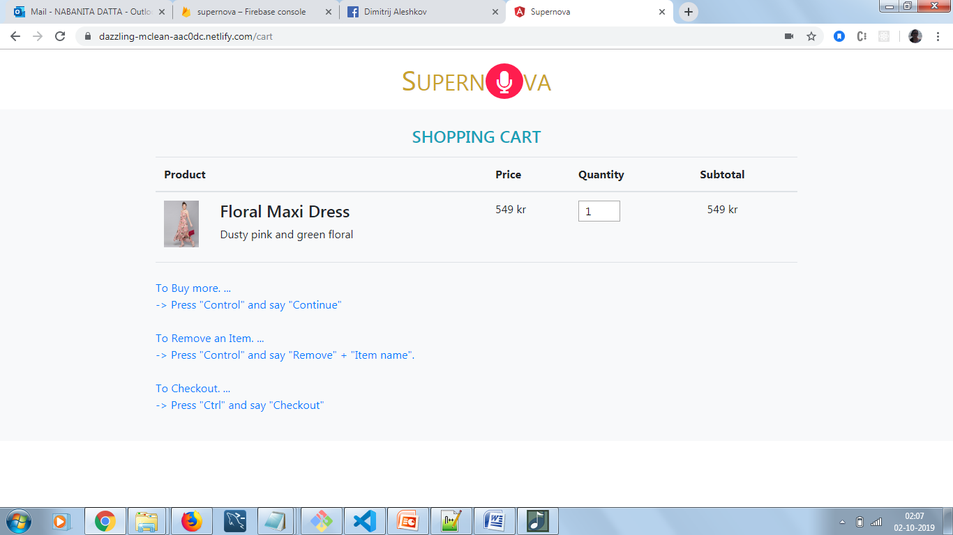

**Registration page:** This page is used to register a particular user. Audio navigation is established to navigate the site to Checkout Page.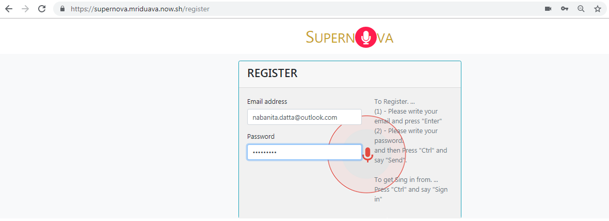

**Sign In page:** This page is used to Sign in a particular user. Audio navigation is established to navigate the site to Check Out Page.

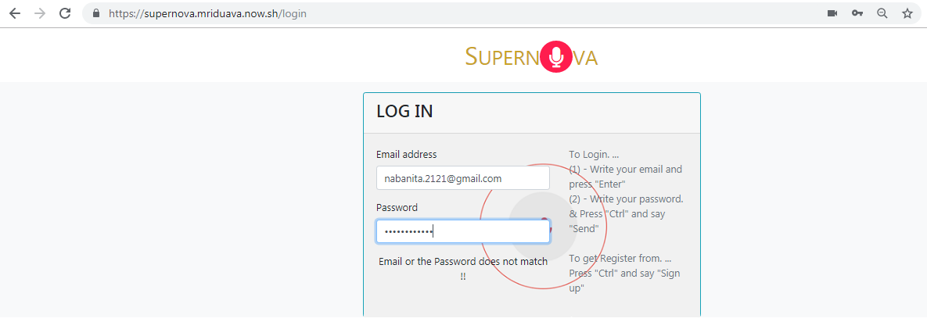

**Checkout page: This** page is used for shipping for a particular address.

