Prepare rules for the all the data sets

1) Try different values of support and confidence. Observe the change in number of rules for different support, confidence values

2) Change the minimum length in apriori algorithm

3) Visualize the obtained rules using different plots

1.) Book Datasets

The datasets consist of 11 books and the datasets is in binary format.

So need to convert in transaction format.

book_trans <- as(as.matrix(book), "transactions")

book_rules <- apriori(book_trans,parameter = list(support = 0.002, confidence=0.5))

Total no. of rules generated = 6288

There are duplicates rules also

After removing those rules,

Total No. of rules = 553

Based on the lift ratio, rules are sorted (descending)

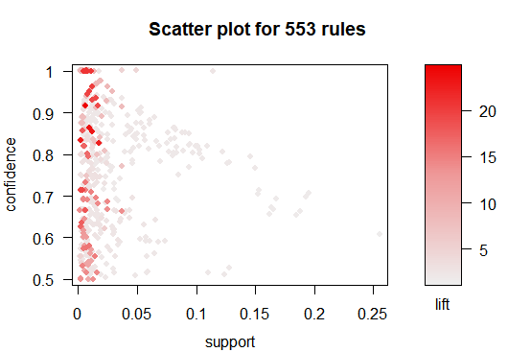

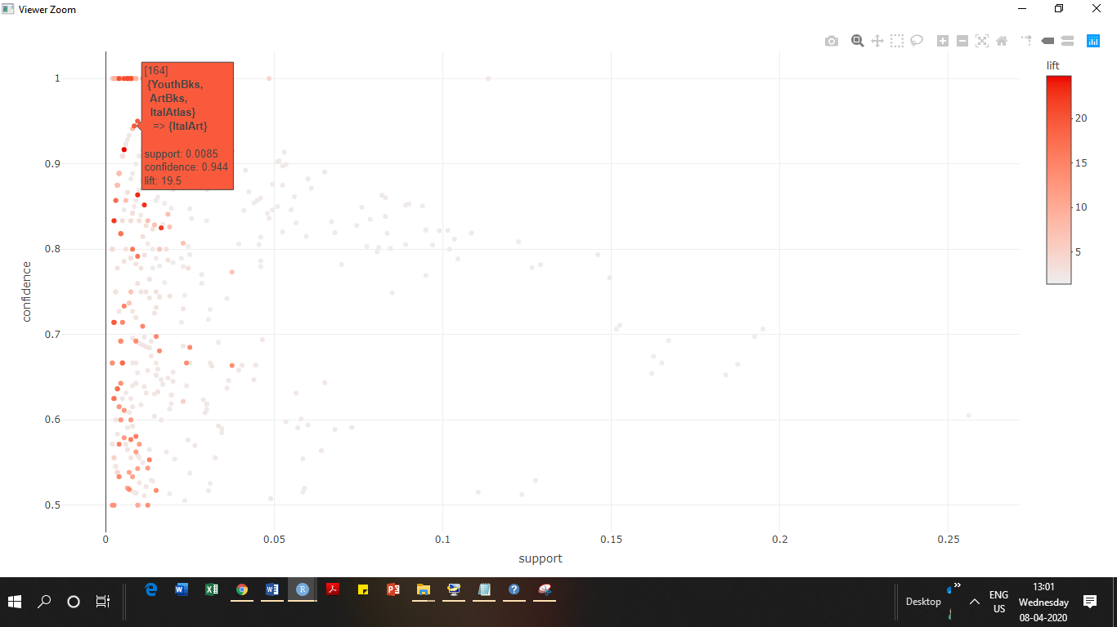

2.) Groceries Datasets

The datasets consist of four different classes of food products with various combination of food products and the datasets is in transaction format

After applying apriori algorithm

Total no. of rules generated = 477

There are duplicates rules also

After removing those rules,

Total No. of rules = 317

Based on the lift ratio, rules are sorted (descending)

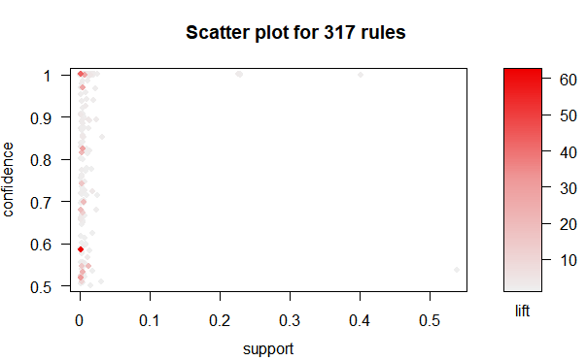

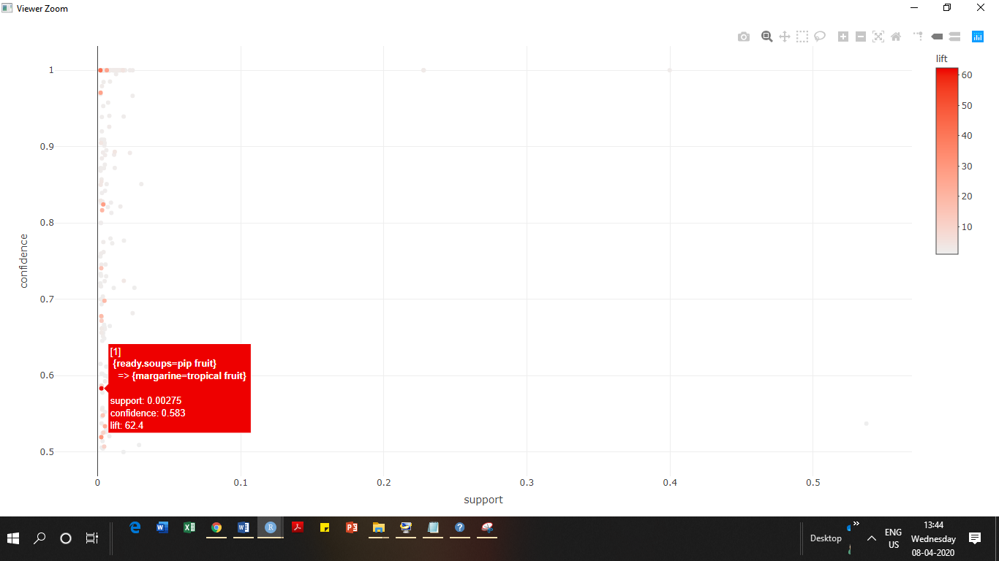

3.) Groceries Datasets

The datasets consist of five different classes of movies with various of combination of movies and the datasets is in transaction format as well as the binary format.

Removed the columns consists of binary data and considered only product transaction data

After applying apriori algorithm

Total no. of rules generated = 84

There are duplicates rules also

After removing those rules,

Total No. of rules = 34

Based on the lift ratio, rules are sorted (descending)

