1. Forecast the Coca Cola prices and Airlines Passengers data set. Prepare a document for each model explaining how many dummy variables you have created and RMSE value for each model. Finally which model you will use for Forecasting.

Solution:-

# Coca Cola

**Business Problem:** To build a model to forecast Coca Cola prices

**Datasets:**

Cocacola_Sales_Rawdata.xlsx data set is imported.

There are 42 observations of two variables (Quarter, Sales). There are four quarters Q1, Q2, Q3 & Q4

**EDA:**

**Graphical representation**

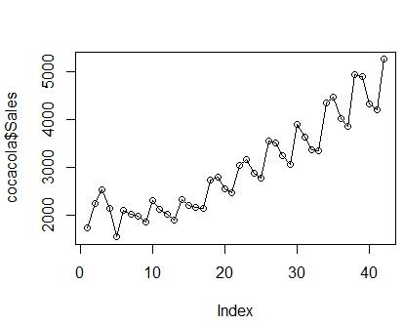

Creating 4 dummy variables.

Q1, Q2, Q3 and Q4

cocacola<-cbind(cocacola, Q1,Q2,Q3,Q4)

cocacola["t"] <- c(1:42)

cocacola["log_sales"] <- log(cocacola["Sales"])

cocacola["t_square"] <- cocacola["t"]*cocacola["t"]

**Summary**

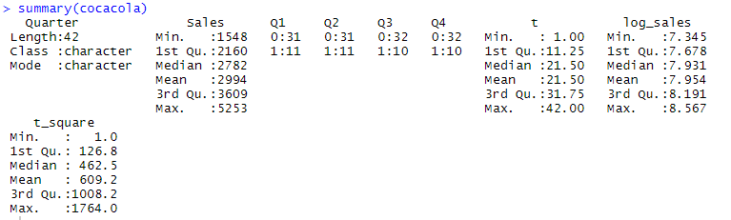

**Data Partitioning**

train <- cocacola[1:38,]

test <- cocacola[39:42,] --- It will contain one cycle data , Q1, Q2, Q3 and Q4.

**Building Model:**

**1. Linear Model (Linear Trend)**

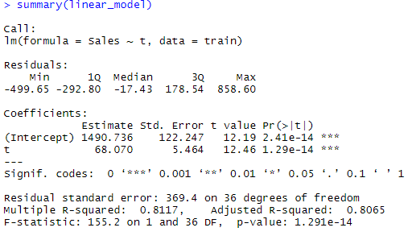

**RMSE = 591.553**

**2. Exponential Model (Exponential Trend)**

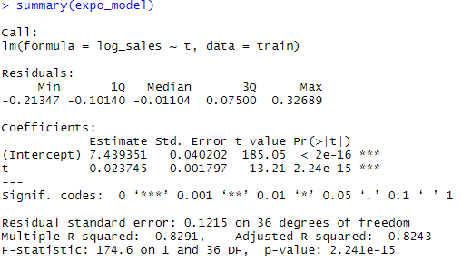

**RMSE = 466.248**

**3. Quadratic Model (Quadratic Trend)**

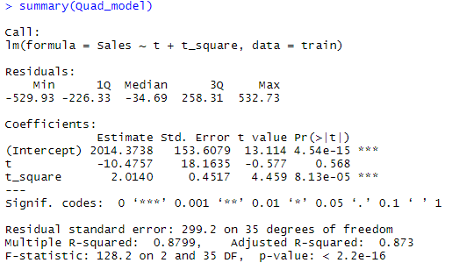

**RMSE = 475.5618**

**4. Additive Seasonality Model (Linear)**

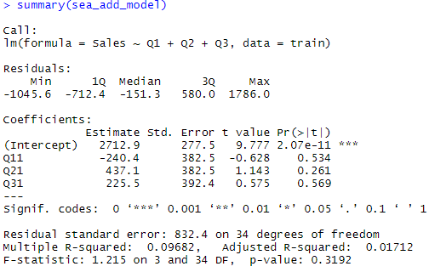

**RMSE = 1860.024**

**5. Additive Seasonality with Quadratic Trend**

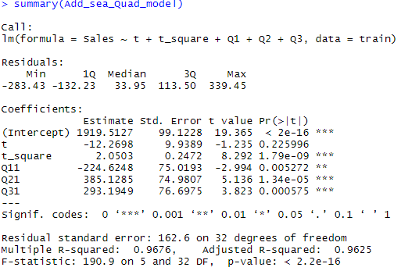

**RMSE = 301.738**

**6. Multiplicative Seasonality**

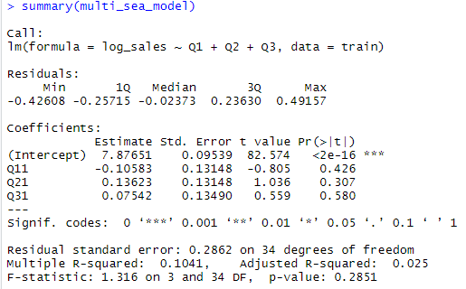

**RMSE = 1963.39**

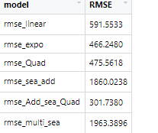

Lesser the RMSE model, better the model is.

So here Additive Seasonality With Quadratic trend has least RMSE value.

So here final model is build Additive Seasonality With Quadratic trend combining train and test data.

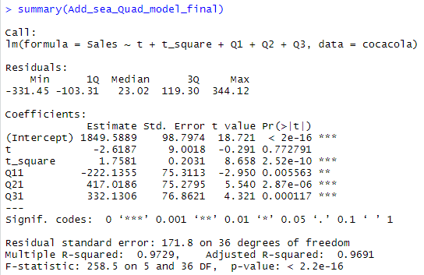

new_model_fin <- Add_sea_Quad_model_final$fitted.values

Quarter <- as.data.frame(cocacola$Quarter)

Final <- as.data.frame(cbind(Quarter,cocacola$Sales,new_model_fin))

colnames(Final) <-c("Quarter","Sales","New_Pred_Value")

**Visualization**

**Actual Sales Vs Quarter**

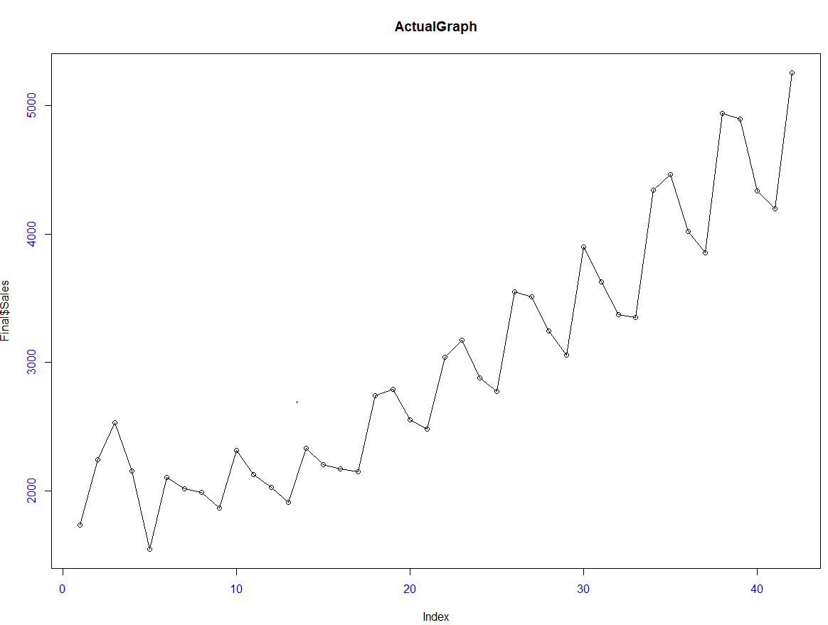

**Predicted Sales Vs Quarter**

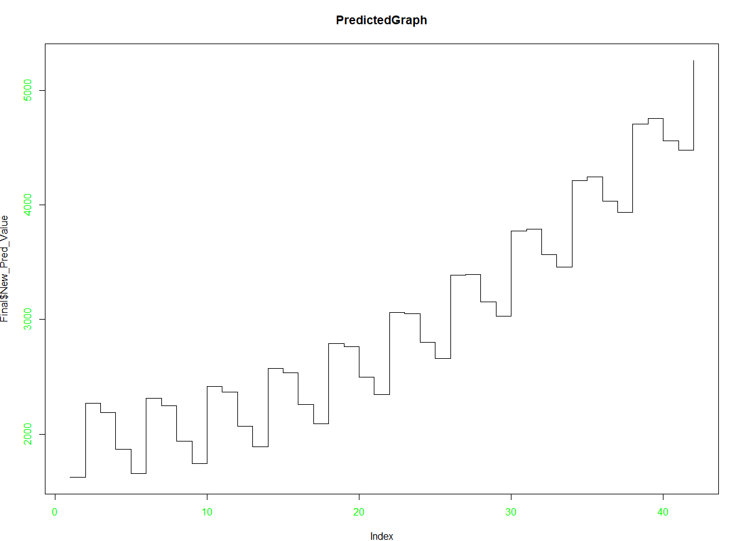

**# For Airlines**

**Business Problem:** To predict a model to forecast airlines passengers.

**Datasets:** Airlines+Data.xlsx is imported.

There are 96 observations with two variables (“Month”, Passengers)

**EDA:**

**Graphical representation**

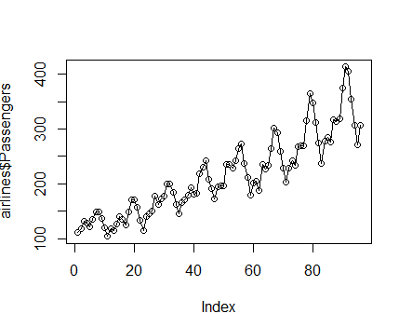

Creating 12 dummy variables.

Jan, Feb, Mar, Apr, May, Jun, Jul, Aug, Sep, Oct, Nov, Dec

X <- data.frame(outer(rep(month.abb,length = 96), month.abb,"==") + 0

colnames(X) <- month.abb

airlines_passengers <- cbind(airlines,X)

airlines_passengers["t"] <- c(1:96)

airlines_passengers["log_passengers"] <- log(airlines_passengers["Passengers"])

airlines_passengers["t_square"] <- airlines_passengers["t"]*airlines_passengers["t"]

**Summary**

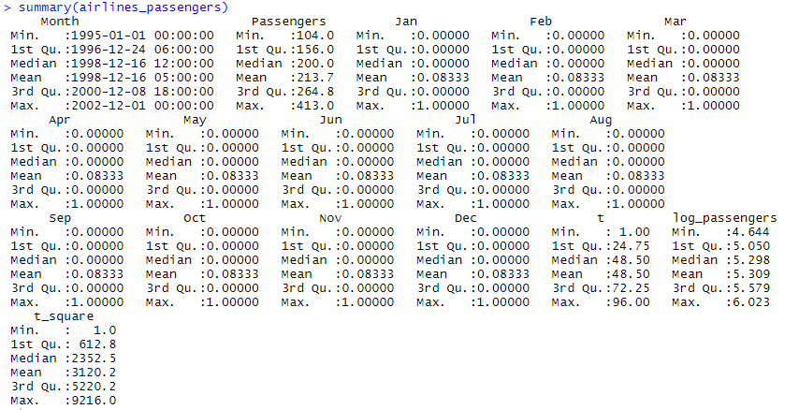

**Data Partitioning**

train <- airlines_passengers[1:84,]

test <- airlines_passengers[85:96,]--- It will contain one cycle data , Q1, Q2, Q3 and Q4.

**Building Model:**

**1. Linear Model (Linear trend)**

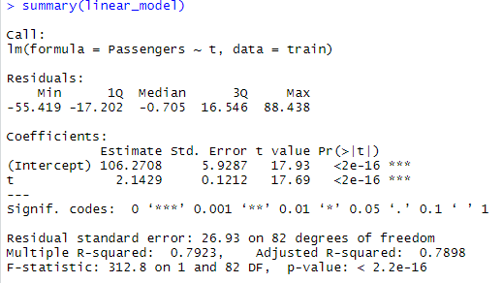

**RMSE = 53.19924**

**2. Exponential Model (exponential trend)**

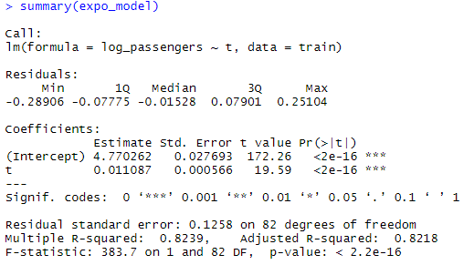

**RMSE =46.05736**

**3. Quadratic Model (quadratic trend)**

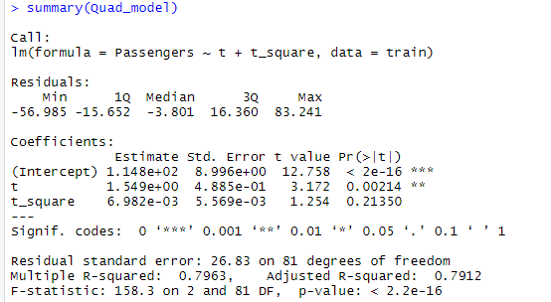

**RMSE = 48.05189**

**4. Additive Seasonality Model (linear trend)**

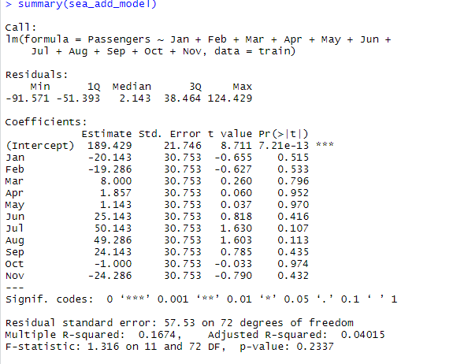

**RMSE = 132.898**

**5. Additive Seasonality with Quadratic Trend (Quadratic Trend)**

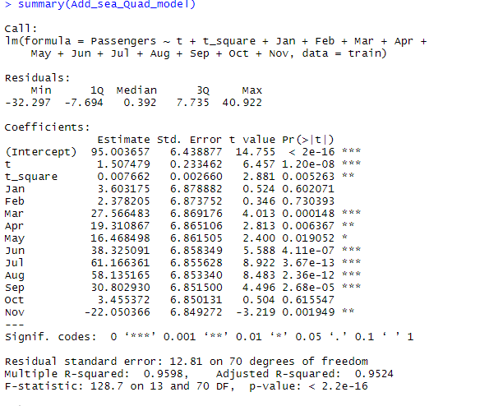

**RMSE = 26.36082**

**6. Multiplicative Seasonality**

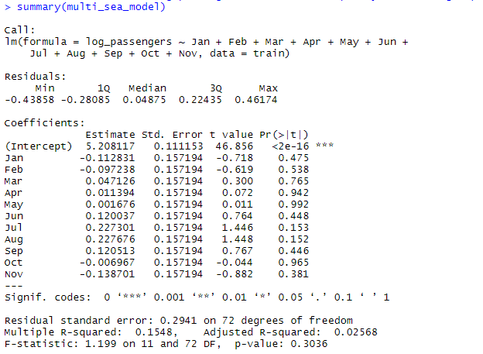

**RMSE = 140.0632**

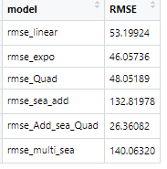

Lesser the RMSE model, better the model is.

So here Additive Seasonality With Quadratic Trend model has least RMSE value.

So here final model is build Additive Seasonality With Quadratic Trend combining train and test data.

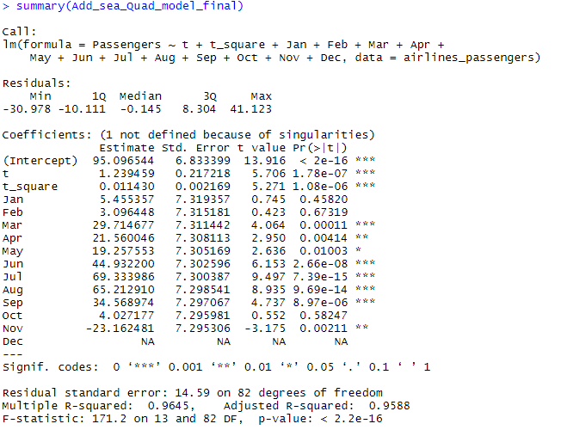

new_model_fin <- Add_sea_Quad_model_final$fitted.values

Month <- as.data.frame(airlines_passengers$Month)

Final <- as.data.frame(cbind(Month,Passengers,new_model_fin))

colnames(Final) <-c("Month","Passengers","New_Pred_Value")

**Visualization**

**Actual Passengers Vs Month**

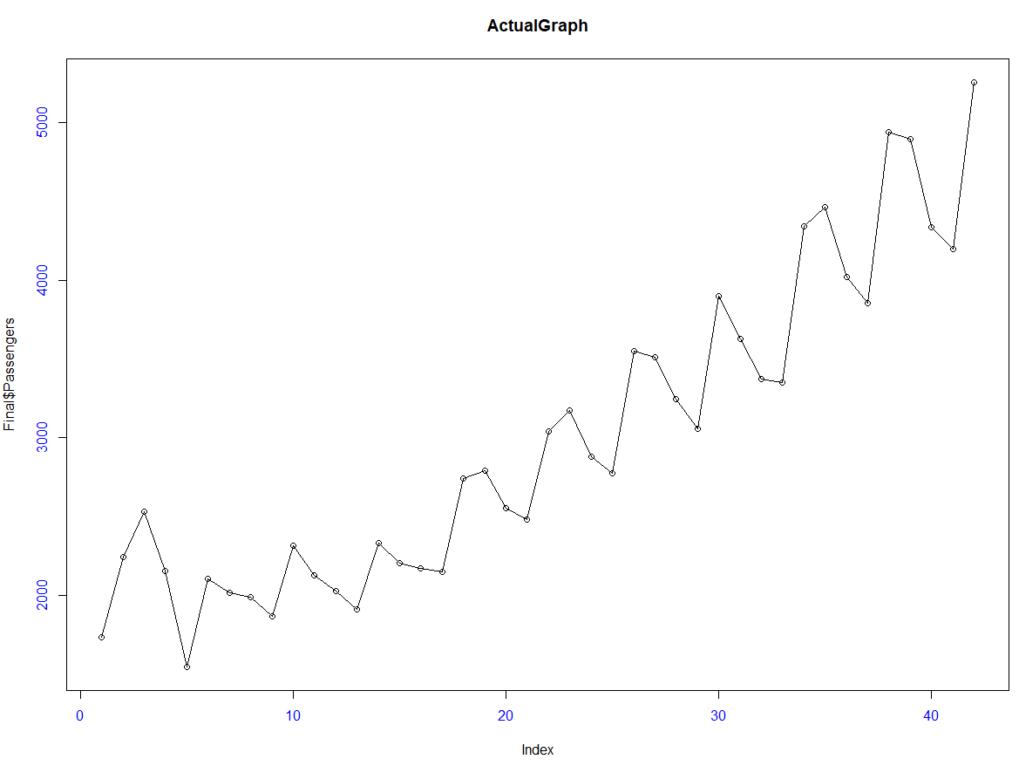

**Predicted Passengers Vs Month**

