**Data Driven Models and Smoothing Techniques.**

**Business Problem:**

To build a model to forecast plastic sales

**Datasets:**

PlasticSales.csv data set is imported.

There are 60 observations of two variables(Month, Sales). There are 12 months.

**EDA:**

**Graphical representation**

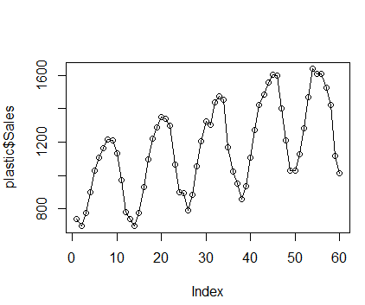

**Converting the data into time series data**

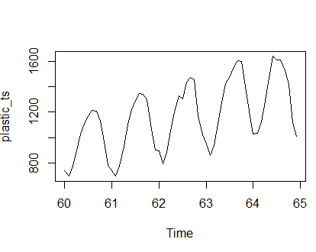

The above plots is showing linear trend and additive seasonality.

**Data Partitioning**

plastic_train<-plastic_ts[1:48]

plastic_test<-plastic_ts[49:60]--- It will contain one year data

plastic_train<-ts(plastic_train,frequency = 12)

plastic_test<-ts(plastic_test,frequency = 12))

**Building Model:**

**1. Moving average model**

plastic_sales_ma <- ma(plastic_ts,order= 12, centre = TRUE)

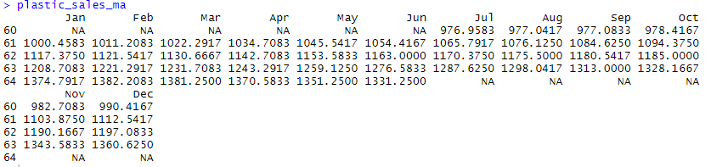

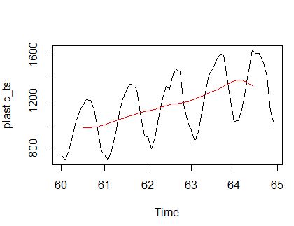

The above plot compare the moving average to the actual time series data. It smoothed out the seasonality but captured the overall trend.

**2. Exponential Smoothing technique**

**1. Simple Exponential Smoothing Technique**

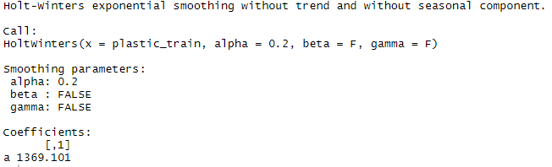

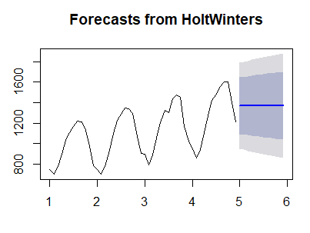

**Predicted for 12 months**

**MAPE =** 18.18196

**2. Double Exponential Model**

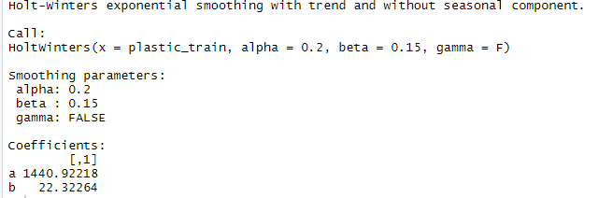

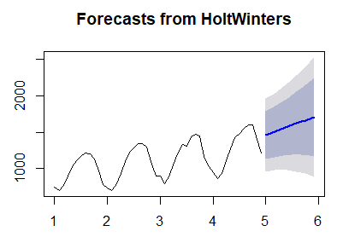

**MAPE =** 24.51507

**3. Winters Methood**

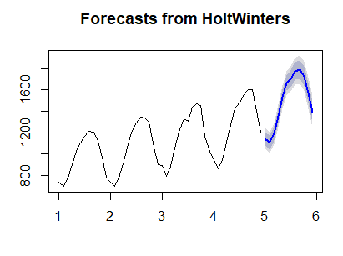

**MAPE =** 14.05325

Here the forecasted value is following the trend of historical data

**4. Without giving any optimum value for Alpha. Beta and Gamma is FALSE**

Best Alpha value will be automatically chosen by R

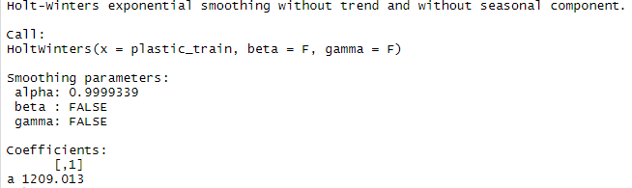

Here alpha value taken by R is 0.9999339

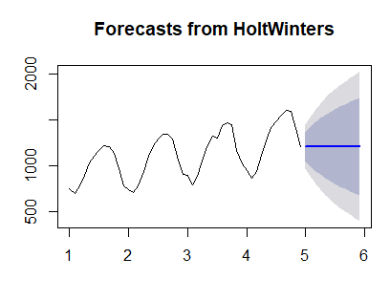

**MAPE =** 17.04152

**5. Without giving any optimum value for Alpha and Beta. Gamma is FALSE**

Best Alpha and best Beta value will be chosen by R

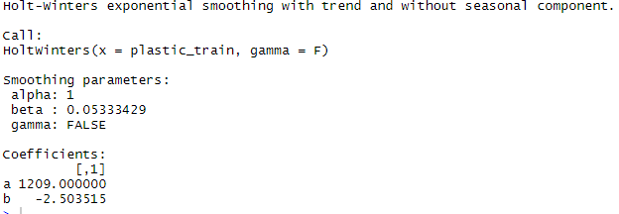

**Alpha = 1, Beta= 0.05333429**

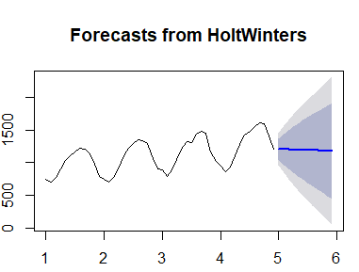

**MAPE =** 17.14974

6. **Without giving any optimum value for Alpha, Beta and Gamma**

Best Alpha, best Beta and best Gamma value will be chosen by R

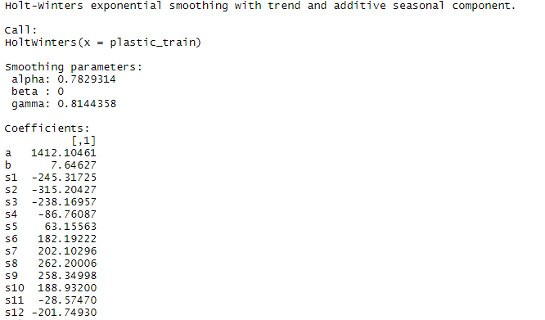

**Alpha= 0.7829314, Beta = 0, Gamma= 0.8144358**

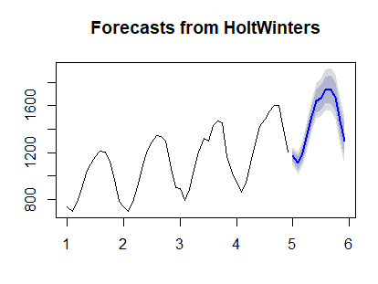

**MAPE** **= 11.66716**

**The following table summarizes the MAPE value as per different smoothing techniques.**

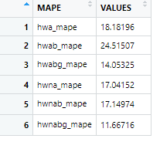

Lesser the MAPE value, better is the model

So here winter’s model with no optimum value for alpha beta and gamma model has least MAPE value. So it is considered as best model. Moreover the forecasted value is showing the trend of historical data.

So here final model is build on Winter’s model with no optimum value for alpha beta and gamma for overall plastic sales data.

**New Model**

new_model <- HoltWinters(plastic_ts)

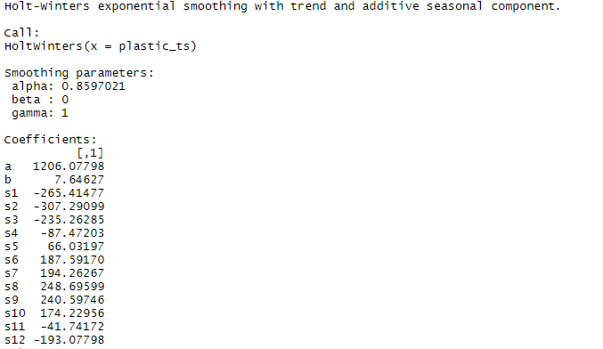

**Here Alpha = 0.8597021, Beta= 0, Gamma= 1**

plot(forecast(new_model,n.ahead=12)) 