1.) Problem statement.

Recommend a best book based on the author, publisher and ratings.

Solution: -

**Business Problem:** To recommend a best book based on the ratings.

**Datasets:** Books.csv is imported

Dependent variable: Book.Title

Independent variable: User.ID, Book.Rating

**EDA:**

**Summary**

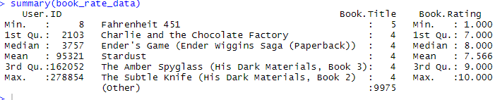

# Rating Distribution

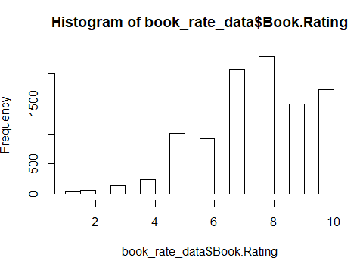

In order to build recommendation system the datatype should be real rating matrix

book_rate_data_matrix <- as(book_rate_data,'realRatingMatrix')



**Model building:**

**1. Popular Model :**

**book_recomend_model_popular <- Recommender(book_rate_data_matrix, method='POPULAR')**

The recommended books given by this model will be common for all users.

Here 5 same books are recommended for All users

1."In the Beauty of the Lilies"

2."Black House"

3. "White Oleander : A Novel"

4. “The Magician's Tale"

5. "Nowle's Passing: A Novel"