1.) Perform Clustering for the crime data and identify the number of clusters formed and draw inferences.

Data Description:
Murder -- Muder rates in different places of United States
Assualt- Assualt rate in different places of United States
UrbanPop - urban population in different places of United States
Rape - Rape rate in different places of United States

Solution:-
Business Problem:- To perform clustering for the crime data and identify the number of clusters formed and draw inferences.
Datasets:- crime_data.csv
Variables :- X – State names
Murder -- Muder rates in different places of United States
Assualt- Assualt rate in different places of United States
UrbanPop - urban population in different places of United States
Rape - Rape rate in different places of United States
EDA:-
Summary :-

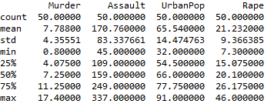
Normalization : - To make the data unit free and scale free.
Summary of Normalized Data
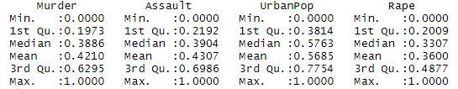

Clustering
Scree plot/ Elbow Curve

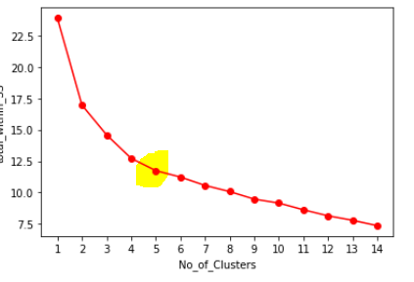

Now from the elbow chart it can be interpreted that k =5, is required no. of clusters
After applying k-means for, k=5
Labels
4, 0, 0, 3, 0, 0, 2, 3, 0, 4, 2, 1, 0, 3, 1, 3, 3, 4, 1, 0, 2, 0, 1, 4, 3, 3, 3, 0, 1, 2, 0, 0, 4, 1, 2, 3, 3, 2, 2, 4, 1, 4, 0, 2, 1, 3, 2, 1, 1, 3
The following are the 5 clusters

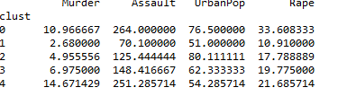
Interpretation

Now the states belong to cluster 5 is the highest in murder cases ,
compared to others states
Rape cases are more in the states of cluster 1
Urban population is more in 3rd clusters and less in 2nd clusters.

2.) Perform clustering (Both hierarchical and K means clustering) for the airlines data to
obtain optimum number of clusters.

Business Problem: To perform clustering
Datasets: EastWestAirlines.xlsx
EDA:
Summary
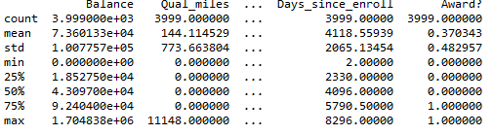
Normalization
Summary of normalized data
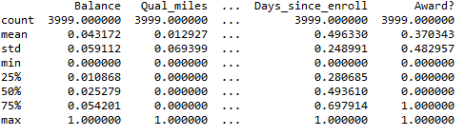

Hierarchical Clustering

Dendogram for 4000 data points
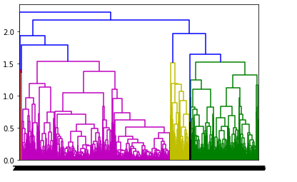

Divided into five cluters
Agglomerative Clusters
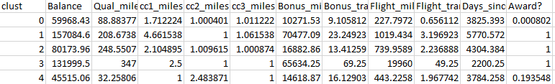

K-Means
Elbow Curve/ Scree Plot

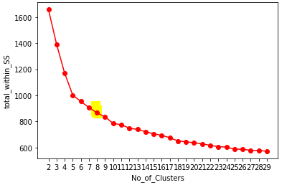
This chart shows 7 no. of clusters

The plot represents the seven clusters
Aggregation

