1.) Build a Neural Network model for 50_startups data to predict profit
Solution:
Business Objective: To prepare a model to predict profit of startups
Datasets:
Dependent variable: Profit (Continous)
Independent variable: R.D.Spend (Continous), Administration (Continous), Marketing.Spend (Continous), State (Categorical)

EDA:
Data information
<class 'pandas.core.frame.DataFrame'>
RangeIndex: 50 entries, 0 to 49
Data columns (total 5 columns):
# Column Non-Null Count Dtype
--- ------ -------------- -----
0 R&D Spend 50 non-null float64
1 Administration 50 non-null float64
2 Marketing Spend 50 non-null float64
3 State 50 non-null object
4 Profit 50 non-null float64
dtypes: float64(4), object(1)
memory usage: 2.1+ KB
(50, 5)

Summary

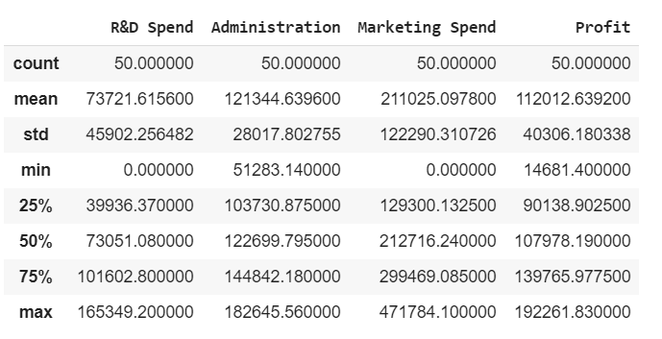

Graphical representation

For Administartion

Skewness = -0.47

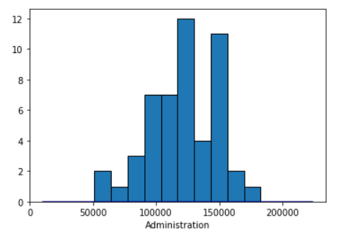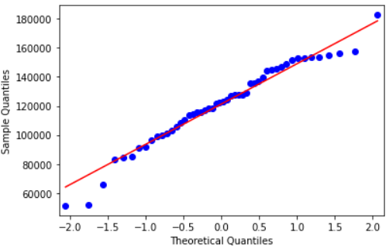

This is negatively skewed data and is not normally distributed. There is no outliers.

For R.DSpent

Skewness = 0.16

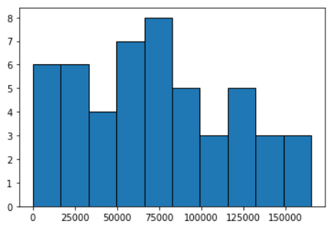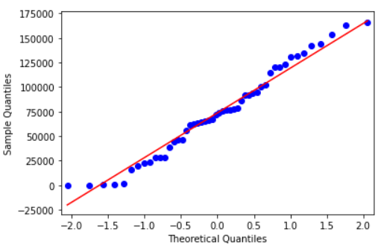

This is positively skewed data and is no normally distributed. There is no outliers.

For Marketing.Spend

Skewness = -0.045

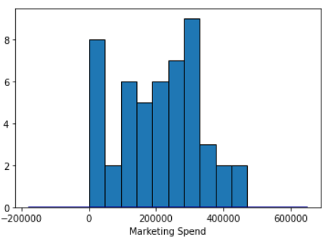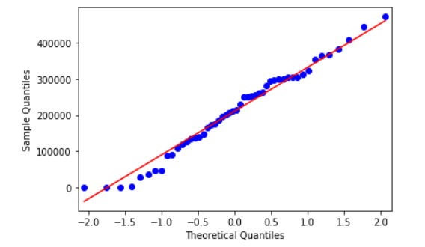

This is negatively skewed data and is not normally distributed. There is no outliers.

For Profit
Skewness = 0.02

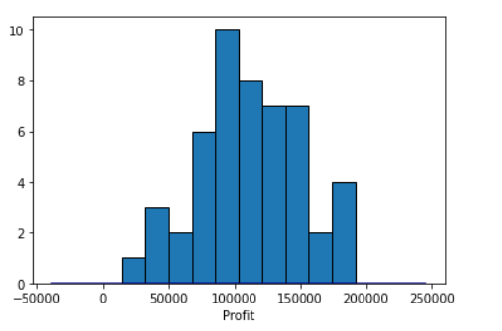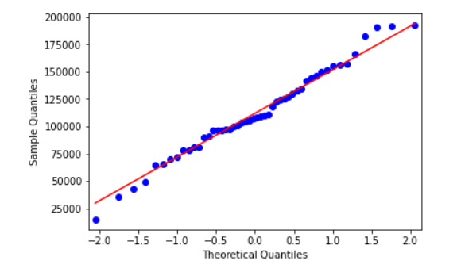

This is positively skewed data and is not normally distributed. There is no outlier.

For States

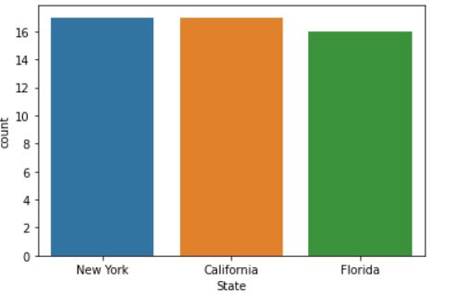
California= 17
Florida = 16
New York =17

Association between continuous variables
Correlation between profit and other variables (Administration, R.D Spend,
Marketing Spend, States)
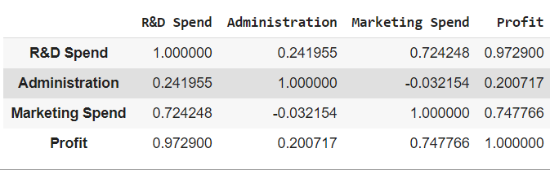

Correlation coefficient – strength and direction of correlation

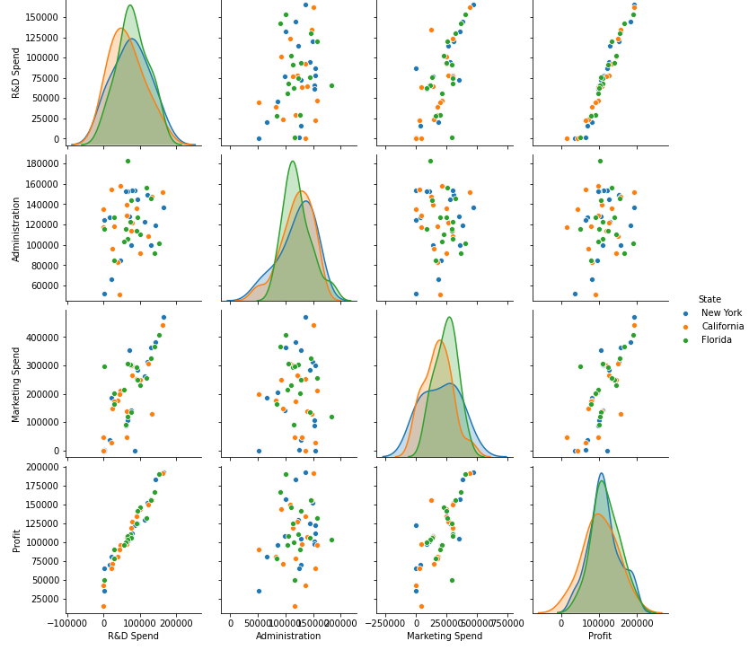

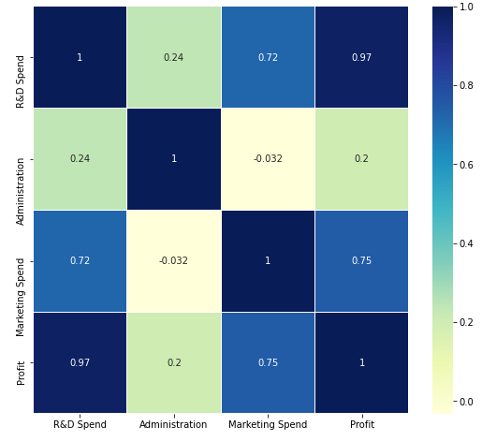

The above plot represents heatmap. The darker colour indicates high correlation. The light
colour indicates less correlation among the variables. The co-relation between profit and R&D speed is high with 0.97. The co-relation between profit and Marketing spend is moderate.
We can also see there is moderate co-relation between Marketing spend and profit

From the summary above, it can be said that the data of different variables is on different
scale so need to normalize the data

Association between categorical and continuous output variable

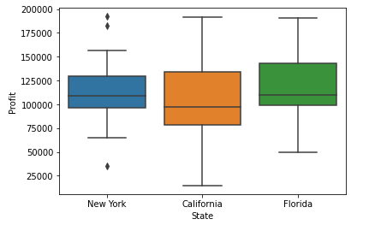
The above plot represents the box plot for different states along profit.
We can observe that there is some outlier in case of New York.

Anova Test
Summary of Anova test

sum_sq df F PR(>F)
State 1.900582e+09 2.0 0.574791 0.566729
Residual 7.770424e+10 47.0 NaN NaN

Here P-value > 0.566729 then fail to reject null hypothesis.
Can be concluded that State is not so significant for profit.

Missing value
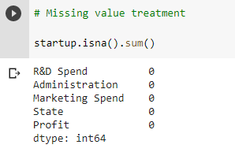

There is no missing value in our dataset

Label Encoding

Normalization

Summary of Normalized data
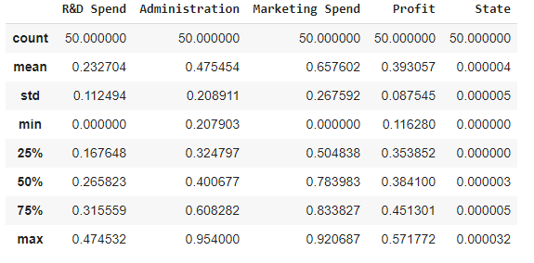

From the above summary, it can be said that the data of all the variables have same
common scale from 0 to 1.

Data Partitioning
Here our data is portioned into train test data by random split using 7:3 ratio.

Model Building:

Building a neural network model on training data using two hidden neuron layers

- Architecture of neural network model
- # Defining the input layers

- # number of input nurons = 4 since four input features
- input_neurons = x_train.shape[1]
- input_neurons

# Defining the output layers

output_neurons=1
# Defining hidden layers
no_hidden_layers=2
no_neurons_hl1= 10
no_neurons_hl2= 5

# Defining the architecture of the model
model = Sequential()
model.add(InputLayer(input_shape =(input_neurons,))) # input
model.add(Dense(units=no_neurons_hl1,kernel_initializer='normal', activation="relu")) # hidden layer1
model.add(Dense(units=no_neurons_hl2, kernel_initializer='normal',activation="relu")) # hidden layer2
model.add(Dense(units=output_neurons,kernel_initializer='normal'))
# output

Summary
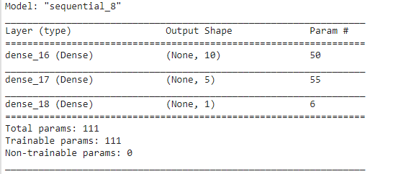
# Compiling the model
model.compile(loss="mean_squared_error", optimizer="adam",metrics=["mse"])

# Training the model
model_history = model.fit(x_train,y_train,validation_data=(x_test,y_test),epochs=30)

Model Evaluation
rmse = 0.06643958994269072

Visualization of Model

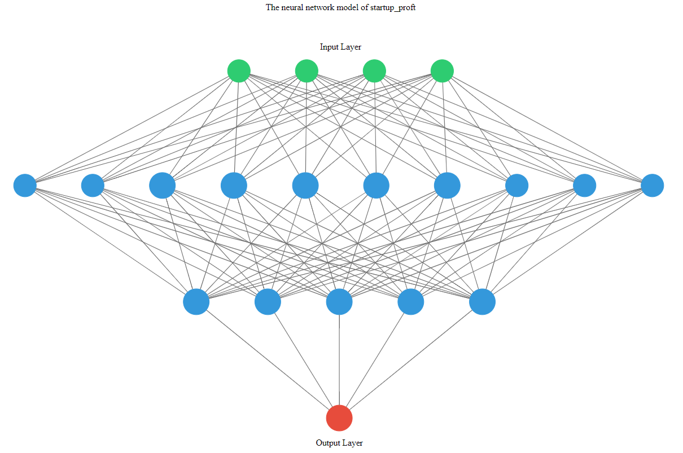

2.) PREDICT THE BURNED AREA OF FOREST FIRES WITH NEURAL NETWORKS
Solution:

Business Problem: To prepare a model to predict the burned area
Datasets:
Independent Variable: month, day, FFMC, DMC, DC, ISI, temp, RH, wind, rain, area,
Dependent Variable: size_category
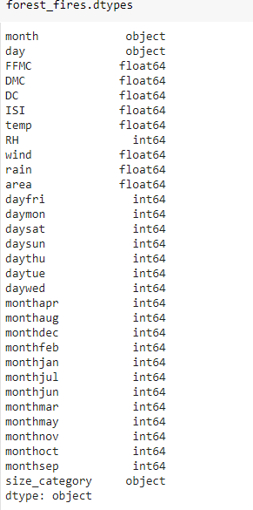
EDA:
Summary

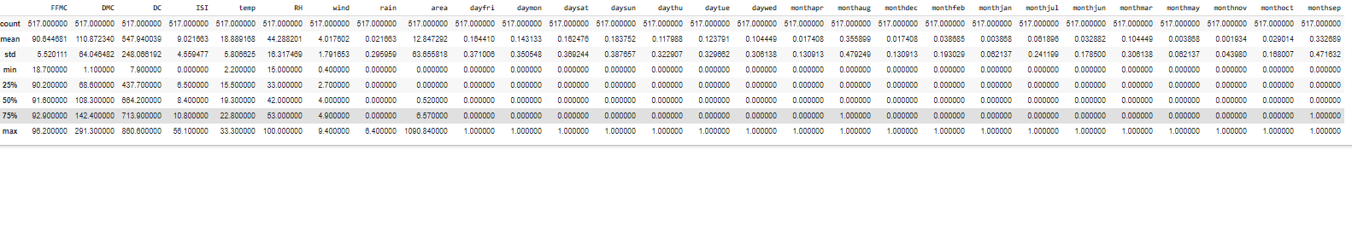
Co realation matrix

The output variable (size_category) is converted to numeric from factor
Large is encoded as 1 and small as 0.
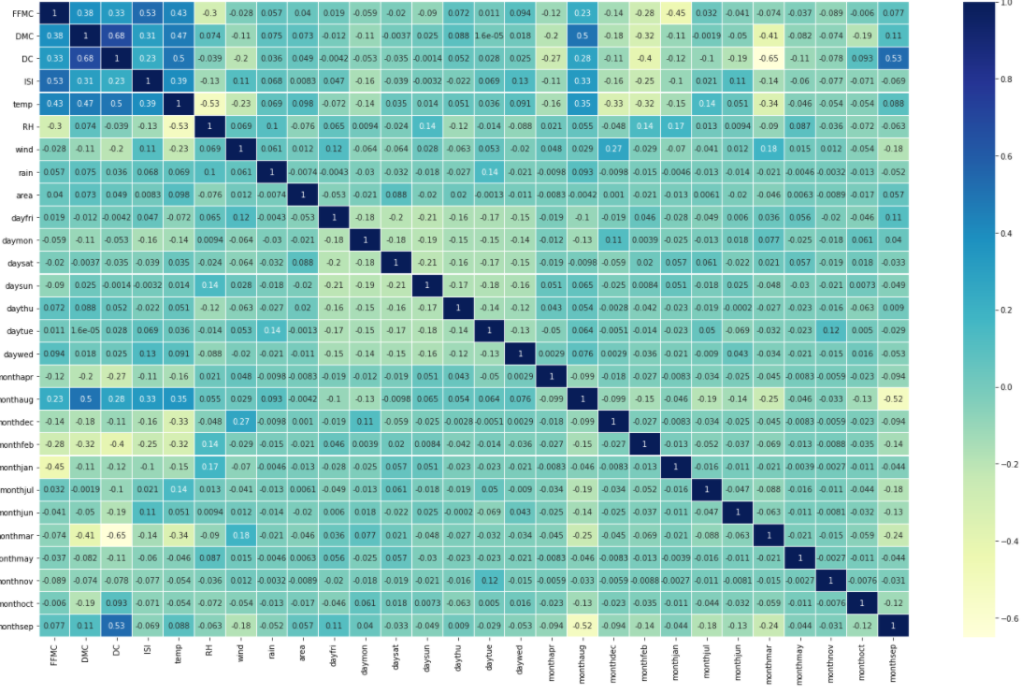

Label encoded
The output variable (size_category) is converted to numeric from factor
Large is encoded as 1 and small as 0.

Missing Value treatment
There is no missing value

Normalization
Since data is not having similar scale and unit we have to normalize the data.
The following is the summary of all normalized numerical variables

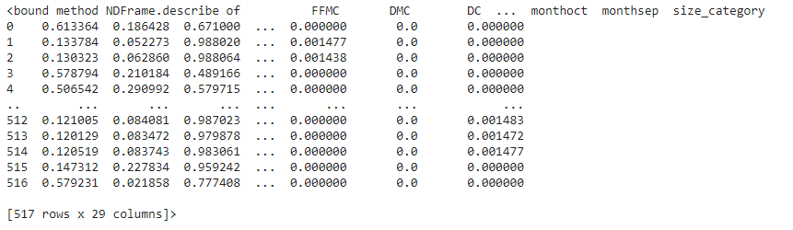
From the above summary, it can be said that the data of all the variables have same
common scale and units and data value ranges from 0 to 1.

Data Partitioning:

The normalized forest_fire data is divided into two sets of train and test by 7: 3 ratio.

Model Building:
Building a neural network model on training data using single hidden neuron
Summary
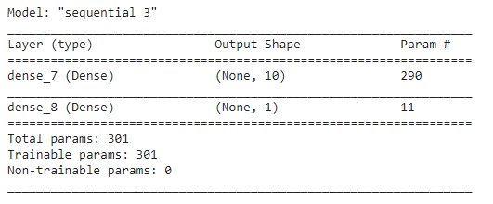

Visualiztion

