1.) Implement a KNN model to classify the animals in to categories

**Business problem**: To classify the animals into categories.

**Data set** : Import zoo.csv dataset

**EDA:**

Summary :

The following is the summary of zoo data set.

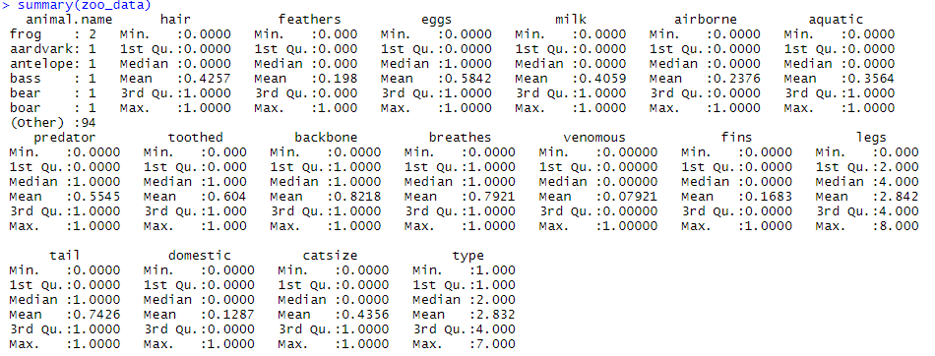

I will classify the animals based on the variable domestic And assigned labels like 0= Wild Animal & 1 = Domestic Animal and converted the domestic variable into factor

Normalization: - Leaving the variables domestic and animal.name other numerical variables are normalized with the help of custom function

Partitioning the data sets: From caret package, using createDataPartition function data is divided into train and test datasets in 70:30 ratio.

**Building Model:**

Using KNN alogorithm

zoo_pred <- knn(train = zoo_data_train, test = zoo_data_test, cl = zoo_data_train_labels, k=i)

We will train our model with train data to predict test data

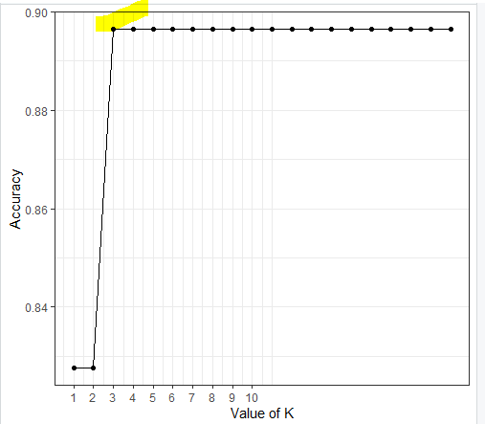

The above graph, is the plot between different values of k and accuracy at different models with the changing values of k

It is observed the maximum value is observed at k=3, So a final model is prepared at k= 3

zoo_data_pred <- knn(train = zoo_data_train, test = zoo_data_test, cl = zoo_data_train_labels, k=3)

Cross tabulation of actual and predicted

| zoo_data_test_labels

zoo_data_pred | Wild Animal | Domestic Animal | Row Total |

--------------|-----------------|-----------------|-----------------|

Wild Animal | 26 | 3 | 29 |

| 0.897 | 0.103 | |

--------------|-----------------|-----------------|-----------------|

Column Total | 26 | 3 | 29 |

--------------|-----------------|-----------------|-----------------|

Confusion Matrix

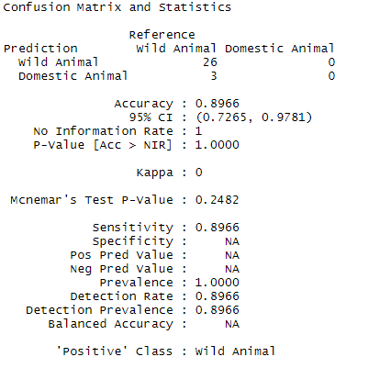

Train Accuracy = 89.65517 %

Error= 10.344 %

2.) Prepare a model for glass classification using KNN

**Business problem**: To classify the glass into different categories and build a model to identify the category of glass.

**Data set** : Import glass.csv dataset

**EDA:**

Summary :

The following is the summary of glass data set.

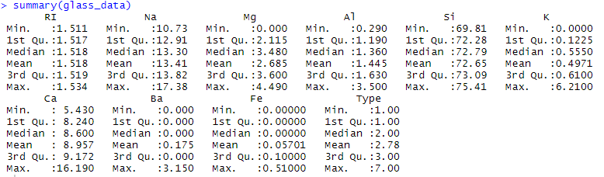

I will classify the glass based on the variable Types And assigned labels like

1 -- building_windows_float_processed

2 --building_windows_non_float_processed

3 --vehicle_windows_float_processed

4 --vehicle_windows_non_float_processed (none in this database)

5 --containers

6 --tableware

7 --headlamps

Normalization: - Leaving the variables Type, other numerical variables are normalized with the help of custom function

Partitioning the data sets: From caret package, using createDataPartition function data is divided into train and test datasets in 70:30 ratio.

**Building Model:**

Using KNN alogorithm

glass_pred <- knn(train = glass_train, test = glass_test, cl = glass_train_labels,k=i)

We will train our model with train data to predict test data

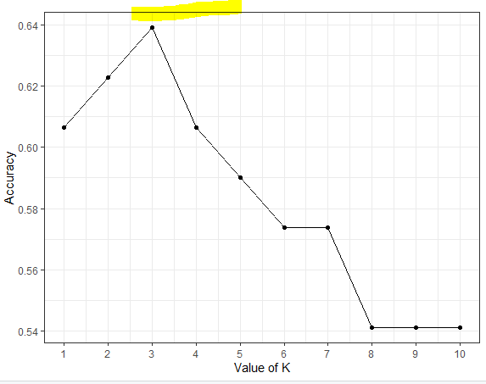

The above graph, is the plot between different values of k and accuracy at different models with the changing values of k

It is observed the maximum value is observed at k=3, So a final model is prepared at k= 3

glass_data_pred <- knn(train = glass_train, test = glass_test, cl = glass_train_labels, k=3)

Confusion Matrix

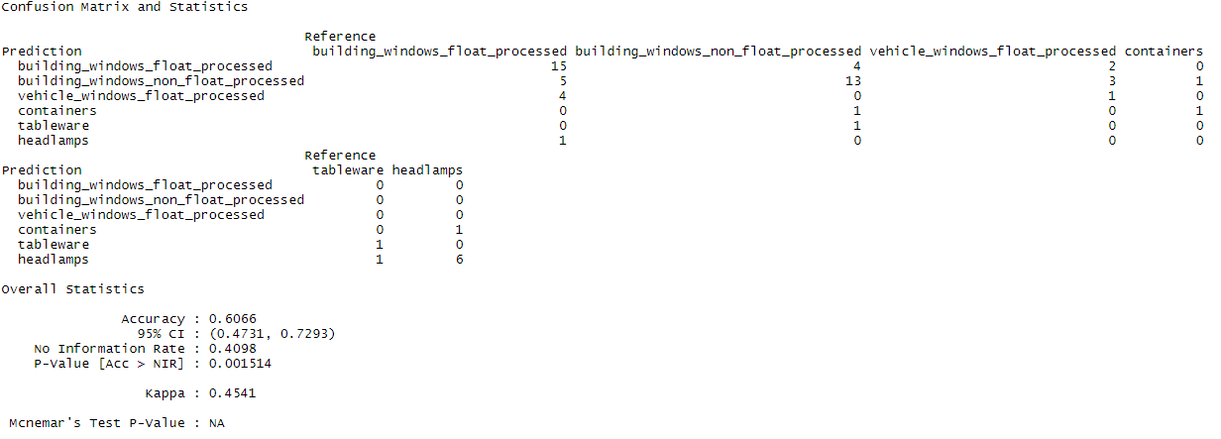

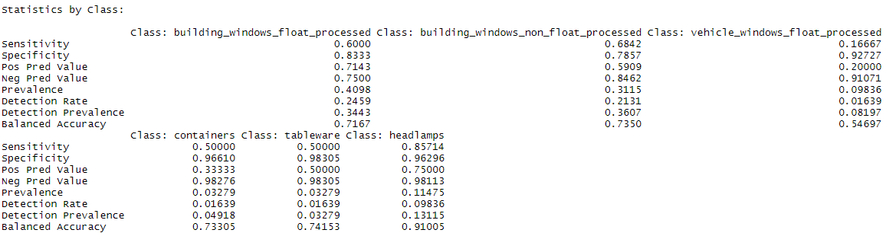

Train Accuracy = 63.93 %

Error = 36.05 %