**Background Study**

In every IT company, there is help or service desk unit which provides the facilities to raise ticket if any technical or non-technical issues occurs or incident take place during day to day operations of the organization. The issues can be impacting a single person, a team, a department or the entire organization. By raising ticket, the user can take assistance from the help desk and the help desk representatives in turn solve the issues depending on the level of priority of the incident.

Now the priority depends on the two things,

1. Impact
2. Urgency
3. **Impact**: - A measure of the effect of an Incident on organizational processes. It measures the number of clients potentially affected by an Incident.

It is categorized into following types:

|  |  |  |
| --- | --- | --- |
| **Sl No.** | **Impact** | **Description** |
| 1. | High | * A large number of staff are affected and/or not able to do their job. * A large number of customers are affected and/or acutely disadvantaged in some way. * The financial impact of the Incident is (for example) likely to exceed $10,000. * The damage to the reputation of the business is likely to be high. * Someone has been injured. |
| 2. | Medium | * A moderate number of staff are affected and/or not able to do their job properly. * A moderate number of customers are affected and/or inconvenienced in some way. * The financial impact of the Incident is (for example) likely to exceed $1,000 but will not be more than $10,000. * The damage to the reputation of the business is likely to be moderate. |
| 3. | Low | * A minimal number of staff are affected and/or able to deliver an acceptable service but this requires extra effort. * A minimal number of customers are affected and/or inconvenienced but not in a significant way. * The financial impact of the Incident is (for example) likely to be less than $1,000. * The damage to the reputation of the business is likely to be minimal. |

2. **Urgency: -** It is measured by how quickly the incident needs to be resolved. It is a measure of how long it will be until an Incident has a significant Impact on the organization.

Eg:- A high Impact Incident may have low Urgency, if the Impact will not affect the organization until the end of the financial year.

High Incident causes immediate and significant disruption but not affecting life, safety, business transaction-critical and teaching-related services while in use.

Moderate Incident will cause disruption in the near term.

It is categorized in the following ways

|  |  |  |
| --- | --- | --- |
| **Sl. No** | **Urgency** | **Description** |
| 1. | High | * The damage caused by the Incident increases rapidly. * Work that cannot be completed by staff is highly time sensitive. * A minor Incident can be prevented from becoming a major Incident by acting immediately. * Several users with VIP status are affected. |
| 2. | Medium | * The damage caused by the Incident increases considerably over time. * A single user with VIP status is affected. |
| 3. | Low | * The damage caused by the Incident only marginally increases over time. * Work that cannot be completed by staff is not time sensitive. |

**Priority: -** It refers which task to solve first i.e., sequence of solving task

**Priority Matrix**

|  |  |  |  |  |
| --- | --- | --- | --- | --- |
| **Priority** | | **Impact** | | |
| **High** | **Medium** | **Low** |
| **Urgency** | **High** | Critical | High | Moderate |
| **Medium** | High | Moderate | Low |
| **Low** | Moderate | Low | Low |

1. Low-priority incidents are those that do not interrupt users or the business and can be worked around. Services to users and customers can be maintained.
2. Medium-priority incidents affect a few staff and interrupt work to some degree. Customers may be slightly affected or inconvenienced.
3. High-priority incidents affect a large number of users or customers, interrupt business, and affect service delivery. These incidents almost always have a financial impact.

**Ticket Processing Flow**

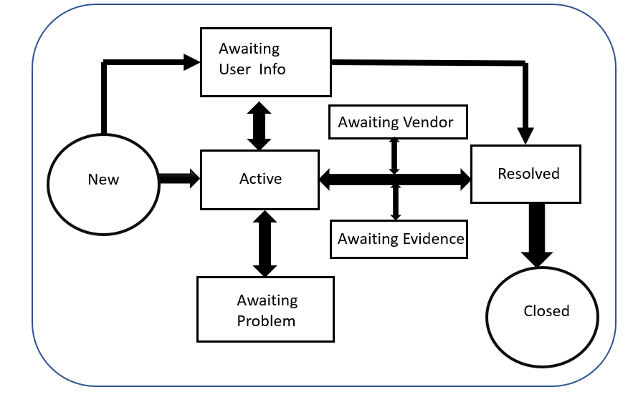

**Business Objective:**

To predict the impact of the incident raised by the customer

**Datasets Details:**

There are 141712 number of records and 25 columns

**Target or Dependent Variable:** Impact ----> High, Medium, Low

**Independent Variables:**

Categorical Variables:

|  |  |  |
| --- | --- | --- |
| Sl no. | Variables | Categories |
| 1. | ID | 24198 unique ID’s |
| 2. | ID_status | -100, Active, Awaiting Evidence, Awaiting user info , Awaiting Problem, Awaiting Vendor, Closed, New, Resolved |
| 3. | active | True, False |
| 4. | ID_caller | 5244 unique caller id’s |
| 5. | opened_by | 207 unique users |
| 6 | created_by | 185 unique identified |
| 7. | updated_by | 846 unique users who updated the tickets |
| 8. | type_contact | Direct opening, Email, IVR, Phone, Self service |
| 9. | location | 224 locations |
| 10 | category_ID | 58 different categories |
| 11. | user_symptom | 525 different user symptoms |
| 12. | Support_group | 78 different support groups |
| 13. | support_incharge | 234 unique support incharge |
| 14. | Doc_knowledge | True, False |
| 15. | confirmation_check | True, False |
| 16. | notify | Do Not Notify, Send Email |
| 17. | problem_id | There are 253 different problems |
| 18. | change request | 182, different change request |

Quantitative Variables:

1. Numerical Variables
2. count_reassign
3. count_opening
4. count_updated
5. Date/Time
6. Opened_time
7. Created_at
8. Updated_at

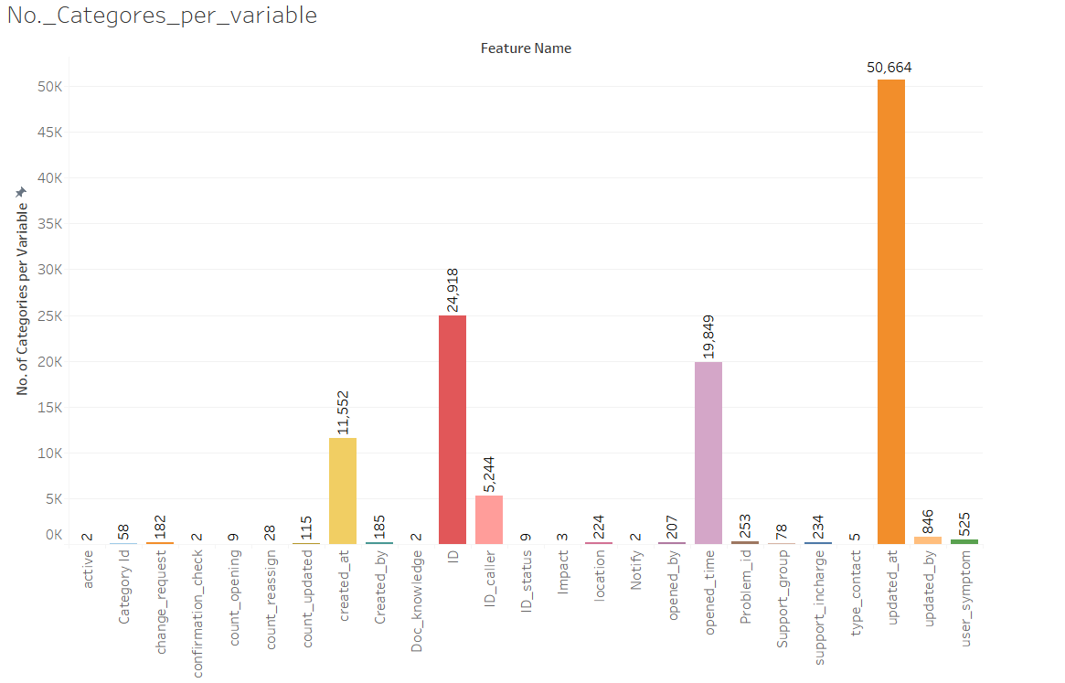

**Exploratory Data analysis**

**Analysis of the variables which have influence in deciding the category of Impact (Initial Research)**

1. ID Caller: - identifier of the user affected

This will identify the person who is affected by the incident. This can be useful in classify the impact.

Eg:- In an organization if large number of valuable client is getting affected because of the interrupted services impact can be high for that particular case.

1. Opened by: - Identifier of the user who reported the incident.

Incident can be reported by any associate who is link with the organization. Eg:- If the incident reported by any VIP level people it can be very important to solve immediately and can be categorized accordingly based on the impact.

1. Location: - identifier of the location of the place affected

This refers to the place which is affected by the service disruption. For some organization, certain location may be very important for business profit, if from such location, incident is reported than it may cause high impact as it will be related to company’s finances

1. Category Id: - first-level description of the affected service

This will tell about the details about the service which is affected.

1. user_symptom :- description of the user perception about service availability

This is what a user will describe what he is facing because of the incident.

1. Support_group :- identifier of the support group in charge of the incident

This may have influence on the impact because support group may be different according to the type of incident raised. Different level of incidents will require different level of services, knowledge, resource technicians to resolve and they may belong to different support group.

1. support_incharge: - identifier of the user in charge of the incident

Similarly high critical incident may require different incharge compared to the incident with low impact.

1. confirmation_check: - boolean attribute that shows whether the priority field has been double-checked.

This may indicate that service which is having high impact that may require high priority to solve immediately or at faster pace.

1. Problem_id = identifier of the problem associated with the incident

This may say what problem arises because of the incidents

1. change_request: - identifier of the change request associated with the incident

This can be important because this may identify what type of change is required for the incident raised.

**Feature Engineering**

**Data Cleaning**

1. Sorting
2. Removing duplicate values

After removing duplicate values based on ID and ID_Status we get 87233 records

**Visualizations**

**Dependent Variable**

**Impact**

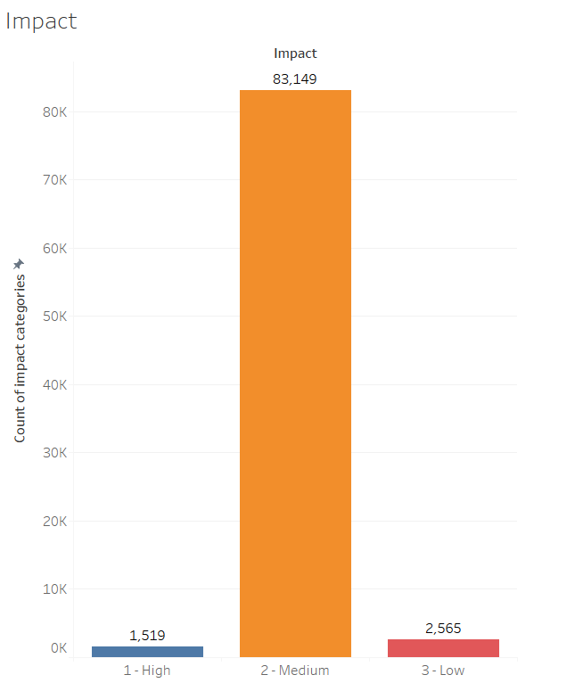

Out of 87233 total incidents, 1519 is having high impact, 83149 has medium impact and 2565 has low impact.

**Independent Variables**

1. **ID**

There are 24918 unique incident id’s are there in the given dataset.

1. **Id_Status**

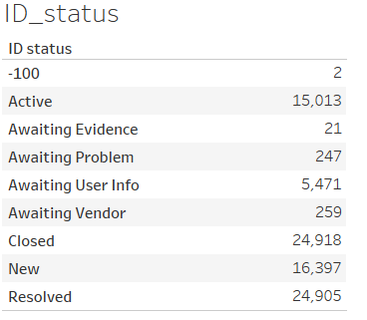 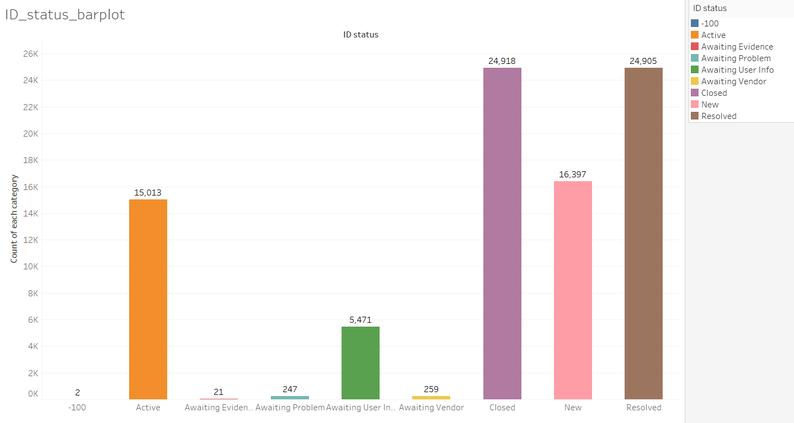

In the above polt, we can find that there is two records for -100 category, this can be an error in the dataset. This will be replaced with some other value or records can be deleted in further treatment

**Impact Vs ID status**

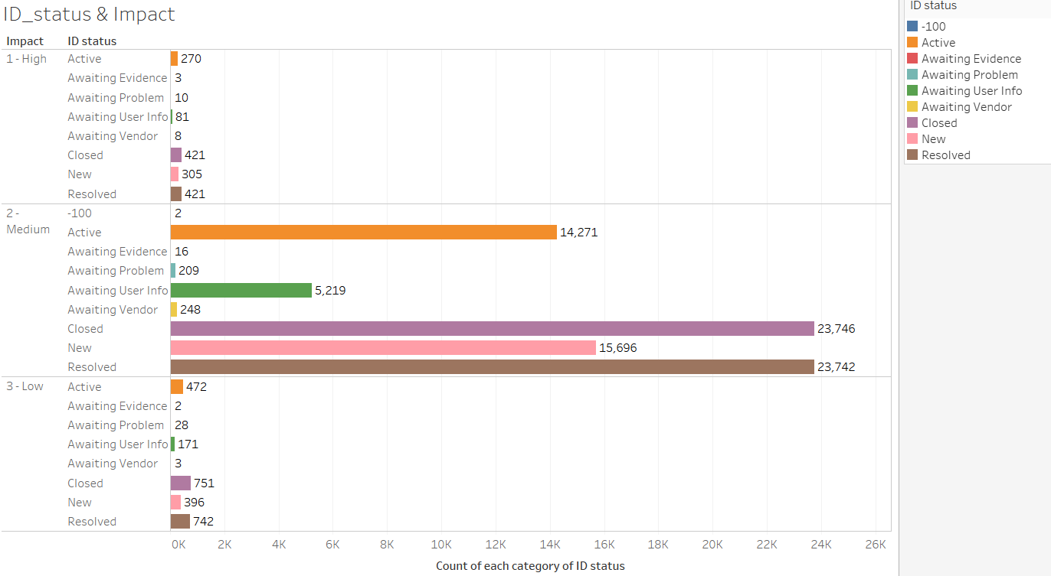

1. **Active**

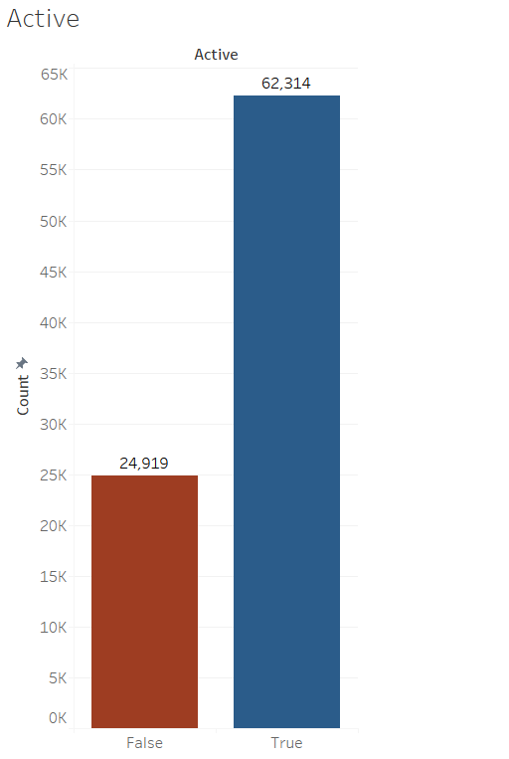 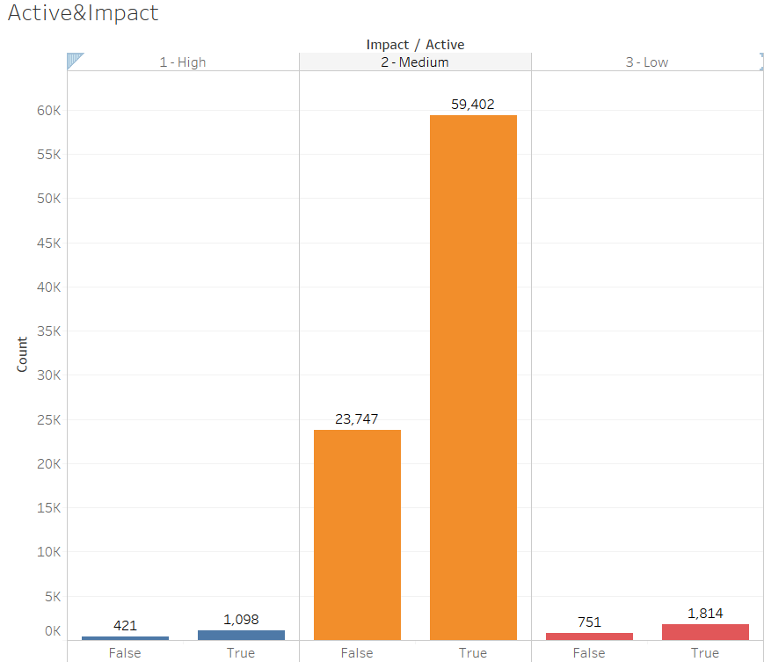

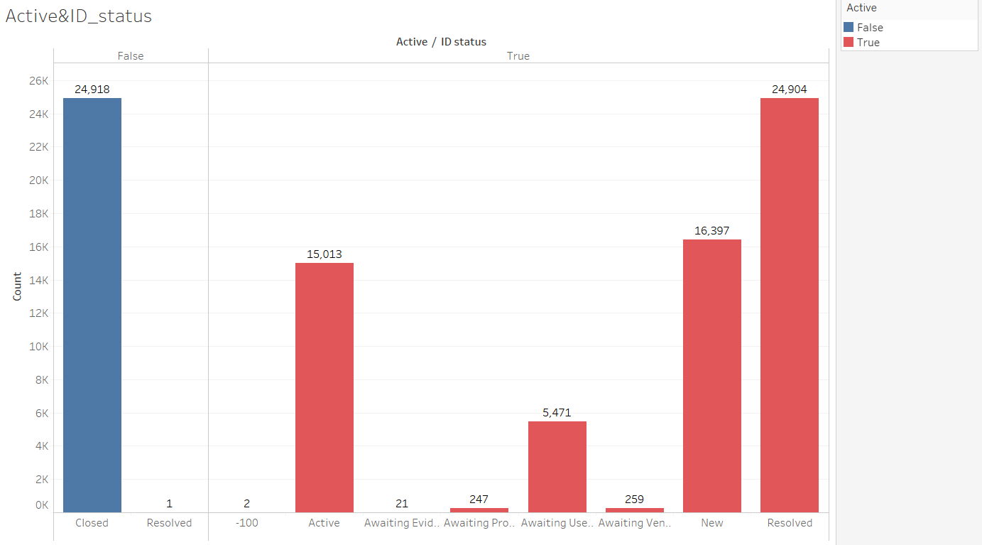

From the above plot it can be observed that, “Active” is False when the incidents are mainly having closed “Status” and in other case “Active” will be True.

1. **ID_Caller**

There are 5244 unique ID_callers

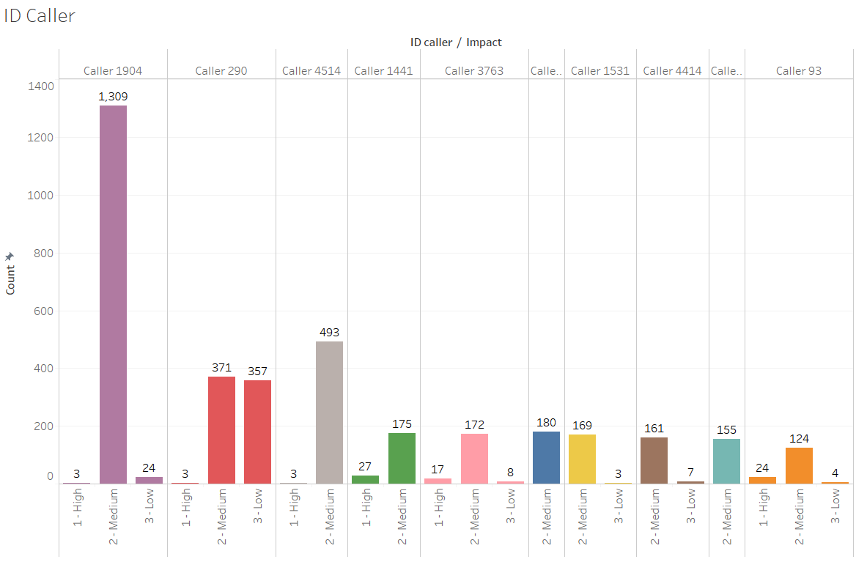

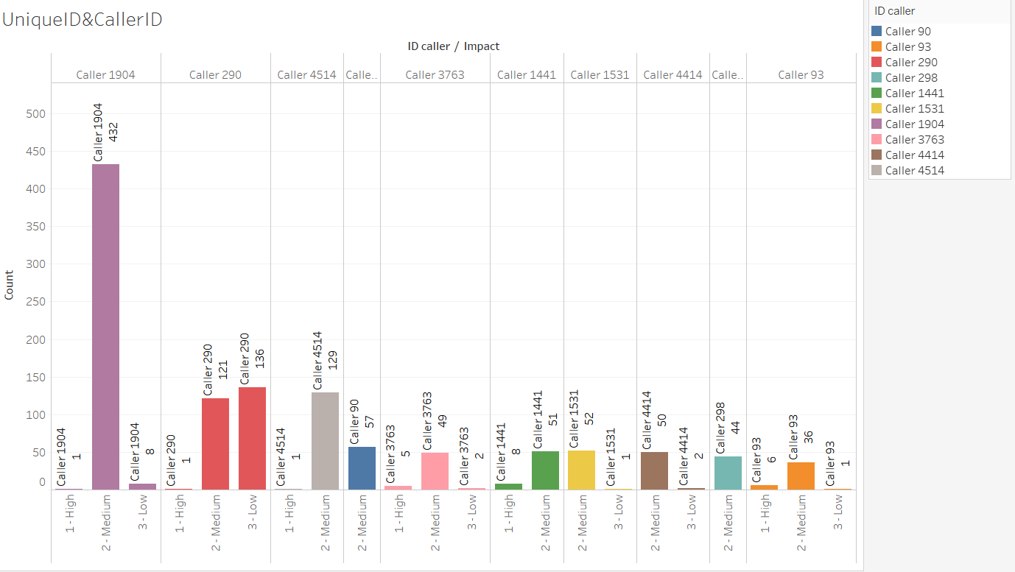

1. opened_by 207 unique users

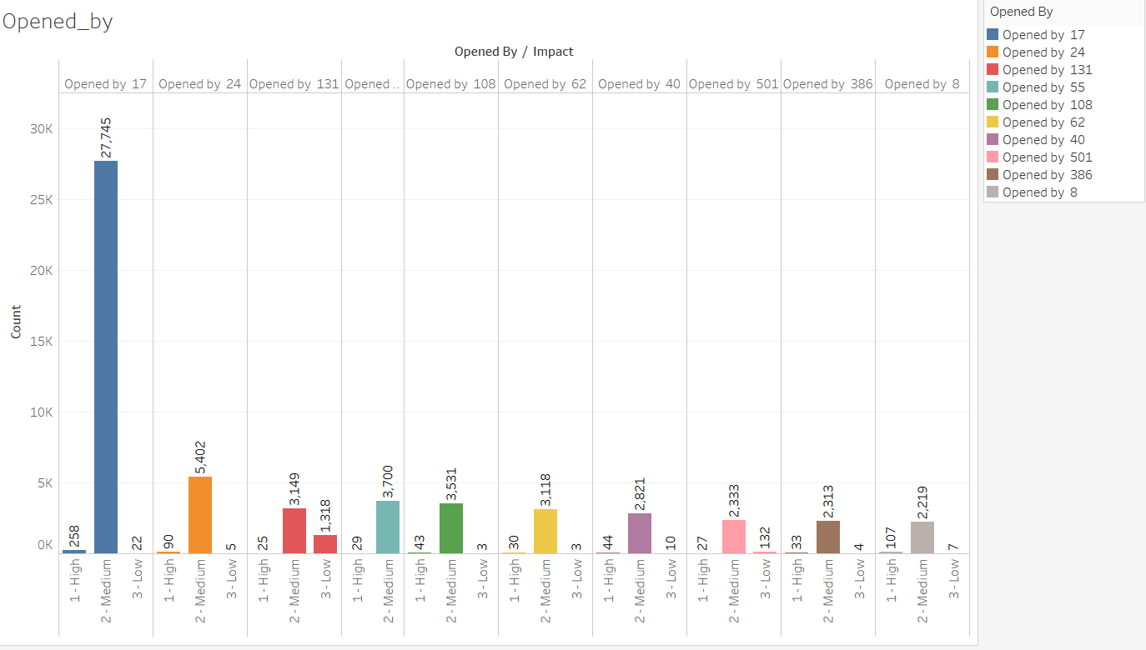

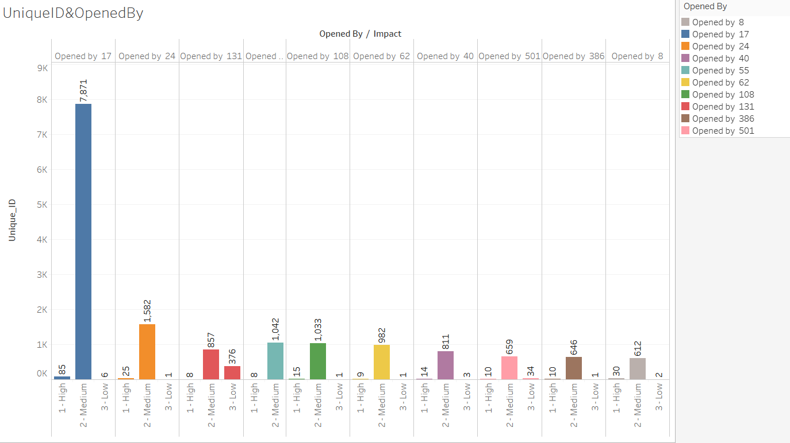

1. created_by 185 unique identified

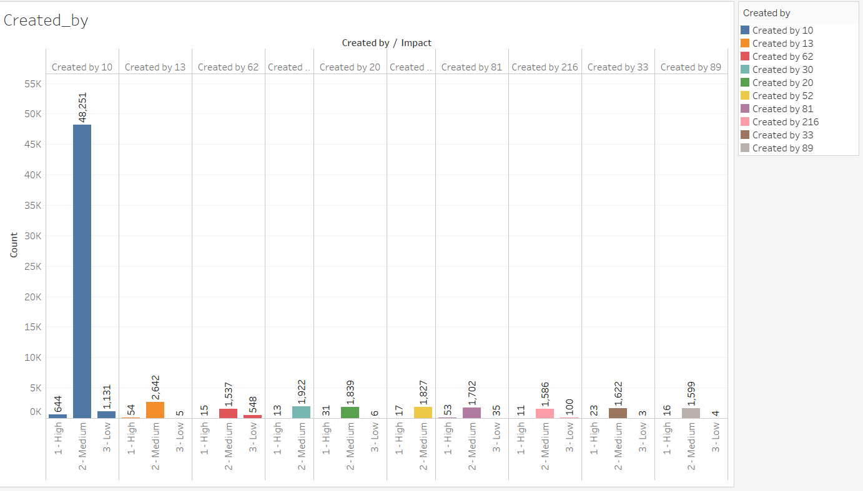

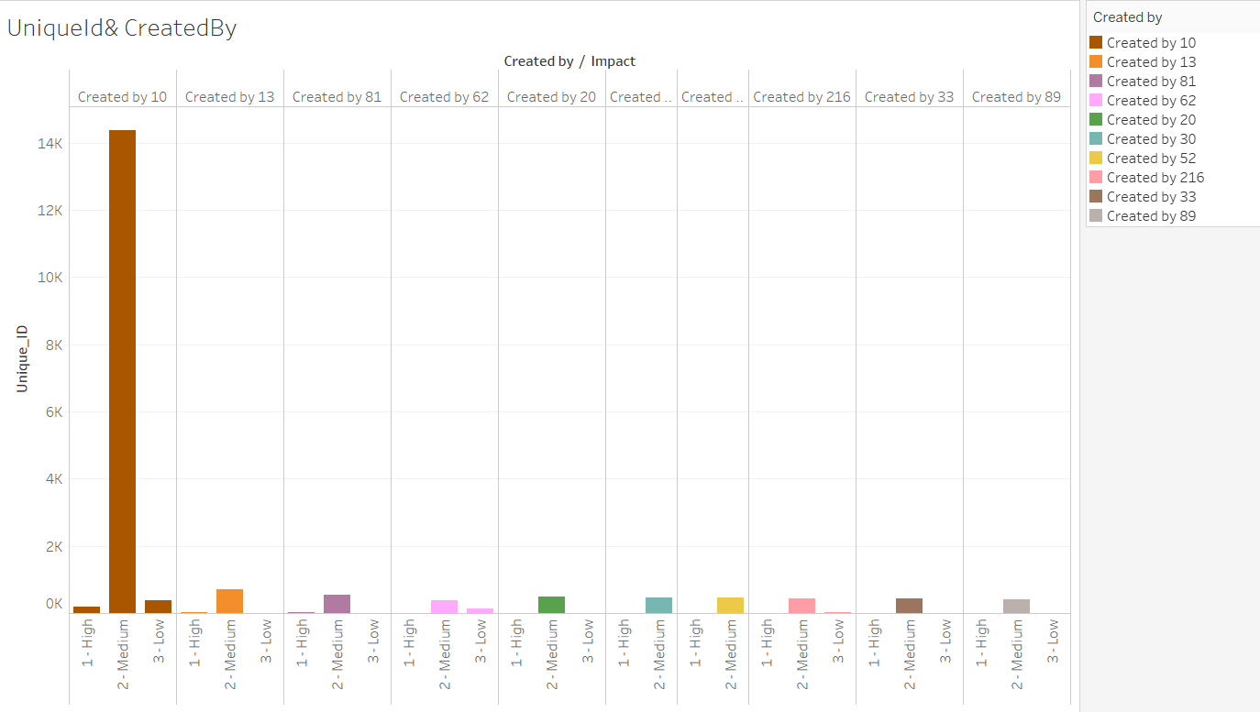

1. updated_by 846 unique users who updated the tickets

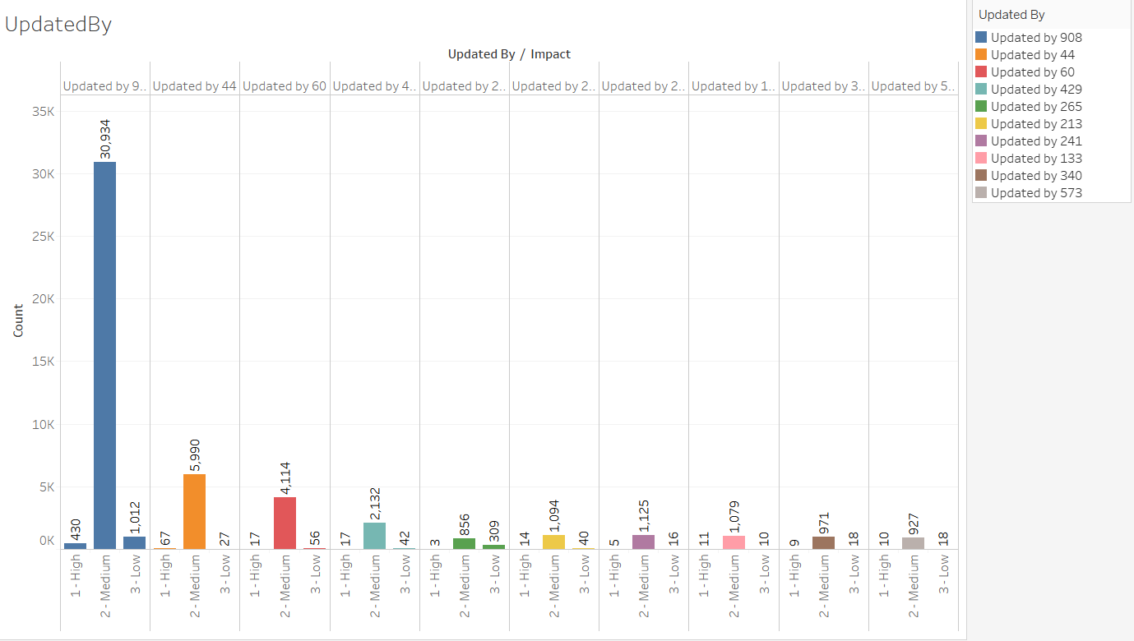

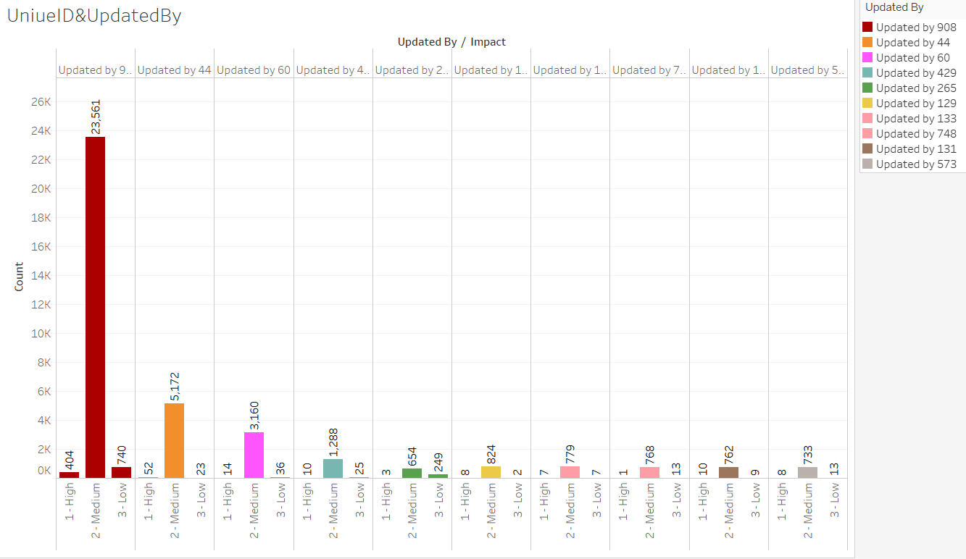

1. type_contact-Direct opening, Email, IVR, Phone, Self service

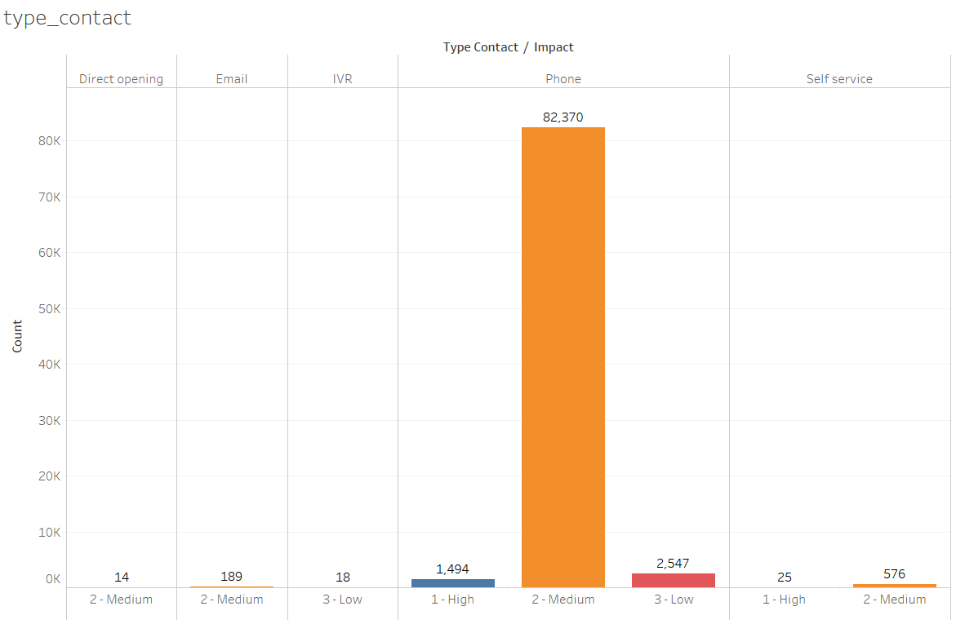 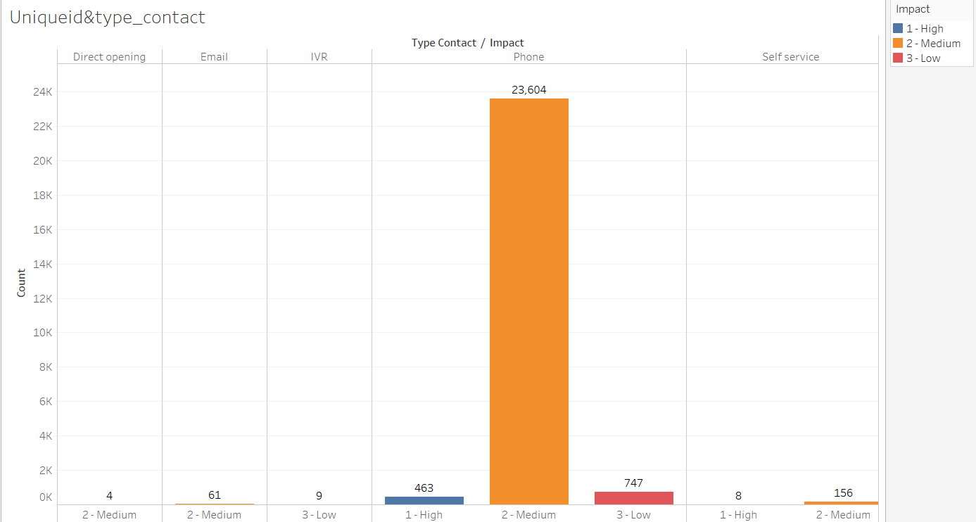

From the above plot, maximum incidents is raised by Phone.

1. location -- There are 224 different locations

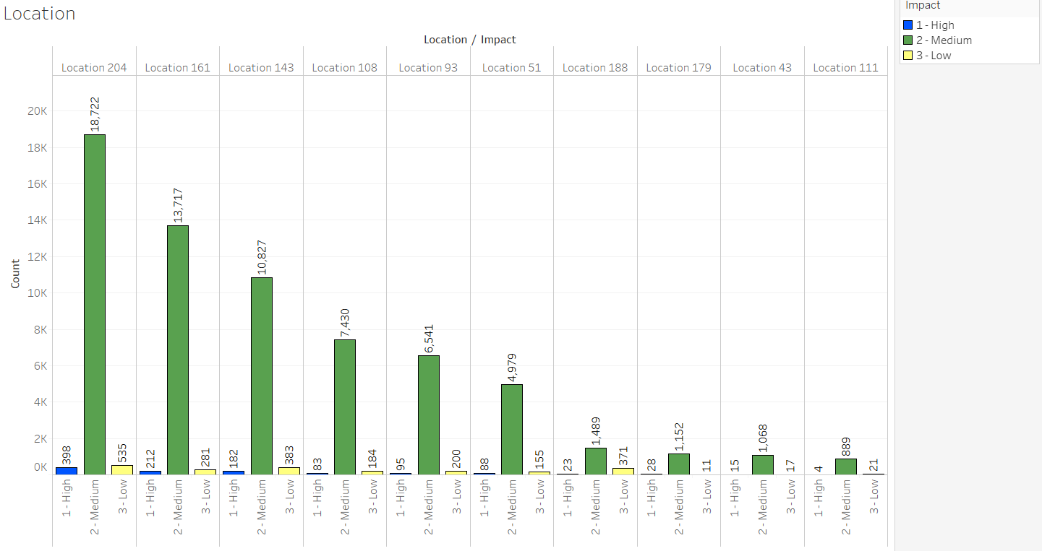

The above is top 10 Locations from where maximum incidents is raised.

Maximum incidents is raised from Location 204

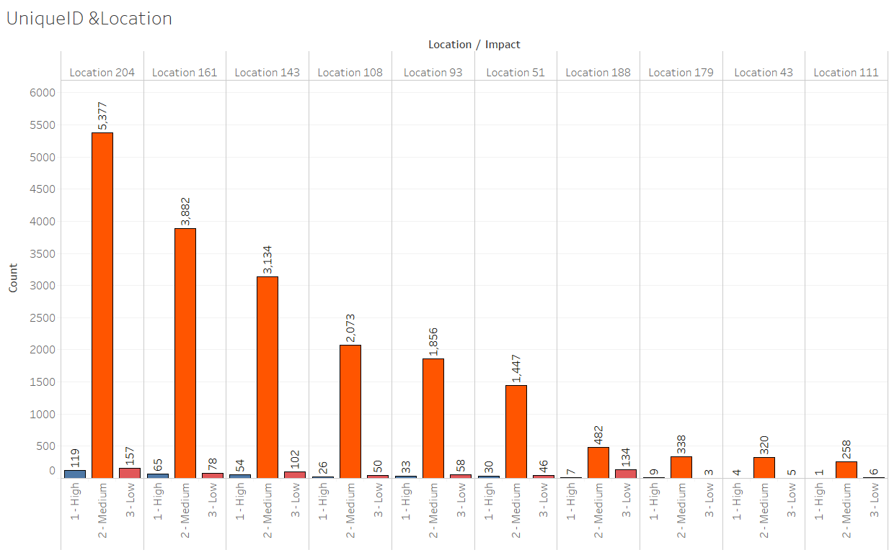

1. Category ID – There are 58 different category id

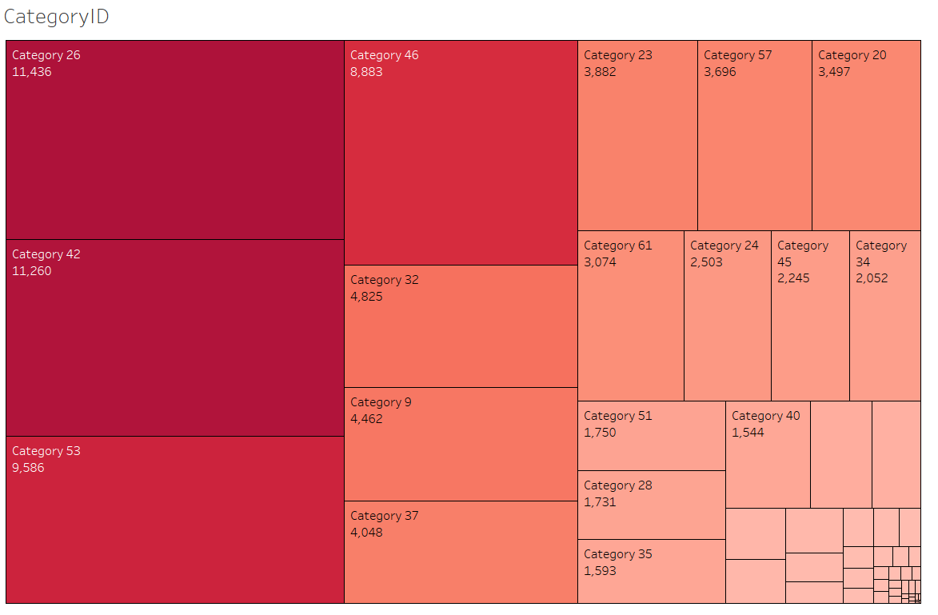

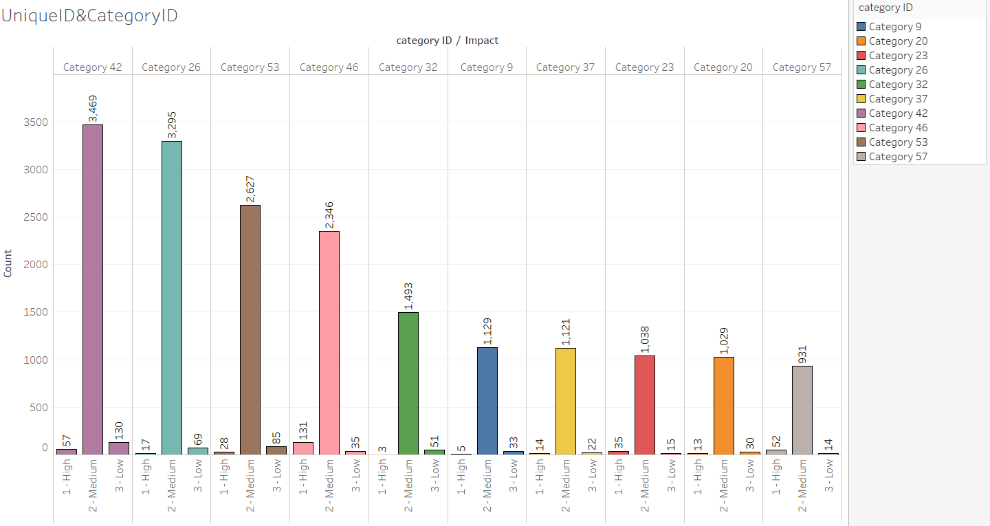

Maximum incident belongs to Category 42 and Category 26

1. user_symptom—There are 525 different user symptoms

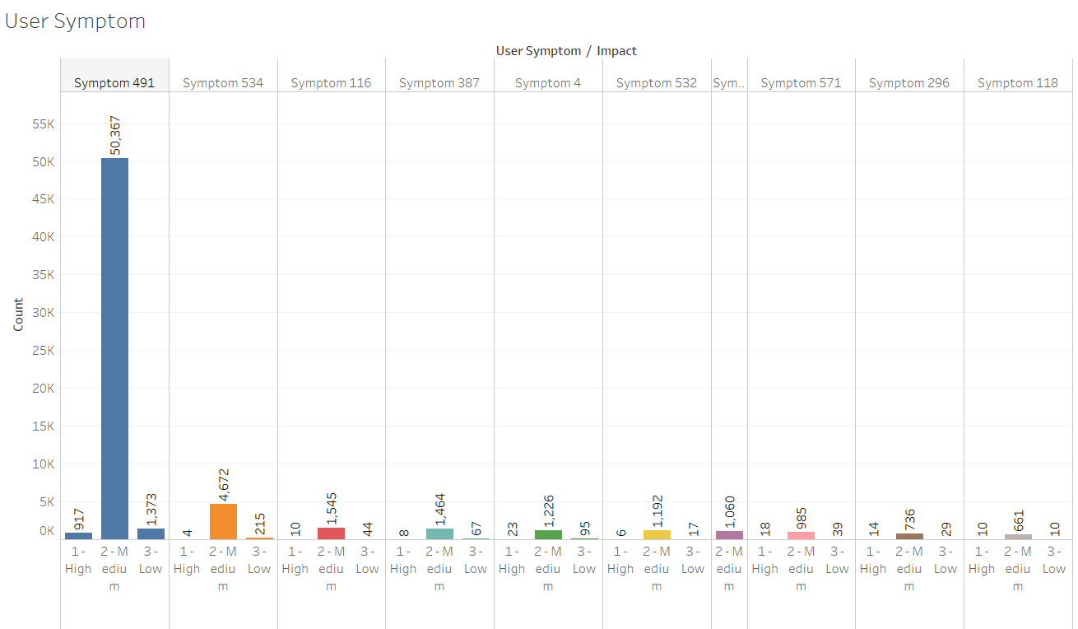

Maximum incident having symptom 491

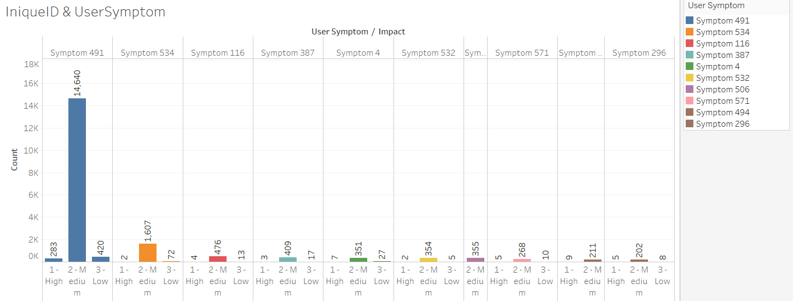

1. Support_group There are 78 different support groups

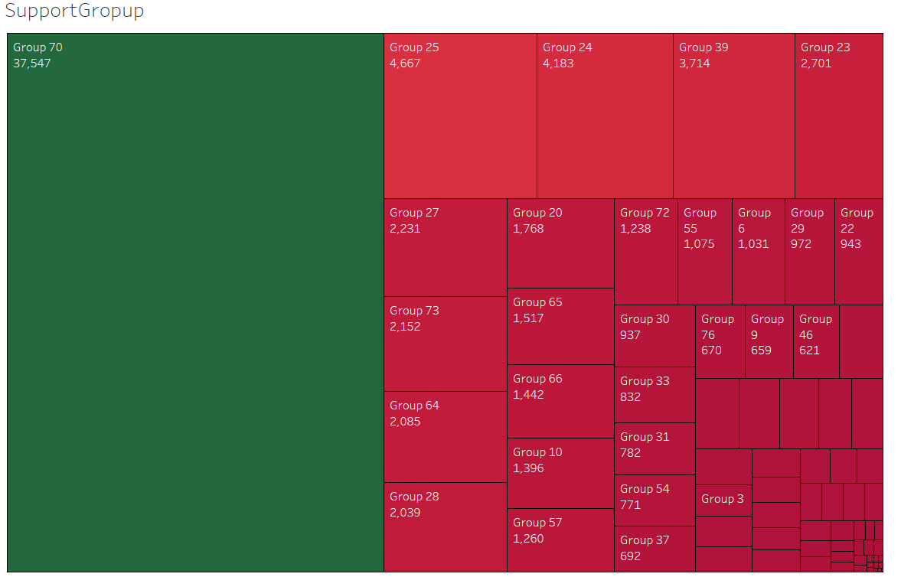

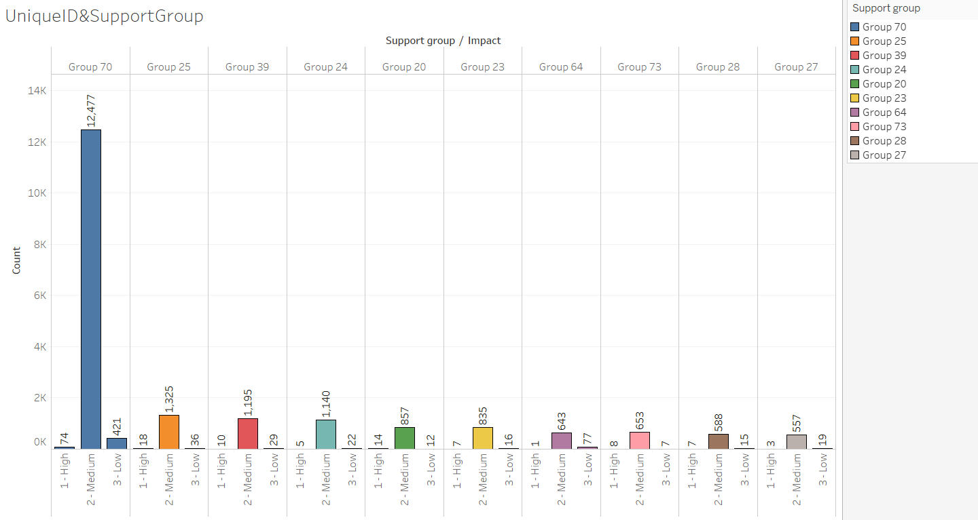

Maximum number of incidents is assigned to support Group70

1. support_incharge-- 234 unique support incharge

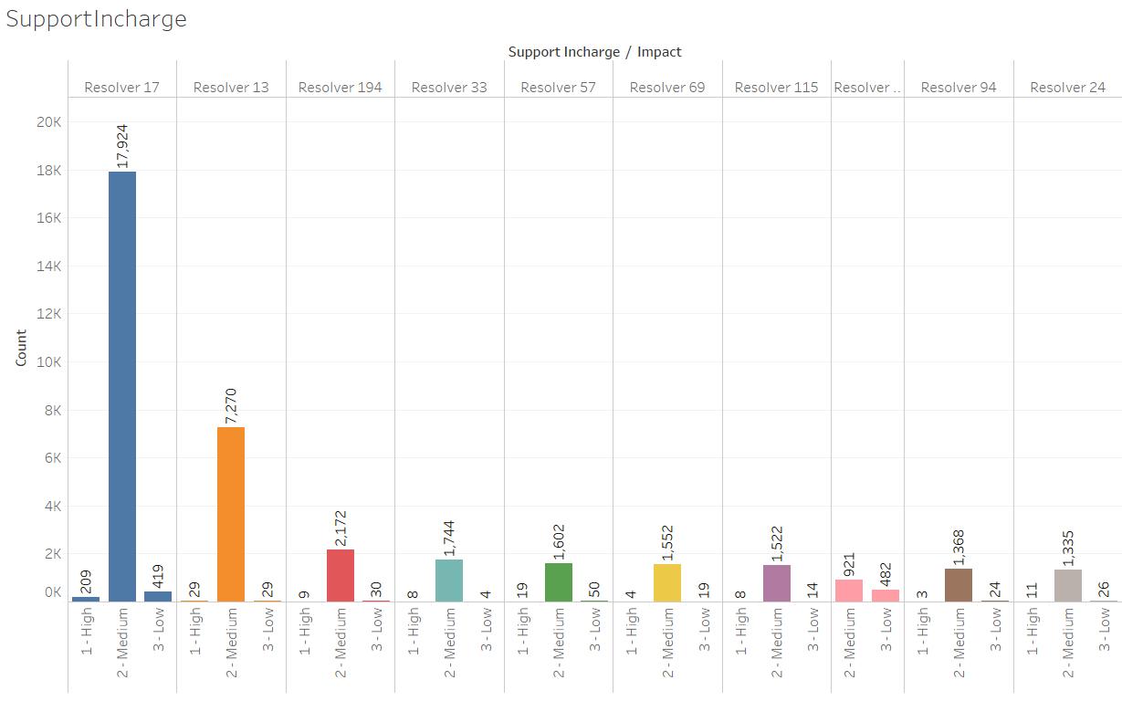

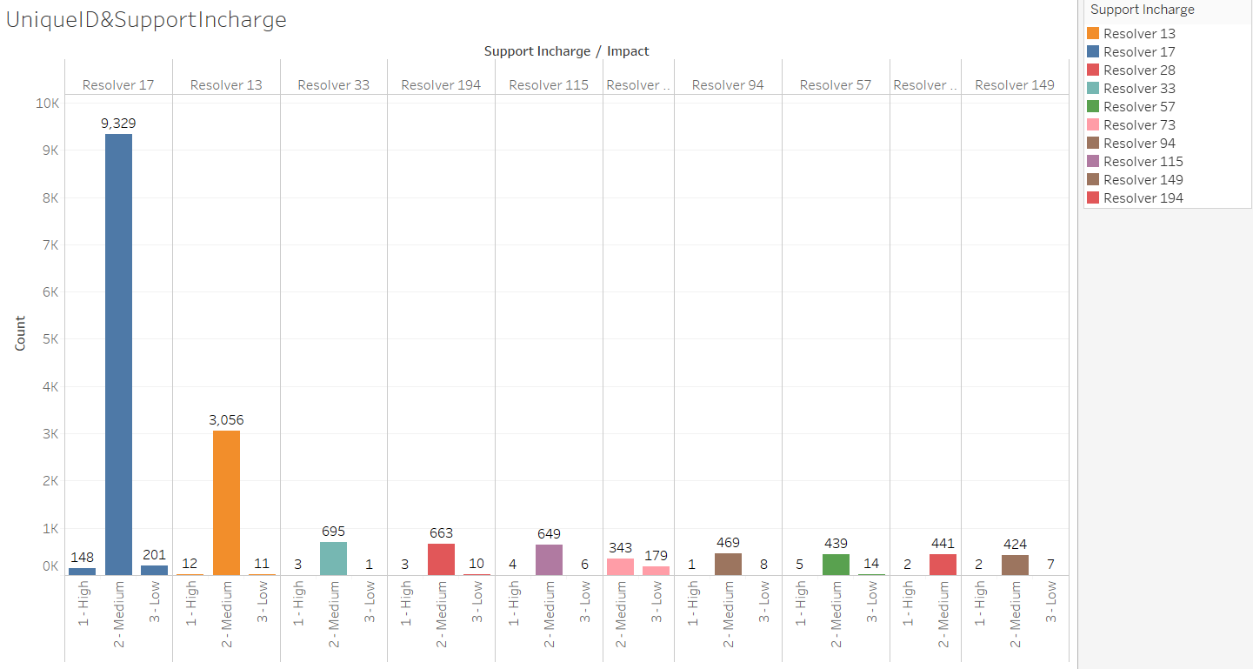

Maximum incident is assigned to support incharge Resolover 17

1. Doc_knowledge ---- True, False

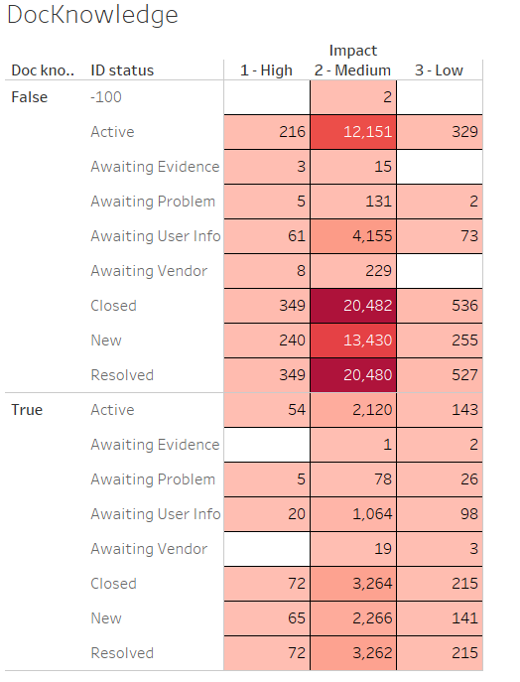 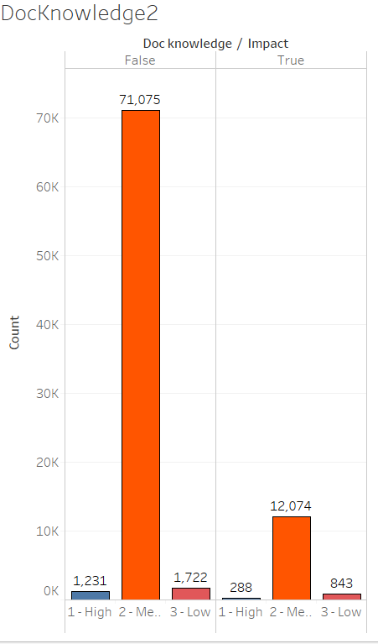

For Maximum Incident Document knowledge is not provided.

1. confirmation_check True, False

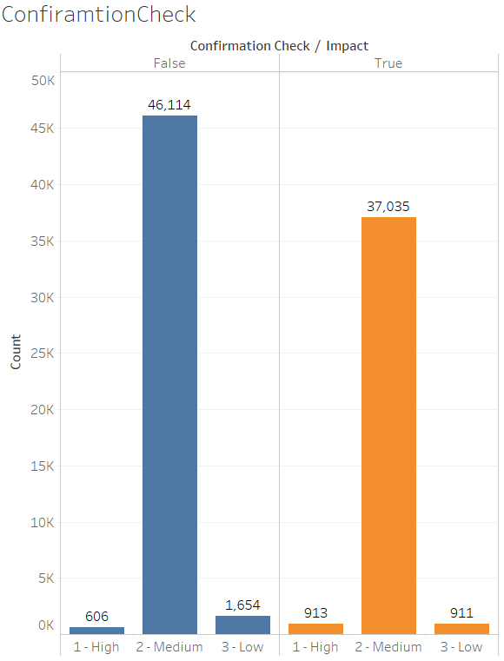 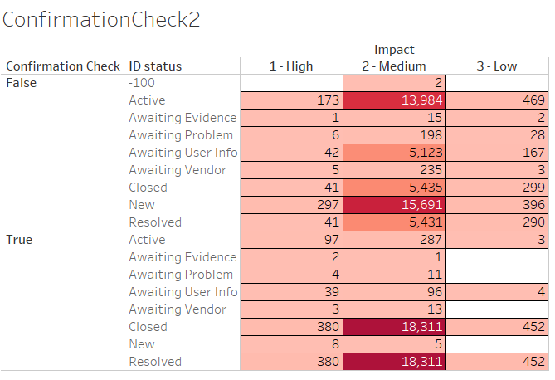

There are almost equal number of incidents Confirmation Check is False and True.

Confirmation Check – This is Boolean value True if Priority value is double checked or not

1. notify Do Not Notify, Send Email

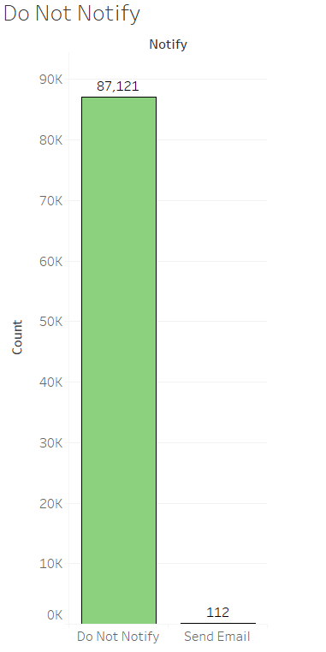 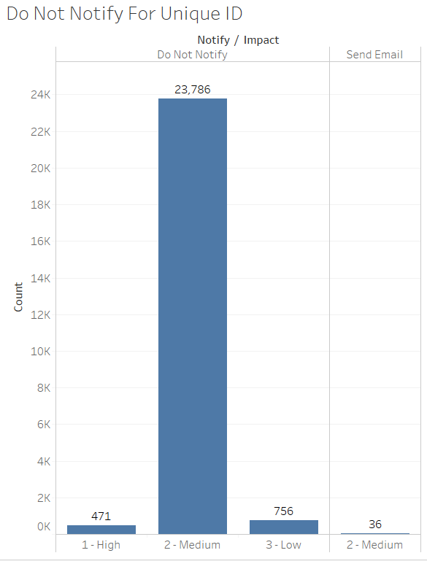

For maximum incidents Notification is not genrated and there are very few incidents where email is generated.

1. problem_id There are 253 different problems

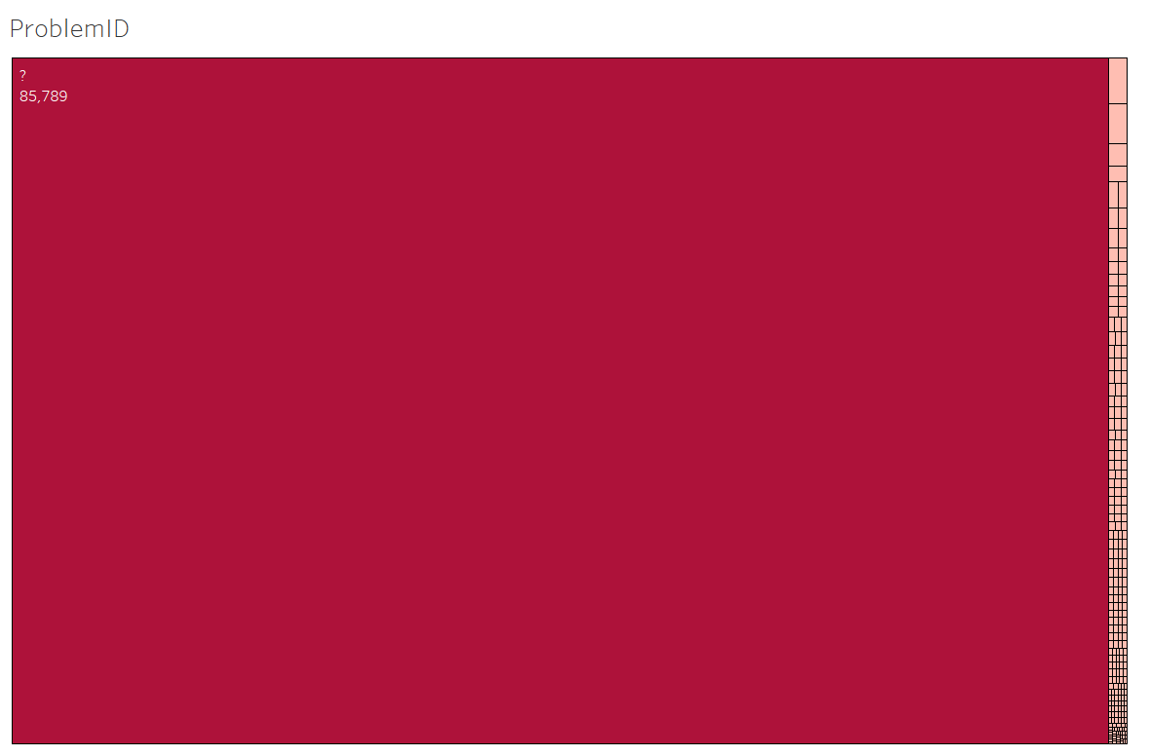

Around 85789 incident records belong to problem-ID Indicating by “?”. For which proper name is not mentioned. Have to deal with it separately.

1. change request 182, different change request



Around 86634 incident records belong to Change request indicating by “?”. For which proper name is not mentioned. Have to deal with it separately.

**Feature Selection**

Quantitative Variables like count_reassign, count_opening, count_updated, opened_time, created_at, updated_at do not have any influence on impact (Domain Knowledge). So, these variables are not taken into any consideration for further analysis.

**Check for association between Impact and other input variables**

**Chi Square Test**

H0: There are no relationship between two variables

H1 : There is significant relationship between variables of interest

After performing Chi Square Test we find the following results

**feature_names P-Values Significant**

0 ID_status 2.435171e-18 Yes

1 active 5.547200e-01 No

2 ID_caller 0.000000e+00 Yes

3 opened_by 0.000000e+00 Yes

4 Created_by 0.000000e+00 Yes

5 updated_by 0.000000e+00 Yes

6 type_contact 2.068557e-133 Yes

7 location 0.000000e+00 Yes

8 category_ID 0.000000e+00 Yes

9 user_symptom 0.000000e+00 Yes

10 Support_group 0.000000e+00 Yes

11 support_incharge 0.000000e+00 Yes

12 Doc_knowledge 4.354526e-146 Yes

13 confirmation check 1.952573e-51 Yes

14 notify 6.366832e-02 No

15 problem_id 3.971051e-104 Yes

16 change request 1.169109e-96 Yes

From the p-values we calculated after Chi-Test , it is found that features like “active: and “notify” are not significant in this case and therefore not taken into consideration for further analysis.

Handling unwanted values and coulmns

1. Droping the Unwanted records from feature ID_status where ID_status =-100.

**Label Encoding :** This step involves conversion of categorical variables into numerical. As most of the machine learning algorithm do not deals with text data.

After Label Encoding, Correlation analysis is done. The following plot and table is the result of

co-relation analysis

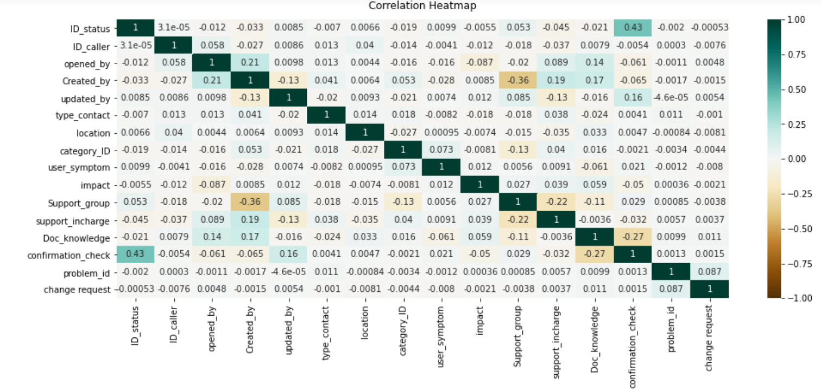

The above heatmap signifies more the deep in color more is the correlation associated among the variables.

From the correlation heat map the following table can be summarized

|  |  |
| --- | --- |
| **Impact VS Input Variables** | **Correlation-Coefficients** |
| ID_status | -0.0055 |
| ID_caller | -0.012 |
| Opened_by | -0.087 |
| Created_by | -0.0085 |
| Updated_by | 0.012 |
| Type_contact | -0.018 |
| location | -0.0074 |
| Category_id | -0.0081 |
| User_symptom | 0.012 |
| Support_group | 0.027 |
| Support_Incharge | 0.039 |
| Doc_knowledge | 0.059 |
| Confirmation_check | -0.05 |
| Problem_id | 0.00036 |
| Change_request | -0.0021 |

From the above table, “problem_id” and “change_request” features have very low co-relation value. Moreover there are number of missing values is very high for these two variables. So these two variables are not considered for further consideration.

The following are the variables will be considered for further analysis

|  |  |
| --- | --- |
| **Input variables** | **Output Variables** |
| ID_status | impact |
| ID_caller |
| Opened_by |
| Created_by |
| Updated_by |
| Type_contact |
| location |
| Category_ID |
| User_symptom |
| Support_group |
| Support_incharge |
| Doc_knowledge |
| Confirmation_check |

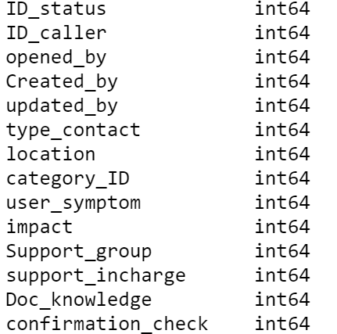

**Data Partitioning**

Dataset is now splited into train and test dataset by 7:3 ratio

Train = 61061

Test = 26170

**Balancing Imbalance datasets**

|  |  |
| --- | --- |
| **Categories** | **Value count** |
| medium = 1 | 58245 |
| low = 2 | 1765 |
| High = 0 | 1051 |

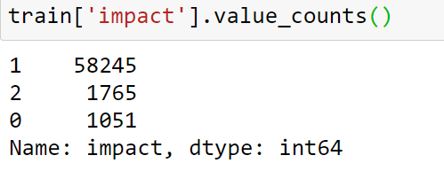

Since from the above snapshot, it can be found that there is no proper balance between different categories of target variable(impact) from train dataset, need to balance this imbalance in the dataset

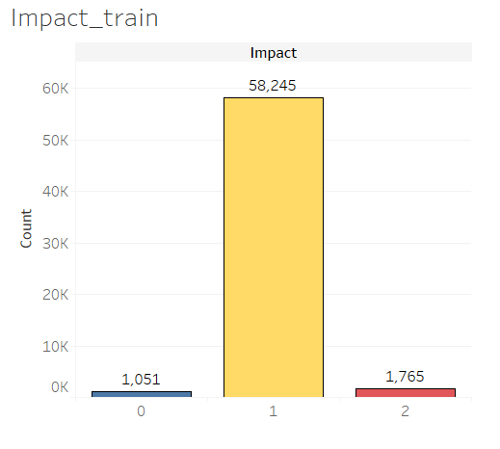 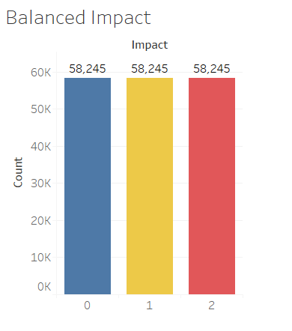

SMOTE

**Model Building**

The following are the models trained withtrain datasets

1. Decision Tree
2. K-Nearest neighbour
3. Random Forest
4. Gradient Boosting
5. XG Boost

**Model Evaluation**

The following are the accuracy report of train and test data generated from each of the model is summerized in one table for better selection.

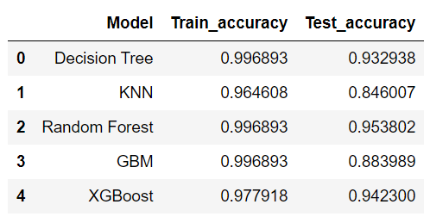

From the above table it can be interpreted that train and test accuracy from Random Forest Model is the highest 99.6 and 95.3 % respectively. So this can be selected as best model.

**Further Research**

Dataset that is provided have lot of categorical variables and each categorical variable have very high cardinality, So its better to go and train with **Catboost Model** which is very efficient in dealing with high cardinality categorical variable.

For catboost model label encoding is not required. Model can very easily interpret text data and can perform efficiently.

Accuracy Train = 97.70 %

Accuracy Test = 97.24 %

Classification Report for Catboost

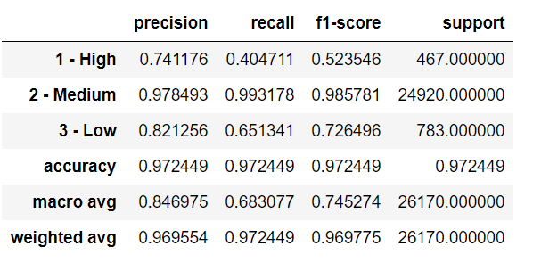

From the above report, Precision, recall, and f1-score is quite high if it is compared to previous models that is built.

Therefore, this model is taken as a final model and used for deployment

**Deployment**

The following are the Steps required to deploy a model in flask

1. Pickle File creation – Selected model is dumped into pickle file
2. App.py – This file is the main executed file for deployment
3. Model.py- This is main Python file
4. Create “**Templates**” folder – This folder should contain HTML file by name index.html
5. Create “**Static folder**”- In static folder, two folders are created one is **image**s folder other is **Js** folder. In **images** folder all image file is saved and in **Js** folderjavasript file is saved.

For deploying in Heroku the following are the necessary files required to create

1. requirements file
2. Procfile

UI Application

