

**UI ASSIGNMENT**

***Task:***

Build a Add to Cart experienceby consuming the below API <https://api.myjson.com/bins/qzuzi>

(for initial data only)

***Design:***

*Shopping List Page* ***(Mobile)****:*

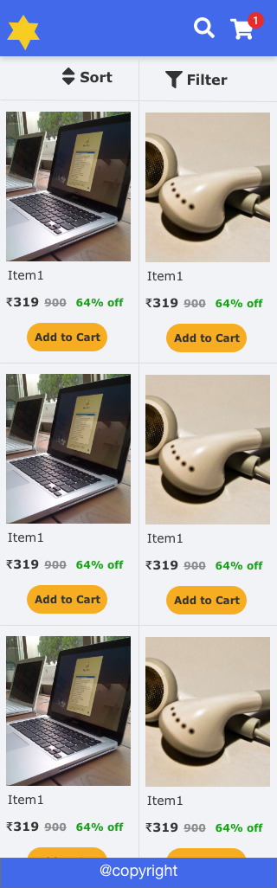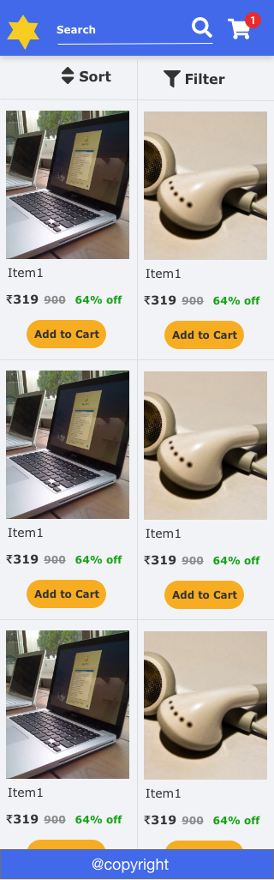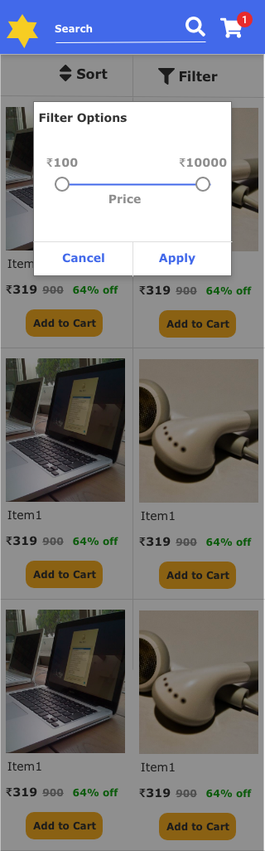

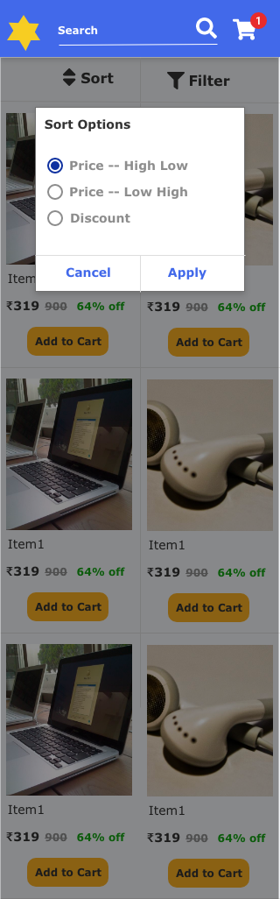

*Desktop:*

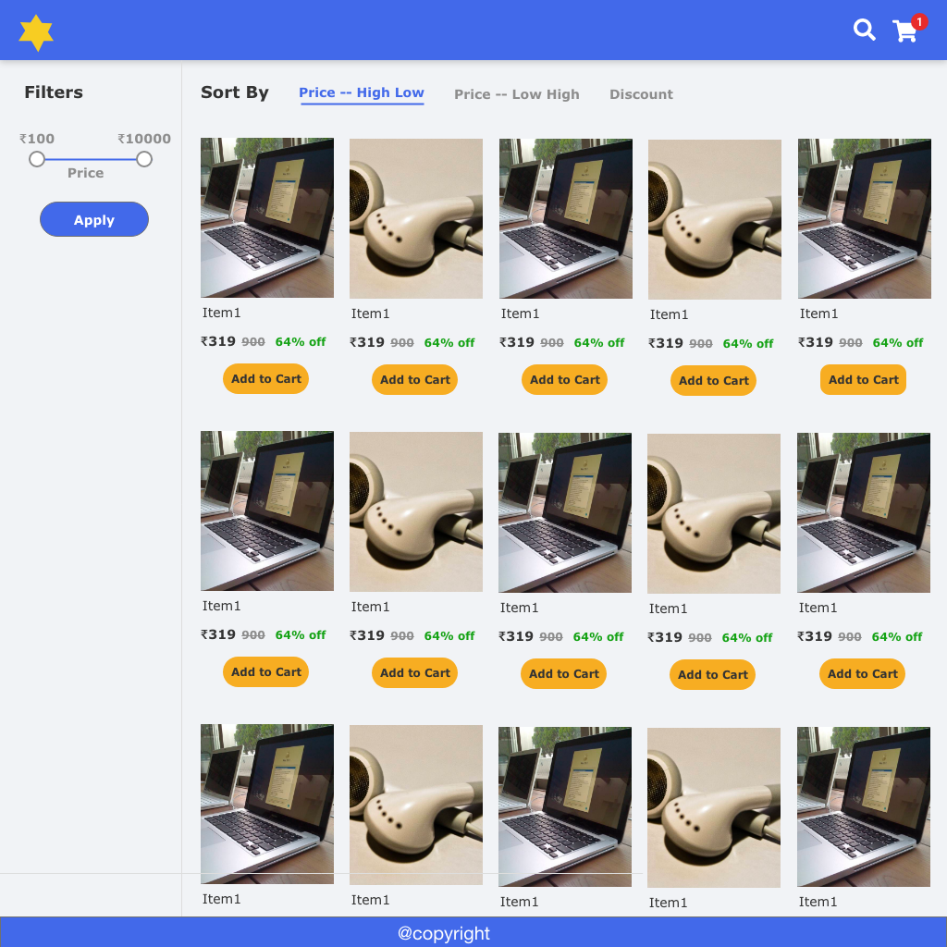

*Cart Page:* ***(Mobile)***

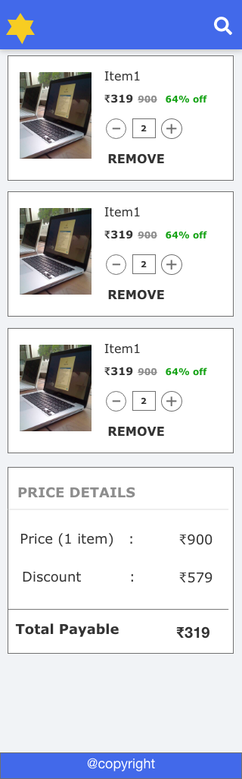

*Desktop:*

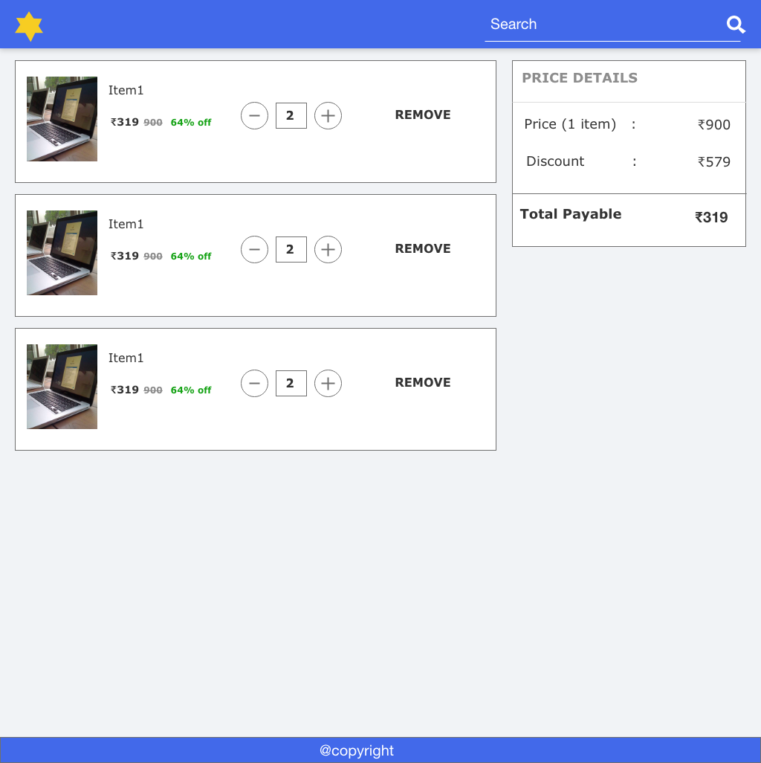

**Font Used:** Verdana

**Icons:** FontAwesome

***Description:***

* Create below individual components

1. Search Component
2. Cart Icon Component
3. Sort Component
4. Filter Component
5. Shopping list Component
6. Header

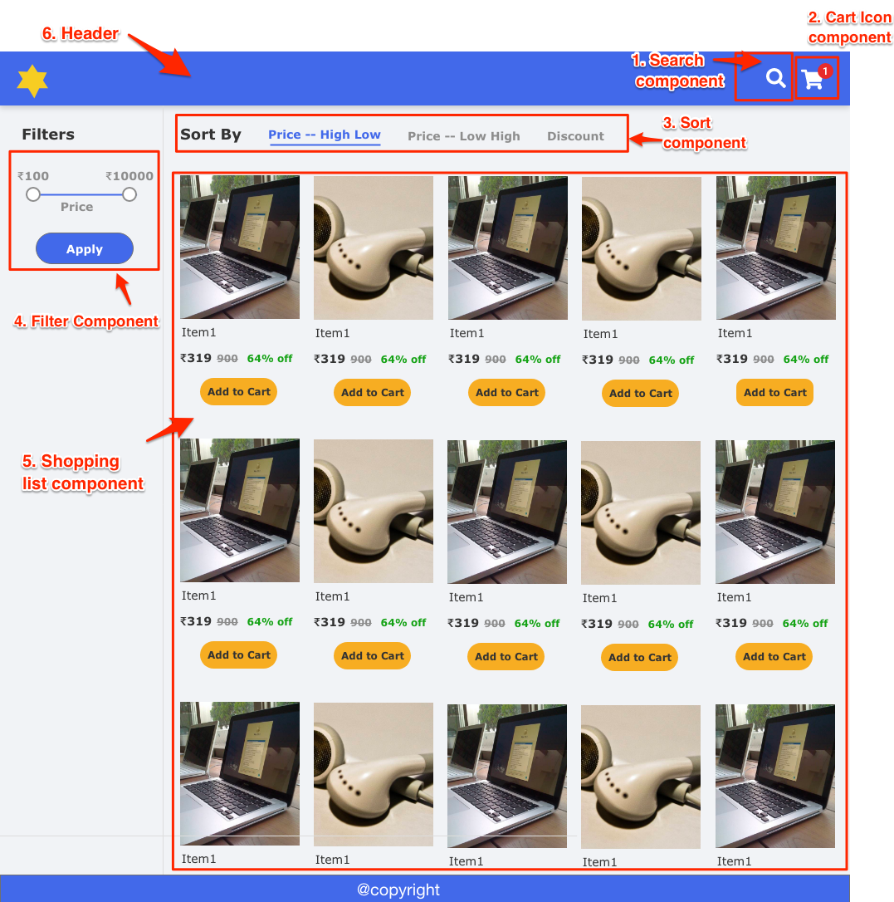

* Implement the flow and all the calculations.
* Data should persist between pages.
* Use event mechanism/state management to communicate between components

Mobile view prototype: <https://xd.adobe.com/view/3e00a2bb-199f-4e35-77e9-6007acbc50bb-4831/screen/0e17b269-ca6f-4d26-816c-00742b6c076d/Mobile-Shopping-list-1>

***Technology requirement:***

* HTML5
* Javascript (ES6)/jQuery/Typescript
  + OO approach will earn additional value
* CSS3, usage of SASS/LESS is mandatory
* Use Gulp/Webpack to
  + compile SASS to CSS
  + Concat and minify JS
* Use ajax/fetch API to fetch menu data from the above endpoint.
* Good to have,
  + Including custom fonts [**adding local web fonts** instead of including google or typekit is prefered]
  + Add icons [Font icon or SVG] (Fontawesome can be used)

***Submission guidelines:***

* Upload the code into public [Github](https://github.com/) repository and share the repo link
* Host the final outcome into [Heroku](https://www.heroku.com/) or [githubpages](https://pages.github.com/) and share the link to see the demo in action.