Definite and Indefinite Articles in English Economic News: A Corpus-Based Study of Semantic Reference Types
Abstract
This study examines the occurrence of the definite article the and the indefinite articles a/an, and the semantic reference categories they mark in contemporary English economic news. It addresses the limited corpus-based evidence on how professional economic journalism uses overt articles to organize definiteness, specificity, and genericity across outlets. Using a mixed-methods corpus-based design, the study combines quantitative frequency analysis with qualitative semantic reference coding. The data come from the English Economic News Corpus 2026 (EENC-2026), a balanced, specialized, manually compiled, synchronic one-million-word corpus collected from ten English-language economic news outlets between January 1 and March 31, 2026; after Sketch Engine processing, it contained 1,174,893 tokens. Frequencies were extracted for the, a, an, and total a/an. Semantic analysis was based on 2,000 randomly sampled noun phrases, with 100 definite and 100 indefinite samples from each outlet. The coded data were organized in Microsoft Excel and analyzed using IBM SPSS Statistics, Version 27, through cross-tabulations, chi-square tests, and inter-coder reliability on a 200-sample subset. The findings show that the occurs 61,311 times, while a/an occurs 25,368 times, representing 70.73% and 29.27% of overt article tokens, respectively. Semantic coding identifies 1,402 specific, 598 non-specific, 19 generic, and 1,981 non-generic references, showing that English economic news strongly favors specific and context-bound reference. Overall, the findings indicate that article choice in economic journalism helps present economic entities, events, and indicators as identifiable, specific, and situated in immediate news contexts.
Keywords: English Articles , Semantic Reference, Economic News, Corpus Linguistics

1. Introduction
English articles are compact grammatical markers with important discourse-semantic roles. The definite article the generally presents a referent as identifiable, unique, recoverable from context, or shared knowledge, whereas a/an usually introduces a referent as non-unique or newly introduced. However, article interpretation also depends on specificity and genericity, not only on article form (Hawkins, 1978; Huddleston & Pullum, 2002; Lyons, 1999). These meanings are especially important in news discourse, where writers condense information and rely on shared institutional knowledge (Bednarek & Caple, 2012; Bell, 1991).
Economic news intensifies this need because it repeatedly names markets, central banks, prices, indicators, policies, and reports, often through dense noun phrases. This register is therefore suitable for examining how article choice helps organize identifiable, specific, and context-bound reference (Akbarova, 2024; Li & Gao, 2023). The present study examines definite and indefinite articles in EENC-2026, a balanced one-million-word corpus manually compiled from ten English-language economic news outlets. It asks whether the is more frequent than a/an, how article-marked noun phrases express definiteness, specificity, and genericity, and how frequencies vary across outlets.
The study is significant because it combines corpus-frequency evidence with semantic coding and inter-coder reliability. It therefore treats articles not as minor function words, but as reference-management devices that help economic journalists present entities, institutions, and events as identifiable, specific, and situated in immediate news contexts.

2. Literature Review
The English article system is traditionally described through the contrast between definiteness and indefiniteness. The definite article the signals that a referent is identifiable to the reader, whereas a/an usually introduces one member of a class or a referent that is not yet uniquely identifiable. Standard grammars treat this contrast as central to English noun-phrase interpretation (Biber et al., 1999; Huddleston & Pullum, 2002; Quirk et al., 1985). However, article meaning cannot be explained by form alone. A noun phrase with the may be definite because of uniqueness, shared knowledge, or situational context, while an indefinite noun phrase may still be specific when the writer has a particular referent in mind.
Theoretical studies of definiteness emphasize accessibility and identifiability. A reference is definite when the reader can identify the intended referent through previous discourse, contextual knowledge, uniqueness, or shared assumptions (Gundel et al., 1993; Hawkins, 1978; Lyons, 1999). This is highly relevant to economic news because journalists often refer to the government, the economy, the central bank, or the market without lengthy introduction. The reader is expected to retrieve the referent from the economic context and from shared institutional knowledge.
Specificity adds another layer to article interpretation. Definiteness concerns whether the reader can identify a referent, whereas specificity concerns whether the writer has a particular referent in mind. Indefinite noun phrases may therefore be referential or non-specific, depending on context (Fodor & Sag, 1982; Heim, 1982; von Heusinger, 2002). For example, a new report may be indefinite but specific if it refers to a particular document, while a better recovery may be non-specific if it refers to a possible future condition. This distinction is central to the present coding framework.
Genericity concerns whether a noun phrase refers to a class, kind, domain, or general concept rather than a particular instance. Generic reference is a major semantic category in English noun-phrase interpretation (Carlson, 1977; Carlson & Pelletier, 1995; Krifka et al., 1995). In economic reporting, a term such as market may refer to a specific market reaction in one context and to a broad economic domain in another. Genericity therefore cannot be inferred automatically from article form; it must be coded from context.
News discourse is characterized by compact information packaging, institutional reference, and a high density of noun phrases (Bednarek & Caple, 2012; Bell, 1991; Fairclough, 1995). Economic news strengthens these features because it regularly reports indicators, prices, policies, central-bank actions, business outcomes, and market movements. Register studies also show that grammatical patterns vary according to communicative purpose (Biber, 2006; Biber & Conrad, 2009; Biber & Conrad, 2019). Economic news can therefore be treated as a specialized register in which article choice supports rapid identification of economic entities and events.
Corpus linguistics provides the methodological foundation for this study. Frequency lists, concordance lines, and subcorpus comparisons allow grammatical patterns to be studied empirically rather than impressionistically (Biber et al., 2021; Hunston, 2022; McEnery & Hardie, 2012; Sinclair, 1991). Sketch Engine is particularly useful because it supports frequency searches, concordance display, CQL queries, and random sampling, while AntConc provides an additional platform for checking corpus patterns (Anthony, 2020; Kilgarriff et al., 2014).

2.1 Previous Studies
Previous research has examined article use, news discourse, economic language, corpus-based grammar, and semantic reference from different perspectives. These studies provide an important background for the present research, although none combines article-frequency analysis with semantic coding of definiteness, specificity, and genericity in a balanced corpus of contemporary English economic news.
Delice and Pinto (2025) investigated the relationship between financial-news language and economic analysis. Their study used textual data and news-content analysis to examine how information from news can support economic interpretation. The study is relevant because it shows that economic-news language is not simply descriptive; it can contribute to how economic conditions are understood. However, its focus is mainly lexical, textual, and analytical rather than grammatical. It does not examine article marking or how noun phrases are organized semantically.
Valdeón (2025) reviewed twenty-five years of journalistic translation research and discussed how global news production is shaped by methods, topics, and stylistic pressures. This is useful for the present study because news writers frequently make compact grammatical choices to present information quickly. However, Valdeón’s work is mainly concerned with journalistic translation and global news research. It does not provide a quantitative account of definite and indefinite article frequencies, nor does it code article-marked noun phrases for reference categories.
Lei (2025) conducted a corpus-based critical discourse analysis of post-pandemic news reports. Using frequency lists and corpus tools, the study identified dominant lexical patterns and themes in news discourse. The findings show how corpus methods can reveal repeated patterns in large news datasets. This is methodologically relevant to the present research because it supports the use of corpus tools for studying news language. Nevertheless, Lei’s study focuses on content words and discourse themes rather than grammatical reference. It identifies common topics in news, but not how article-marked noun phrases structure reference.
Salih et al. (2024) examined noun post-modifiers in political news through a corpus-based quantitative approach. Their study found that post-modifying structures, especially prepositional phrases, are common in news noun phrases. This is relevant because it confirms that noun-phrase structure is a key feature of news discourse. However, their analysis focuses on elements that follow the noun, while the present study focuses on articles, which occur before the noun and help determine the reference value of the noun phrase. The current study therefore extends noun-phrase research by examining the determiner position rather than post-modification alone.
Derkach and Alexopoulou (2024) studied definite and indefinite article accuracy in learner English. Their work is particularly important because it highlights the role of specificity in article choice. They show that article use cannot be explained only through definiteness; specificity also affects whether a speaker or writer has a particular referent in mind. This supports the coding framework of the present study, which separates definiteness from specificity. However, their study is based on learner English and article accuracy, while the present research analyzes professional journalistic language. In economic news, article choices are treated as discourse strategies, not learner errors.
Akbarova (2024) examined the discourse characteristics of economic texts, emphasizing the density and nominal nature of economic language. The study shows that economic discourse frequently uses nominalization and abstract nouns such as growth, inflation, decline, and recovery. This is directly relevant because articles often precede such nouns and influence whether they are presented as identifiable, specific, abstract, or context-bound. However, Akbarova’s study does not focus specifically on the article system. It explains the nominal nature of economic discourse, but does not examine how definite and indefinite articles contribute to reference.
Clancy and Vaughan (2023) demonstrate the value of corpus linguistic methods in the analysis of economic news texts. Their work shows how concordance lines, keywords, and repeated patterns can reveal meanings that are difficult to identify through manual reading alone. This supports the use of Sketch Engine and corpus-based analysis in the present study. However, their emphasis is broader discourse interpretation rather than the semantic classification of article-marked noun phrases. The present study builds on this methodological direction by combining corpus extraction with semantic reference coding.
Li and Gao (2023) examined semantic and sentimental features of economic news texts. Their study shows that economic news may vary in its use of concrete and abstract meanings. This distinction is relevant because specificity and genericity depend partly on whether a noun phrase refers to a concrete event, institution, indicator, or a more general economic concept. However, Li and Gao do not directly examine article forms. Their study helps explain the semantic environment of economic news, while the present study examines how articles signal reference within that environment.
Park (2023) analyzed English article occurrence patterns with attention to genericity. Because genericity is one of the central semantic categories in article interpretation, the study is useful for the present research. Park’s findings support the view that article use is related to whether a noun phrase refers to a class, kind, or broad concept. However, Park’s research does not focus on contemporary professional economic news from multiple outlets. The present study therefore applies genericity coding to a specialized economic-news corpus and compares generic and non-generic reference across definite and indefinite article samples.
Poesio and Vieira (1998) provided one of the most relevant earlier studies by investigating definite descriptions in Wall Street Journal data. Their study showed that definite descriptions do not always refer back to previously mentioned information; they may introduce new referents when readers can identify them through shared knowledge or bridging inference. This is highly relevant to economic news, where expressions such as the economy, the market, and the Federal Reserve may be treated as identifiable even without prior mention. However, their study focused mainly on definite descriptions and earlier Wall Street Journal data. The present study extends this line of research by analyzing both definite and indefinite articles across ten contemporary economic news outlets.
Taken together, these studies show that previous research has examined sentiment and news analytics, news style, corpus-based discourse patterns, noun-phrase structure, learner article use, economic discourse, and definite descriptions (Akbarova, 2024; Clancy & Vaughan, 2023; Delice & Pinto, 2025; Derkach & Alexopoulou, 2024; Lei, 2025; Li & Gao, 2023; Park, 2023; Poesio & Vieira, 1998; Salih et al., 2024; Valdeón, 2025). However, there remains a clear gap in research on how definite and indefinite articles mark semantic reference categories in contemporary English economic news. The present study addresses this gap by combining quantitative frequency analysis with semantic coding of definiteness, specificity, and genericity in a balanced, specialized, synchronic corpus of ten major economic news outlets.

3. Methodology

3.1 Research Design and Corpus Description
The study uses a mixed-methods corpus-based design that combines quantitative frequency analysis with qualitative semantic reference coding. The quantitative component counts the frequency of the, a, an, and combined a/an in the full corpus and in each outlet subcorpus. The qualitative component codes 2,000 randomly selected article-marked noun phrases for definiteness, specificity, and genericity. This design is suitable because article use is both frequent and meaning-sensitive: counting reveals distributional patterns, while semantic coding clarifies the reference values expressed in context.
The English Economic News Corpus 2026 (EENC-2026) is a manually compiled, balanced, specialized, monolingual, synchronic corpus of written English economic news. By design, it contains 1,000,000 running words, with 100,000 words collected from each of ten outlets. After processing in Sketch Engine, the corpus contained 1,174,893 tokens. The difference between the word total and token total reflects automatic tokenization, which counts punctuation, contractions, digits, and other textual units differently from manual word counting.
Table 1: Corpus Composition by Outlet
Outlet | Sketch Engine tokens
AP | 117,779
BBC | 117,478
CNN | 118,407
Reuters | 118,858
The Guardian | 117,662
Bloomberg | 116,116
CNBC | 119,102
The Wall Street Journal | 116,598
The New York Times | 115,795
The Telegraph | 117,098
Note. Each outlet contributed 100,000 words during manual corpus construction; token counts reflect Sketch Engine tokenization after processing.

3.2 Corpus Balancing and Outlet-Based Word Control
Corpus balancing was controlled at the word level. Each of the ten outlet subcorpora contributed 100,000 running words, preventing larger outlets from dominating the frequency results. After Sketch Engine processing, tokenization produced slightly different token totals across outlets. For this reason, the analysis reports both raw frequencies and normalized per-million-token frequencies. Raw frequencies show the absolute number of article occurrences, while normalized frequencies standardize those counts in relation to corpus size, allowing fairer comparison across outlets.

3.3 Outlet Selection, Time Period, and Collection
The ten outlets were selected after preliminary checking with Sketch Engine and BootCaT Corpus Builder, followed by manual screening. These tools helped identify and confirm English-language news sources that regularly published economic news suitable for the study (Baroni & Bernardini, 2004; Kilgarriff et al., 2014). The selected outlets were Associated Press, BBC, Bloomberg, CNBC, CNN, The New York Times, Reuters, The Guardian, The Telegraph, and The Wall Street Journal. Articles were then collected manually between January 1 and March 31, 2026. Non-economic texts, duplicates, inaccessible items, and unsuitable materials were excluded during corpus preparation.

3.4 Frequency Analysis and Sampling Procedure
Article frequencies were extracted for the, a, and an. The forms a and an were also combined as total a/an. Raw frequency refers to the actual number of occurrences found in the corpus or outlet subcorpus. Normalized frequency refers to the rate per million tokens, calculated as raw frequency divided by the relevant token total and multiplied by 1,000,000. This standardization allows outlets with slightly different Sketch Engine token totals to be compared fairly. For semantic coding, Sketch Engine concordance results were used to select 2,000 random noun phrases: 100 definite article samples and 100 indefinite article samples from each outlet.

3.5 Semantic Coding, Reliability, and Statistics
Each noun phrase was coded along three semantic dimensions: definiteness, specificity, and genericity. Generic reference means that the noun phrase refers to a class, kind, domain, or general concept, while non-generic reference refers to a particular entity, event, dataset, or context-bound situation. Specific reference refers to a particular identifiable entity, event, institution, indicator, or amount, while non-specific reference is hypothetical, predictive, evaluative, abstract, general, or not a concrete instance. Definite reference is identifiable, unique, previously mentioned, or contextually known, while non-definite reference is introduced or not uniquely identifiable in context.
Table 2: Semantic Reference Coding Framework
Code | Dimension | Reference name | Definition
1 | Genericity | Generic reference | Class, kind, domain, or general concept
2 | Genericity | Non-generic reference | Particular situation, event, entity, dataset, or context-bound referent
3 | Specificity | Specific reference | Particular identifiable entity, event, institution, indicator, or amount
4 | Specificity | Non-specific reference | Hypothetical, predictive, abstract, evaluative, general, or not a concrete instance
5 | Definiteness | Definite reference | Identifiable, unique, previously mentioned, or contextually known
6 | Definiteness | Non-definite reference | Introduced, open, nonspecific, or not uniquely identifiable in context
Inter-coder reliability was checked on 200 samples using the same semantic framework. The final reliability dataset contained no missing or invalid coding cells. After semantic coding, the coded data were organized, checked, and tabulated in Microsoft Excel. Cross-tabulations, chi-square tests, Cramer’s V, pairwise similarity, and inter-coder reliability statistics were then calculated using IBM SPSS Statistics, Version 27 (IBM Corp., 2020). Excel was used for data cleaning, coding-sheet arrangement, and summary tables, while SPSS was used for statistical testing and reliability analysis.

4. Results

4.1 Overall Article Frequencies
The overall frequency results show that the definite article is dominant in English economic news. In EENC-2026, the occurs 61,311 times, while a occurs 21,914 times and an occurs 3,454 times. There are 25,368 instances of the indefinite articles a/an. Out of the 86,679 overt article tokens examined, the accounts for 70.73%, whereas a/an accounts for 29.27%. This dominance is consistent with the institutional and event-based nature of economic reporting, where readers are often expected to recognize markets, known institutions, economic indicators, and previously established events from shared context.
Table 3: Overall Article Frequencies in EENC-2026
Article form/category | Raw frequency | Per million tokens | Share of analyzed overt articles
the | 61,311 | 52,184.33 | 70.73%
a | 21,914 | 18,651.91 | 25.28%
an | 3,454 | 2,939.84 | 3.98%
a/an total | 25,368 | 21,591.75 | 29.27%
Figure 1: Overall Frequencies of the Definite Article and Indefinite Article Forms in EENC-2026
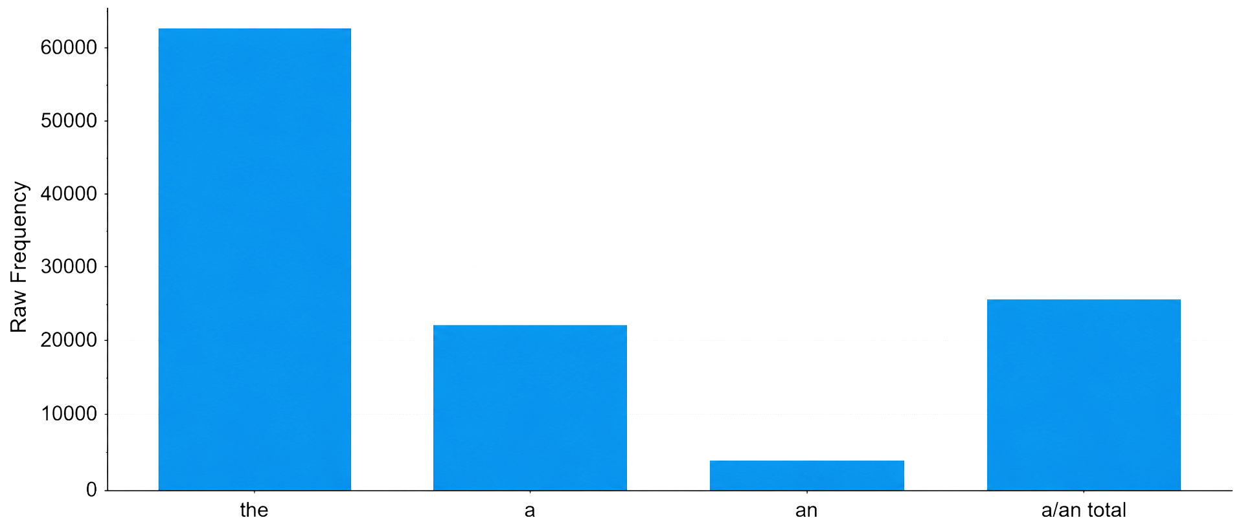
Note. The figure shows raw frequencies, meaning the actual number of article hits before adjustment for corpus size. It presents the absolute occurrence of the, a, an, and the combined a/an category in EENC-2026. The much higher bar for the shows the overall dominance of definite article marking in the corpus.

4.2 Outlet-Based Frequency Patterns
Outlet comparison shows that the definite article is more frequent than the total indefinite category in every outlet. Raw frequencies describe the absolute number of article hits in each outlet, while normalized frequencies describe the rate per million tokens. The Guardian records the highest raw frequency of the, followed by The Telegraph, BBC, and Bloomberg. The New York Times records the highest total a/an frequency. The normalized results confirm that the dominance of the is not simply a result of small differences in outlet token totals.
Table 4: Article Frequencies Across Outlets
Outlet | Tokens | the | a | an | a/an | the per million | a/an per million | the share
AP | 117,779 | 5,926 | 2,129 | 310 | 2,439 | 50,314.57 | 20,708.28 | 70.84%
BBC | 117,478 | 6,408 | 1,880 | 336 | 2,216 | 54,546.38 | 18,863.11 | 74.30%
CNN | 118,407 | 5,716 | 2,351 | 356 | 2,707 | 48,274.17 | 22,861.82 | 67.86%
Reuters | 118,858 | 5,624 | 2,135 | 312 | 2,447 | 47,316.97 | 20,587.59 | 69.68%
The Guardian | 117,662 | 6,680 | 2,272 | 346 | 2,618 | 56,772.79 | 22,250.17 | 71.84%
Bloomberg | 116,116 | 6,366 | 2,262 | 348 | 2,610 | 54,824.49 | 22,477.52 | 70.92%
CNBC | 119,102 | 6,100 | 2,117 | 325 | 2,442 | 51,216.60 | 20,503.43 | 71.41%
The Wall Street Journal | 116,598 | 5,991 | 2,290 | 391 | 2,681 | 51,381.67 | 22,993.53 | 69.08%
The New York Times | 115,795 | 6,018 | 2,405 | 377 | 2,782 | 51,971.16 | 24,025.22 | 68.39%
The Telegraph | 117,098 | 6,482 | 2,073 | 353 | 2,426 | 55,355.34 | 20,717.69 | 72.77%
Figure 2: Raw Frequencies of the Definite Article and Total Indefinite Articles by Outlet
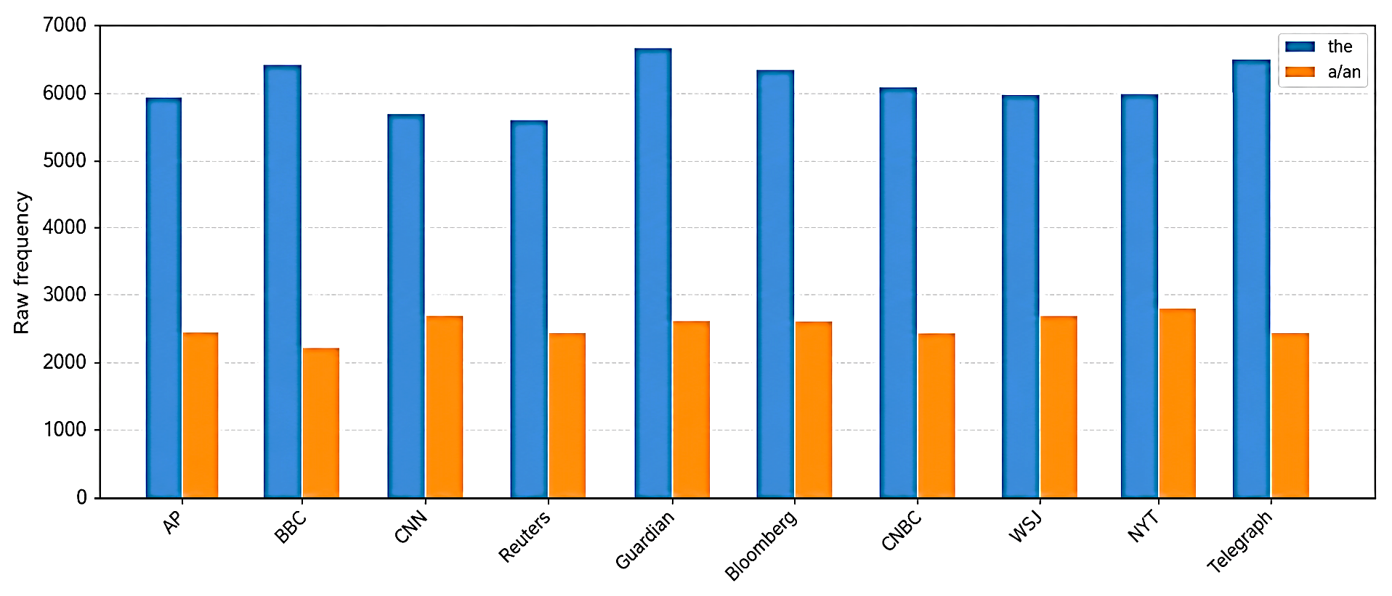
Note. The figure shows raw article frequencies by outlet. Raw frequency means the actual number of hits found within each outlet subcorpus. Because the outlets have slightly different Sketch Engine token totals, these values show absolute volume; Figure 3 provides the standardized rate-based comparison.
Figure 3: Normalized Frequencies per Million Tokens by Outlet
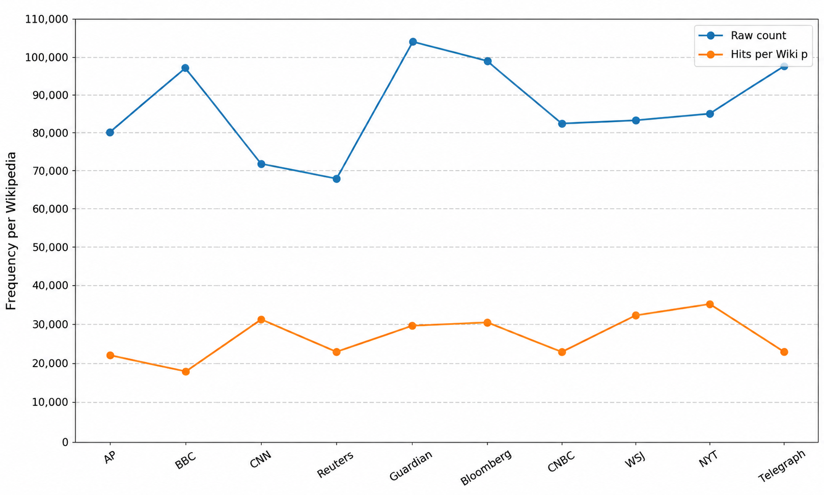
Note. The figure shows normalized article frequencies per million tokens. Normalized frequency is calculated by dividing raw hits by the outlet token total and multiplying by 1,000,000. This standardization allows fair comparison across outlets with slightly different token totals and confirms that the remains more frequent after size adjustment.

4.3 Semantic Reference Types
The 2,000-item reference-coding dataset shows that economic news strongly favors non-generic reference. There are 1,981 non-generic samples and only 19 generic samples. Specific reference also predominates: 1,402 samples are specific and 598 are non-specific. Because the dataset contains 1,000 definite and 1,000 indefinite article noun phrases, definiteness is evenly balanced by design. This means that the sample structure was controlled, while contextual coding was still able to reveal meaningful patterns in specificity and genericity.
Table 5: Overall Semantic Reference Categories in the RQ2 Dataset
Dimension | Category | Frequency | Percentage
Genericity | Generic | 19 | 0.95%
Genericity | Non-generic | 1,981 | 99.05%
Specificity | Specific | 1,402 | 70.10%
Specificity | Non-specific | 598 | 29.90%
Definiteness | Definite | 1,000 | 50.00%
Definiteness | Non-definite | 1,000 | 50.00%
Figure 4: Overall Semantic Reference Categories in the 2,000-Sample Dataset
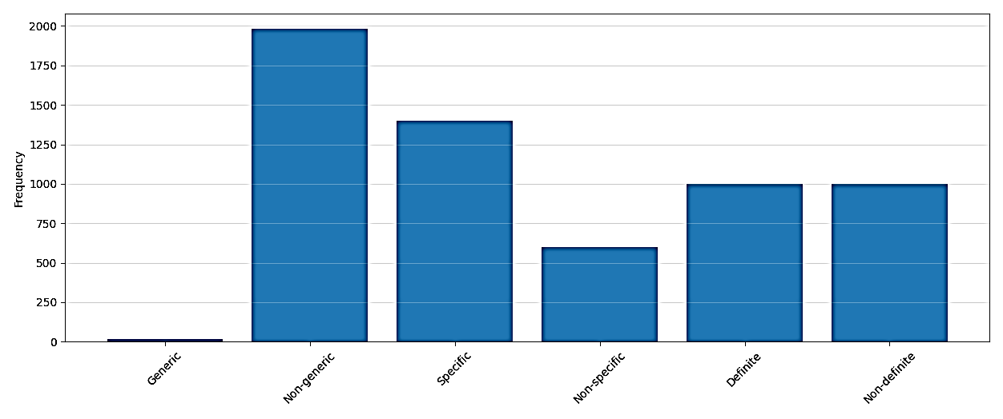
Note. The figure shows the frequency of each semantic reference category in the 2,000-sample RQ2 dataset. These values come from the coding of genericity, specificity, and definiteness. The pattern shows that non-generic and specific references dominate, while generic reference is rare.
Definiteness is structurally linked to article type in this design: definite article samples were coded as definite reference, while indefinite article samples were coded as non-definite reference. The more revealing dimensions are specificity and genericity. Specificity results show that both article types can occur with specific reference, but definite article noun phrases are especially associated with particular institutions, indicators, and event-bound referents. Indefinite article noun phrases are more divided because they often introduce new specific items but also appear in predictive, evaluative, or hypothetical contexts.
Table 6: Specificity by Article Type
Article type | Specific | Non-specific | Specific % | Non-specific %
Definite article | 903 | 97 | 90.30% | 9.70%
Indefinite article | 499 | 501 | 49.90% | 50.10%
Figure 5: Specific and Non-Specific Reference by Article Type
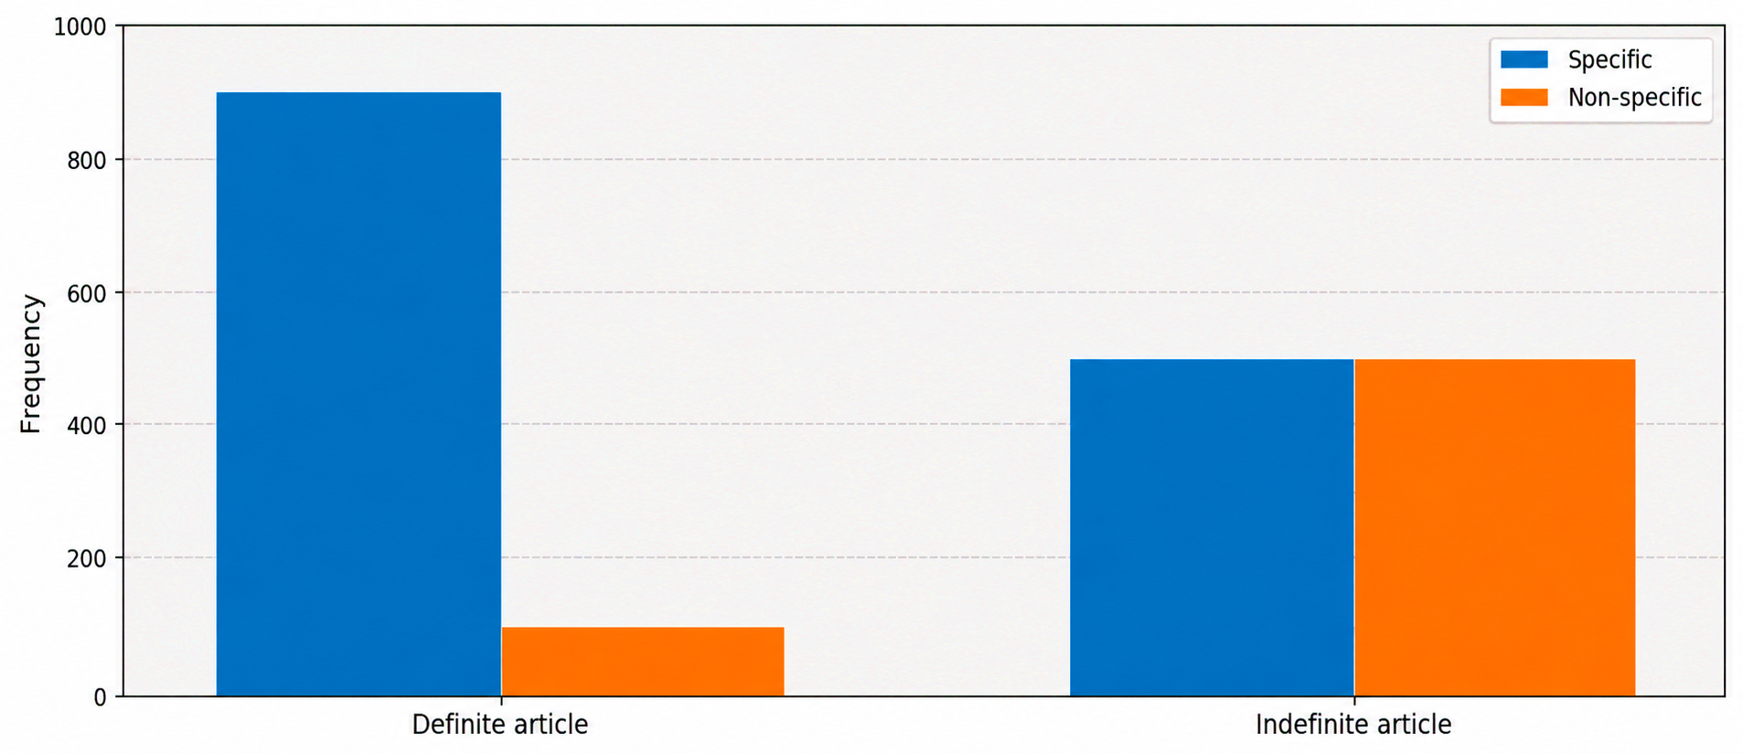
Note. The figure shows how specific and non-specific references are distributed across definite and indefinite article samples. Specific reference means that the noun phrase refers to a particular entity, event, indicator, amount, or context-bound situation. The result shows that definite article samples are mostly specific, while indefinite article samples are divided more evenly between specific and non-specific uses.
Genericity is very low across the dataset. This result suggests that economic news mainly reports particular developments rather than making broad general statements about classes or kinds. Even when nouns such as economy, market, government, or bank appear abstract, they are often tied to a specific national, institutional, temporal, or event-based context.
Table 7: Genericity by Article Type
Article type | Generic | Non-generic | Generic % | Non-generic %
Definite article | 12 | 988 | 1.20% | 98.80%
Indefinite article | 7 | 993 | 0.70% | 99.30%
Figure 6: Generic Reference by Outlet in the RQ2 Sample
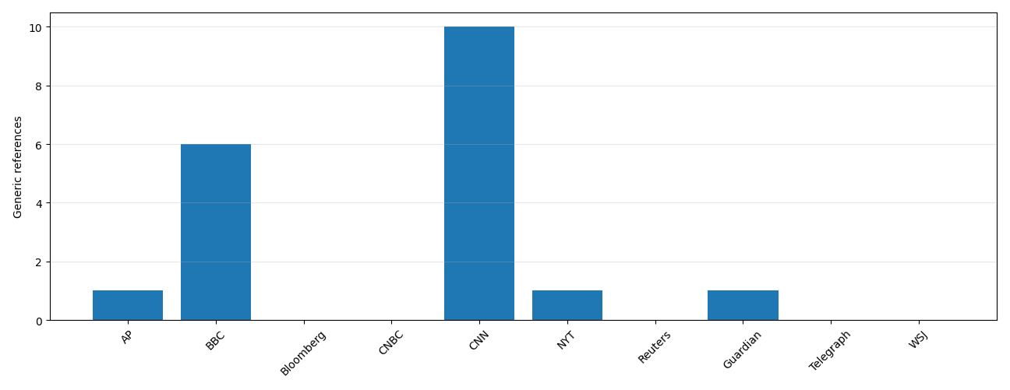
Note. The figure shows the number of generic references in each outlet. Generic reference means reference to a class, kind, domain, or general concept rather than to a particular event or situation. The low values show that economic news mainly reports specific contexts and developments rather than broad generic statements.

4.4 Outlet-Level Semantic Results
Outlet-level semantic results show variation in specificity while maintaining a shared preference for non-generic reference. Bloomberg has the highest number of specific references, while The Telegraph has the lowest. Generic references remain rare overall, although CNN and BBC record slightly more generic cases than most other outlets. This suggests that outlet style may influence the degree of specificity, but the broader discourse pattern remains stable: economic news is mainly event-oriented and non-generic.
Table 8: Semantic Reference Categories by Outlet
Outlet | Rows | Def. article samples | Indef. article samples | Generic | Non-generic | Specific | Non-specific | Definite ref. | Non-definite ref.
AP | 200 | 100 | 100 | 1 | 199 | 140 | 60 | 100 | 100
BBC | 200 | 100 | 100 | 6 | 194 | 137 | 63 | 100 | 100
Bloomberg | 200 | 100 | 100 | 0 | 200 | 168 | 32 | 100 | 100
CNBC | 200 | 100 | 100 | 0 | 200 | 147 | 53 | 100 | 100
CNN | 200 | 100 | 100 | 10 | 190 | 159 | 41 | 100 | 100
NY Times | 200 | 100 | 100 | 1 | 199 | 129 | 71 | 100 | 100
Reuters | 200 | 100 | 100 | 0 | 200 | 129 | 71 | 100 | 100
The Guardian | 200 | 100 | 100 | 1 | 199 | 129 | 71 | 100 | 100
The Telegraph | 200 | 100 | 100 | 0 | 200 | 114 | 86 | 100 | 100
Wall Street Journal | 200 | 100 | 100 | 0 | 200 | 150 | 50 | 100 | 100
Figure 7: Specific and Non-Specific Reference by Outlet
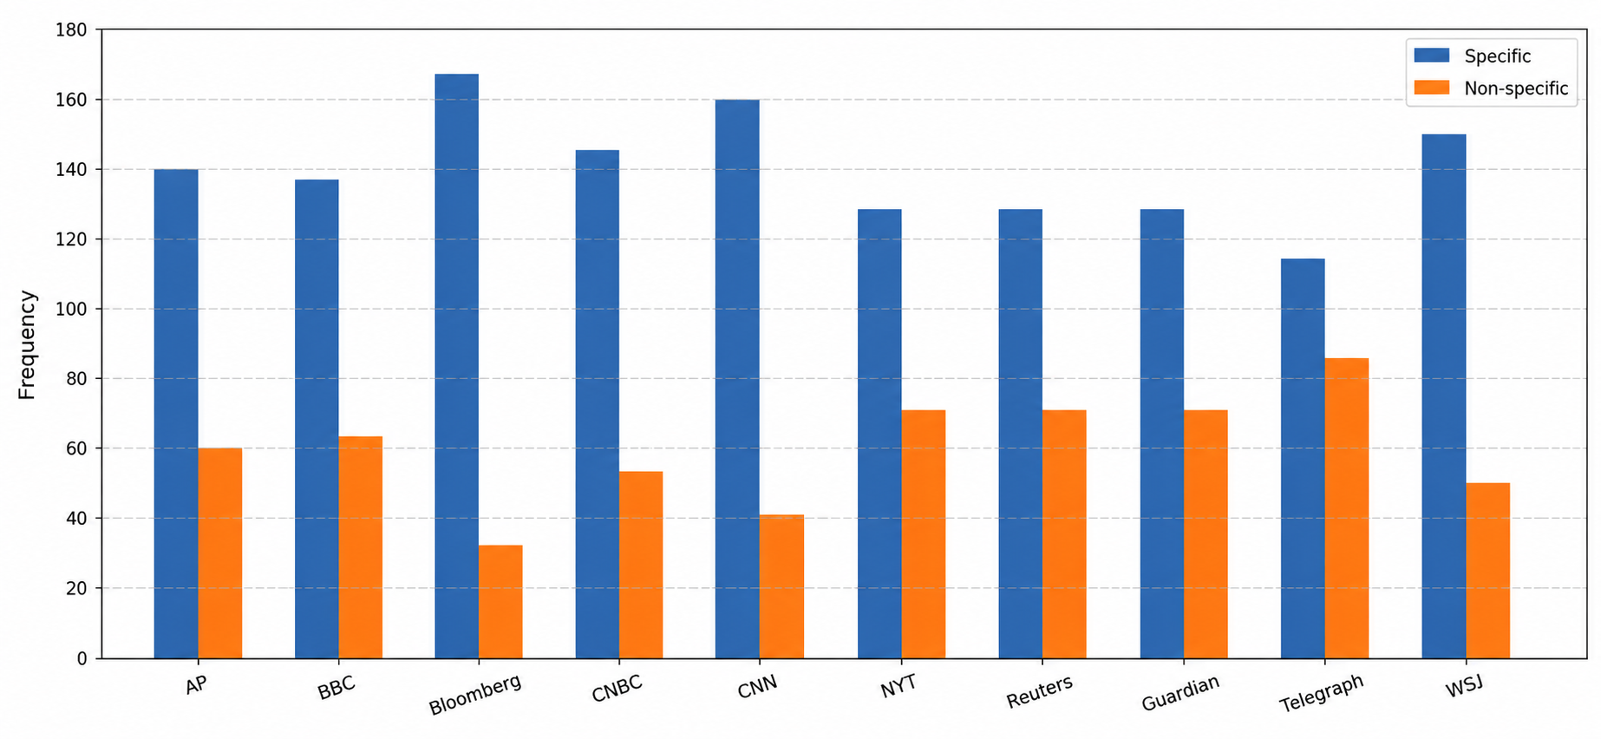
Note. The figure shows outlet-level variation in specific and non-specific reference. Specific reference denotes particular entities, events, indicators, institutions, or amounts, whereas non-specific reference denotes hypothetical, abstract, evaluative, or less concrete meanings. Specific reference is dominant in most outlets, although the size of the difference varies.

4.5 Reliability and Statistical Tests
Inter-coder reliability was strong. Pairwise similarity reached 96.50% for Intercoder 1 versus Intercoder 2, 95.83% for Intercoder 1 versus Intercoder 3, and 96.33% for Intercoder 2 versus Intercoder 3. Overall kappa values were high, showing that the coding framework was applied consistently. The strongest agreement appeared in definiteness because article type provided a clear structural cue, while specificity and genericity required more contextual judgment.
Table 9: Pairwise Inter-Coder Similarity and Overall Kappa
Pair | Same cells | Different cells | Similarity (%) | Overall kappa
Intercoder 1 vs Intercoder 2 | 579 | 21 | 96.50 | 0.956
Intercoder 1 vs Intercoder 3 | 575 | 25 | 95.83 | 0.947
Intercoder 2 vs Intercoder 3 | 578 | 22 | 96.33 | 0.954
Table 10: Fleiss' Kappa by Semantic Dimension
Dimension | Fleiss' kappa | Observed agreement | Expected agreement
Genericity | 0.819 | 0.953 | 0.743
Specificity | 0.825 | 0.933 | 0.618
Definiteness | 1.00 | 1.00 | 0.500
Figure 8: Pairwise Inter-Coder Similarity Across All Coding Cells
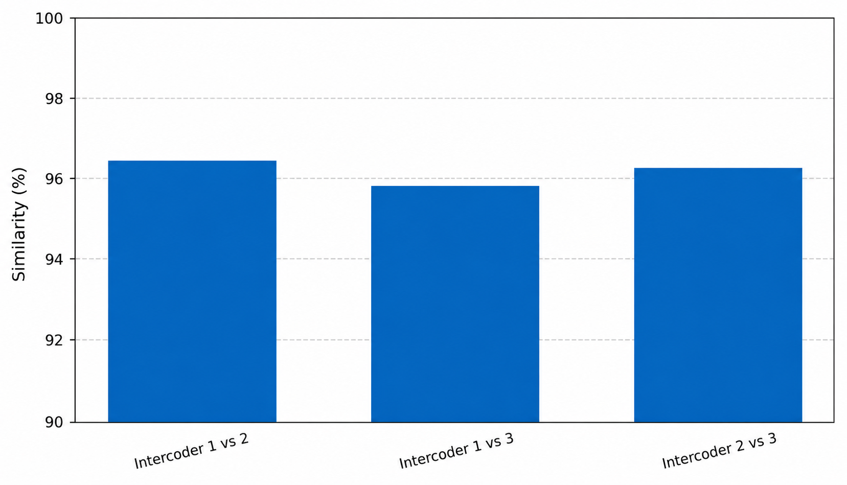
Note. The figure shows pairwise similarity between the three anonymized intercoders across 600 coding cells in the reliability subset. Similarity is the percentage of coding decisions that match between two intercoders. The high percentages indicate consistent application of the semantic coding framework.
Figure 9: Inter-Coder Reliability by Semantic Dimension
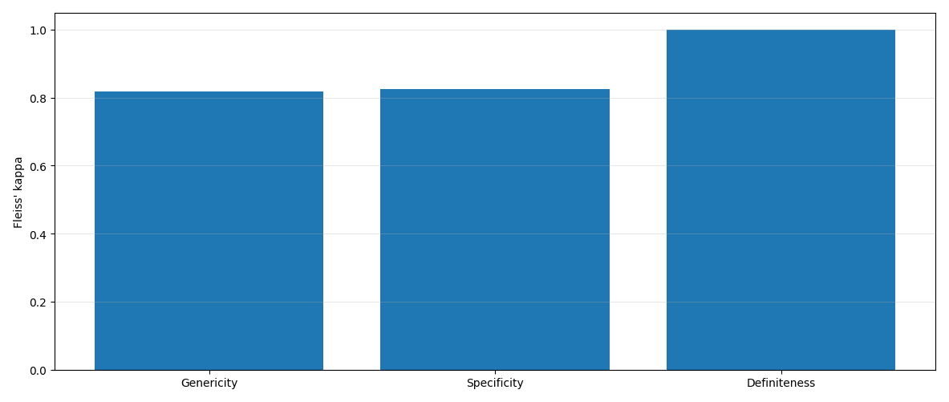
Note. The figure shows Fleiss' kappa for genericity, specificity, and definiteness. Kappa evaluates observed agreement in relation to the degree of agreement expected by chance. Values above .80 indicate strong reliability, and definiteness achieves full agreement because of its structural alignment with the article-type sampling design.
Chi-square tests confirm significant associations between article type and several semantic coding results. The strongest association appears between article type and definiteness because the sample distinguishes definite and indefinite article forms by design. The specificity and genericity tests are more analytically important because they show how article type interacts with semantic reference rather than simply marking a formal grammatical opposition.
Table 11: Summary of Chi-Square Tests and Effect Sizes
Test | Categories | Chi-square | df | p | Cramer's V | Interpretation
Outlet x article category | the vs a/an | 151.21 | 9 | < .001 | .042 | Significant outlet variation; small effect
Article type x definiteness | definite vs non-definite | 1996.00 | 1 | < .001 | .999 | Perfect alignment in the coded sample
Article type x specificity | specific vs non-specific | 387.43 | 1 | < .001 | .440 | Moderate association
Article type x genericity | generic vs non-generic | 0.85 | 1 | .357 | .021 | No meaningful article-type difference
Outlet x specificity | specific vs non-specific | 55.86 | 9 | < .001 | .167 | Significant outlet variation; small-to-moderate effect
Outlet x genericity | generic vs non-generic | 54.68 | 9 | < .001 | .165 | Significant but interpreted cautiously because generic cases are rare

5. Discussion
The findings indicate that the most common overt article form in English economic news is the definite article the. This dominance reflects the communicative requirements of the register. Economic journalists frequently refer to institutions, indexes, markets, policies, and public entities that are assumed to be identifiable to the reader. Expressions such as the economy, the market, the Federal Reserve, the government, and the inflation rate are not merely grammatical noun phrases; they are discourse strategies that present economic entities as identifiable and relevant in the news context.
This result is consistent with definiteness theories that link identifiability and shared knowledge (Gundel et al., 1993; Hawkins, 1978; Lyons, 1999). In economic reporting, identifiability often comes from institutional knowledge rather than previous mention. Readers of economic news are expected to understand the domain, so a journalist can mention the market or the central bank without first introducing the referent. This explains why the is much more frequent than a/an across all ten outlets.
The semantic results also demonstrate the importance of specificity in economic-news discourse. Most sampled noun phrases refer to particular events, institutions, indicators, reports, dates, amounts, or financial situations. This supports the distinction between definiteness and specificity (Fodor & Sag, 1982; Heim, 1982; von Heusinger, 2002). Although definite noun phrases are strongly associated with specific reference, indefinite noun phrases are not automatically non-specific. Examples such as a new report or an increase can introduce new but still specific referents.
One of the clearest findings is the very low level of genericity. Only 19 of the 2,000 samples are generic references. This suggests that economic news prioritizes reporting context-bound developments rather than making broad class-level claims. Even apparently general terms often function as non-generic references when tied to a particular economy, market movement, policy decision, or data release. This finding extends earlier discussions of genericity by showing that professional economic journalism strongly prefers event-based reference over class-level generalization (Carlson, 1977; Chierchia, 1998; Krifka et al., 1995).
Although outlet variation exists, it does not reverse the overall pattern. Every outlet shows the same broad tendency: the is more frequent than a/an, specific reference is more frequent than non-specific reference, and non-generic reference dominates. Outlet differences are therefore best interpreted as editorial and stylistic variation within a shared register. Financial outlets such as Bloomberg, Reuters, and The Wall Street Journal may emphasize highly specific market or institutional references, while general news outlets may include somewhat broader explanatory framing.
Methodologically, the study shows the value of combining corpus frequency with semantic coding. Frequency counts alone show that the is dominant, but they cannot explain what kinds of reference article forms mark. Semantic coding adds this interpretive layer, and inter-coder reliability supports the consistency of the framework. The balanced corpus design also improves comparability by giving each outlet equal word-level representation. This combined corpus-frequency and semantic-coding approach can be applied to other grammatical features in specialized news discourse.

6. Conclusion
This study examined definite and indefinite articles in English economic news using EENC-2026, a balanced one-million-word corpus compiled from ten selected outlets. The frequency results show that the definite article the is much more frequent than the indefinite articles a/an. The semantic results show that article-marked noun phrases in economic news are mostly specific and non-generic. These findings indicate that articles play an important role in how economic journalism presents entities, events, institutions, indicators, and developments as identifiable or context-bound. The study contributes to article research by showing how definiteness, specificity, and genericity operate in a specialized professional register. It also supports corpus-based discourse analysis by combining outlet-balanced frequency analysis with a 2,000-item semantic coding dataset and inter-coder reliability checking. The study is limited to overt definite and indefinite articles, ten outlets, and one three-month period. Future research could extend the time span, compare economic news with other registers, or examine related noun-phrase features such as modifiers, possessives, quantifiers, and proper-name reference.

References
Akbarova, F. S. (2024). The characteristics of discourse in economic texts. Path of Science, 10(2), 1015-1020. https://doi.org/10.22178/pos.101-15
Anthony, L. (2020). AntConc (Version 3.5.9) [Computer software]. Waseda University. https://www.laurenceanthony.net/software
Baroni, M., & Bernardini, S. (2004). BootCaT: Bootstrapping corpora and terms from the web. In M. T. Lino, M. F. Xavier, F. Ferreira, R. Costa, & R. Silva (Eds.), Proceedings of LREC 2004 (pp. 1313-1316). European Language Resources Association.
Bednarek, M., & Caple, H. (2012). News discourse. Continuum.
Bell, A. (1991). The language of news media. Blackwell.
Biber, D. (2006). University language: A corpus-based study of spoken and written registers. John Benjamins.
Biber, D., & Conrad, S. (2009). Register, genre, and style. Cambridge University Press.
Biber, D., & Conrad, S. (2019). Register, genre, and style (2nd ed.). Cambridge University Press.
Biber, D., Conrad, S., & Reppen, R. (2021). Corpus linguistics: Investigating language structure and use. Cambridge University Press.
Biber, D., Johansson, S., Leech, G., Conrad, S., & Finegan, E. (1999). Longman grammar of spoken and written English. Longman.
Carlson, G. N. (1977). Reference to kinds in English. Garland Publishing.
Carlson, G. N., & Pelletier, F. J. (Eds.). (1995). The generic book. University of Chicago Press.
Chierchia, G. (1998). Reference to kinds across languages. Natural Language Semantics, 6(4), 339-405.
Clancy, B., & Vaughan, E. (2023). Using corpus linguistics to interpret economic news texts. In B. Clancy & E. Vaughan (Eds.), Corpus linguistics and business communication (pp. 185-210). Routledge. https://doi.org/10.4324/9781003154747-10
Delice, P., & Pinto, D. (2025). Decoding economic insights: The analytical power of news content. Journal of Scientometric Research, 14(1), 365-372. https://doi.org/10.5530/jscires.20251459
Derkach, K., & Alexopoulou, T. (2024). Definite and indefinite article accuracy in learner English. Studies in Second Language Acquisition, 46(2), 385-418. https://doi.org/10.1017/S0272263123000463
Fairclough, N. (1995). Media discourse. Edward Arnold.
Fodor, J. D., & Sag, I. A. (1982). Referential and quantificational indefinites. Linguistics and Philosophy, 5(3), 355-398.
Gundel, J. K., Hedberg, N., & Zacharski, R. (1993). Cognitive status and the form of referring expressions in discourse. Language, 69(2), 274-307.
Hawkins, J. A. (1978). Definiteness and indefiniteness: A study in reference and grammaticality prediction. Croom Helm.
Heim, I. (1982). The semantics of definite and indefinite noun phrases [Doctoral dissertation, University of Massachusetts Amherst].
Huddleston, R., & Pullum, G. K. (2002). The Cambridge grammar of the English language. Cambridge University Press.
Hunston, S. (2022). Corpora in applied linguistics (2nd ed.). Cambridge University Press.
IBM Corp. (2020). IBM SPSS Statistics for Windows (Version 27.0) [Computer software]. IBM Corp.
Kilgarriff, A., Baisa, V., Busta, J., Jakubicek, M., Kovar, V., Michelfeit, J., Rychly, P., & Suchomel, V. (2014). The Sketch Engine: Ten years on. Lexicography, 1(1), 7-36.
Krifka, M., Pelletier, F. J., Carlson, G. N., ter Meulen, A., Chierchia, G., & Link, G. (1995). Genericity: An introduction. In G. N. Carlson & F. J. Pelletier (Eds.), The generic book (pp. 1-124). University of Chicago Press.
Lei, H. (2025). Navigating health communication in China: A corpus-based critical discourse analysis of post-pandemic news reports. Humanities and Social Sciences Communications, 12, Article 47727. https://doi.org/10.1057/s41599-025-04727-w
Li, L., & Gao, F. (2023). Contrasting semantic and sentimental features of economic news texts: A corpus-based study. Social Sciences & Humanities Open, 7(1), Article 100435. https://doi.org/10.1016/j.ssaho.2023.100435
Lyons, C. (1999). Definiteness. Cambridge University Press.
McEnery, T., & Hardie, A. (2012). Corpus linguistics: Method, theory and practice. Cambridge University Press.
Park, S. (2023). Corpus analysis of L2 English article occurrence patterns: Focus on genericity. Cogent Education, 10(1), Article 2197662. https://doi.org/10.1080/2331186X.2023.2197662
Poesio, M., & Vieira, R. (1998). A corpus-based investigation of definite description use. Computational Linguistics, 24(2), 183-216. https://doi.org/10.1162/089120198563456
Quirk, R., Greenbaum, S., Leech, G., & Svartvik, J. (1985). A complete grammar of the English language. Longman.
Salih, A. M. M., Ibrahim, H. H., & Ahmed, S. I. (2024). The occurrence of noun post-modifiers in political news: A corpus-based study. International Journal of Social Sciences & Educational Studies, 11(3), 64-91. https://doi.org/10.23918/ijsses.v11i3p64
Sinclair, J. (1991). Corpus, concordance, collocation. Oxford University Press.
Stefanowitsch, A. (2020). Corpus linguistics: A guide to the methodology. Language Science Press.
Valdeón, R. A. (2025). Journalistic translation research twenty-five years on: Methods, topics, and prospects. Perspectives: Studies in Translation Theory and Practice, 33(4), 635-653. https://doi.org/10.1080/0907676X.2025.2516364
von Heusinger, K. (2002). Specificity and definiteness in sentence and discourse structure. Journal of Semantics, 19(3), 245-274.

Appendices

Appendix A: Semantic Coding Framework
The definitions described in the methodology and inter-coder form were used throughout the semantic reference coding framework.
Appendix Table A1: Semantic Coding Framework
Code | Dimension | Reference name | Definition
1 | Genericity | Generic reference | Class, kind, domain, or general concept
2 | Genericity | Non-generic reference | Particular situation, event, entity, dataset, or context-bound referent
3 | Specificity | Specific reference | Particular identifiable entity, event, institution, indicator, or amount
4 | Specificity | Non-specific reference | Hypothetical, predictive, abstract, evaluative, general, or not a concrete instance
5 | Definiteness | Definite reference | Identifiable, unique, previously mentioned, or contextually known
6 | Definiteness | Non-definite reference | Introduced, open, nonspecific, or not uniquely identifiable in context

Appendix B: Sample Coding Table
The format of the semantic coding table is shown in the following extract. The complete RQ2 dataset contains 2,000 coded samples.
Appendix Table B1: Sample Semantic Coding Extract
No. | Outlet | Noun phrase | Article type | Genericity | Specificity | Definiteness | Reason
1 | AP | the euro currency union | Definite article | Non-generic | Specific | Definite | A context-bound institutional/economic entity joined by Bulgaria.
2 | AP | the European Union's shared currency area | Definite article | Non-generic | Specific | Definite | A uniquely identifiable economic area specified by the phrase.
3 | AP | the eurozone | Definite article | Non-generic | Specific | Definite | A named economic region identifiable to readers.
4 | AP | the Federal Reserve | Definite article | Non-generic | Specific | Definite | A unique institution in the economic-news context.
5 | AP | the economy | Definite article | Non-generic | Specific | Definite | The phrase refers to the economy discussed in the article context.
6 | AP | a long-standing national goal | Indefinite article | Non-generic | Specific | Non-definite | A particular goal achieved by Bulgaria is introduced.
7 | AP | a common currency | Indefinite article | Non-generic | Specific | Non-definite | A particular currency arrangement in the eurozone context is introduced.
8 | AP | a growing economy | Indefinite article | Non-generic | Non-specific | Non-definite | A possible economic condition is discussed rather than a concrete instance.
9 | AP | a significant increase | Indefinite article | Non-generic | Specific | Non-definite | A particular reported increase is introduced in the sentence.
10 | AP | a potential listing | Indefinite article | Non-generic | Non-specific | Non-definite | The phrase refers to a possible future listing rather than an actualized instance.

Appendix C: Inter-Coder Reliability Summary
Appendix Table C1: Pairwise Inter-Coder Similarity
Appendix Table C2: Reliability by Semantic Dimension
Dimension |  | Fleiss' kappa |  | Observed agreement |  | Expected agreement
Genericity |  | 0.819 |  | 0.953 |  | 0.743
Specificity |  | 0.825 |  | 0.933 |  | 0.618
Definiteness |  | 1.00 |  | 1.00 |  | 0.500
Pair | Same cells |  | Different cells |  | Similarity (%) |  | Overall kappa
Intercoder 1 vs Intercoder 2 | 579 |  | 21 |  | 96.50 |  | 0.956
Intercoder 1 vs Intercoder 3 | 575 |  | 25 |  | 95.83 |  | 0.947
Intercoder 2 vs Intercoder 3 | 578 |  | 22 |  | 96.33 |  | 0.954

Appendix D: Corpus Frequency Tables
Appendix Table D1: Corpus Frequency Table by Outlet
Outlet | Tokens | the | a | an | a/an | the per million | a/an per million | the share
AP | 117,779 | 5,926 | 2,129 | 310 | 2,439 | 50,314.57 | 20,708.28 | 70.84%
BBC | 117,478 | 6,408 | 1,880 | 336 | 2,216 | 54,546.38 | 18,863.11 | 74.30%
CNN | 118,407 | 5,716 | 2,351 | 356 | 2,707 | 48,274.17 | 22,861.82 | 67.86%
Reuters | 118,858 | 5,624 | 2,135 | 312 | 2,447 | 47,316.97 | 20,587.59 | 69.68%
The Guardian | 117,662 | 6,680 | 2,272 | 346 | 2,618 | 56,772.79 | 22,250.17 | 71.84%
Bloomberg | 116,116 | 6,366 | 2,262 | 348 | 2,610 | 54,824.49 | 22,477.52 | 70.92%
CNBC | 119,102 | 6,100 | 2,117 | 325 | 2,442 | 51,216.60 | 20,503.43 | 71.41%
The Wall Street Journal | 116,598 | 5,991 | 2,290 | 391 | 2,681 | 51,381.67 | 22,993.53 | 69.08%
The New York Times | 115,795 | 6,018 | 2,405 | 377 | 2,782 | 51,971.16 | 24,025.22 | 68.39%
The Telegraph | 117,098 | 6,482 | 2,073 | 353 | 2,426 | 55,355.34 | 20,717.69 | 72.77%
Appendix E: Sample of Sketch Engine Random Sampling Procedure
Screenshots of the Sketch Engine random sampling process used for the second research question are shown in this appendix. The example comes from The Wall Street Journal and displays the 200 concordance lines selected for article-based semantic coding. Only representative pages are shown to document the sampling procedure without reproducing full copyrighted articles.
Appendix Figure E1: Sketch Engine random sample showing the Sample 200 setting and the first concordance lines.
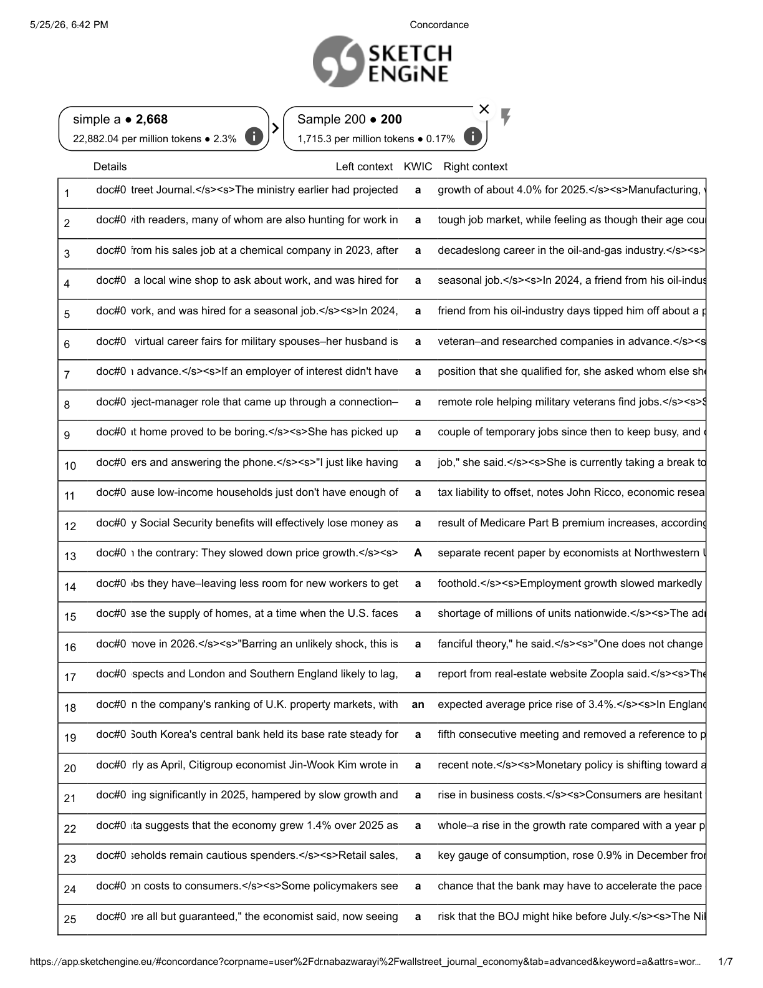
Appendix Figure E2: Continuation of the Sketch Engine random sample concordance lines.
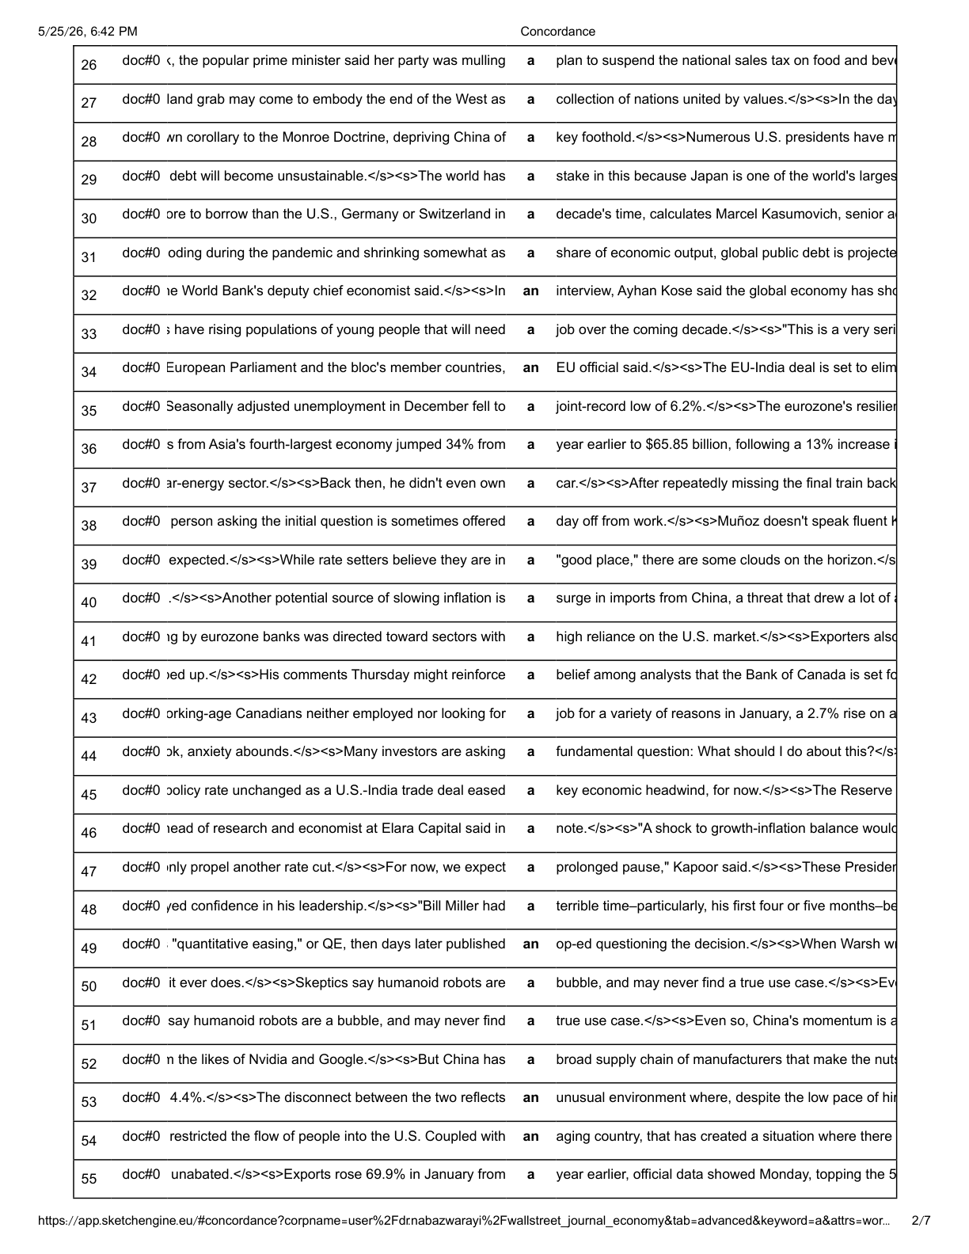
Appendix F: Sample Outlet-Level R2 Reference Coding Table
A sample page from the outlet-level R2 reference coding document is provided in this appendix. The example demonstrates how the Wall Street Journal sample records original sentence context, article type, and the three semantic codes used in the analysis.
Appendix Figure F1: Sample page from the Wall Street Journal R2 reference coding table.
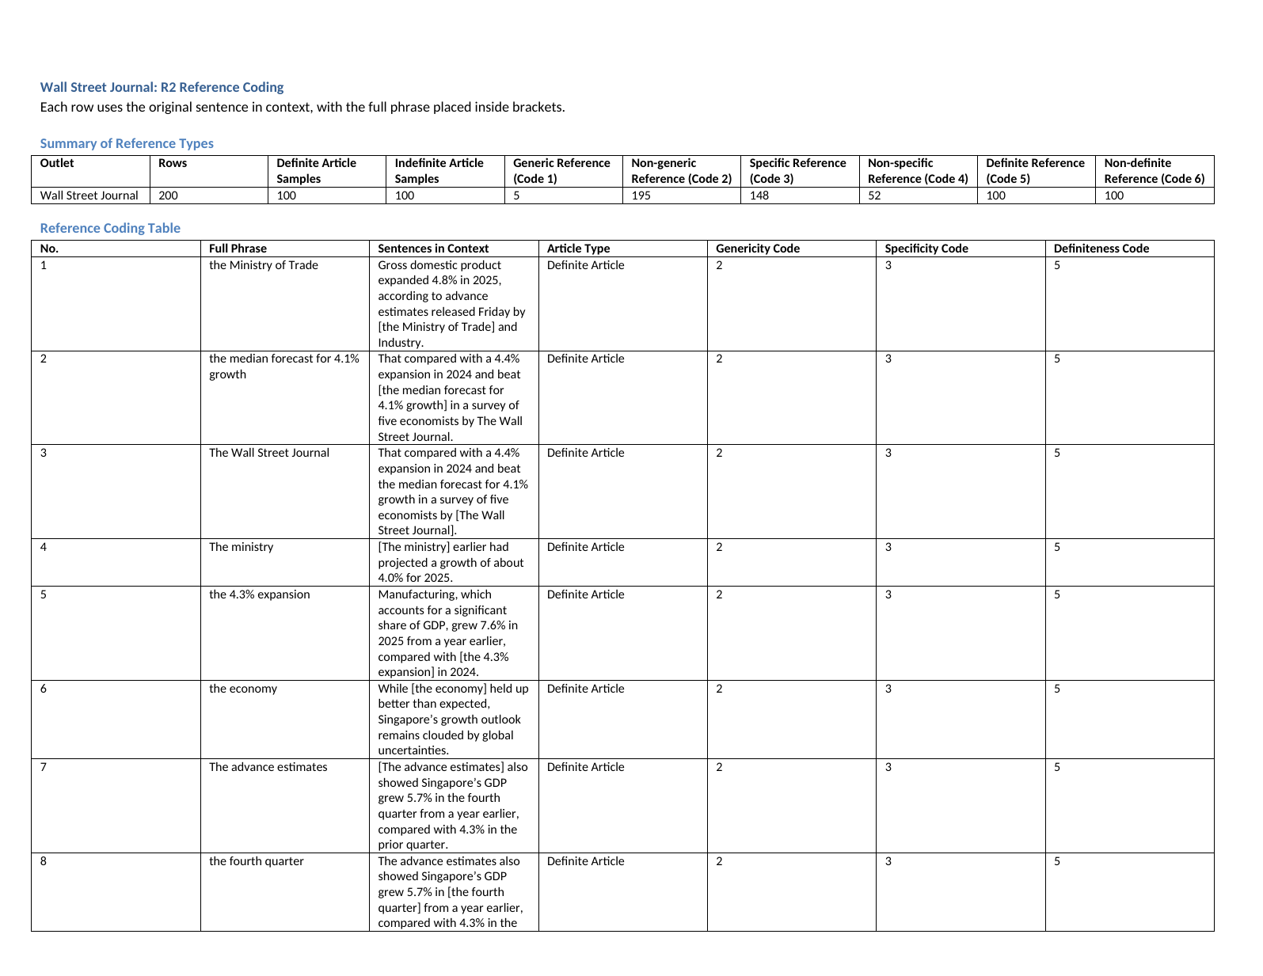
Appendix G: Sample Inter-Coder Reliability Coding Form
Representative pages from the inter-coder reliability coding form are included in this appendix. Three anonymized intercoders used the form to assign one code to each semantic dimension: definiteness, specificity, and genericity.
Appendix Figure G1: Inter-coder reliability form: introductory instructions, consent statement, sample design, and semantic code key.
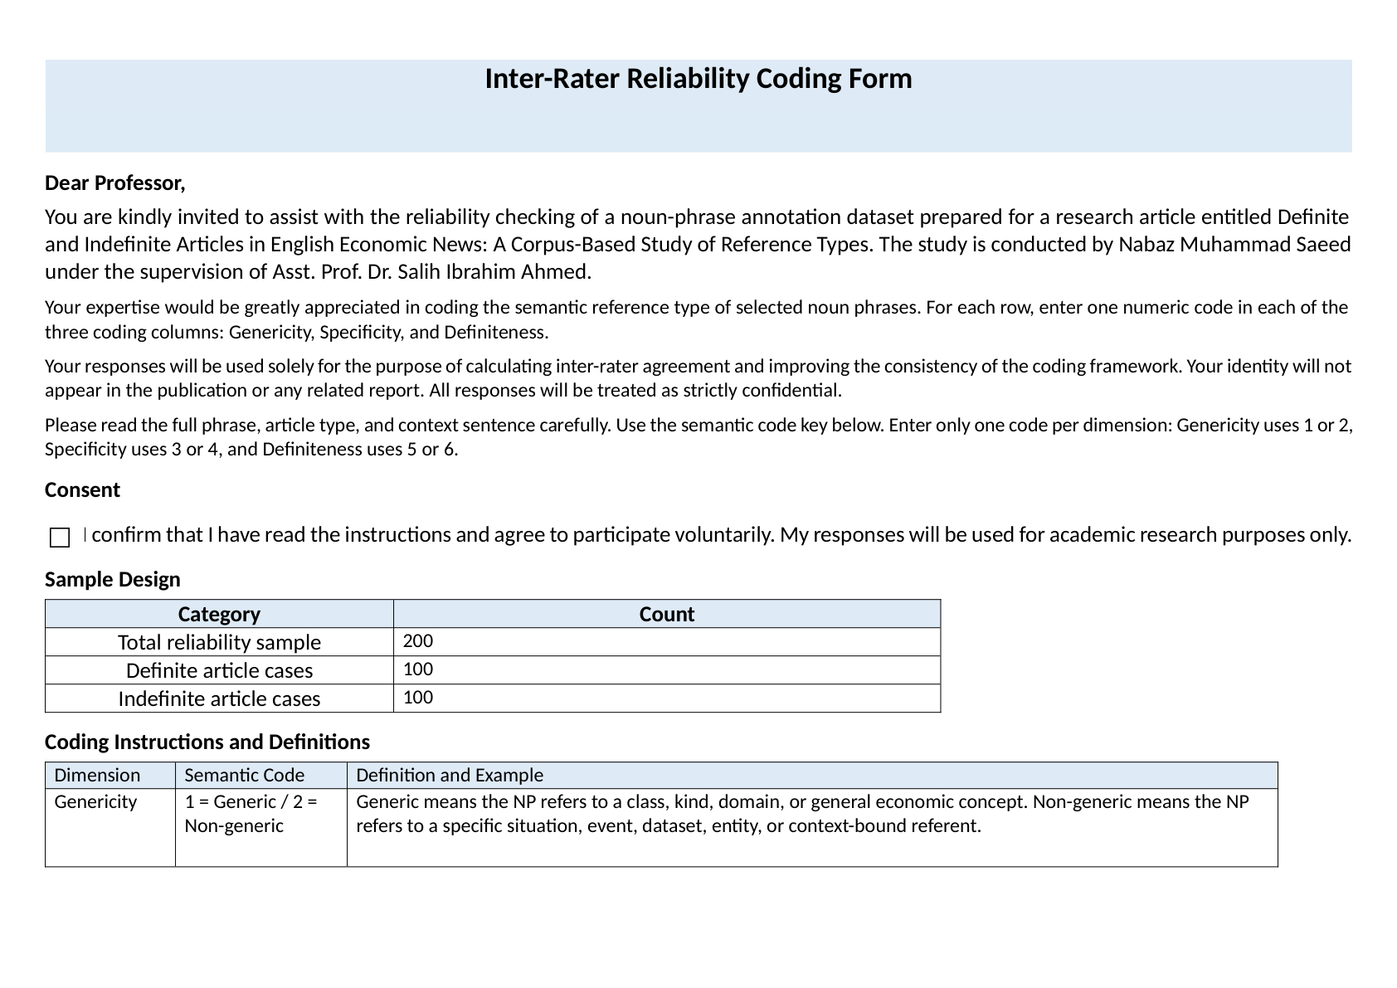
Appendix Figure G2: Inter-coder reliability form: example item and response format for semantic coding.
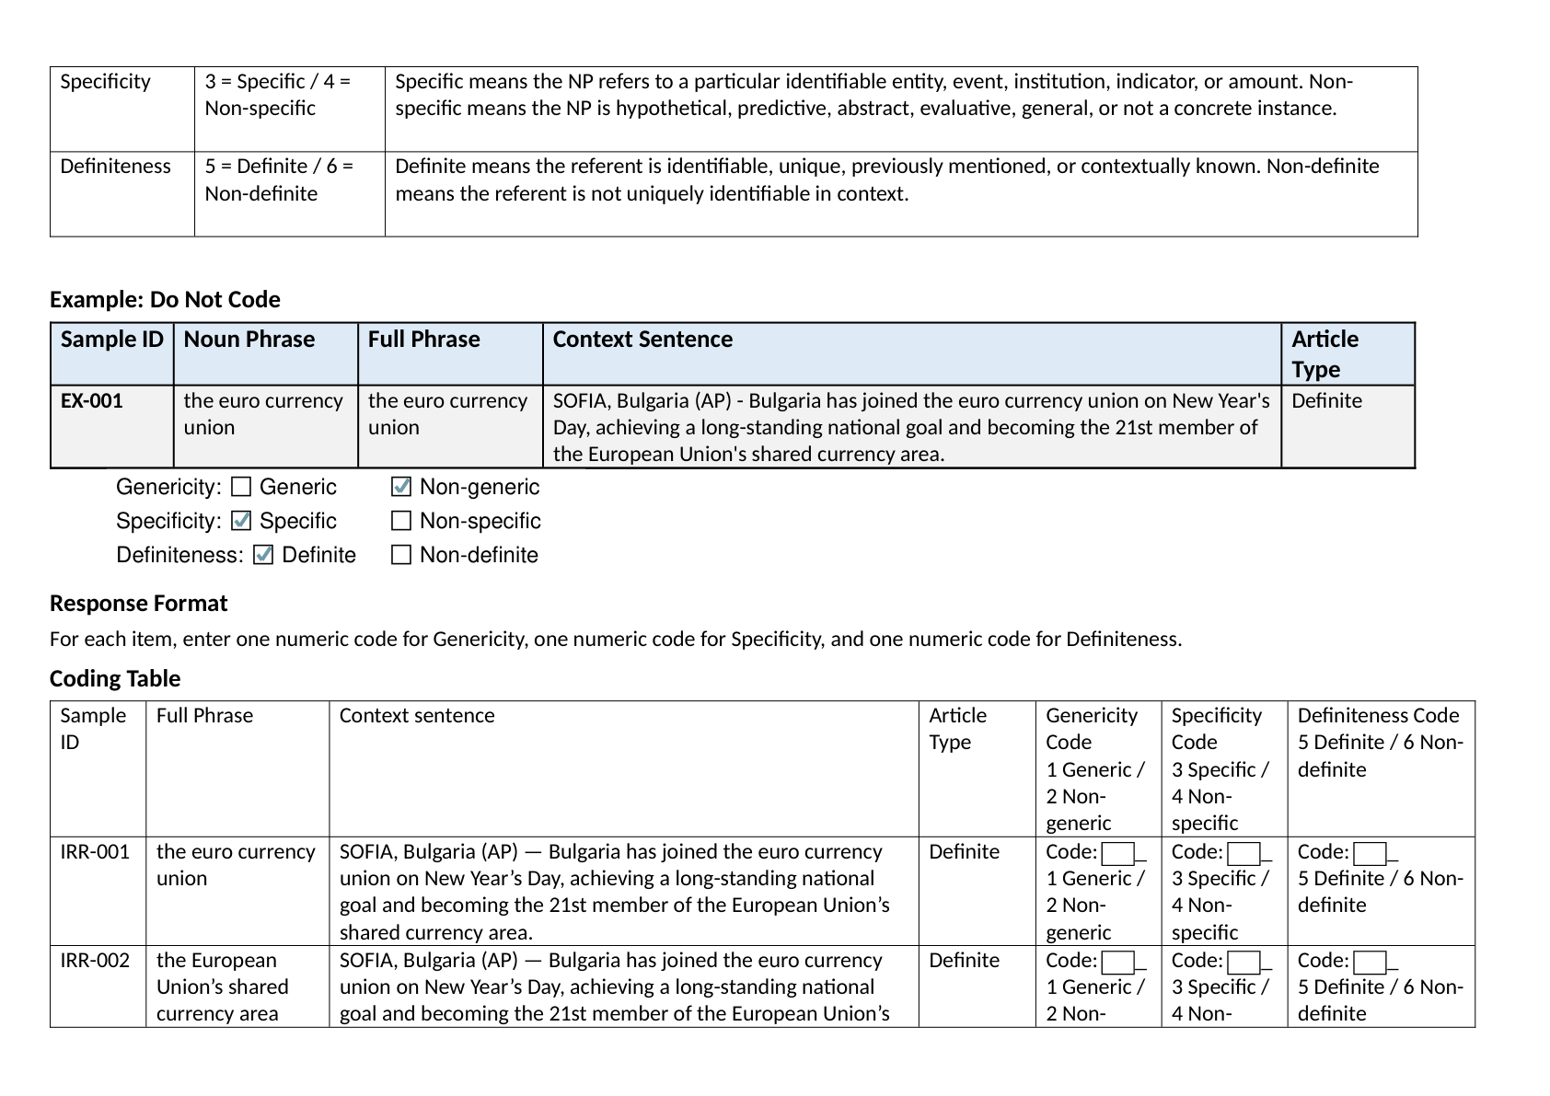
Appendix Figure G3: Inter-coder reliability form: sample coding rows from the 200-item reliability subset.
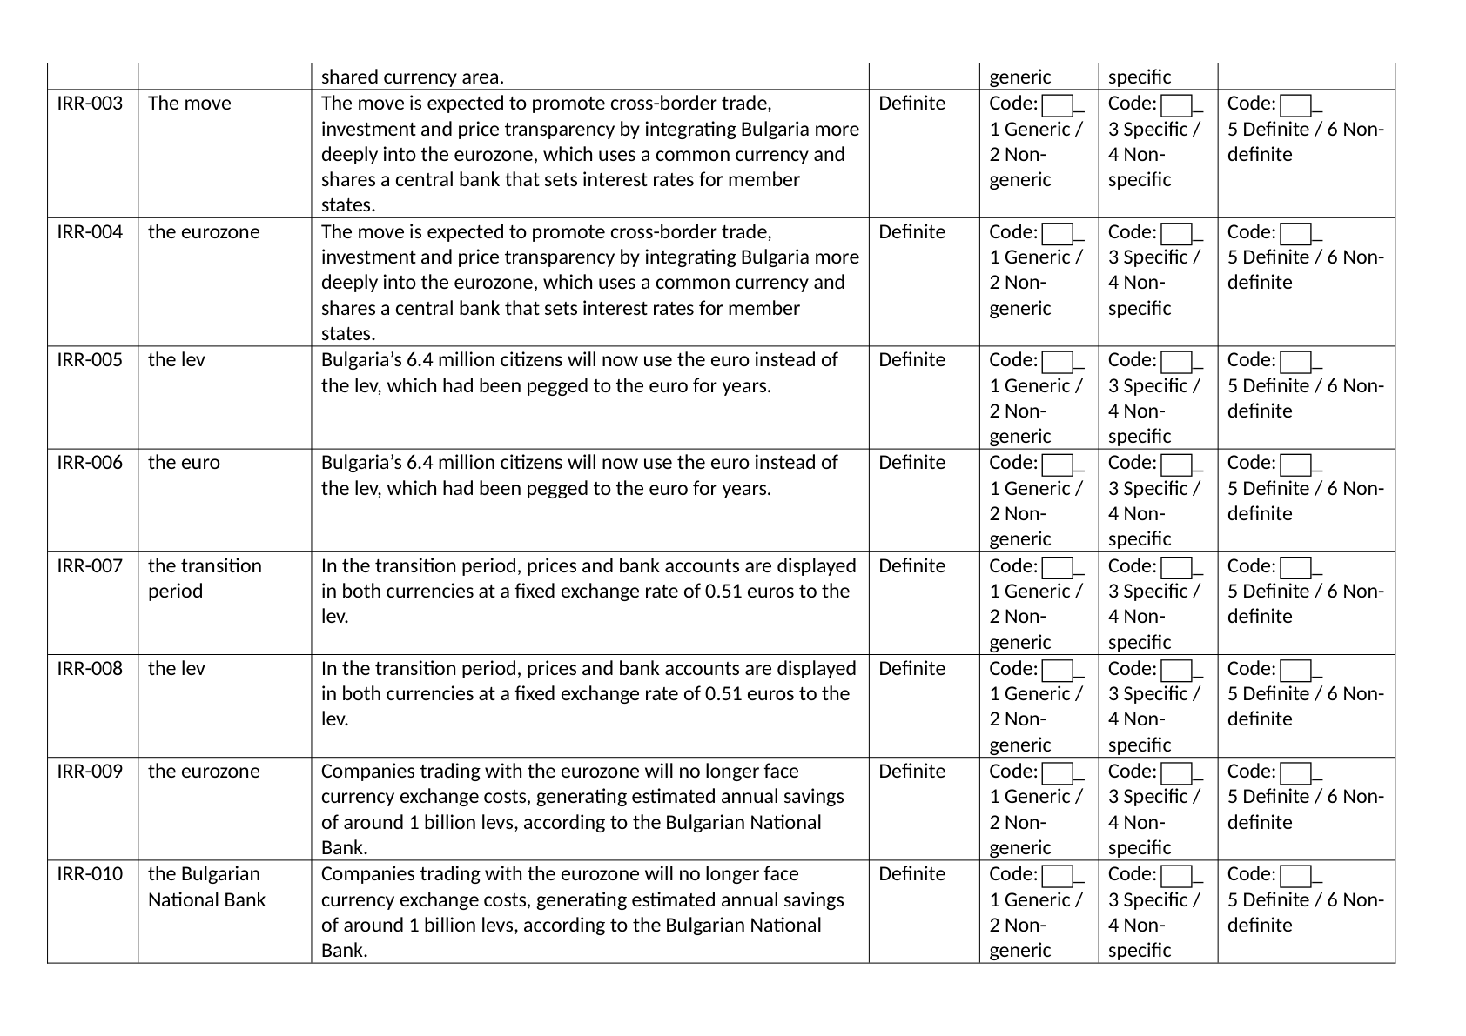
Appendix H: Sample Sketch Engine Concordance for Definite-Article Frequency Extraction
This appendix provides a sample of the Sketch Engine concordance used to extract the frequency of the definite article the in EENC-2026. The screenshot shows 61,311 hits and 52,184.37 occurrences per million tokens.
Appendix Figure H1: Sketch Engine concordance sample for the definite article the
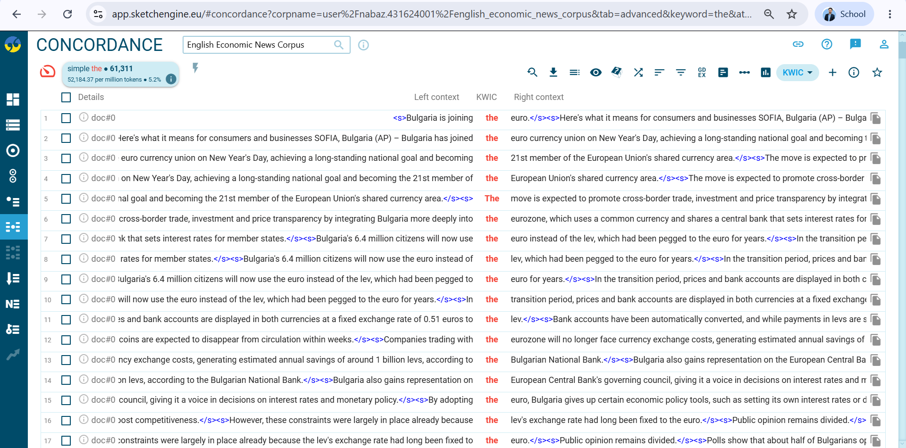
Note. The figure shows the left and right contexts of the keyword-in-context (KWIC) concordance. The full concordance output is not reproduced in order to avoid unnecessary length and copyright-sensitive language reuse.

Appendix I: Sample Sketch Engine Concordance for Indefinite-Article Frequency Extraction
Appendix Figure I1: Sample Sketch Engine Concordance for the Indefinite Article a
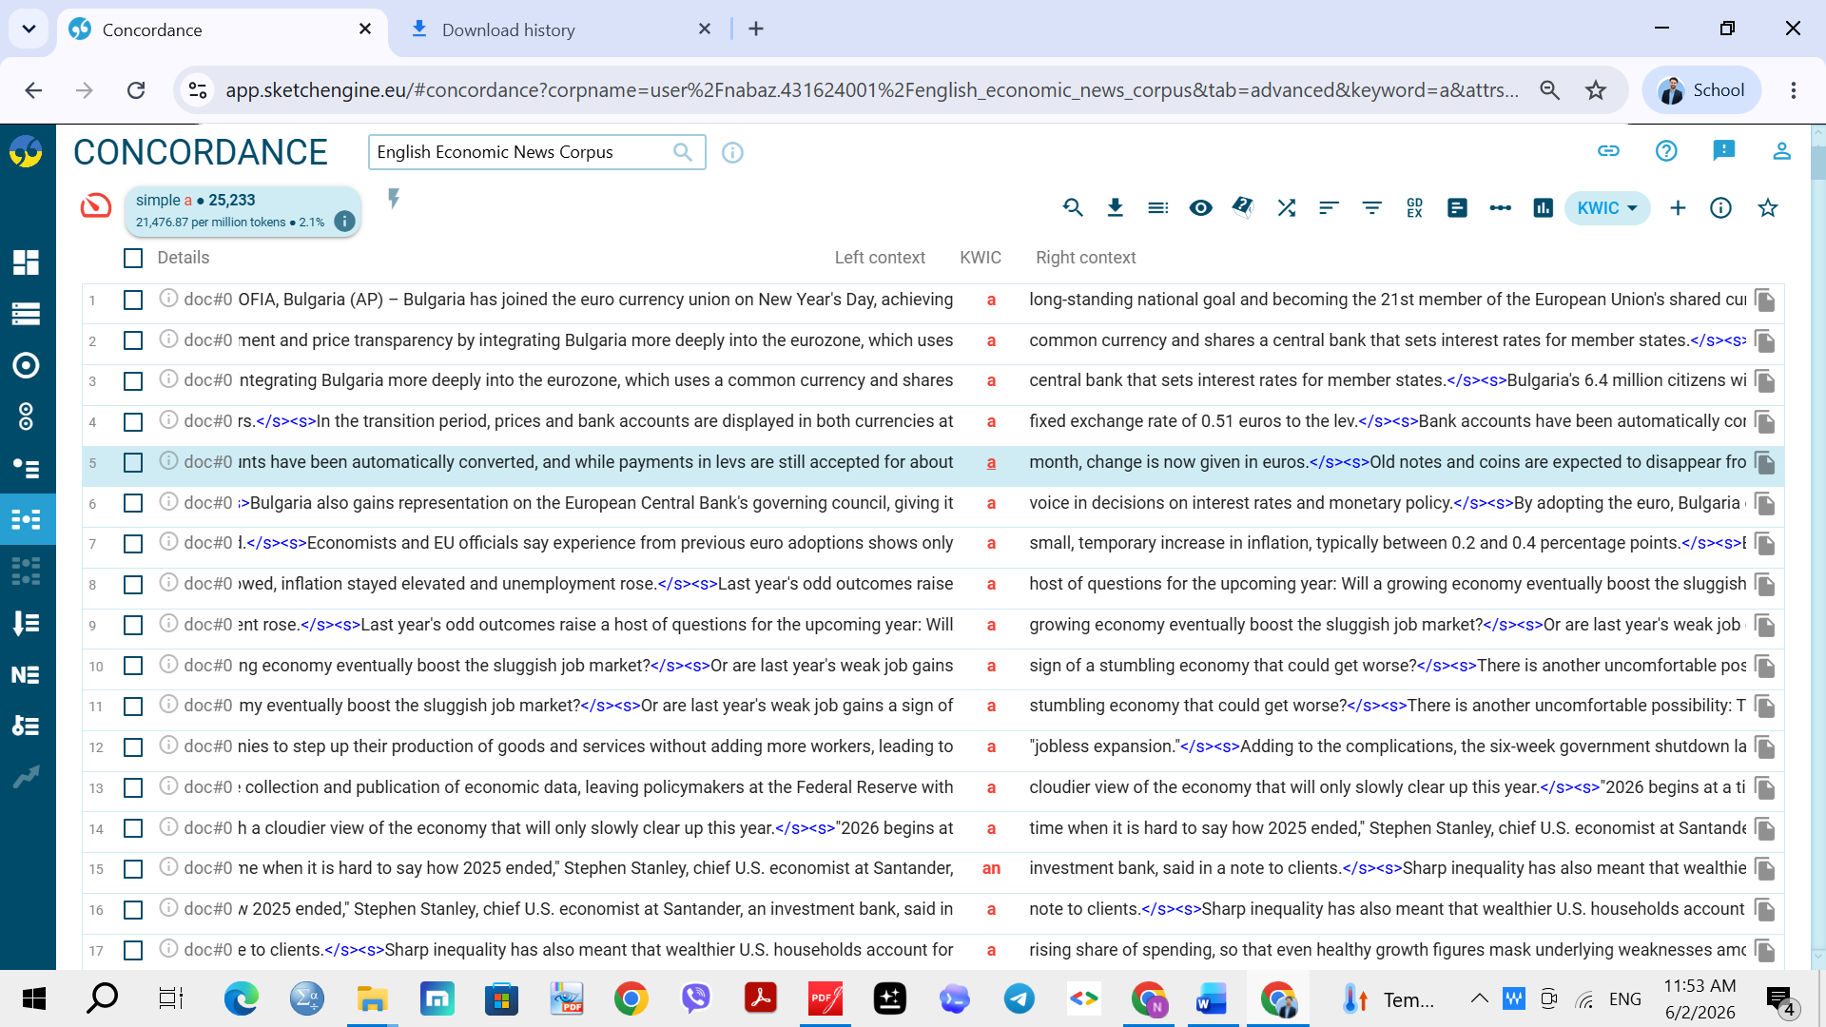
Note. The figure shows a sample Sketch Engine concordance search for the indefinite article a in EENC-2026. The KWIC display presents the left context, keyword, and right context for each item. The final indefinite result in the main analysis combines a and an.

