Student Finance Tracker

Technical Reference & Implementation Documentation
Developer: Nshimiyimana Abdurahim | Track: Frontend Web Development (ALU) | Version: 1.1
Deployments: Launch Live Web Application | Review System Demonstration

🔬 Architectural Overview
An accessible, framework-free single-page application (SPA) engineered with semantic HTML5, mobile-first CSS3, and modular ECMAScript (ES6+) architecture.
- Persistence: Stateless, synchronous transactions committing directly to browser localStorage under the namespace sft:data.
- Universal Design: Built to strict WCAG AA standards featuring visible focus indicators, skip-to-content links, and dynamic aria-live telemetry.
Wireframe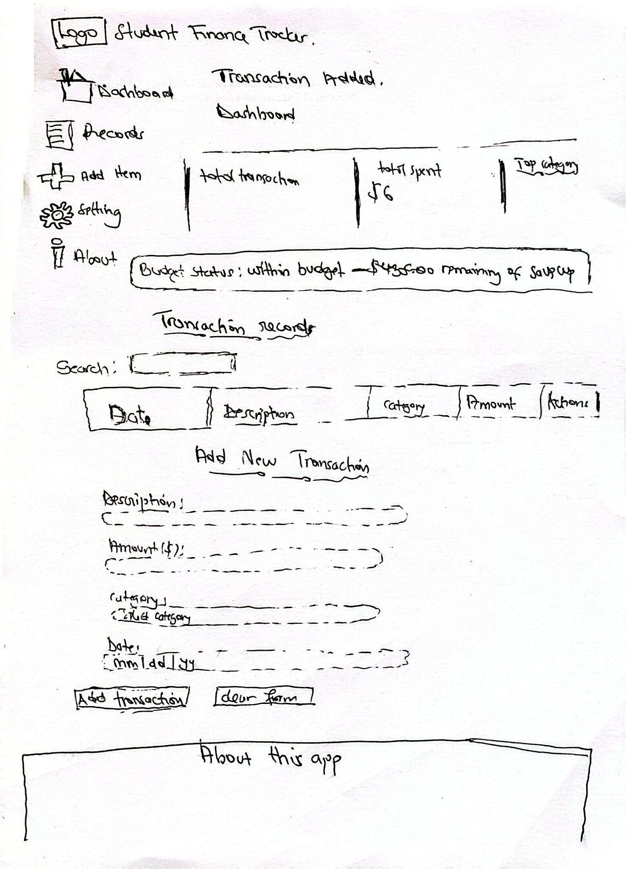

📂 System Directory Architecture
Resource Pathway | Architectural Layer | Operational Context & Dependencies
index.html | Presentation Layer | Application shell housing UI views, semantic nodes, and ARIA landmarks.
seed.json | Mock Database | 15 pre-formatted transactional entries ($279.38) for system validation.
styles/main.css | Presentation Layer | Mobile-first layout using CSS variables and 3 explicit breakpoints.
scripts/state.js | Core Model Layer | Tracks in-memory records, active configuration profiles, and mutation flags.
scripts/storage.js | Data Access Layer | Serializes parameters into local storage and runs data integrity checks.
scripts/validators.js | Security Perimeter | Registry defining the 5 core immutable regex validation rules.
scripts/search.js | Processing Engine | Compiles safe regular expressions to filter tables and highlight substrings.
scripts/ui.js | Presentation Layer | Mutates DOM components, renders canvas charts, and manages form states.
scripts/main.js | System Controller | Wires operational event loops, sidebar state, and sorting routines.

Setup & Local Execution Guide
CORS Requirement: Because this platform uses native ECMAScript Modules (type="module"), modern browsers block local file execution (file:///). The application must run within a localized web server context.
- Clone the Repository:
- Bash
git clone https:https://github.com/nabdurahim-art/student-finance-tracker
cd student-finance-tracker

- Launch Local Server: Open the root folder in VS Code and click Go Live to mount the app at http://127.0.0.1:5500.
- Inject Experimental Seed Data:
  - Navigate to Settings via the sidebar menu.
  - Under Import / Export Data, choose seed.json.
  - The validation engine populates 15 records (Feb 1–19, 2025) totaling $279.38, safely below the default $500.00 budget cap.

Regular Expression (Regex) Validation Catalog
All rules are declared as immutable properties within scripts/validators.js under the validators.PATTERNS object.
Verification Objective | Regular Expression Architecture | Compliant Case | Non-Compliant Case
1. Text Description | /^\S(?:(?!\s{2})[\s\S])*\S$|^\S$/ | "Lunch at canteen" | " Lunch", "Lunch at" (consecutive spaces)
2. Numeric Costs | /^(0|[1-9]\d*)(\.\d{1,2})?$/ | "12.50", "100" | "-5", "1e7" (scientific notation), "12.999"
3. Date ISO Compliance | /^\d{4}-(0[1-9]|1[0-2])-(0[1-9]|[12]\d|3[01])$/ | "2025-09-29" | "29-09-2025", "2025-13-01", Tomorrow's date
4. Categories | /^[A-Za-z]+(?:[ -][A-Za-z]+)*$/ | "Entertainment" | "Food & Drink", "Food123", " Food"
5. Lexical Redundancy | /\b(\w{4,})\b(?=.*\b\1\b)/i | "Lunch at canteen" | "Coffee Coffee shop", "Transport transport pass"

⌨️ Accessibility Keyboard Interface Map
Operational Key Control | Target Interactive Component | Resulting Interface Action
Tab | Universal Document Focus | Steps focus forward sequentially through interactive nodes.
Shift + Tab | Universal Document Focus | Steps focus backward sequentially through interactive nodes.
Tab (First Press) | Hidden Layout Shell | Reveals the off-screen Skip to Content structural anchor link.
Enter (On Skip Link) | Skip-to-Content Anchor | Jumps focus over side menus straight to main data dashboards.
Enter / Spacebar | Focused Buttons & Links | Triggers active buttons, nav options, or form clears.
Enter (On Table ) | Column Header Elements | Sorts table data by that column index (reverses direction on repeat).
Enter (On Actions) | Row Edit / Delete Button | Edit: Pulls row properties into form fields. Delete: Removes record.
Arrow Keys | Form Category Dropdown | Cycles selection values through standard system categories cleanly.

♿ Universal Design & Accessibility Specifications

Semantic Layout Landmarks
- <header id="topbar"> (Role: banner): Global header title and responsive menu toggle.
- <aside id="sidebar"> (Role: navigation): Main navigation routing panel.
- <main id="main-content"> (Role: main): Core dashboard, data tables, and input forms.
- <footer> (Role: contentinfo): Footprint housing metadata and copyright notices.
- Note: Every <section> utilizes aria-labelledby linking to its respective <h2> for screen-reader contextual announcements.

Live Telemetry Announcement Regions
- #budget-message (polite/assertive): Tracks consumption rates. Upgrades to assertive to force immediate speech interruption if budget limits break.
- #status-message (polite): Announces real-time transaction updates upon creation, modification, or deletion.
- #import-feedback (polite): Telemeters real-time parsing outputs when importing configuration files.
- .error-message (polite / role="alert"): Captures and reads input validation failures inline as text fields are modified.

Color Contrast Compliance (WCAG AA)
- The interface colors are meticulously paired to ensure maximum visibility and conform strictly to the WCAG AA contrast threshold of 4.5:1 for standard body text and 3:1 for user interface controls.

Element Area | Foreground Color | Background Color | Contrast Ratio | Compliance Status
Primary Controls (e.g., Add Transaction, Save Cap) | #FFFFFF (White) | #111E30 (Dark Slate Blue) | 14.2:1 | ✅ Exceeds AA ($> 4.5:1$)
Main Readable Text (Labels, headings, and values) | #1A1A1A (Near Black) | #FFFFFF (White) | 16.4:1 | ✅ Exceeds AA ($> 4.5:1$)
Secondary Buttons (e.g., Clear Form) | #111E30 (Dark Navy Text) | #D2D7DF (Light Grayish Blue) | 10.5:1 | ✅ Exceeds AA ($> 4.5:1$)
Structural Borders / Input Placeholders | #555555 (Slate Gray) | #FFFFFF (White) | 6.2:1 | ✅ Passes AA ($> 4.5:1$)
System Alerts (Error field corrections) | #D32F2F (Standard Red) | #FFFFFF (White) | 4.7:1 | ✅ Passes AA ($> 4.5:1$)

💾 LocalStorage Serialization Format
Data parsed automatically under the sft:data key. Corrupted or invalid JSON data shapes are discarded instantly on boot to protect system integrity.
JSON
{
"records": [
{
"id": "rec_1718364000000",
"description": "Monthly Bus Pass",
"amount": 45.00,
"date": "2025-02-19",
"category": "Transport"
}
],
"settings": {
"budgetCap": 500,
"baseCurrency": "USD",
"currency2": { "code": "EUR", "rate": 0.92 },
"currency3": { "code": "KES", "rate": 130 }
},
"version": "1.1",
"lastUpdated": "2025-02-19T12:00:00.000Z"
}

Demo Video

https://www.loom.com/share/9a9a3a1b19ec44c3afba870c8133c88a

The video covers :

- Keyboard- only navigation through the app.
- Error validation (choosing the wrong date)
- Exceeding the budget cap and getting the assertive ARIA announcement
- Responsive layout on mobile, tablet, and desktop.

