**FLEX TRAINER**

**Project**



**SPRING 2024**

**In partial fulfillment**

**Of the requirement for the course of**

***DATABASE SYSTEMS***

**SUBMITTED BY**

**M. Bilal Tariq 22I-1297**

**M. Azeem Ashfaq 22I-1057**

**Nabeed Haider 22I-0871**

**SUBMISSION DATE**

May, 13 2024

**DEPARTMENT OF COMPUTER SCIENCE, FAST-NU, ISLAMABAD**



Added main page that will navigate to login pages of users

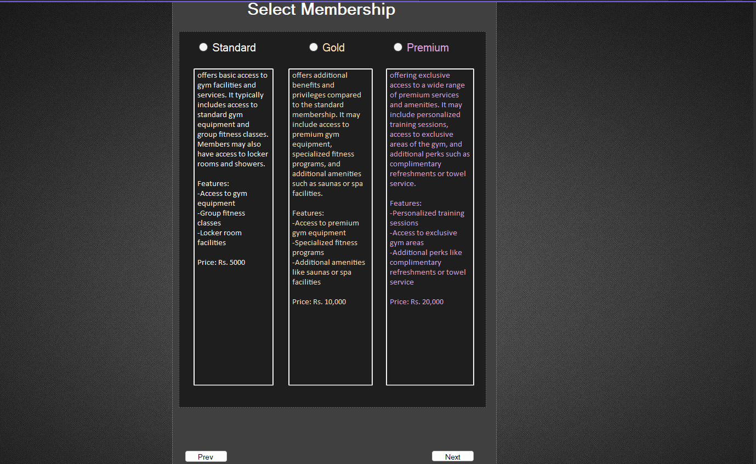

Added form to select membership type for member.

Added membership duration form to Select duration.



Added new form for trainers request to join gym

# Functionality:

1. User Authentication: The project provides user authentication functionality, allowing different types of users to sign in with their respective credentials. Users are categorized into owners, trainers, admins, and members.

2. Owner Requests: Owners have the capability to request membership at specific gyms. These requests are then reviewed and approved by admins, granting owners access to gym-related functionalities.

3. Trainer Requests: Trainers can request to join gyms as staff members. Owners have the authority to review these requests and approve them accordingly, allowing trainers to offer their services at the gym.

4. Member Interactions: Members have various features at their disposal:

Workout and Diet Plans: Members can create personalized workout and diet plans tailored to their fitness goals and dietary requirements.

Booking Sessions: Members have the option to book sessions with trainers for personalized training sessions.

Feedback: Members can provide feedback on their training sessions, enabling trainers to improve their services and tailor them to individual member needs.

5. Trainer Access to Member Reports: Trainers have access to member reports, allowing them to track member progress, view workout history, and adjust training programs accordingly to maximize results.

6. Admin Approval: Admins play a crucial role in the approval process, reviewing requests from both owners and trainers and ensuring that the gym environment remains well-regulated and conducive to fitness activities.

The project facilitates seamless interactions between gym owners, trainers, and members, providing a comprehensive platform for managing gym memberships, training sessions, and fitness-related activities. Through effective user authentication and streamlined approval processes, the project ensures a smooth user experience while promoting accountability and engagement within the fitness community.