RapidReach
Emergency Assistance System
A Python-based Desktop Application for Emergency Response Guidance

Warda Khan · Nabeeha Ahmad
Department of Physics and Applied Mathematics
Pakistan Institute of Engineering and Applied Sciences (PIEAS)

Abstract
RapidReach is a desktop-based emergency assistance application developed using Python and the Tkinter library. It provides structured, category-wise guidance for critical situations, addressing the common issue where individuals panic and are unsure of the correct steps to take. Since delayed or incorrect responses can significantly worsen outcomes, the system offers immediate, actionable protocols.
The application covers a comprehensive range of emergencies, including medical, fire, crime, disaster, transport, and utility failures. Each category is paired with relevant helpline numbers and essential first-aid instructions, making it a practical and accessible tool for the general public. Designed with simplicity in mind, RapidReach requires no prior technical knowledge and functions entirely offline, ensuring reliability when internet access may be compromised.

Objectives
- To provide quick access to emergency helpline numbers relevant to Pakistan.
- To guide users through step-by-step response procedures for various emergency situations.
- To organize emergencies into clear categories for fast navigation.
- To develop a lightweight, offline desktop application accessible to general users.
- To present information in a clean, readable interface without unnecessary complexity.

Libraries Used
The application is built entirely using Python's standard library, requiring no external dependencies.
Tkinter — Used for building the graphical user interface, including all windows, frames, labels, buttons, and the scrollable canvas.
tkinter.font — Imported for font management support within the interface.

System Design
RapidReach follows a three-screen navigation model.
- The first screen displays the project and developers' names alongside all the emergency categories in a two-column grid layout.
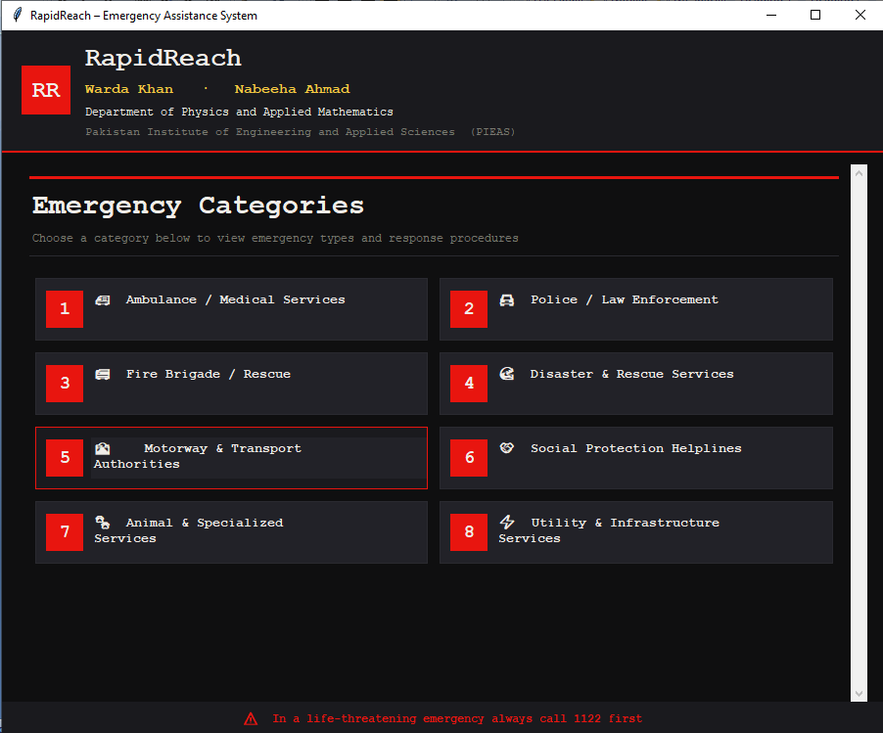
- Clicking any category card opens the second screen, which lists the subcategories belonging to that category.
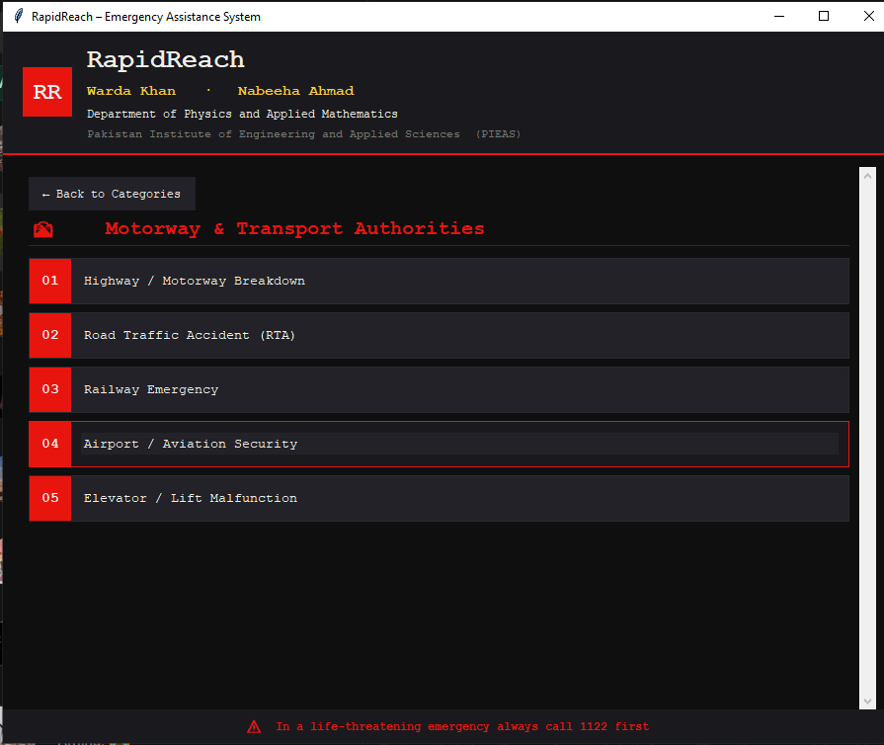
- Clicking a subcategory opens the third screen, which displays the emergency contacts and numbered response steps for that specific situation.
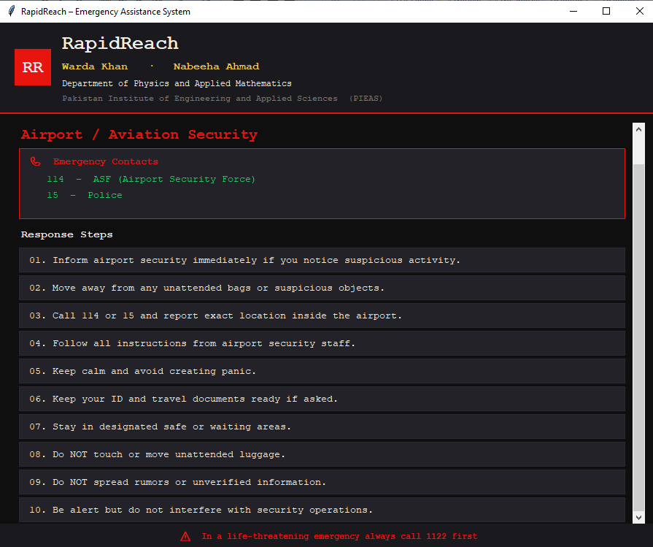
A back button on each screen allows the user to return to the previous view. The interface uses a dark theme with consistent color coding for readability and visual clarity.

Data Structures
The application uses three main Python data structures to store and retrieve information.

- CATEGORIES — A list of tuples, each containing a category ID and its display label.
- SUBS — A dictionary mapping each category ID to a list of subcategory names.
- INFO — A dictionary mapping a (category_id, subcategory_index) tuples to a dictionary containing the title, emergency contacts, and a list of response steps.

This structure allows fast and direct lookup of any emergency information using simple key-based access.

Features
- Covers 8 major emergency categories with over 30 subcategories.
- Displays relevant Pakistani helpline numbers for each emergency type.
- Provides clear, numbered step-by-step response instructions.
- Entire category cards and subcategory rows are clickable for ease of use.
- Smooth three-screen navigation with back button support.
- Fully offline — no internet connection required.
- Scrollable interface to accommodate varying amounts of content.
- Clean dark-themed UI with consistent styling throughout.

Enhanced Version / Web-Based Implementation

An enhanced version of RapidReach was also developed by integrating web technologies including HTML, CSS, and JavaScript alongside Python. This version introduces a splash and intro screen that displays the application name and developer credits before entering the main interface. The enhanced version offers improved visual design, smoother animations, and a more modern user experience compared to the original Tkinter-based application. Both versions serve the same core purpose but differ in their technology stack and interface presentation.
The enhanced version demonstrates the scalability of the original concept and shows how the same emergency response system can be adapted for a more visually engaging platform without changing the underlying data or logic.

The screenshot of the prompt given to AI is attached below:
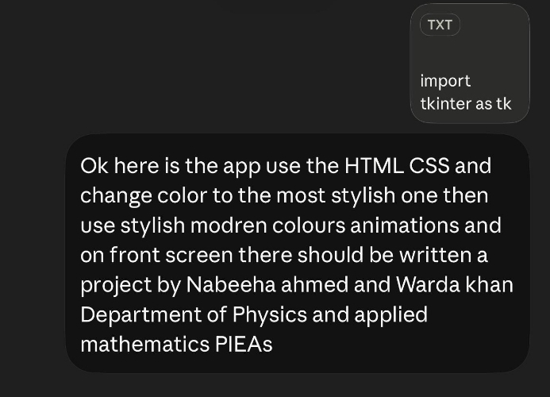

- The screenshots of the enhanced project's version are pasted below.
They show primary emergency categories, 30+ specific crisis situation types, helpline numbers and first aid step
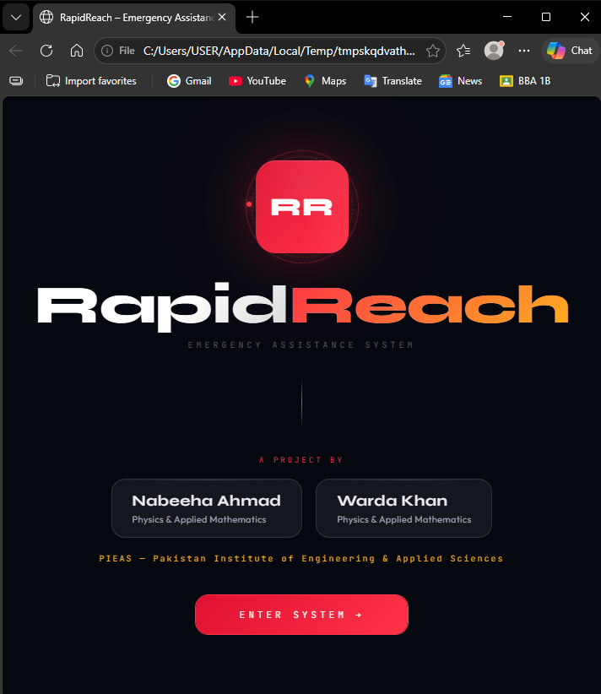
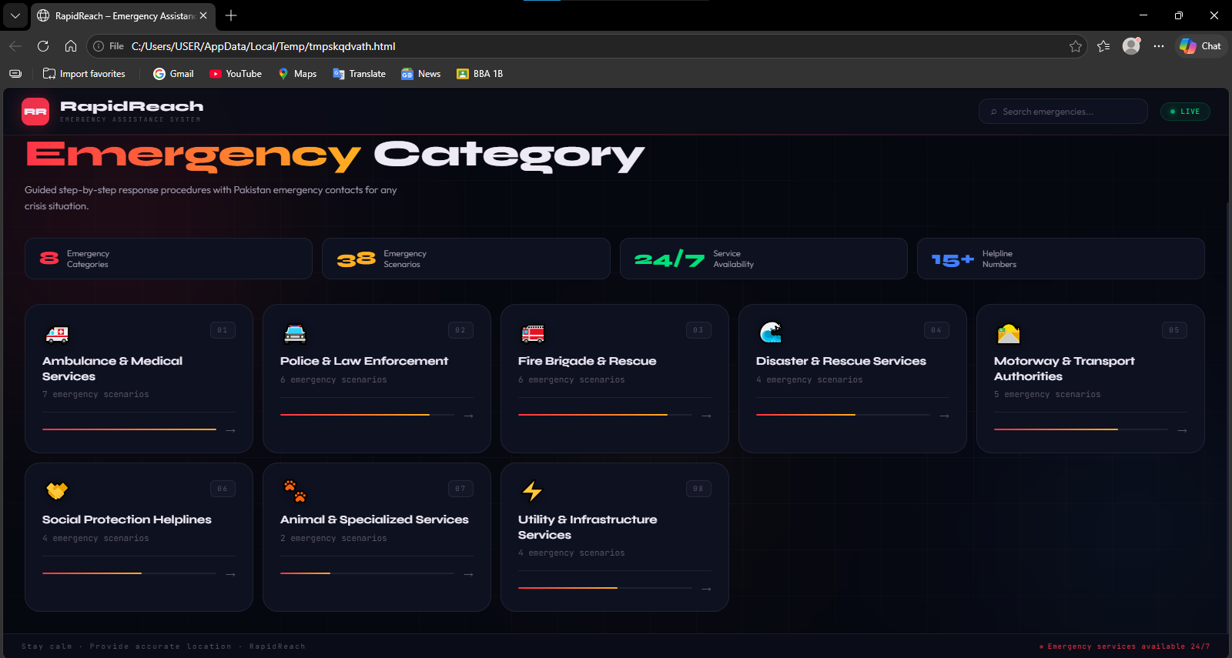
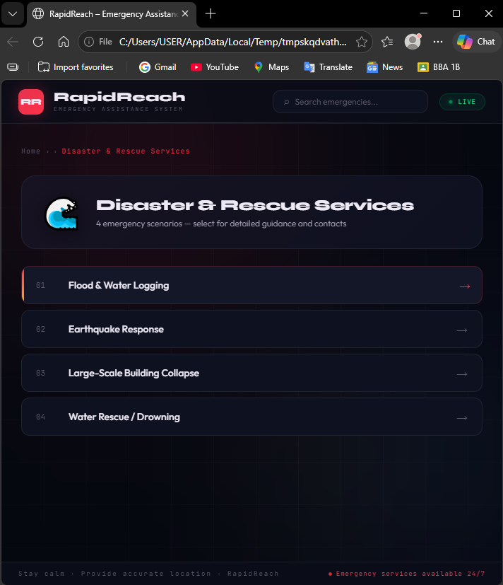
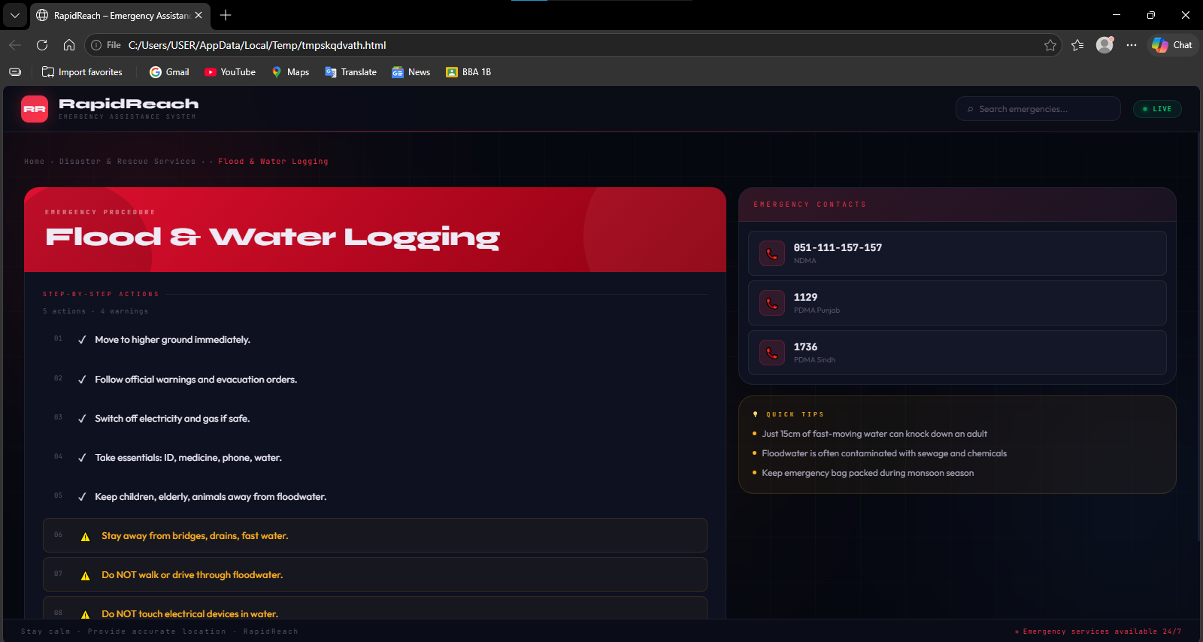

Limitations
- The application is currently desktop-only and is not available on mobile platforms.
- All data is hardcoded within the source file; there is no external database or dynamic content loading.
- The helpline numbers are specific to Pakistan and may not be applicable in other regions.
- There is no search functionality to look up emergencies directly by keyword.
- The application does not support multiple languages.

Future Enhancements
- Adding a search bar to allow users to find emergencies quickly by typing keywords.
- Incorporating multilingual support, particularly Urdu, for wider accessibility.
- Developing a mobile version of the application for Android and iOS platforms.
- Connecting to live emergency services or GPS-based location sharing.
- Allowing the data to be loaded from an external file or database for easier updates.
- Adding audio or text-to-speech support for users who cannot read the screen during an emergency.

Conclusion
RapidReach is a practical and user-friendly emergency assistance tool that addresses a genuine need for structured, accessible emergency guidance. By organizing information into clear categories and providing actionable steps alongside helpline numbers, it equips users to respond more effectively in critical situations. The application is lightweight, fully offline, and easy to navigate, making it suitable for a wide range of users. The development of an enhanced web-based version further demonstrates the potential of this concept to grow into a more polished and widely accessible public safety resource.

