Automated Invoice Processor

Final Report

(Provide GitHub repository URL here)

(Provide KayDrive link to the project here)

BY

Team Lead: Talha Moosani/18017

Member(s): Shehzad Ali/18035

Nabeel Naveed/17874

UNDER THE SUPERVISION OF

SUPERVISOR: Dr. Shahid Hussain

CO-SUPERVISOR: NAME

Member(s): NAME(S)

**SUBMITTED TO**

pROJECTS Manager – FYP

**ON**

DATE (24/05/2022)



(TO BE LEFT BLANK)

CONTRIBUTIONS

Each FYP team member should present their contributions to the project here in a separate matrix followed by their name in BOLD.

Details regarding:

* requirements specification (use cases and non-functional requirements),
* domain modeling (whole system or list the specific modules),
* software design (whole system or list the specific modules),
* report preparation (whole report or list the specific sections/diagrams),
* Other: any other relevant contribution.

Use extra pages if required. If more than one person has worked on a component jointly then specify the percentage each has contributed to that component.

Table of Contents

Proposal Defence Report

Insert earlier submitted and approved (final version) of project defense report here. (including title page and everything)

Software Requirement Specification (SRS)

# Problem Statement

We are in the shipping and logistics Business, as anyone might know getting a Parcel from Point A to Point B is not as simple as it sounds, a lot of intricate complexities and complex processes are involved. One Big complex process is there different kinds of paper work we have to deal with, Paper Work such as : Commercial Invoice, Packing List, Certificate of Origin and numerous other kinds, currently this whole process is manually done, which is not only time intensive but also labor intensive and prone to several errors, We wish to automate this whole process in order to improve the productivity of our team and save time and reduce errors by implementing an automatic Document Parser System, which will be integrated in our existing ERP System, we believe this would also enable us to scale our business in the future as it currently stands scaling would require numerous other expenses if it were to be continuously done manually. It is implicitly obvious but the key is high accuracy, flexibility and a robust system which can adapt and work over different types of document with different formats and still be able to extract Data Out of it, resistant to changes in future changes in the document formats or also be able to work with different format systems used in different parts of the world.

# System Requirement

## List of Functional Requirements

|  |  |
| --- | --- |
| **Name** | **Description** |
| **Retrieve Data from a storage Physical Storage Medium** | The Documents which need to be processed is going to be in a specially marked folder. |
| **Parse Document Data** | In order to automate the process, a parser which can extract different types of data from a document |
| **Algorithm/Software is Accurate** | Since this data will be used in Realtime and for all legality reasons, it must be as accurate as possible |
| **Flexibility** | The documents format can change, so the algorithm needs to be adaptive and flexible |

## List of Non-functional Requirements

There were no Non-Functional Requirements.

## User Interface Requirements

# Functional Requirements Specification

Provide use cases based on 1 and 2 above.

## Stakeholders

What we have implemented is an algorithm, which is integrated into an existing ERP System, what this means is that the stake holders if the shipping company and the Client Management team who would be using the data extracted from the Algorithm to process documents etc.

## Actors and Goals

The Algorithm works on a special Marked Folder or on any physical storage Medium, it is an automated Process.

The Goal is to parse all kinds of data from different kinds of shipping and logistics documents.

## Use Cases

This is the process of how any document is retrieved and processed till it gets added into the Erp System

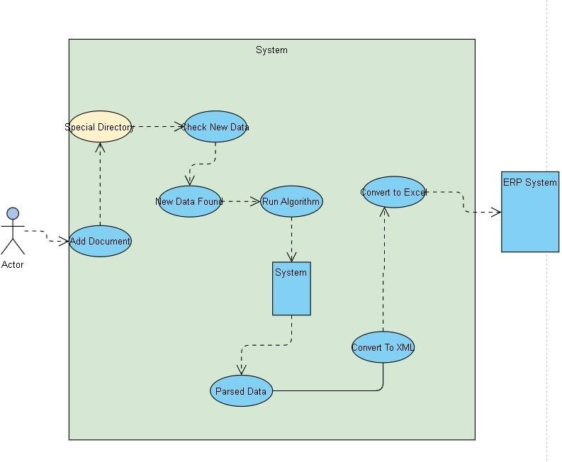

Provide fully dressed use cases of some most important among the above. (Discuss with your supervisor)

# User Interface Specification

For each use case specify the user interface. All reports generated by the system are also part of user interface specification.

1. Homepage

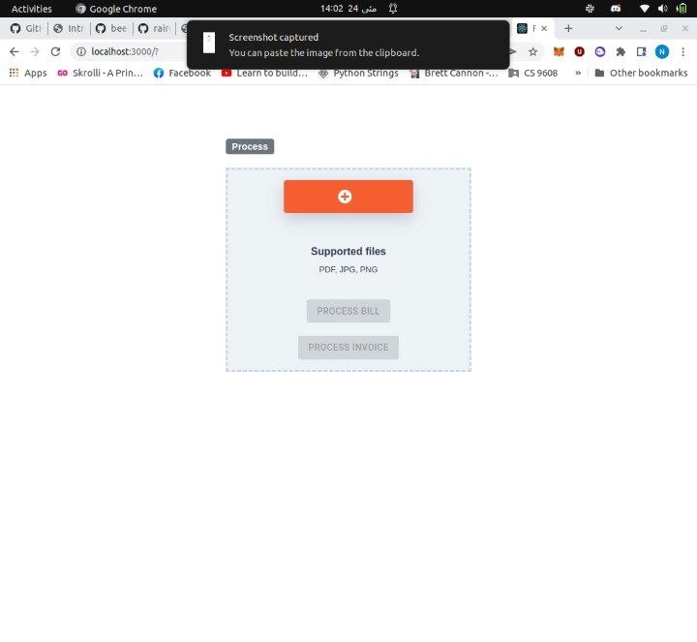

1. Invoices/bills uploaded to process

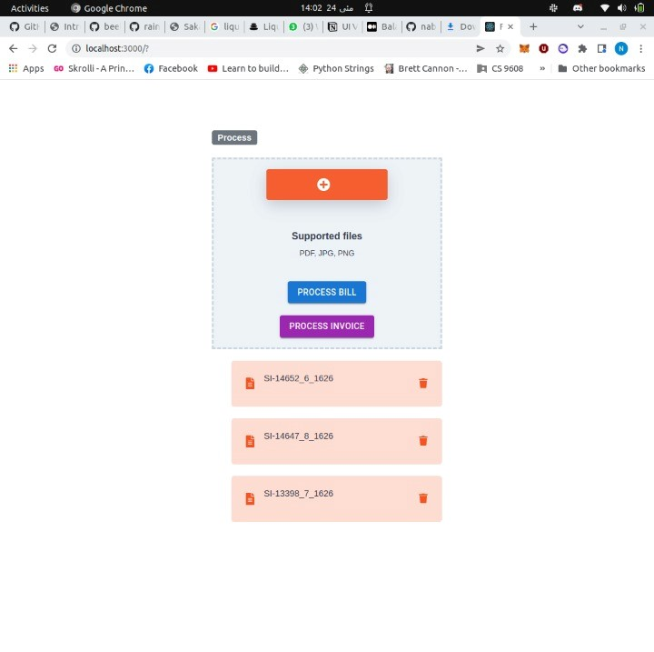

1. Data automatically processed and retrieved from invoices.

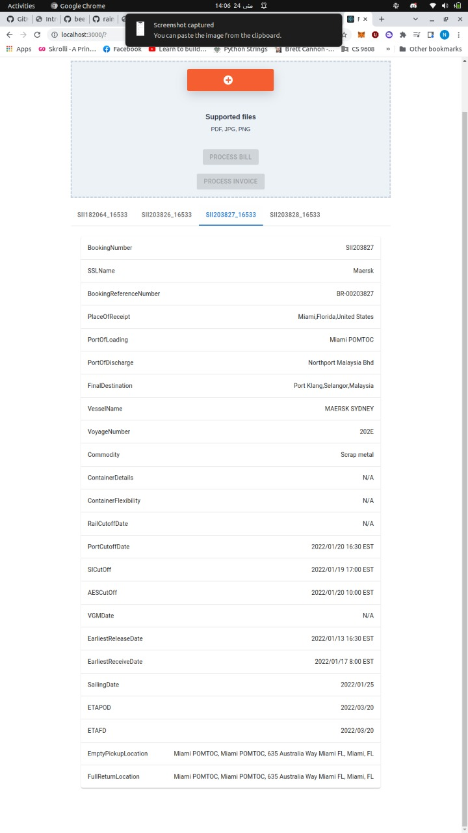

# Domain Analysis

Domain model and or mathematical model used, if any, be provided here in form of diagrams or equations.

System Design

# Interaction Diagrams

Either sequence diagrams or UML of the fully dressed use cases.

# Class Diagram and Interface Specification

Show all classes and their associations. If cannot fit on a single-page, make an overview diagram showing all classes and their associations with just name. Details with attributes can be depicted in partial diagrams.

Use UML notation for class specification with datatypes for each class.

# System Architecture and System Design

## Architectural Style

Google search: Software Architectural Style examples

## Identifying Subsystems

Draw and describe UML package diagram of subsystems

## Mapping Subsystems to Hardware

For systems running on multiple machines like client-server based projects. Specify which subsystems will run on which machine.

## Persistent Data Storage

Attach the description of the file format and/or database schema (format of database tables, printed by the command description)

## Network Protocol

Specify communication protocols if your system runs on network.

## Global Control Flow

You’ll handle execution orderness (linear vs event-driven), time dependency (use of timers) and concurrency (multiple threads) issues here in this section

## Hardware/Sofware Requirements

List complete minimum HW and software (OS/protocol/driver) requirements for the system to run.

# Algorithms and Data Structures

Describe the complete algorithms your system use. Also specify and complex data structure (arrays, link lists, hash tables, trees etc.) your system uses.

# User Interface Design and Implementation

Describe how and if you modified the initial user design used earlier for ease of use.

# Design of Tests

List and describe the test cases used for unit testing

User Manual

If required provide the user manual here.

Project Management and Plan

Present detailed comparison of the proposed timelines and the timeslines after execution of the project in Gantt charts here.

Current Status and Future Work

Discuss any further extension or commercialization that is underway or you intend to take.

References

Specify all resources including journal articles, books, reports and any other resource(s), including online, consulted during the course of work.