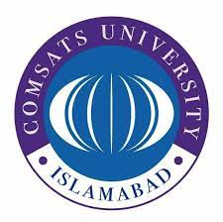 **COMSATS University Islamabad**

**Wah Campus**

**Department of Computer Science**

**Recommendation Letter**

November 15, 2022

**To Whom It May Concern**

I recommend Mr. Nabeel Ahmad (Reg no. CIIT/FA17-BSE-051/WAH) for admission to your prestigious institute. I have known him for the past two years. He has been one of my brilliant students during my time at Comsats University, Wah Campus.  
  
I was his instructor during his 6th Semester, where I taught him the course “Software Project Management”. He performed exceptionally well in my subject and got good grades as well.  
  
Being a class representative, he performed his duties very well. I observed his class participation; he was always eager to learn more and share his knowledge with his classmates. He is hardworking, very disciplined, and above all, respectful. These attributes are evident in his academic performance as well.  
  
One key ability of Nabeel is his teaching skills. His ability to demonstrate concepts to his classmates was outstanding during class presentations. I wish him all the best in his higher studies, and I hope he will do well in his academics as he has done so far.  
  
Mr. Nabeel will do extremely well if given an opportunity. I strongly recommend him for a master’s degree program with absolute confidence in your university.  
  
Thank you for the opportunity to correspond.

## **Dr. Faisal Shafique Butt**

Assistant Professor,

COMSATS University Islamabad,

Wah Campus, Wah Cantt

Email: faisalbutt@ciitwah.edu.pk

Phone: +92 51 9314382-83