COURIER MANAGEMENT SYSTEM
A Salesforce-Based Shipment Booking, Tracking and Delivery Management Solution
Project Documentation
User Story
Courier and logistics businesses find it hard to run shipments and deliveries smoothly because most of their work still happens on paper and in separate tools. With no single place to follow a parcel, staff cannot see where it is, delivery updates reach customers late, and customers are left without clear information.
Delivery agents are assigned manually, which leads to overlapping schedules and delays. Customers are not informed automatically, and managers have no performance figures to judge how well the operation is running. When several branches are involved, coordination becomes harder still. Together these problems cause unhappy customers, lower productivity, wasted effort and lost revenue.

1. Introduction

1.1 Project Overview
Many courier and logistics firms still depend on paper registers, spreadsheets and phone calls to run daily work. Parcel data sits in different places, nobody can see where a consignment is at a given moment, and customers keep calling to ask for updates. Assigning a delivery to an agent is done by hand, so double bookings and missed slots are common, and managers have no reliable numbers to judge how their branches are performing.
The Courier Management System (CMS) addresses these gaps with a cloud application built on the Salesforce Lightning platform. It keeps customers, shipments, delivery agents, branches, status updates and invoices in one connected data model. Flows and validation rules automate the routine steps, role-based security controls who can see what, and reports and dashboards turn raw records into information that managers can act on.

1.2 Purpose
The aim of this project is to replace scattered manual methods with a single, automated platform for the full courier cycle. It is meant to record parcel bookings in a standard, validated format, give staff a live view of each shipment’s status, reduce manual effort in assigning agents and updating statuses, link invoices to the shipments they belong to, and provide branch-wise and agent-wise insight through analytics.
By bringing every branch onto one platform, CMS improves visibility, communication and speed of decisions, and it can grow with the business without a redesign. In the end, the goal is better service, happier customers and higher profitability.

2. Ideation Phase

2.1 Problem Statements
Two key stakeholders were considered: the branch manager, who runs daily operations, and the customer, who depends on timely information about a parcel.
ID | Stakeholder | Goal | Obstacle | Root Cause | Feeling
PS-1 | Branch Manager | Handle shipments smoothly | Tracking is done by hand | Tools and records are not connected | Stressed
PS-2 | Customer | Follow the parcel’s progress | Status updates arrive late | No single system holds shipment data | Uncertain
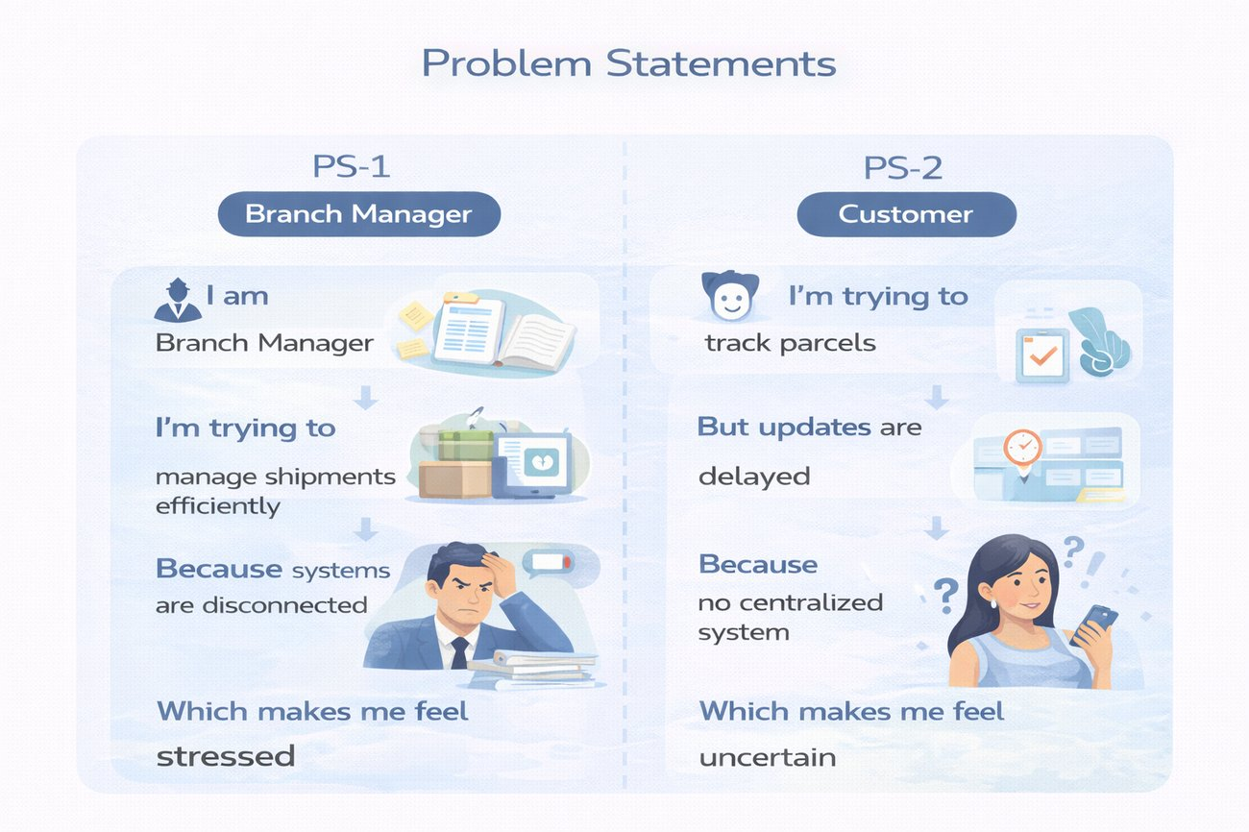
Figure 1: Problem statements for the branch manager and the customer

2.2 Empathy Map Canvas
User Persona: Branch Manager
- Think & Feel: Worried about late deliveries and data-entry mistakes
- Hear: Repeated complaints and follow-up calls from customers
- See: Paper registers and several unconnected spreadsheets
- Say & Do: Chases agents and updates records manually
- Pain: Clashing delivery schedules and updates that never get recorded
- Gain: Automatic tracking and a dashboard that shows the whole picture
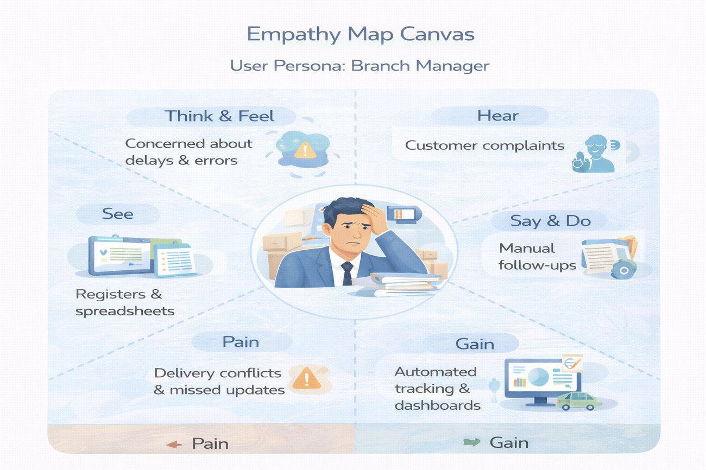
Figure 2: Empathy map for the branch manager persona

2.3 Brainstorming & Idea Prioritization

Ideas Considered
- Paper registers
- Spreadsheet tracking
- Standalone web portal
- Salesforce CRM

Final Selection
Salesforce CRM was selected because of its:
- Built-in automation
- Ability to scale as branches are added
- Real-time visibility through reports and dashboards
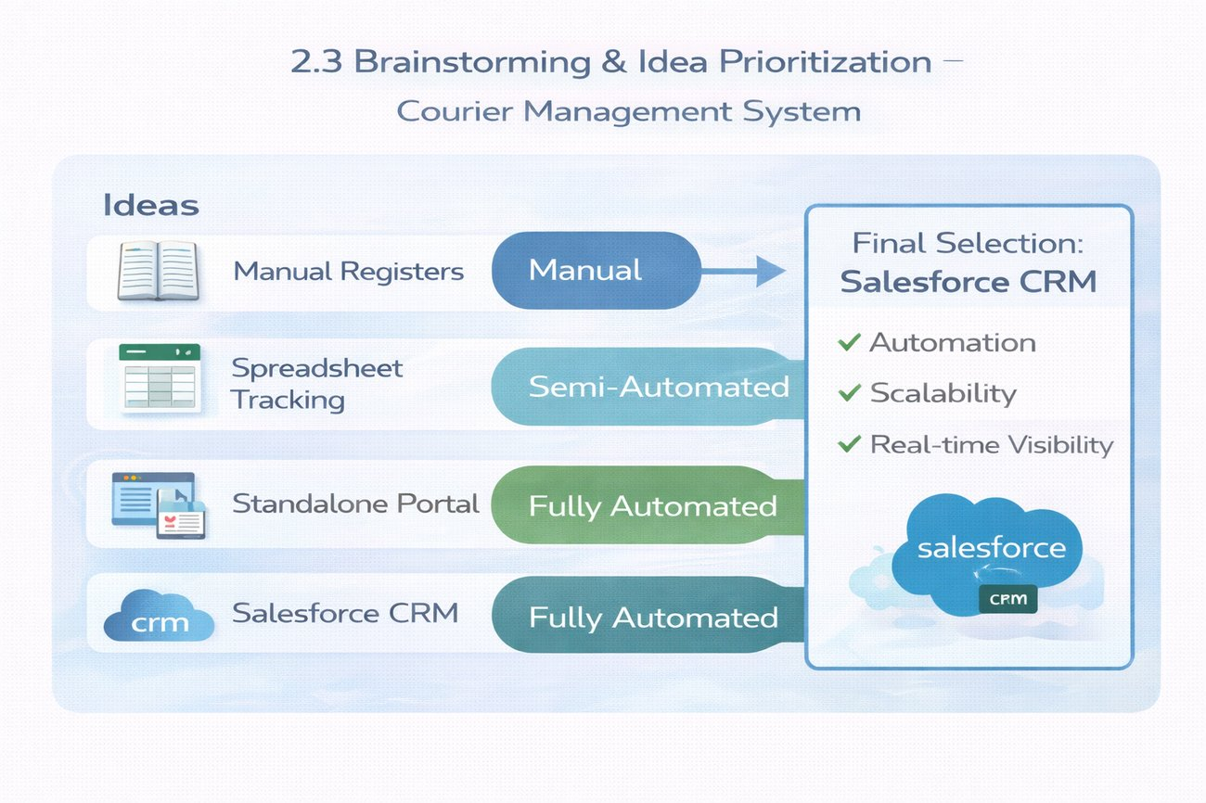
Figure 3: Options considered and the final selection

3. Requirement Analysis Phase

3.1 Customer Journey Map
A parcel moves through these stages: Booking → Shipment creation → Agent assignment → Transit → Delivery update → Invoice → Reporting.
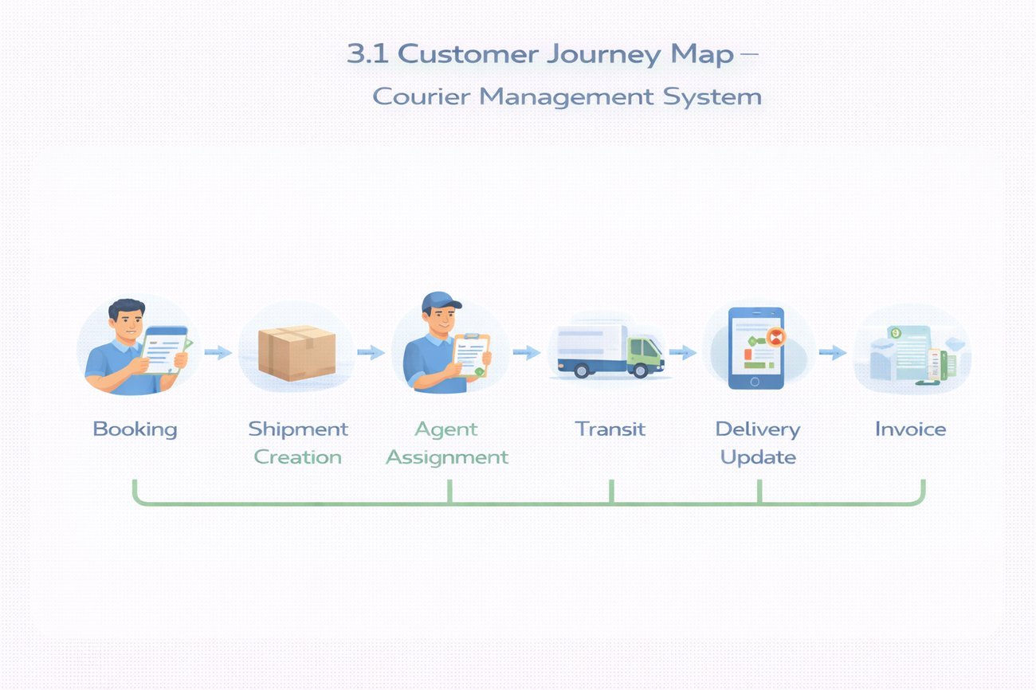
Figure 4: Customer journey through the courier process

3.2 Solution Requirements

Functional Requirements
FR No | Requirement
FR-1 | Customer management
FR-2 | Shipment booking
FR-3 | Delivery agent assignment
FR-4 | Real-time status updates
FR-5 | Invoice generation
FR-6 | Reports and dashboards

Non-Functional Requirements
NFR | Description
Usability | Clean Lightning interface that staff can learn quickly
Security | Role-based access control
Reliability | Automation that runs consistently without manual correction
Performance | Status changes visible almost instantly
Availability | Cloud access at any time, from anywhere
Scalability | Supports a growing number of branches

3.3 Data Flow Diagram
Flow: Customer input → Shipment creation → Validation → Agent assignment → Delivery update → Invoice → Reports.
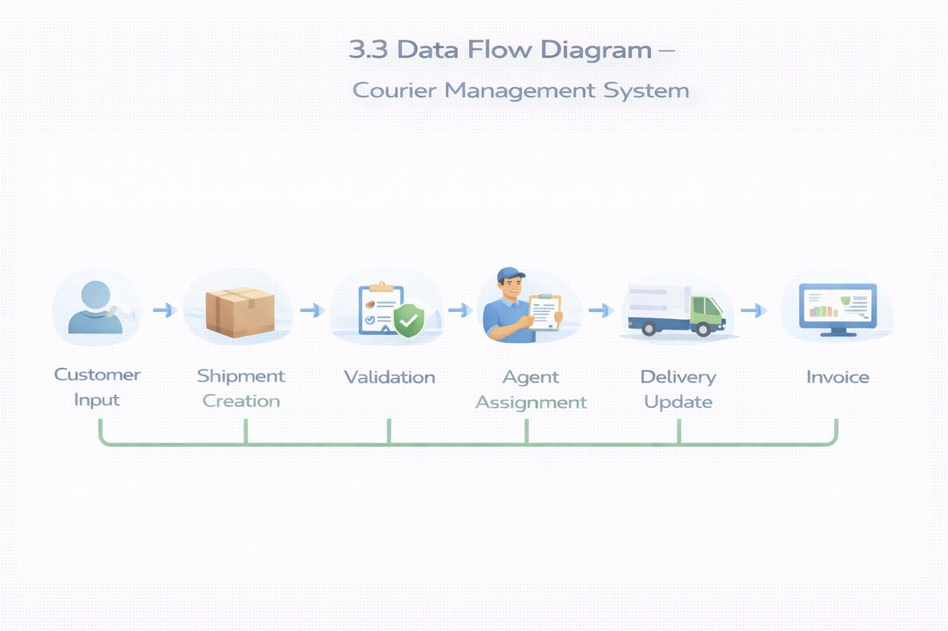
Figure 5: Data flow of the courier system

3.4 Technology Stack
Layer | Technology
UI | Salesforce Lightning
Logic | Salesforce Flows
Database | Salesforce Objects
Automation | Validation Rules, Flows
Security | Profiles, Roles
Reporting | Reports & Dashboards

4. Project Design Phase

4.1 Problem–Solution Fit
CMS removes the fragmentation in courier operations by automating shipment tracking, delivery assignment, billing and reporting on one central Salesforce platform. Each weakness of the manual process has a matching feature: registers are replaced by a central dashboard, delayed updates by automated tracking, scattered sheets by agent assignment, and confused customers by visible billing and status information.
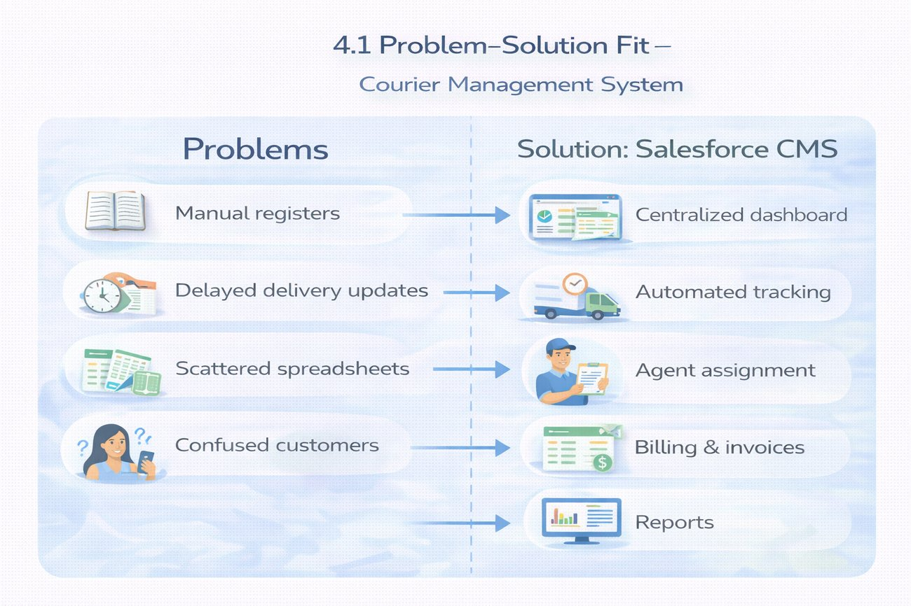
Figure 6: Mapping of current problems to CMS features

4.2 Proposed Solution
Parameter | Description
Problem | Manual shipment management
Solution | Salesforce-based Courier Management System
Innovation | Automated tracking and billing
Impact | Faster deliveries
Business Model | Courier services
Scalability | Ready for multiple branches

4.3 Solution Architecture
Components of the solution:
- Customer object
- Shipment object
- Delivery Agent object
- Branch object
- Delivery Update object
- Invoice object
- Flows
- Reports
- Dashboards
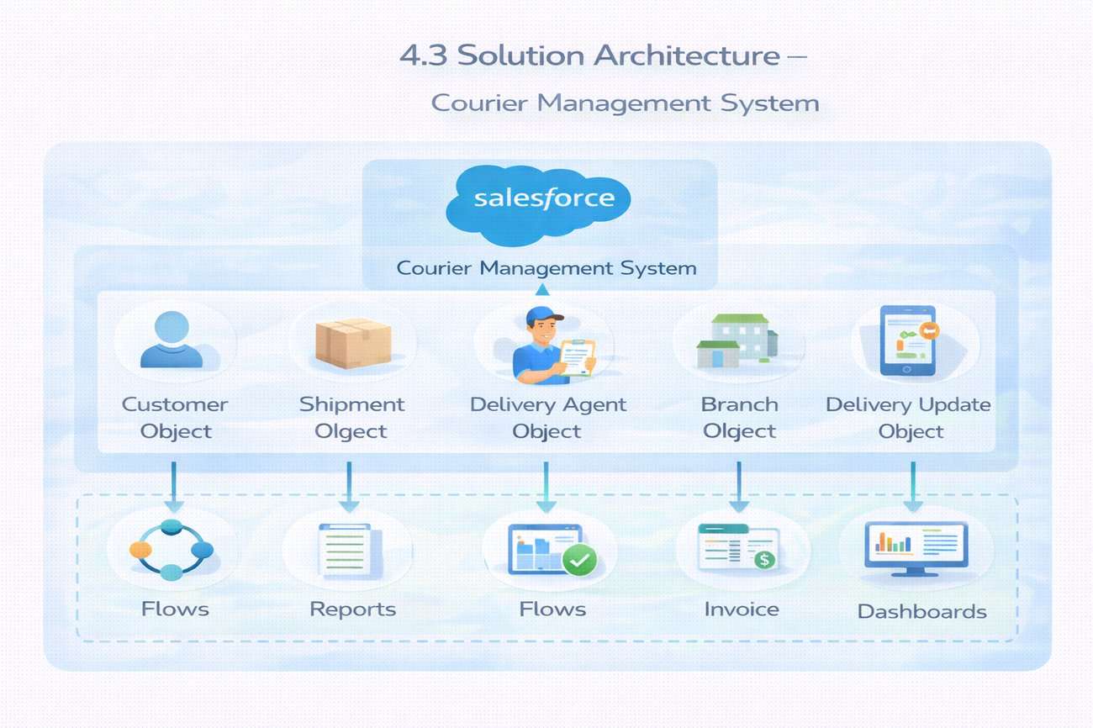
Figure 7: Solution architecture of CMS

5. Project Planning & Scheduling

5.1 Project Planning
- Agile methodology
- Epics → Stories → Story Points
- Sprint-based execution
- Velocity calculation used for estimation

Product Backlog, Sprint Schedule and Estimation
Sprint | Epic | ID | User Story / Task | Pts | Priority | Member
1 | Developer setup | USN-1 | As an administrator, I want to create a Salesforce Developer org so that I can build and test the courier application. | 3 | High | Member 1
2 | Data modeling | USN-2 | As an admin, I want to create Customer, Shipment, Delivery Agent, Branch, Delivery Update and Invoice objects with relationships so that data is stored in an organised way. | 5 | High | Member 2
2 | Data modeling | USN-3 | As a staff member, I want tabs and a Lightning app so that I can move between courier modules easily. | 5 | High | Member 3
3 | Automation | USN-4 | As the system, I want to check dates, weights, prices and mandatory fields so that bad data cannot be saved. | 3 | High | Member 4
3 | Automation | USN-5 | As a dispatcher, I want shipment status to update automatically from delivery updates so that work is faster and manual steps are reduced. | 3 | High | Member 4
4 | Security | USN-6 | As an administrator, I want profiles, roles and users so that shipment and billing data is available only to the right people. | 5 | High | Member 2
5 | Reports | USN-7 | As a branch manager, I want reports on shipment status, agent performance and revenue so that I can monitor operations. | 4 | High | Member 3
6 | Dashboards | USN-8 | As a branch manager, I want a dashboard that combines key reports so that I can review performance at a glance. | 4 | Medium | Member 4

Project Tracker, Velocity & Burndown
Dates below are indicative; adjust them to match your actual schedule.
Sprint | Total Points | Days | Start | Planned End | Points Done | Release Date
Sprint-1 | 3 | 6 days | 05 Oct 2026 | 10 Oct 2026 | 3 | 10 Oct 2026
Sprint-2 | 10 | 6 days | 12 Oct 2026 | 17 Oct 2026 | 10 | 17 Oct 2026
Sprint-3 | 6 | 6 days | 19 Oct 2026 | 24 Oct 2026 | 6 | 24 Oct 2026
Sprint-4 | 5 | 6 days | 26 Oct 2026 | 31 Oct 2026 | 5 | 31 Oct 2026
Sprint-5 | 4 | 6 days | 02 Nov 2026 | 07 Nov 2026 | 4 | 07 Nov 2026
Sprint-6 | 4 | 6 days | 09 Nov 2026 | 14 Nov 2026 | 4 | 14 Nov 2026

Total planned work is 32 story points over 6 sprints, giving an average velocity of about 5.3 points per sprint (32 ÷ 6).

6. Project Development Phase

What you will learn
- Real-time Salesforce project implementation
- Designing custom objects and relationships
- Creating page layouts
- Writing validation rules
- Building automation with flows
- Developing reports and dashboards
- Setting up security with profiles, roles and users
- End-to-end application testing

Milestone 1: Salesforce Account

Introduction
If you are new to Salesforce and unsure where to begin, this project shows how a real business application, in this case a courier management system, can be built on the platform without writing code. Salesforce offers tools that automate processes, improve accuracy and manage customer operations with ease. Here they are used to streamline the courier workflow from parcel booking to delivery, billing and reporting.

What is Salesforce?
Salesforce is a customer success platform that helps organisations sell, serve, market, analyse and connect with their customers. It lets you manage relationships with customers and partners, collaborate with employees, and store data securely in the cloud, all accessible from anywhere.

Activity 1: Creating a Developer Account
A developer org is a free personal Salesforce environment used for learning and building.
- Open https://developer.salesforce.com/signup in your browser.
- On the sign-up form enter your first name and last name.
- Enter your email address.
- Set Job Title to Developer.
- Set Company to your college name.
- Set Country to India.
- Accept the agreement and click Sign me up.
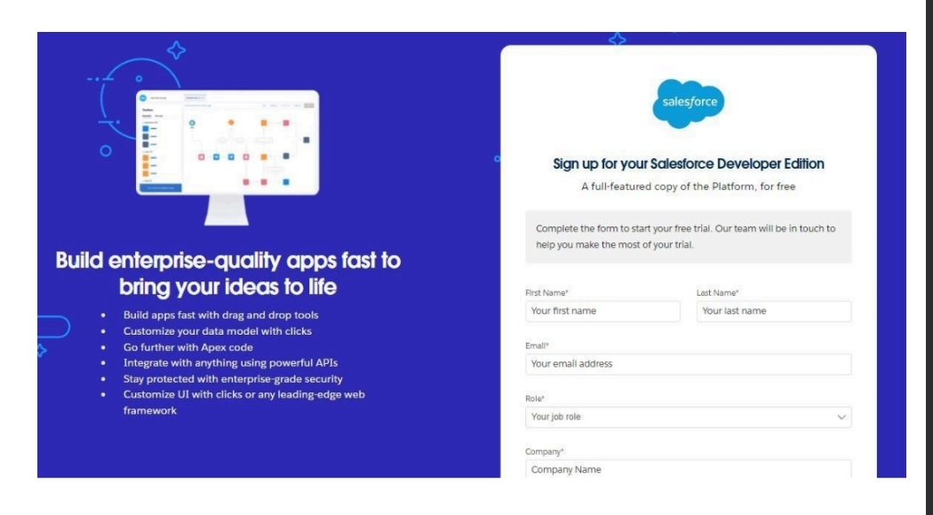
Figure 8: Developer Edition sign-up form

Activity 2: Account Activation
- Open the inbox of the email address used during sign-up. The message can take between 10 minutes and 2 hours to arrive.
- Click Verify Account in the email.
- Choose a password and answer the security question, then click Change Password.
- You are redirected to the Salesforce Setup home page.
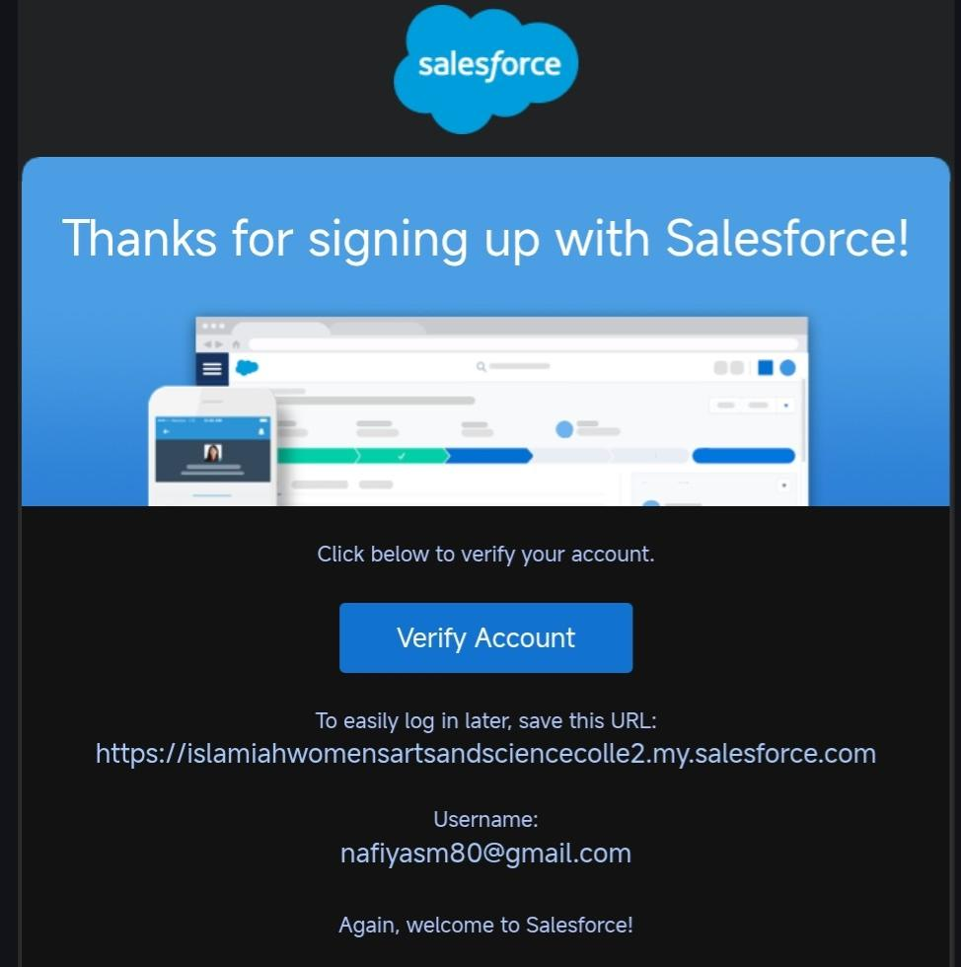
Figure 9: Verification email from Salesforce
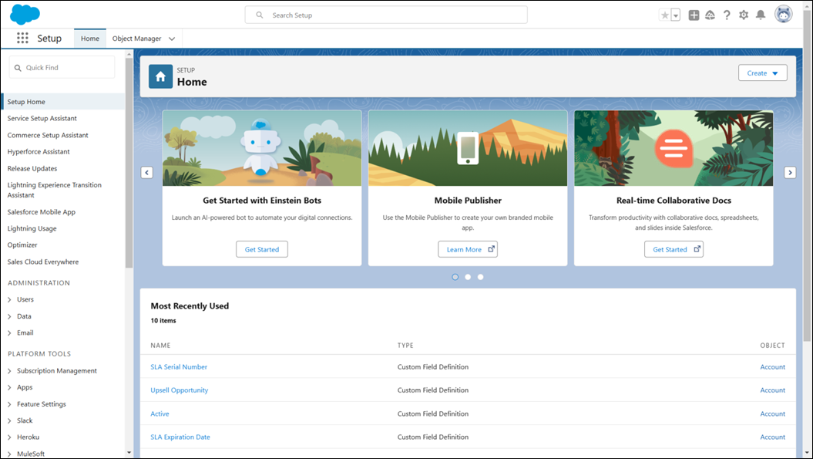
Figure 10: Salesforce Setup home page

Milestone 2: Objects

What is an object?
Objects in Salesforce are database tables that store data specific to an organisation. An object is made up of fields (columns) and records (rows).

Custom objects created
- Customer__c – stores personal and contact details of customers
- Shipment__c – holds parcel details, source, destination and tracking information
- Delivery_Agent__c – keeps delivery agent profiles and branch details
- Branch__c – represents the courier branch offices
- Delivery_Update__c – records each status update of a shipment
- Invoice__c – manages billing details for delivered shipments

Relationships
Child Object | Parent Object | Type
Shipment | Customer | Lookup
Shipment | Delivery Agent | Lookup
Delivery Agent | Branch | Lookup
Delivery Update | Shipment | Master-Detail
Invoice | Shipment | Lookup

Steps to Implement

Activity 1: Create the Customer object
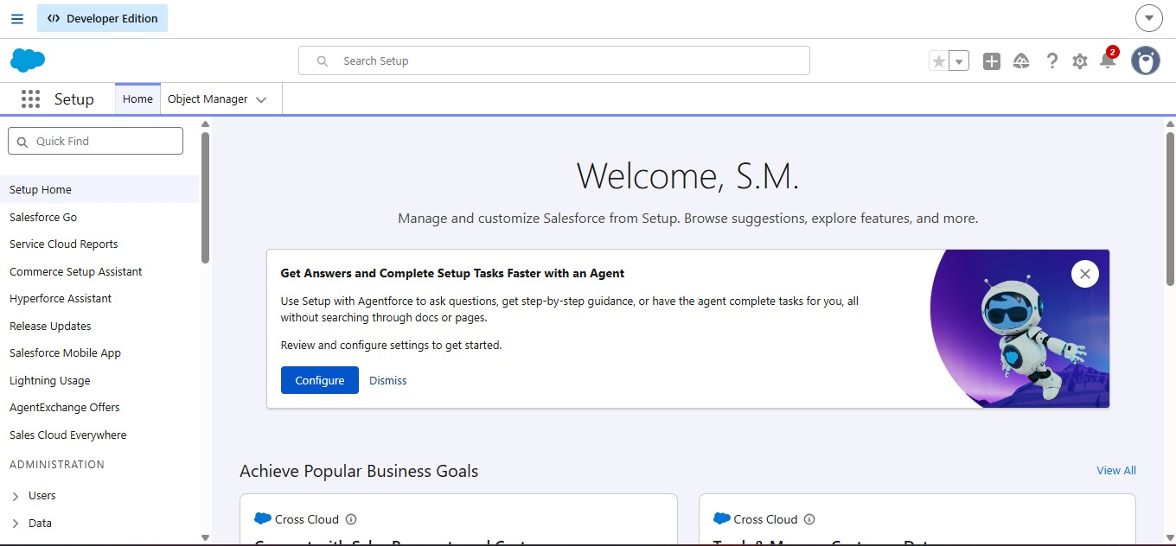
- Click the gear icon → Setup → Object Manager → Create → Custom Object.
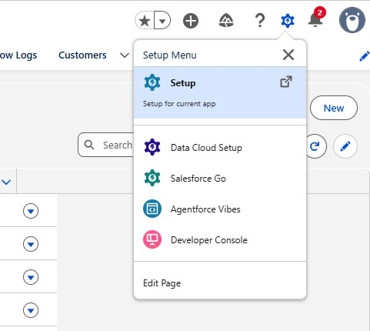

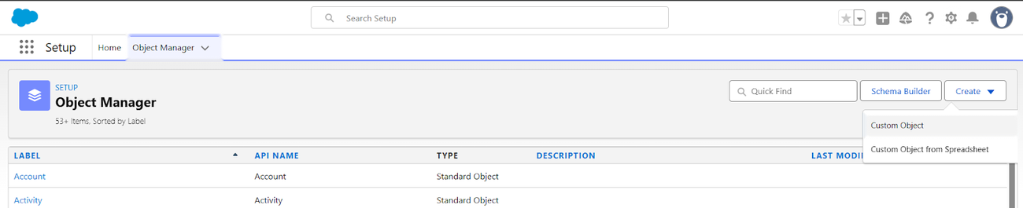

Figure 11: Object Manager – Create Custom Object

- Enter Label: Customer, Plural Label: Customers and Record Name: Customer Name (Text).
- Under Optional Features enable Allow Reports and Track Field History.

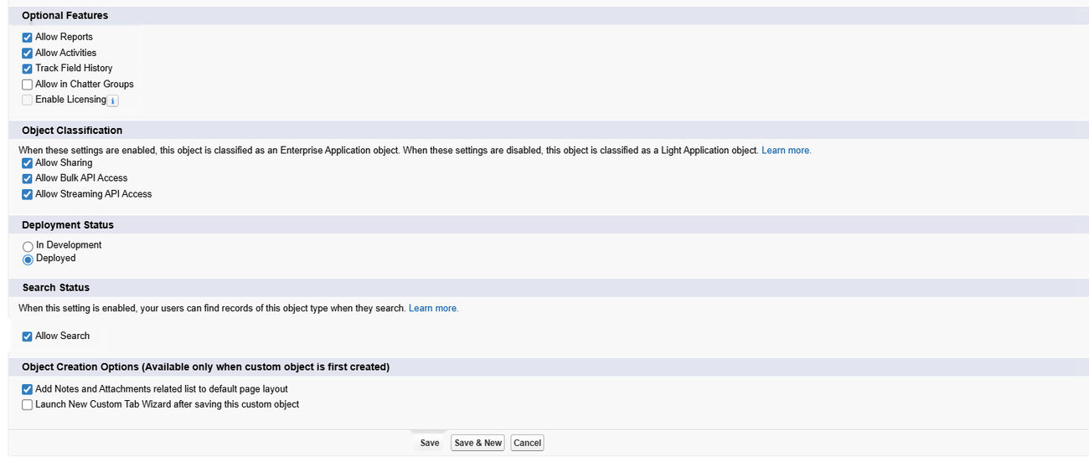
Figure 12: Optional features and creation options for the object
- In Search Status tick Allow Search.
- Under Object Creation Options tick Add Notes and Attachments related list to default page layout.
- Click Save.

Activity 2: Create the Shipment object
- Go to Setup → Object Manager → Create → Custom Object.
- Enter Label: Shipment and Plural Label: Shipments (Shipments).
- Set Record Name: Tracking Number (Auto Number).
- Use the display format SHP-{00000} with the starting number 0.
- Enable Allow Reports and Track Field History.
- Click Save.

Activity 3: Create the Delivery Agent object
- Go to Setup → Object Manager → Create → Custom Object.
- Enter Label: Delivery Agent and Plural Label: Delivery Agents (Delivery Agents).
- Set Record Name: Agent Name (Text).
- Enable Allow Reports and Track Field History.
- Click Save.

Activity 4: Create the Branch object
- Go to Setup → Object Manager → Create → Custom Object.
- Enter Label: Branch and Plural Label: Branchs (Branches).
- Set Record Name: Branch Name (Text).
- Enable Allow Reports.
- Click Save.

Activity 5: Create the Delivery Update object
- Go to Setup → Object Manager → Create → Custom Object.
- Enter Label: Delivery Update and Plural Label: Delivery Updates (Delivery Updates).
- Set Record Name: Update Number (Auto Number).
- Use the display format UPD-{0000} with the starting number 0.
- Enable Allow Reports and Track Field History.
- Click Save.

Activity 6: Create the Invoice object
- Go to Setup → Object Manager → Create → Custom Object.
- Enter Label: Invoice and Plural Label: Invoices (Invoices).
- Set Record Name: Invoice Number (Auto Number).
- Use the display format INV-{0000} with the starting number 0.
- Enable Allow Reports and Track Field History.
- Click Save.

Milestone 3: Tabs

What is a tab?
Tabs let users see the records of an object at a glance. They display the data of objects and other web content inside the application.

Activity 1: Create a tab for the Customer object
- Click Home, type Tabs in Quick Find and select Tabs. 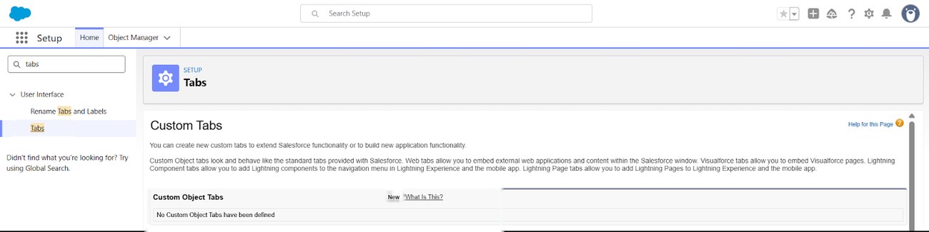
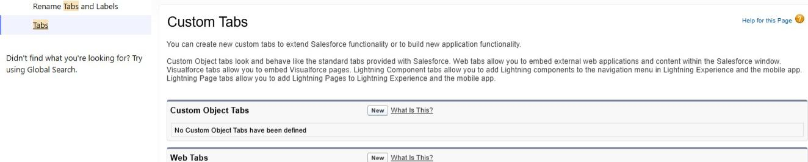
- Under Custom Object Tabs click New.

- For Object, select Customer
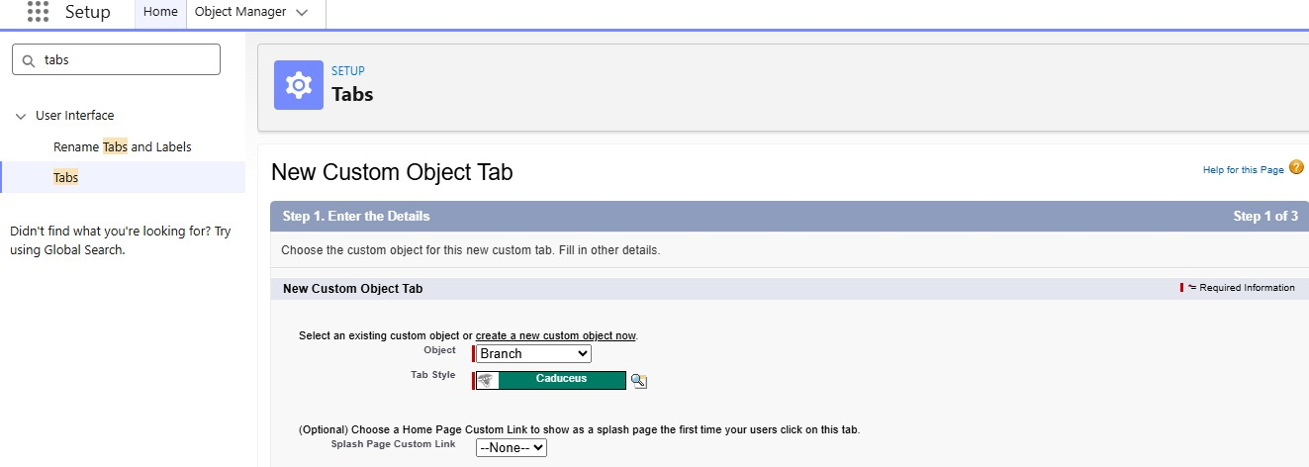
- Choose any tab style.
- Leave the other settings as they are.
- Click Next, Next and Save.
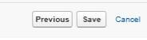

Activity 2: Create a tab for the Shipment object
- Click Home, type Tabs in Quick Find and select Tabs.
- Under Custom Object Tabs click New.
- For Object, select Shipment.
- Choose any tab style.
- Leave the other settings as they are.
- Click Next, Next and Save.

Activity 3: Create a tab for the Delivery Agent object
- Click Home, type Tabs in Quick Find and select Tabs.
- Under Custom Object Tabs click New.
- For Object, select Delivery Agent.
- Choose any tab style.
- Leave the other settings as they are.
- Click Next, Next and Save.

Activity 4: Create a tab for the Branch object
- Click Home, type Tabs in Quick Find and select Tabs.
- Under Custom Object Tabs click New.
- For Object, select Branch.
- Choose any tab style.
- Leave the other settings as they are.
- Click Next, Next and Save.

Activity 5: Create a tab for the Delivery Update object
- Click Home, type Tabs in Quick Find and select Tabs.
- Under Custom Object Tabs click New.
- For Object, select Delivery Update.
- Choose any tab style.
- Leave the other settings as they are.
- Click Next, Next and Save.

Activity 6: Create a tab for the Invoice object
- Click Home, type Tabs in Quick Find and select Tabs.
- Under Custom Object Tabs click New.
- For Object, select Invoice.
- Choose any tab style.
- Leave the other settings as they are.
- Click Next, Next and Save.
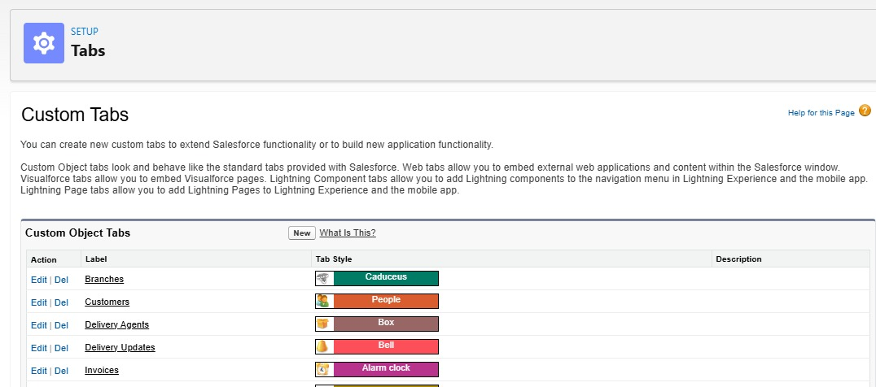

Milestone 4: Fields & Relationships

What are fields?
Fields are the columns of an object, just like columns in a relational database. Each field stores one kind of value for a record.

Activity 1: Fields of the Customer object
Field Name | API Name | Data Type | Required | Description
Customer Name | Name | Text | Yes | Full name of customer
Email | Email__c | Email | Yes | Customer email
Phone | Phone__c | Phone | Yes | Contact number
Address | Address__c | Text Area | Yes | Customer address
Customer Type | Customer_Type__c | Picklist | Yes | Regular / Business
City | City__c | Text | No | Customer city
State | State__c | Text | No | Customer state
Pincode | Pincode__c | Text | No | Postal code
Is Active | Is_Active__c | Checkbox | No | Active status

- Email (Email): Setup → Object Manager → Customer__c → Fields & Relationships → New. Select Email → Next. Field Label: Email. Tick Required. Click Next → Next → Save.
- Phone (Phone): Setup → Object Manager → Customer__c → Fields & Relationships → New. Select Phone → Next. Field Label: Phone. Tick Required. Click Next → Next → Save.
- Address (Text Area): Setup → Object Manager → Customer__c → Fields & Relationships → New. Select Text Area → Next. Field Label: Address. Tick Required. Click Next → Next → Save.
- Customer Type (Picklist): Setup → Object Manager → Customer__c → Fields & Relationships → New. Select Picklist → Next. Field Label: Customer Type. Enter the values Regular and Business. Tick Required. Click Next → Next → Save.
- City (Text): Setup → Object Manager → Customer__c → Fields & Relationships → New. Select Text → Next. Field Label: City. Click Next → Next → Save.
- State (Text): Setup → Object Manager → Customer__c → Fields & Relationships → New. Select Text → Next. Field Label: State. Click Next → Next → Save.
- Pincode (Text): Setup → Object Manager → Customer__c → Fields & Relationships → New. Select Text → Next. Field Label: Pincode. Click Next → Next → Save.
- Is Active (Checkbox): Setup → Object Manager → Customer__c → Fields & Relationships → New. Select Checkbox → Next. Field Label: Is Active. Click Next → Next → Save.

Activity 2: Fields of the Shipment object
Field Name | API Name | Data Type | Required | Description
Tracking Number | Name | Auto Number | Yes | Unique ID
Customer | Customer__c | Lookup (Customer) | Yes | Related customer
Source Address | Source_Address__c | Text Area | Yes | Pickup location
Destination Address | Destination_Address__c | Text Area | Yes | Delivery location
Weight | Weight__c | Number | Yes | Parcel weight
Price | Price__c | Currency | Yes | Shipping charge
Status | Status__c | Picklist | Yes | Shipment status
Expected Date | Expected_Date__c | Date | Yes | Delivery estimate
Assigned Agent | Assigned_Agent__c | Lookup (Delivery Agent) | No | Delivery agent
Shipment Type | Shipment_Type__c | Picklist | Yes | Domestic / International

- Source Address (Text Area): Setup → Object Manager → Shipment__c → Fields & Relationships → New. Select Text Area → Next. Field Label: Source Address. Tick Required. Click Next → Next → Save.
- Destination Address (Text Area): Setup → Object Manager → Shipment__c → Fields & Relationships → New. Select Text Area → Next. Field Label: Destination Address. Tick Required. Click Next → Next → Save.
- Weight (Number): Setup → Object Manager → Shipment__c → Fields & Relationships → New. Select Number → Next. Field Label: Weight. Tick Required. Click Next → Next → Save.
- Price (Currency): Setup → Object Manager → Shipment__c → Fields & Relationships → New. Select Currency → Next. Field Label: Price. Tick Required. Click Next → Next → Save.
- Status (Picklist): Setup → Object Manager → Shipment__c → Fields & Relationships → New. Select Picklist → Next. Field Label: Status. Enter the values Booked, In Transit, Out for Delivery, Delivered, Delayed and Cancelled. Tick Required. Click Next → Next → Save.
- Expected Date (Date): Setup → Object Manager → Shipment__c → Fields & Relationships → New. Select Date → Next. Field Label: Expected Date. Tick Required. Click Next → Next → Save.
- Shipment Type (Picklist): Setup → Object Manager → Shipment__c → Fields & Relationships → New. Select Picklist → Next. Field Label: Shipment Type. Enter the values Domestic and International. Tick Required. Click Next → Next → Save.

Activity 3: Fields of the Delivery Agent object
Field Name | API Name | Data Type |  |  | Required | Description
Agent Name | Name | Text |  |  | Yes | Name of the agent
Email | Email__c | Email |  |  | Yes | Agent email
Phone | Phone__c | Phone |  |  | Yes | Agent contact number
Branch | Branch__c | Lookup (Branch) |  |  | Yes | Home branch
Status | Status__c | Picklist |  |  | Yes | Availability
Joining Date | Joining_Date__c | Date | No | Date of joining

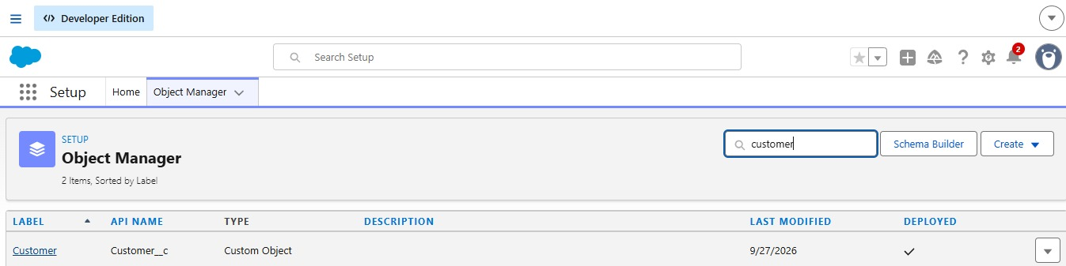
- Email (Email): Setup → Object Manager → Delivery_Agent__c → Fields & Relationships → New. Select Email → Next. Field Label: Email. Tick Required. Click Next → Next → Save.
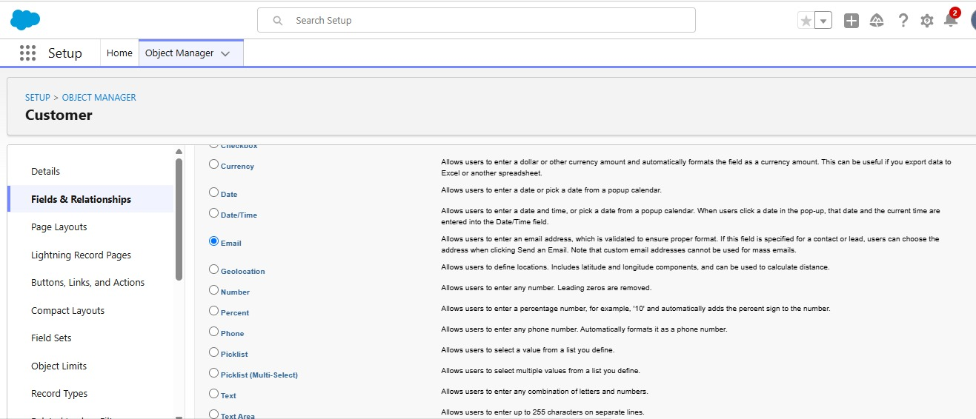
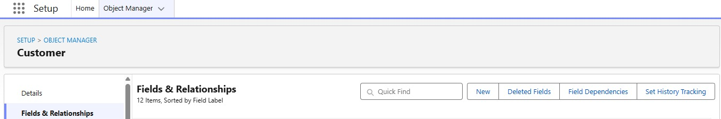
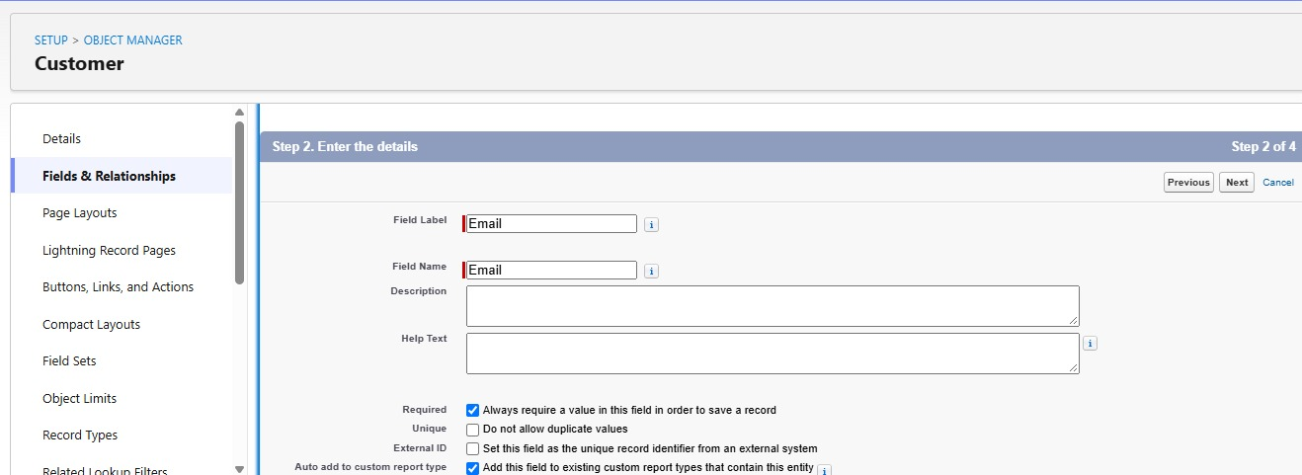
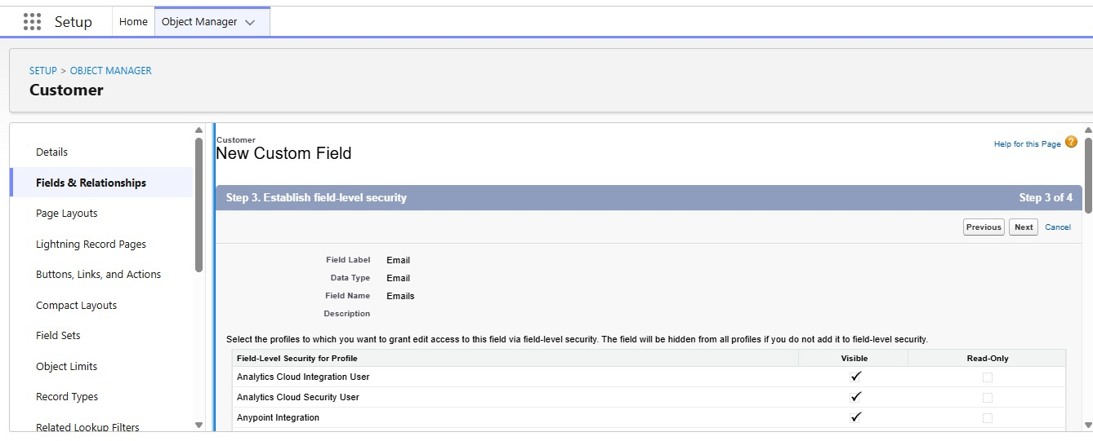
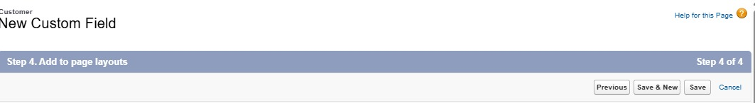
- Phone (Phone): Setup → Object Manager → Delivery_Agent__c → Fields & Relationships → New. Select Phone → Next. Field Label: Phone. Tick Required. Click Next → Next → Save.
- Status (Picklist): Setup → Object Manager → Delivery_Agent__c → Fields & Relationships → New. Select Picklist → Next. Field Label: Status. Enter the values Active, Inactive and On Leave. Tick Required. Click Next → Next → Save.
- Joining Date (Date): Setup → Object Manager → Delivery_Agent__c → Fields & Relationships → New. Select Date → Next. Field Label: Joining Date. Click Next → Next → Save.

Activity 4: Fields of the Branch object
Field Name | API Name | Data Type | Required
Branch Name | Name | Text | Yes
Branch Code | Branch_Code__c | Text | Yes
City | City__c | Text | Yes
State | State__c | Text | Yes
Manager Name | Manager_Name__c | Text | No

For each field: Setup → Object Manager → Branch__c → Fields & Relationships → New, select the data type, enter the field label, set Required where shown and click Save. Repeat for all fields.

Activity 5: Fields of the Delivery Update object
Field Name | API Name | Data Type | Required
Update Number | Name | Auto Number | Yes
Shipment | Shipment__c | Master-Detail | Yes
Status | Status__c | Picklist | Yes
Update Date | Update_Date__c | Date/Time | Yes
Remarks | Remarks__c | Text | No

Status picklist values: In Transit, Out for Delivery, Delivered, Delayed. Tick Required and Save.

Activity 6: Fields of the Invoice object
Field Name | API Name | Data Type | Required
Invoice Number | Name | Auto Number | Yes
Shipment | Shipment__c | Lookup | Yes
Amount | Amount__c | Currency | Yes
Invoice Date | Invoice_Date__c | Date | Yes
Payment Status | Payment_Status__c | Picklist | Yes

Payment Status values: Paid, Unpaid, Pending. Tick Required and Save.

Relationships
Child Object | Field | Parent Object | Type
Shipment | Customer__c | Customer | Lookup
Shipment | Assigned_Agent__c | Delivery Agent | Lookup
Delivery Agent | Branch__c | Branch | Lookup
Delivery Update | Shipment__c | Shipment | Master-Detail
Invoice | Shipment__c | Shipment | Lookup

Relationship creation steps

Activity 1: Shipment → Customer
- Setup → Shipment__c → Fields & Relationships → New.
- Select Lookup Relationship.
- Related Object: Customer__c.
- Field Label: Customer.
- Save.

Activity 2: Shipment → Delivery Agent
- Setup → Shipment__c → New.
- Select Lookup Relationship.
- Related Object: Delivery_Agent__c.
- Field Label: Assigned Agent.
- Save.

Activity 3: Delivery Agent → Branch
- Setup → Delivery_Agent__c → New.
- Select Lookup Relationship.
- Related Object: Branch__c.
- Field Label: Branch.
- Save.

Activity 4: Delivery Update → Shipment
- Setup → Delivery_Update__c → New.
- Select Master-Detail Relationship.
- Related Object: Shipment__c.
- Save.

Activity 5: Invoice → Shipment
- Setup → Invoice__c → New.
- Select Lookup Relationship.
- Related Object: Shipment__c.
- Save.

Milestone 5: Validation Rules
Validation rules are checked whenever a user tries to save a record. If the data does not meet the condition, an error message is shown and the record cannot be saved until the problem is corrected.

Activity 1: Validation rules on Customer__c
- Email_Required: Setup → Object Manager → Customer__c → Validation Rules → New. Tick Active, paste the formula, click Check Syntax, enter the error message and set the error location to the Email field. Save.
Formula: ISBLANK(Email__c)
Error message: Email is required.
- Validate_Phone_Number: Setup → Object Manager → Customer__c → Validation Rules → New. Tick Active, paste the formula, click Check Syntax, enter the error message and set the error location to the Phone field. Save.
Formula: LEN(Phone__c) <> 10
Error message: Phone number must be 10 digits.
- Validate_Pincode: Setup → Object Manager → Customer__c → Validation Rules → New. Tick Active, paste the formula, click Check Syntax, enter the error message and set the error location to the Pincode field. Save.
Formula: LEN(Pincode__c) <> 6
Error message: Pincode must be 6 digits.

Activity 2: Validation rules on Shipment__c
- Validate_Weight: Setup → Object Manager → Shipment__c → Validation Rules → New. Tick Active, paste the formula, click Check Syntax, enter the error message and set the error location to the Weight field. Save.
Formula: Weight__c <= 0
Error message: Weight must be greater than zero.
- Validate_Price: Setup → Object Manager → Shipment__c → Validation Rules → New. Tick Active, paste the formula, click Check Syntax, enter the error message and set the error location to the Price field. Save.
Formula: Price__c <= 0
Error message: Price must be greater than zero.
- Validate_Expected_Date: Setup → Object Manager → Shipment__c → Validation Rules → New. Tick Active, paste the formula, click Check Syntax, enter the error message and set the error location to the Expected Date field. Save.
Formula: Expected_Date__c < TODAY()
Error message: Expected delivery date cannot be in the past.

Activity 3: Validation rule on Delivery_Agent__c
- Validate_Agent_Email: Setup → Object Manager → Delivery_Agent__c → Validation Rules → New. Tick Active, paste the formula, click Check Syntax, enter the error message and set the error location to the Email field. Save.
Formula: NOT(CONTAINS(Email__c, "@"))
Error message: Enter a valid email address.

Activity 4: Validation rule on Branch__c
- Branch_Code_Required: Setup → Object Manager → Branch__c → Validation Rules → New. Tick Active, paste the formula, click Check Syntax, enter the error message and set the error location to the Branch Code field. Save.
Formula: ISBLANK(Branch_Code__c)
Error message: Branch Code is mandatory.

Activity 5: Validation rule on Delivery_Update__c
- Remarks_Required_For_Delay: Setup → Object Manager → Delivery_Update__c → Validation Rules → New. Tick Active, paste the formula, click Check Syntax, enter the error message and set the error location to the Remarks field. Save.
Formula: AND(ISPICKVAL(Status__c, "Delayed"), ISBLANK(Remarks__c))
Error message: Remarks are required when status is Delayed.

Milestone 6: Page Layouts
Page layouts control what a user sees on a record page and how the information is organised. They arrange fields, sections, buttons and related lists so that users can enter, update and view data easily.

Activity 1: Edit the page layout of Customer__c
- Setup → Object Manager → Customer__c → Page Layouts.
- Open the default Customer layout.
- From the top palette drag Section onto the layout, enter the section name, choose a two-column layout with top-down tab order, and click OK.
- Drag the fields listed below into the section.
- Arrange the fields neatly and click Save.
Section 1 – Customer Information: Customer Name, Customer Type, Email, Phone, Is Active
Section 2 – Address Details: Address, City, State, Pincode

Activity 2: Edit the page layout of Shipment__c
- Setup → Object Manager → Shipment__c → Page Layouts.
- Open the default Shipment layout.
- From the top palette drag Section onto the layout, enter the section name, choose a two-column layout with top-down tab order, and click OK.
- Drag the fields listed below into the section.
- Arrange the fields neatly and click Save.
Section 1 – Shipment Details: Tracking Number, Customer, Shipment Type, Weight, Price, Status
Section 2 – Address Information: Source Address, Destination Address
Section 3 – Delivery Information: Expected Date, Assigned Agent

Activity 3: Edit the page layout of Delivery_Agent__c
- Setup → Object Manager → Delivery_Agent__c → Page Layouts.
- Open the default Delivery Agent layout.
- From the top palette drag Section onto the layout, enter the section name, choose a two-column layout with top-down tab order, and click OK.
- Drag the fields listed below into the section.
- Arrange the fields neatly and click Save.
Agent Details: Agent Name, Email, Phone, Branch, Status, Joining Date
Additional Information: Related lists: Shipments and Delivery Updates

Activity 4: Edit the page layout of Branch__c
- Setup → Object Manager → Branch__c → Page Layouts.
- Open the default Branch layout.
- From the top palette drag Section onto the layout, enter the section name, choose a two-column layout with top-down tab order, and click OK.
- Drag the fields listed below into the section.
- Arrange the fields neatly and click Save.
Branch Information: Branch Name, Branch Code, City, State, Manager Name

Activity 5: Edit the page layout of Delivery_Update__c
- Setup → Object Manager → Delivery_Update__c → Page Layouts.
- Open the default Delivery Update layout.
- From the top palette drag Section onto the layout, enter the section name, choose a two-column layout with top-down tab order, and click OK.
- Drag the fields listed below into the section.
- Arrange the fields neatly and click Save.
Update Information: Update Number, Shipment, Status, Update Date, Remarks

Activity 6: Edit the page layout of Invoice__c
- Setup → Object Manager → Invoice__c → Page Layouts.
- Open the default Invoice layout.
- From the top palette drag Section onto the layout, enter the section name, choose a two-column layout with top-down tab order, and click OK.
- Drag the fields listed below into the section.
- Arrange the fields neatly and click Save.
Invoice Details: Invoice Number, Shipment, Amount, Invoice Date, Payment Status

Milestone 7: Flows
A flow is a powerful Salesforce tool for automating business processes, collecting and updating data, and guiding users through screens. Flows are built in a visual interface, so no coding is required.

Activity 1: Auto-update the shipment status when a delivery update is created
Scenario: Whenever a Delivery_Update__c record is created, the Status of the related Shipment__c record should automatically take the latest status from the update.

Part 1: Create the record-triggered flow
Step 1: Open Flow Builder
- Click the gear icon → Setup.
- Type Flows in Quick Find and open Flows.
- Click New Flow.
- Select Record-Triggered Flow and click Create.
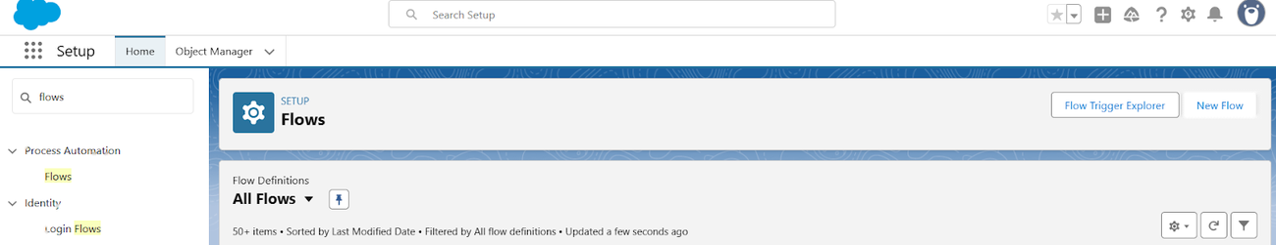
Figure 14: Flows page in Setup
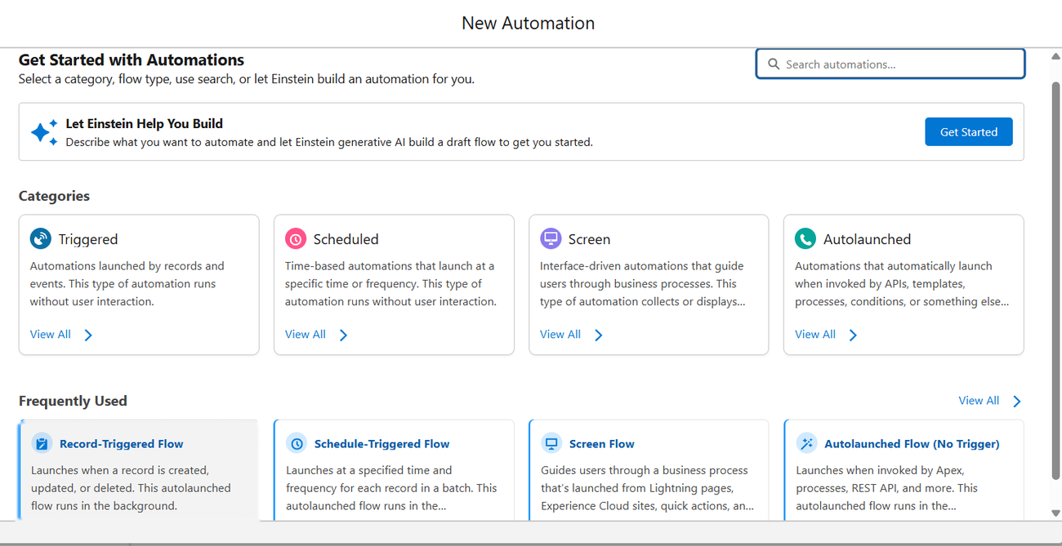
Figure 15: Selecting the Record-Triggered Flow type
Step 2: Configure the Start element
- Object: Delivery_Update__c.
- Trigger the flow when: A record is created.
- Condition Requirements: None (always run the flow).
- Optimise the flow for: Actions and Related Records.
- Click Done.

Part 2: Update the related shipment
Step 3: Add the Update Records element
- Click the + icon under Start and choose Update Records.
- Label: Update_Shipment_Status.
- Select Specify conditions to identify records.
- Object: Shipment__c; Field: Id; Operator: Equals; Value: {!$Record.Shipment__c}.
- Under Set Field Values choose Status__c and set the value to {!$Record.Status__c}.
- Click Done.

Part 3: Save and activate
- Click Save. Enter the flow label Auto_Update_Shipment_Status; the API name fills in automatically.
- Click Activate and check that the status shows Active.
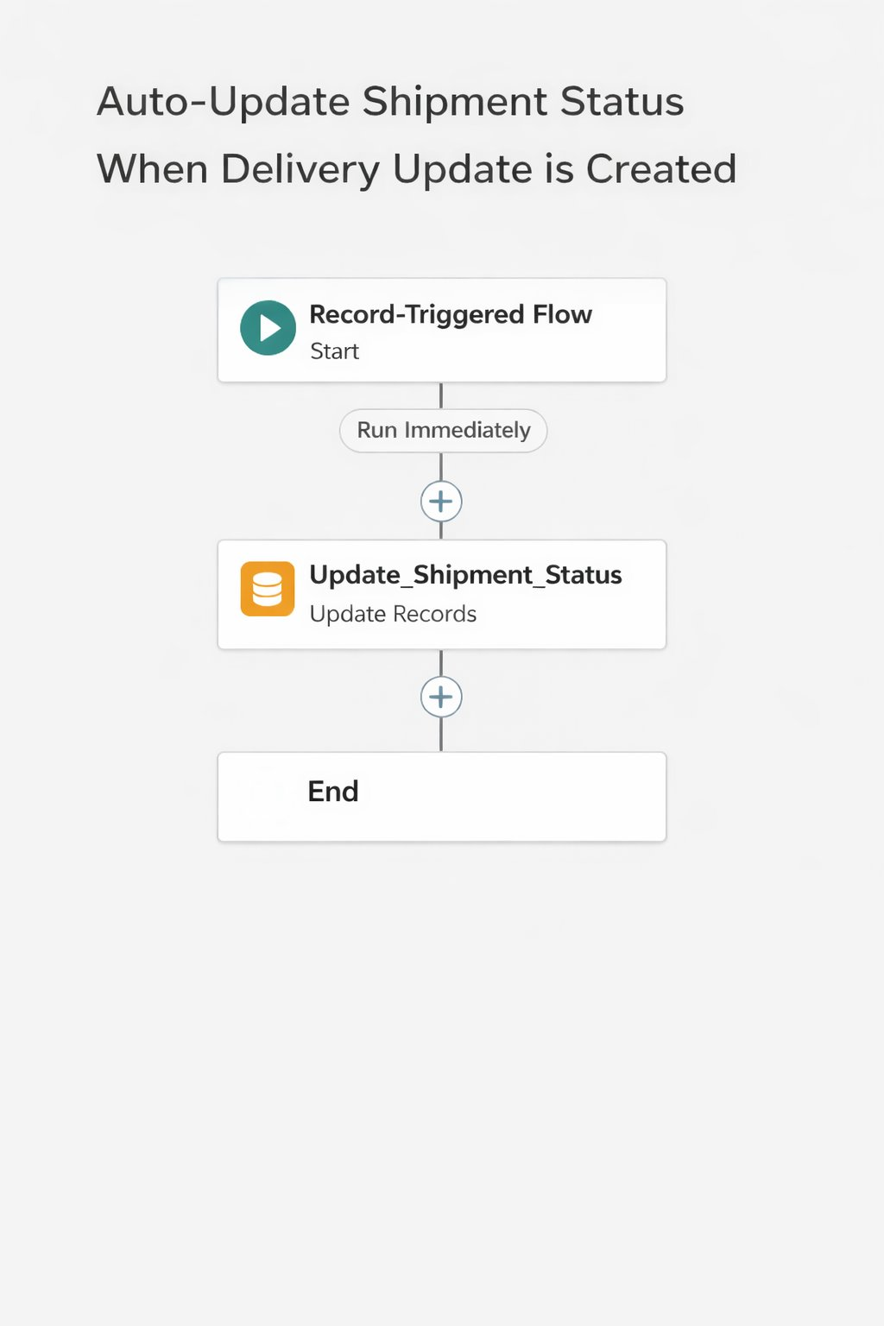
Figure 16: Completed flow layout

Milestone 8: The Lightning App

What is an app?
An app in Salesforce is a group of tabs that work together as one unit. It has a name, a logo and a set of tabs. The simplest app may have only two tabs.

Activity 1: Create the Courier Management System app
- From Setup type App Manager in Quick Find and select App Manager.
- Click New Lightning App and enter Courier Management System as the App Name.
- Upload an image or icon for the app and click Next.
- Keep the default App Options and click Next.
- Keep the Utility Items as they are and click Next.
- From Available Items move Customer, Shipment, Delivery Agent, Branch, Delivery Update, Invoice, Reports and Dashboards to Selected Items, then click Next.
- From Available Profiles move System Administrator to Selected Profiles.
- Click Save & Finish.
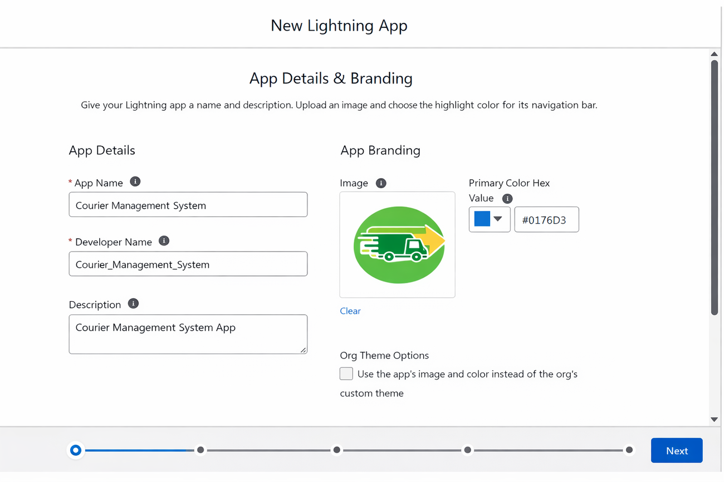
Figure 17: App details and branding
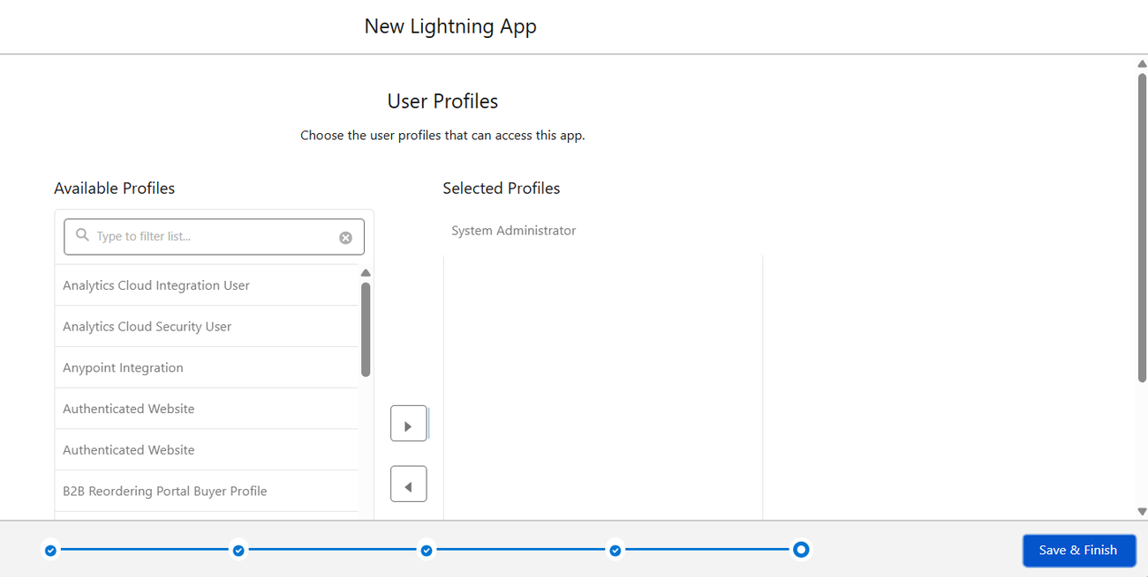
Figure 18: Choosing user profiles for the app

Milestone 9: Profiles

What is a profile?
A profile is a collection of settings and permissions that defines what a user can do in Salesforce. It controls object permissions, field permissions, user permissions, tab settings, app settings, Apex class and Visualforce page access, page layouts, record types, login hours and login IP ranges. A profile can be assigned to many users, but a user can have only one profile at a time.

Activity 1: Create the Courier Admin profile
- From Setup enter Profiles in Quick Find and open Profiles.
- Click New Profile.
- Set Existing Profile to System Administrator.
- Enter the Profile Name: Courier Admin.
- Click Save.
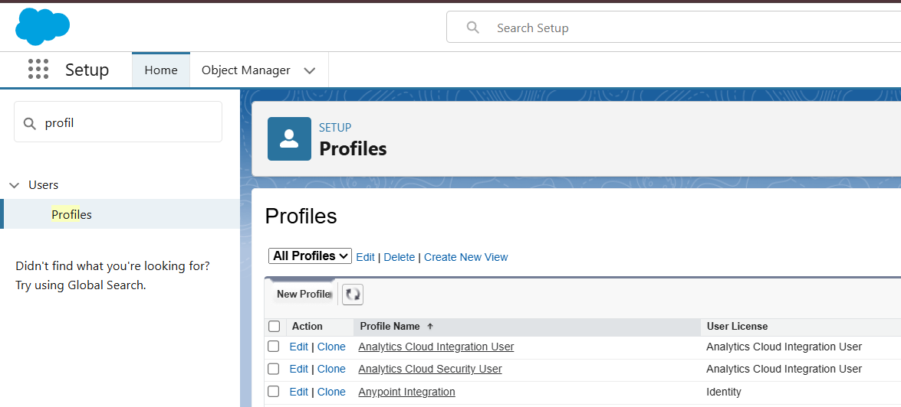
Figure 19: Profiles page in Setup
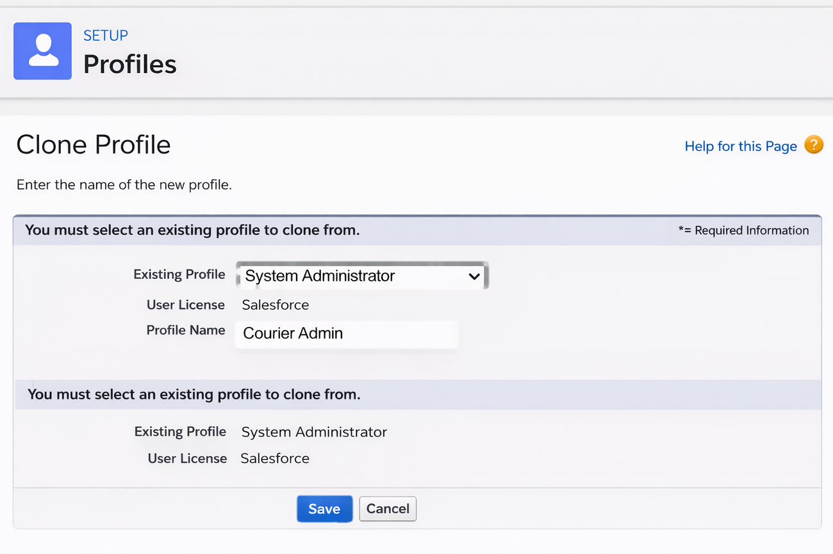
Figure 20: Cloning the System Administrator profile to create Courier Admin
Why use System Administrator as the base? It already has Modify All Data, Customize Application and full create-read-edit-delete access on all objects. By cloning it, Courier Admin inherits full access automatically, and permissions can be restricted later if required.

Activity 2: Create the Branch Manager profile
- Setup → Profiles → New Profile.
- Existing Profile: Standard Platform User; Profile Name: Branch Manager; click Save.
- Click Edit on the new profile.
- Set the default app to Courier Management System.
- Make these tabs visible: Customers, Shipments, Delivery Agents, Branches, Delivery Updates, Invoices, Reports and Dashboards.
- Set the custom object permissions shown below.
- Under Session Settings set the timeout to 2 hours of inactivity; under Password Policies set passwords to never expire with a minimum length of 8.
- Click Save.
Object | Permissions
Customer__c | Create, Read, Edit
Shipment__c | Create, Read, Edit
Delivery_Agent__c | Read, Edit
Branch__c | Read, Edit
Delivery_Update__c | Create, Read, Edit
Invoice__c | Read
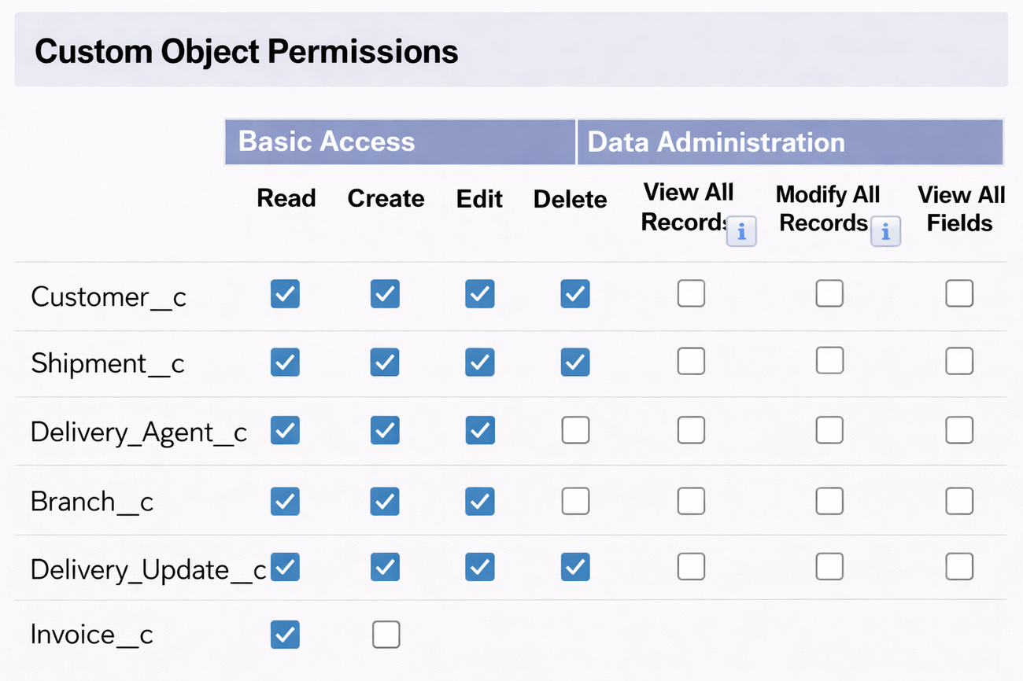
Figure 21: Custom object permissions configured for a profile

Activity 3: Create the Delivery Agent profile
- Setup → Profiles → New Profile.
- Existing Profile: Standard Platform User; Profile Name: Delivery Agent; click Save.
- Set the default app to Courier Management System.
- Make only the Shipments and Delivery Updates tabs visible.
- Set the object permissions shown below.
- Restrictions: no branch editing, no delete permission and limited reporting access.
- Click Save.
Object | Permissions
Shipment__c | Read, Edit
Delivery_Update__c | Create, Read, Edit
Customer__c | Read
Invoice__c | Read

Activity 4: Create the Customer Support profile
- Setup → Profiles → New Profile.
- Existing Profile: Standard User; Profile Name: Customer Support.
- Make the Customers, Shipments and Delivery Updates tabs visible.
- Set the object permissions shown below.
- Set the session timeout to 2 hours and the minimum password length to 8.
- Click Save.
Object | Permissions
Customer__c | Read, Edit
Shipment__c | Read, Edit
Delivery_Update__c | Read
Invoice__c | Read

Final profiles created in the project
Profile Name | Purpose
Courier Admin | Full system control
Branch Manager | Manage shipments and agents
Delivery Agent | Update delivery status
Customer Support | Handle customers and tracking

Milestone 10: Roles
Roles in Salesforce decide which users can access which data and functions, and they define the reporting hierarchy of the organisation. Users higher in the hierarchy have wider access to data and more control over the system.

Activity 1: Create the Courier Admin role
- From Quick Find search for Roles and open Roles.
- Click Set Up Roles.
- Click Expand All and then Add Role under CEO.
- Enter the label Courier Admin; the role name fills in automatically.
- Click Save.
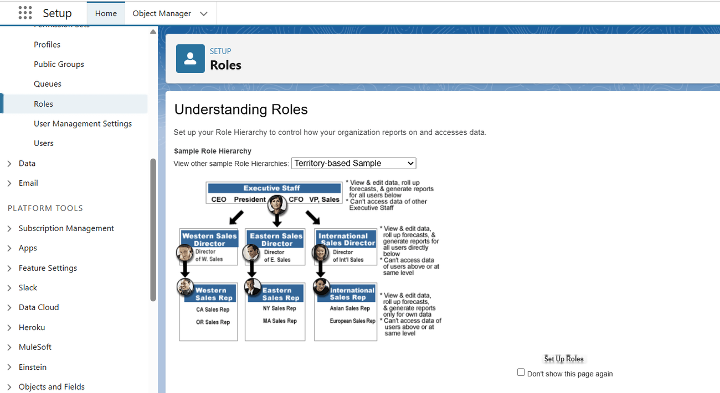
Figure 22: Roles page in Setup
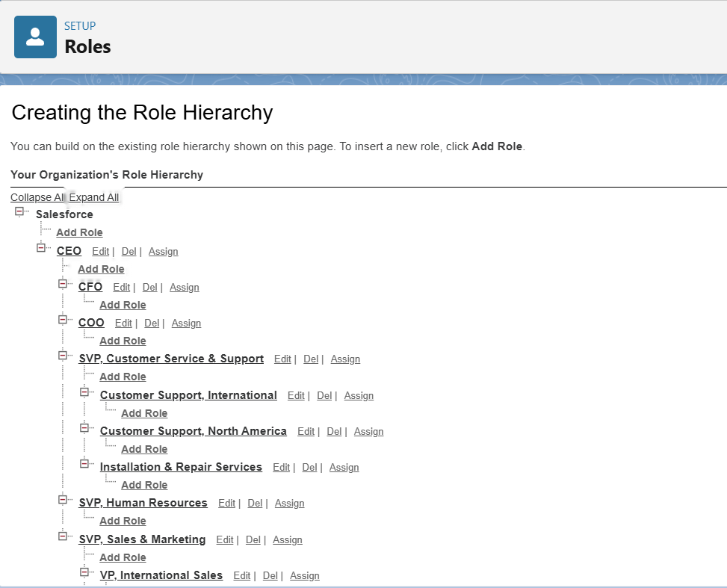
Figure 23: Role hierarchy creation screen

Activity 2: Create the Branch Manager role under Courier Admin
- Below Courier Admin click Add Role.
- Enter the label Branch Manager.
- Click Save.

Activity 3: Create the Delivery Agent role under Branch Manager
- Below Branch Manager click Add Role.
- Enter the label Delivery Agent.
- Click Save.

Activity 4: Create the Customer Support role under Branch Manager
- Under Branch Manager click Add Role.
- Enter the label Customer Support.
- Click Save.

Purpose of the hierarchy
- Courier Admin – highest level, access to all data
- Branch Manager – manages branch-level operations
- Delivery Agent – access limited to assigned shipments
- Customer Support – limited to customer and shipment tracking
This hierarchy ensures proper data sharing and security across the Courier Management System.

Milestone 11: Users

What is a user?
A user is anyone who logs in to Salesforce, such as managers, staff and IT specialists who need access to company records. Every user has an account that identifies them, and the account settings decide which features and records they can use.
Note: A Developer org allows only a small number of full Salesforce licences. If none is available, deactivate a user who holds one, or change the licence type to another such as Salesforce Platform.

Activity 1: Create a user
- From Setup enter Users in Quick Find and select Users.
- Click New User.
- Fill in the fields shown in the table below.
- Click Save.
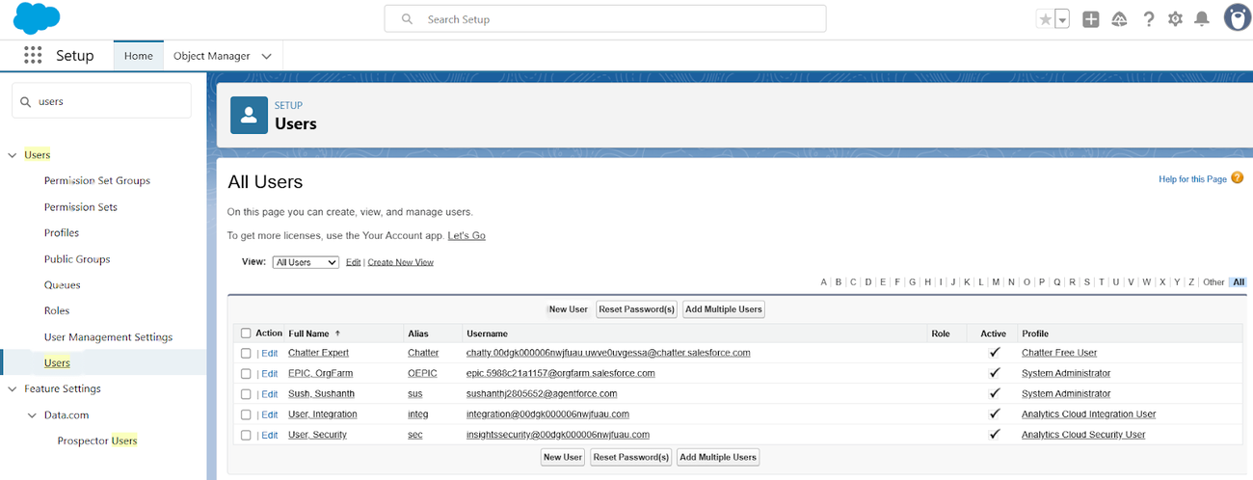
Figure 24: Users list in Setup
Field | Value
First Name | Enter first name (example: Ravi)
Last Name | Enter last name (example: Kumar)
Alias | Any short alias
Email | Your personal email address
Username | Unique, in the format text@text.text
Nickname | Any nickname
Role | Courier Admin
User License | Salesforce
Profile | Courier Admin

Activity 2: Create the other users
Repeat the same steps with the following details:
User Type | Role | User License | Profile
Branch Manager | Branch Manager | Salesforce | Branch Manager
Delivery Agent | Delivery Agent | Salesforce Platform | Delivery Agent
Customer Support | Customer Support | Salesforce Platform | Customer Support

Example – Branch Manager user: First name Arjun, last name Reddy, email arjun@gmail.com, username arjun.manager@cms.com, role Branch Manager, profile Branch Manager.

Important points
- Every user needs a unique username, a valid email, a role and a profile.
- Profiles control permissions.
- Roles control data visibility.

Milestone 12: Reports & Dashboards
Reports and dashboards help analyse business data and follow courier operations efficiently.

Activity 1: Create report types
- Click the gear icon → Setup.
- In Quick Find search Report Types.
- Click New Custom Report Type.
- Create the three report types in the table below; for each one set Category to Reports and Deployment Status to Deployed, then click Next → Save.
Primary Object | Label
Shipment__c | Shipment Tracking Report
Customer__c | Customer Summary Report
Delivery_Agent__c | Agent Performance Report

Activity 2: Create reports

Report 1: Shipment Status Summary
- Open the App Launcher, search Reports and click New Report.
- Choose Shipment Tracking Report and click Continue.
- Add the columns Tracking Number, Customer, Status, Expected Date and Assigned Agent.
- Filters: Show Me All Shipments; Date Filter This Month; optionally a Status filter.
- Group rows by Status and add a summary on Price.
- Click Save & Run. Name: Shipment Status Summary; Folder: CMS Reports.

Report 2: Agent Performance Report
- New Report → choose Agent Performance Report → Continue.
- Add the columns Agent Name, Branch, Number of Shipments and Status.
- Group by Delivery Agent.
- Save & Run. Name: Agent Performance Report; Folder: CMS Reports.

Report 3: Revenue by Branch Report
- Create a report using the Shipment Tracking Report type.
- Add the fields Tracking Number, Customer, Price and Invoice Status.
- Group by Branch and Month.
- Save as Revenue by Branch Report.

Activity 3: Create the dashboard
- Open the App Launcher and search Dashboards.
- Click New Dashboard.
- Name: Courier Management Dashboard; Folder: CMS Reports; click Create.

Activity 4: Add dashboard components
- Component 1 – Shipment Status Overview: click + Component, choose the Shipment Status Summary report, select Donut Chart and click Add.
- Component 2 – Agent Performance: choose the Agent Performance Report, select Bar Chart and click Add.
- Component 3 – Revenue by Branch: choose the Revenue by Branch Report, select Column Chart and click Add.

Activity 5: Save and share the dashboard
- Click Save and then Done.
- Share the dashboard with Courier Admin, Branch Managers and the Customer Support team.

Final layout
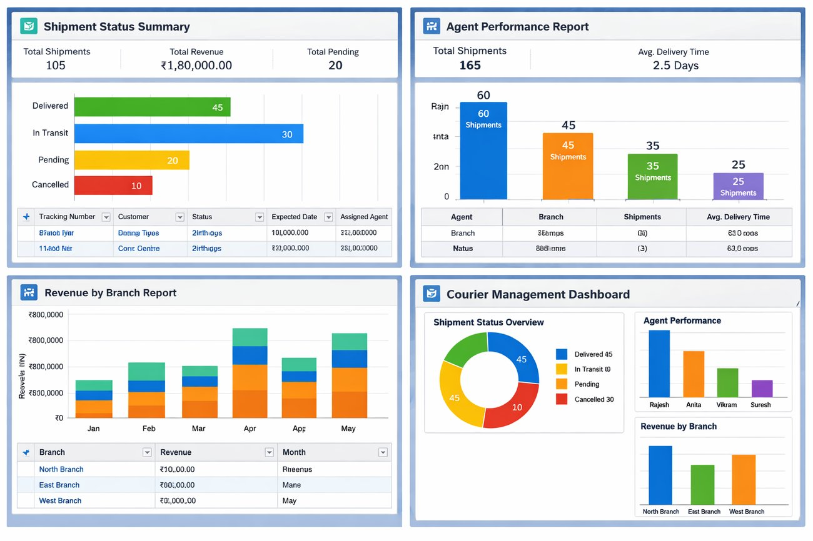
Figure 25: Final reports and Courier Management Dashboard

7. Functional & Performance Testing
During testing, screenshots were captured from Salesforce to verify record creation, validation rule enforcement, delivery status updates, flow automation, invoice generation and dashboard visualisation. All scenarios were validated to make sure the system performs correctly and reliably.
No. | Scenario | Expected Result | Status
1 | Create a customer with a 9-digit phone number | Save blocked; “Phone number must be 10 digits.” | Pass
2 | Create a shipment with weight 0 or a past expected date | Save blocked; the matching error is shown | Pass
3 | Add a Delayed delivery update without remarks | Save blocked; remarks required | Pass
4 | Create a delivery update with status Delivered | Related shipment status changes to Delivered | Pass
5 | Create an invoice for a delivered shipment | Invoice saved and linked to the shipment | Pass
6 | Log in as Delivery Agent | Only Shipments and Delivery Updates tabs visible | Pass
7 | Open the Courier Management Dashboard | Charts show shipment status, agent workload and branch revenue | Pass

8. Advantages & Disadvantages

Advantages
- All courier data is stored in one place
- Workflows are automated
- Reports give real-time insight

Disadvantages
- The solution depends on the Salesforce platform
- It needs some initial configuration effort

9. Conclusion
The Courier Management System successfully moves courier operations onto Salesforce. By combining a structured data model, validation, flow automation, role-based security and analytics, it improves efficiency and accuracy and gives customers and managers the visibility they need.

10. Future Scope
- Mobile tracking app
- GPS integration
- SMS notifications
- AI-based delivery optimisation

11. Appendix
- Source code: Salesforce configuration
- Dataset: Salesforce objects
- GitHub / demo: Salesforce Developer org
Thank You

