ENEL 453 Lab #1a
By: Nabeel Baig, UCID: 30241164
Zayaan Khandakar, UCID: 30249002
Huzaifa Hafeez, UCID: 30246584

Step 7:
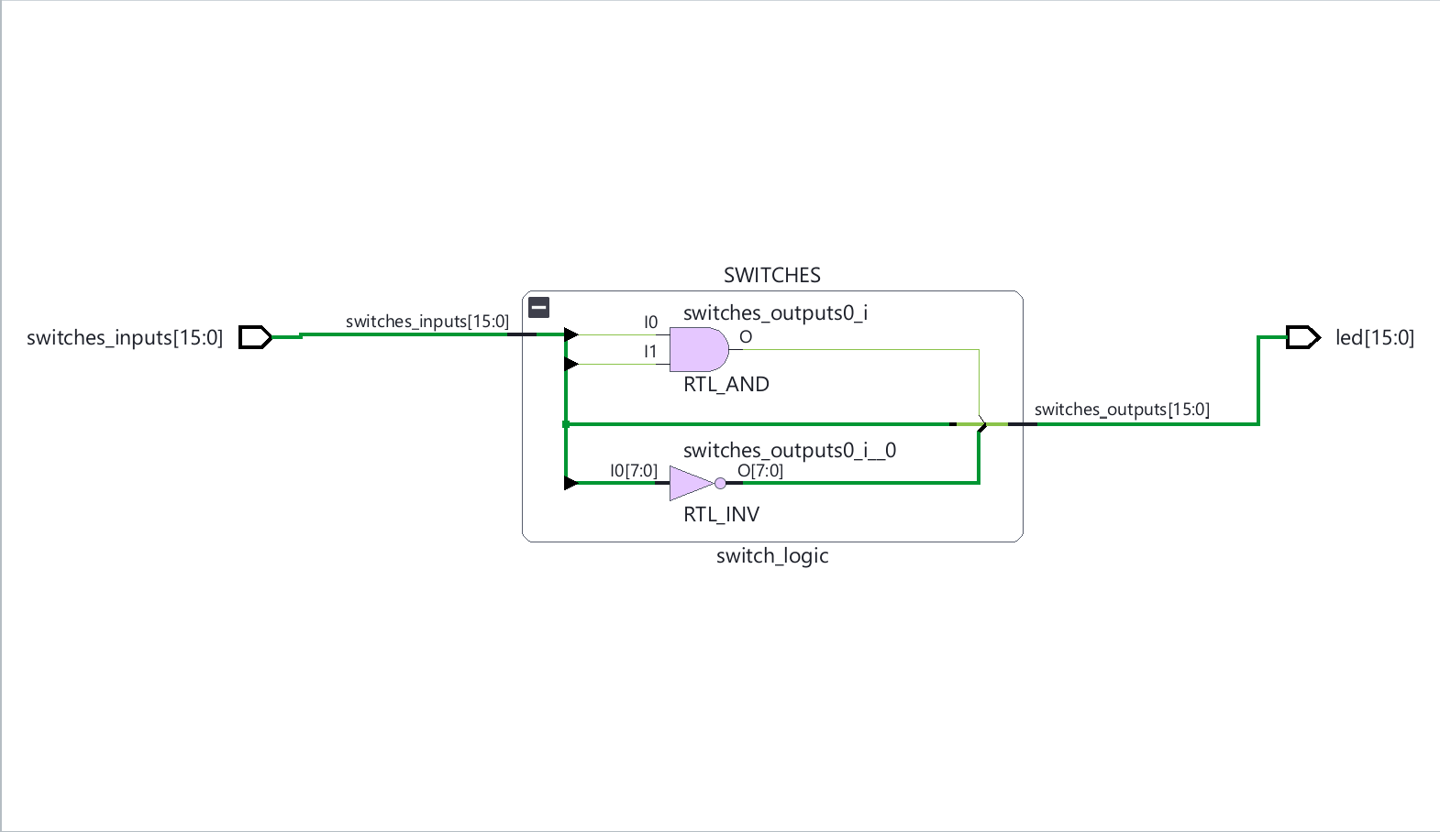
Step 8: 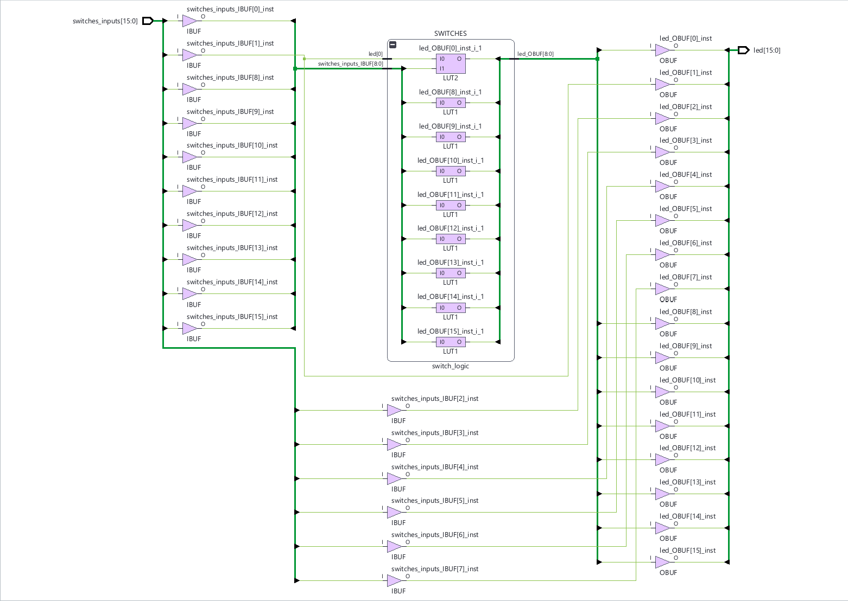

Step 9:
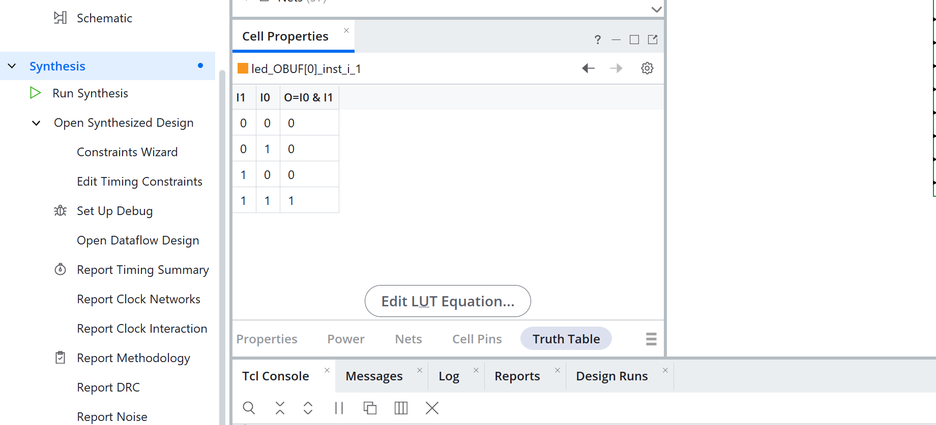
The original switch logic design's two-input AND gate is represented by the LUT2. It generates the output for LED 0 using switches_inputs[0] and switches_inputs[1] as its two inputs. According to the truth table, the result is only 1 when both inputs are 1. The result is 0 for every other combination of inputs. This corresponds to the SystemVerilog expression switches_outputs[0] = switches_inputs[1] & switches_inputs[0].

Step 11:
Testing the Basys3 slide switches revealed two distinct operational behaviors. Switches 15 through 8 functioned with inverted logic. When pushing them up toward the board's center, it deactivated their corresponding LEDs, while pushing them down turned them on. Conversely, switches 7 through 1 operated normally, illuminating their LEDs when pushed up and turning them off when pushed down. Because switches 0 and 1 are programmed with an AND gate, LED 0 only activated when both of those switches were in the up position. Finally, the pushbuttons did not trigger any LED activity because they are not implemented in the current SystemVerilog code.

Step 12:
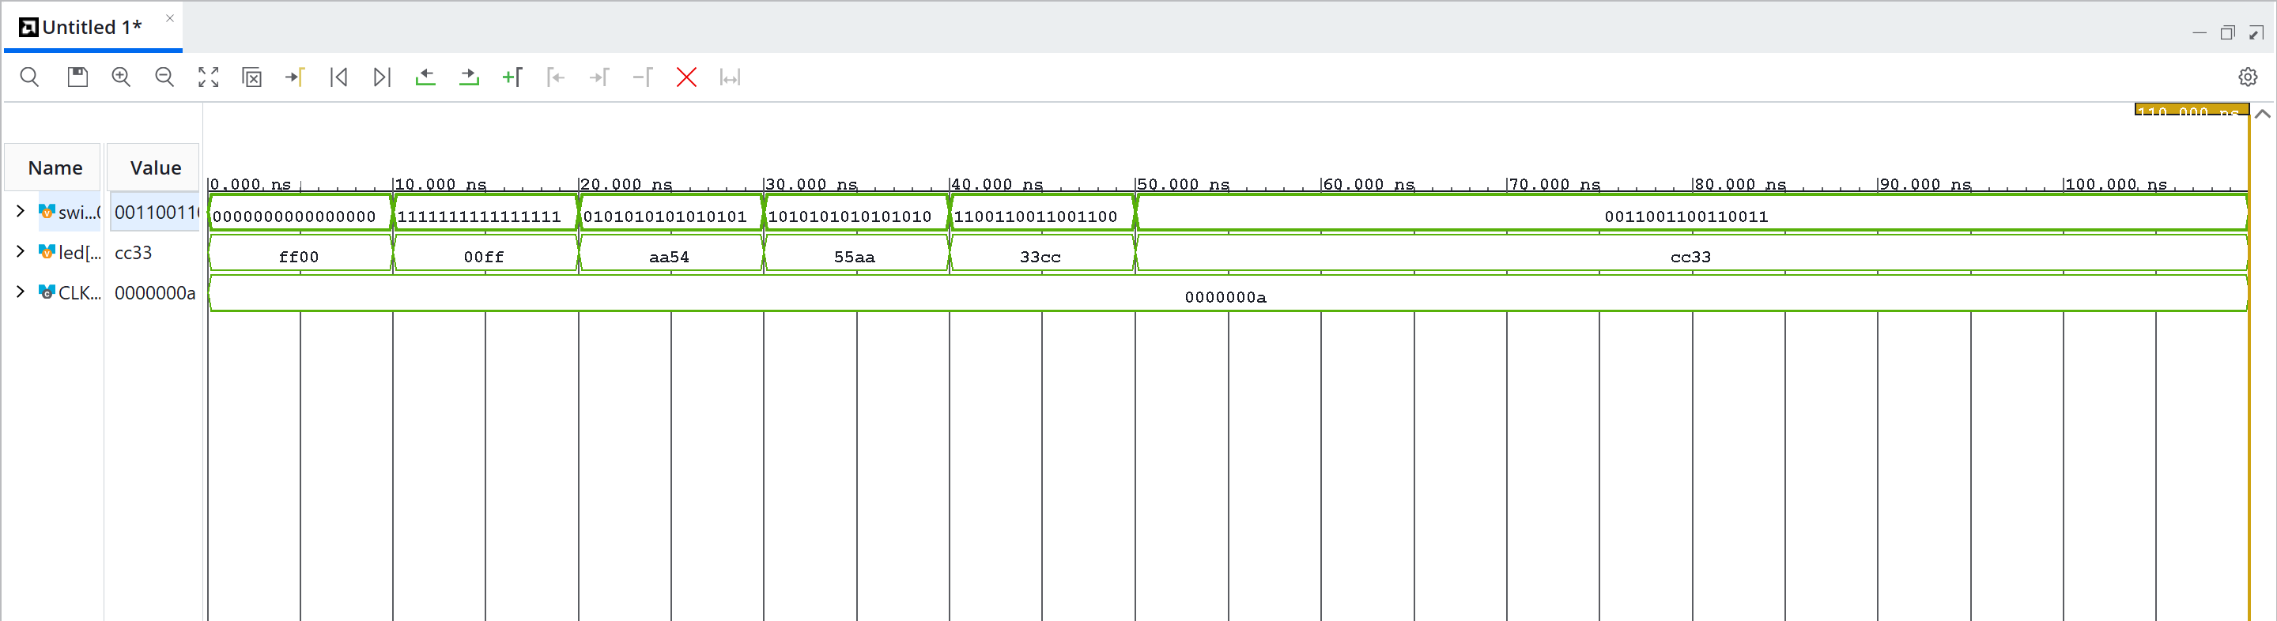

Step 13:
module switch_logic (
input logic [15:0] switches_inputs,
output logic [15:0] switches_outputs
);
// Now when switches are up LEDs are off and when switches are down LEDs are on
assign switches_outputs = ~switches_inputs;

endmodule

Step 14:
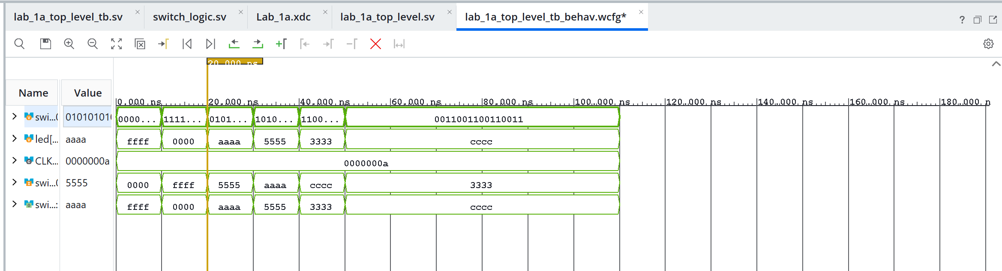

Step 15:
module switch_logic (
input logic [15:0] switches_inputs,
output logic [15:0] switches_outputs
);
// Now when switches are up LEDs are on and when switches are down LEDs are off
assign switches_outputs = switches_inputs;

endmodule

Step 16:
