ENEL 453 Lab #3
By: Nabeel Baig, UCID: 30241164
Zayaan Khandakar, UCID: 30249002
Huzaifa Hafeez, UCID: 30246584

Step 2.) Showcasing the RTL schematic of lab 2
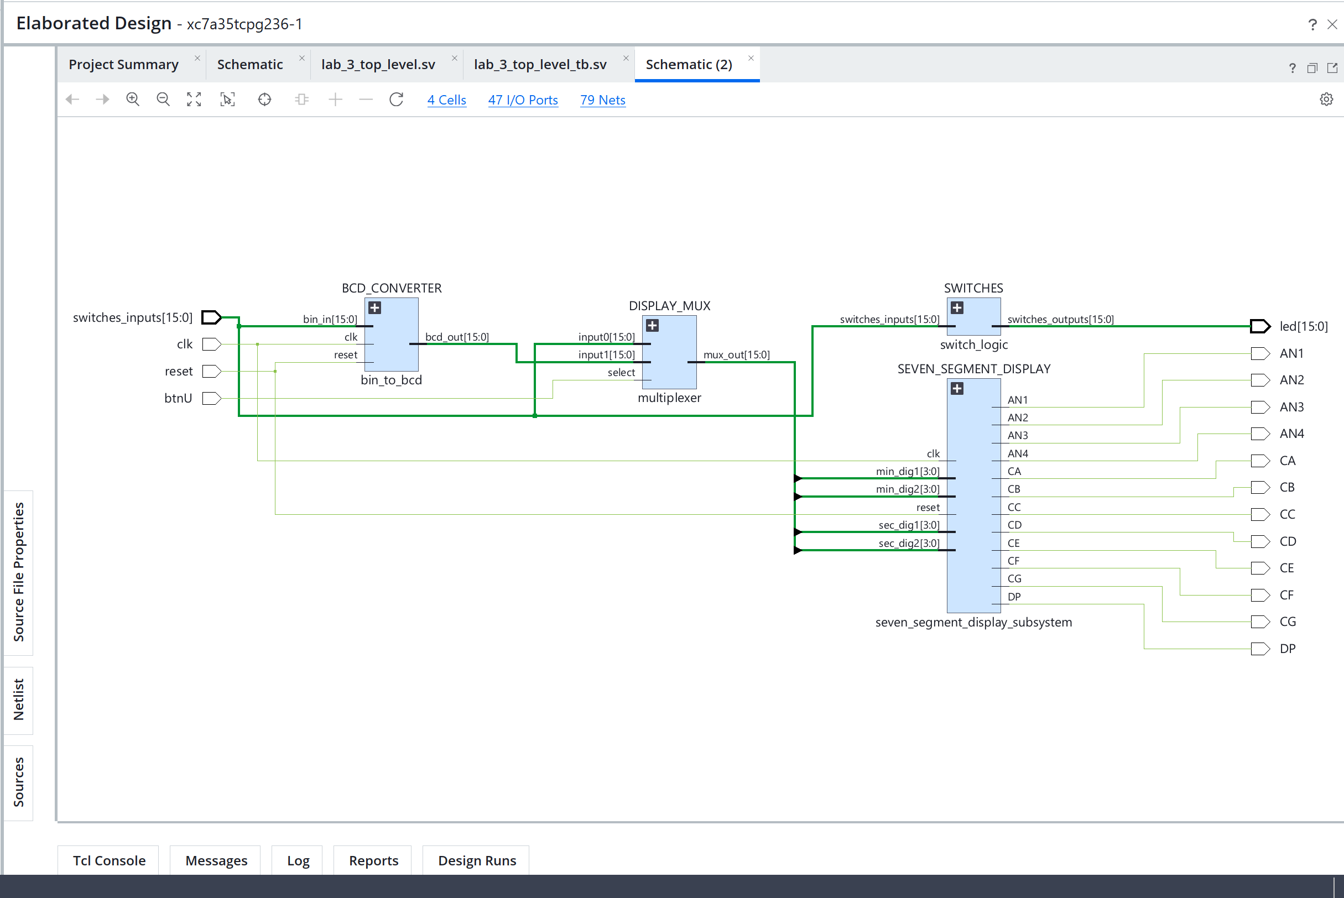

Step 3.)
The debouncer was set up with a steady time of 50 ms and the Basys3 100 MHz system clock. Consequently, stable_time = 50 ms, CLK_period = 10 ns, and clk_freq = 100,000,000 Hz. The supplied debounce.sv and debounce_tb.sv files already contained these values. In order to ensure that the input stays constant for roughly 50 ms until the debounced output is refreshed, the stable time is selected based on the expected 50 ms pushbutton bounce duration.
The projected bounce time should be at least as long as the stable time. The output only changes when the button has ceased bouncing and stayed steady for the whole stable-time interval since each detected transition resets the debounce counter. A larger stable time lengthens the response delay, while an excessively short stable time may permit bounce transitions.

Clock Period:
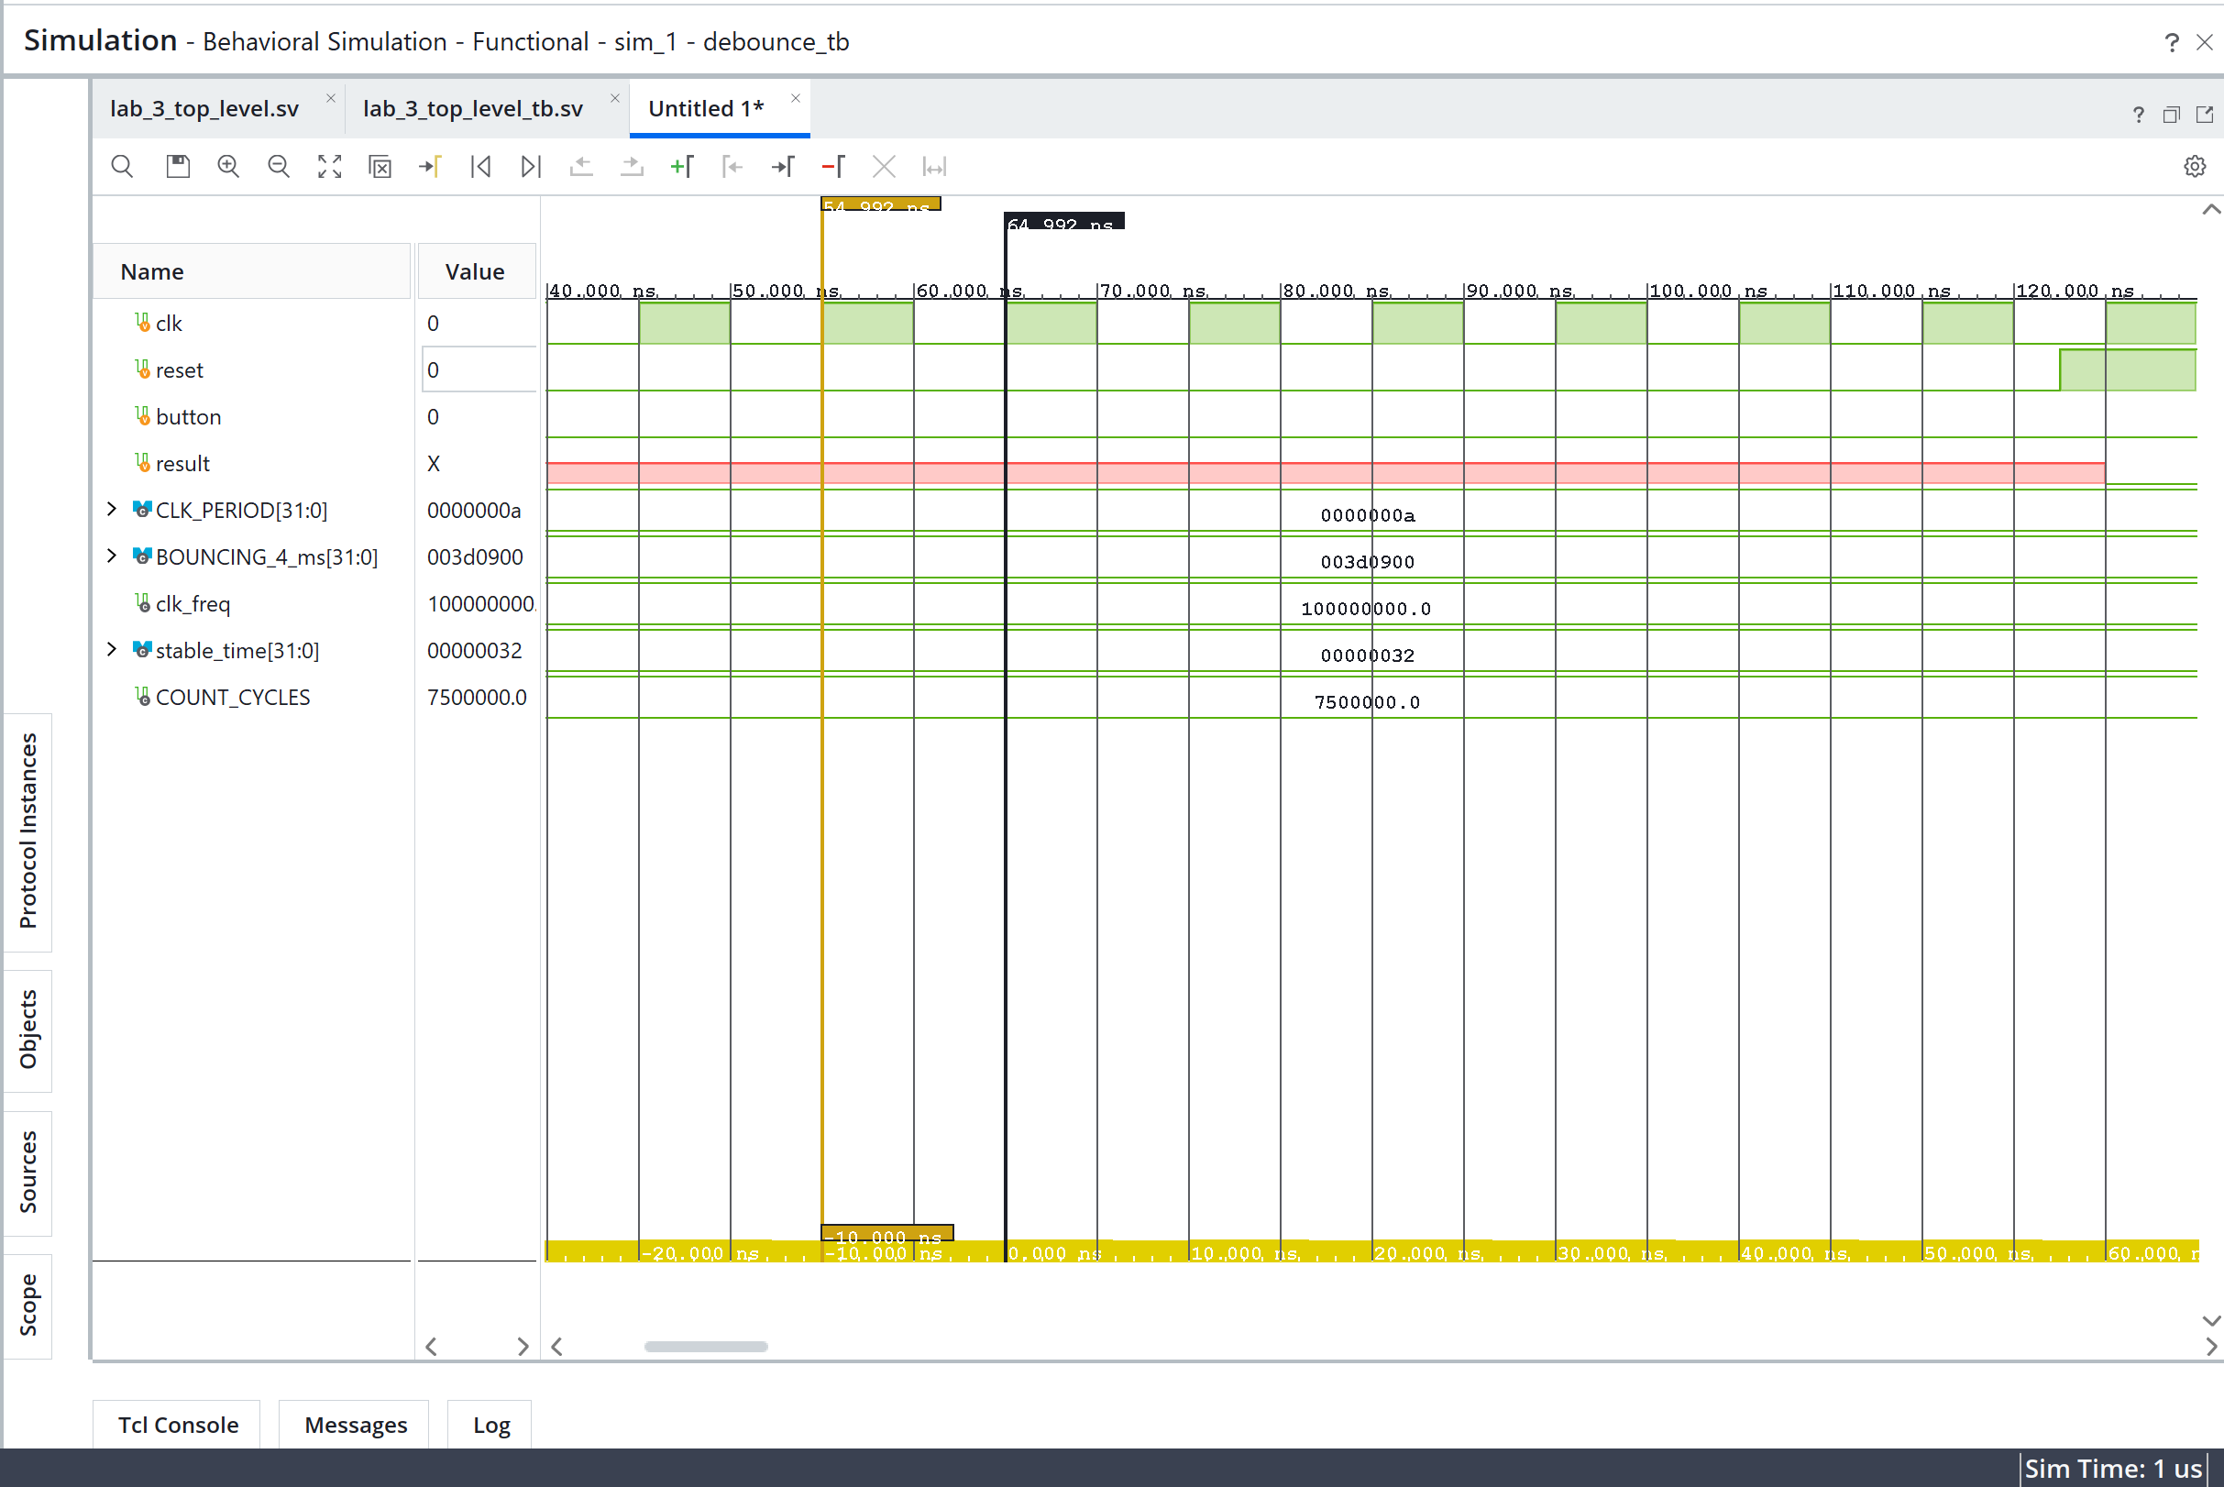

Stable Time:
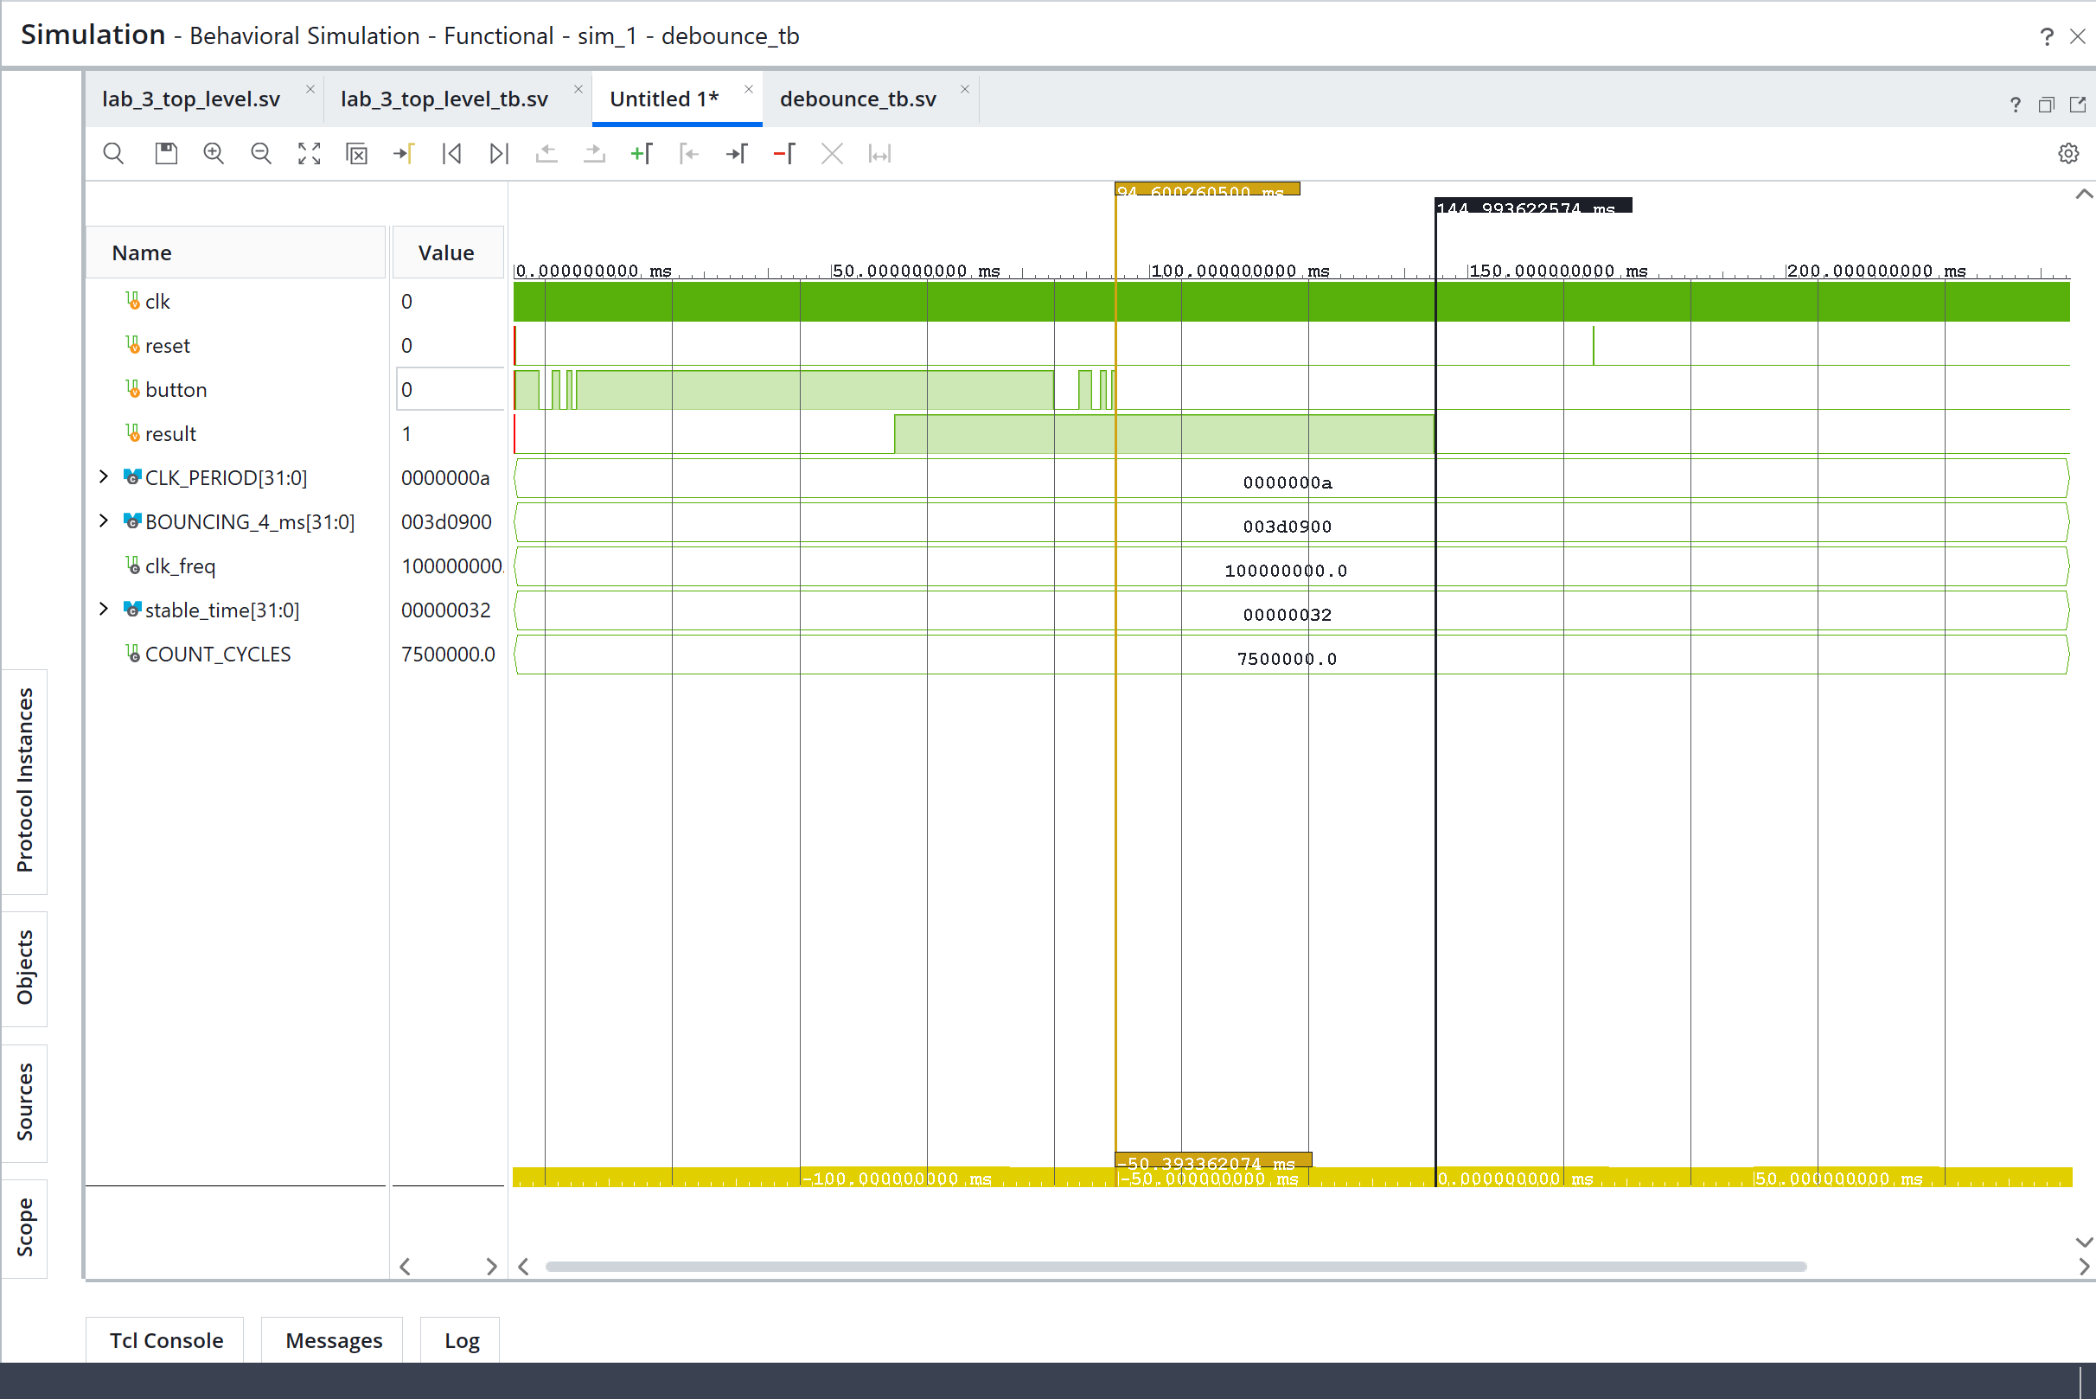
Step 5.)
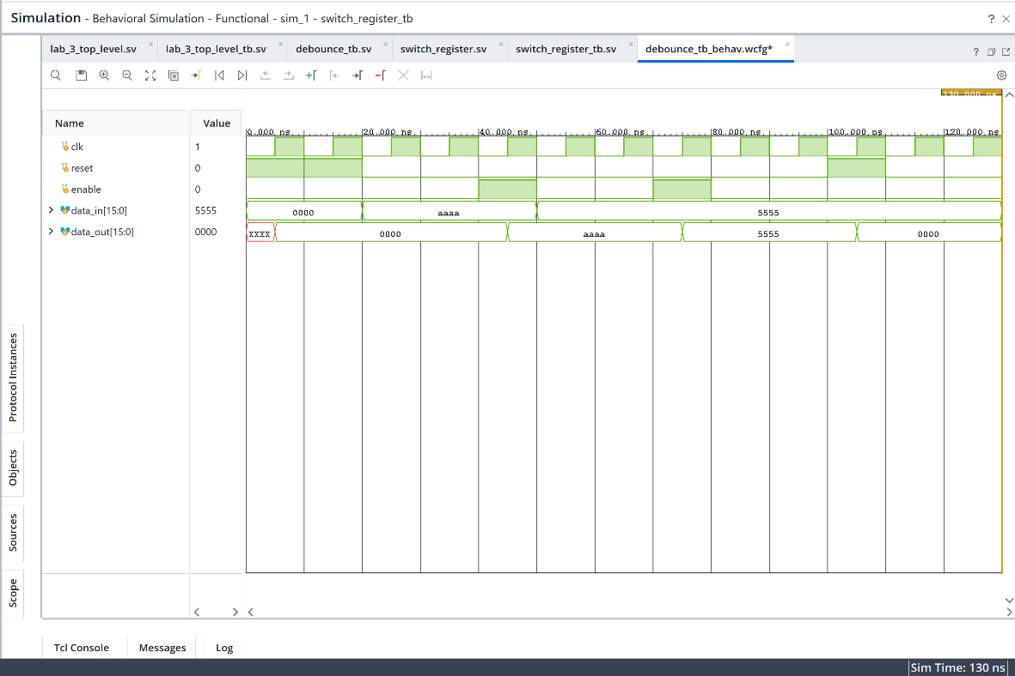
The 16-bit storage register's functionality is confirmed by the simulation. The current input value is recorded on the clock's rising edge when enable = 1. Changes to data_in are ignored and the previously saved value is kept when enable = 0. On a rising clock edge, the stored output is cleared to 0000 by the active-high synchronous reset.

Step 6.)
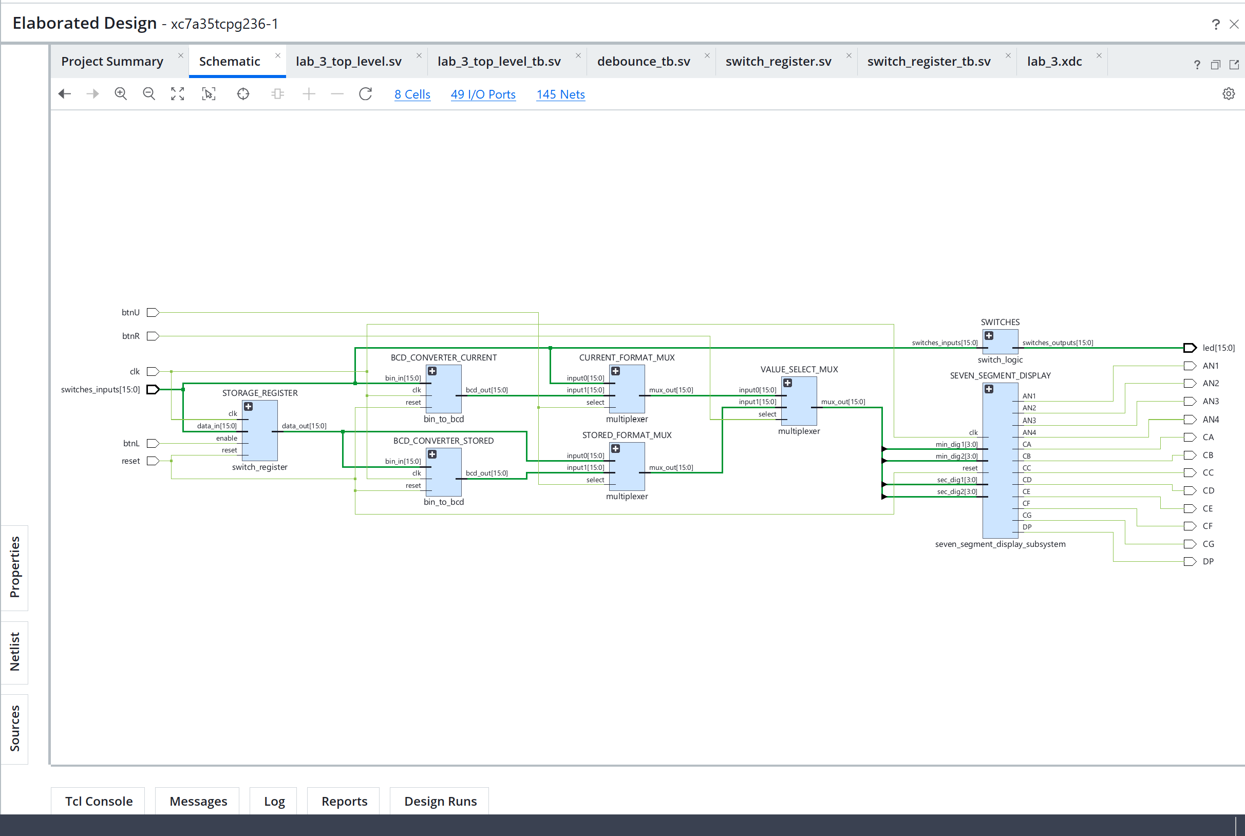

Step 8.)
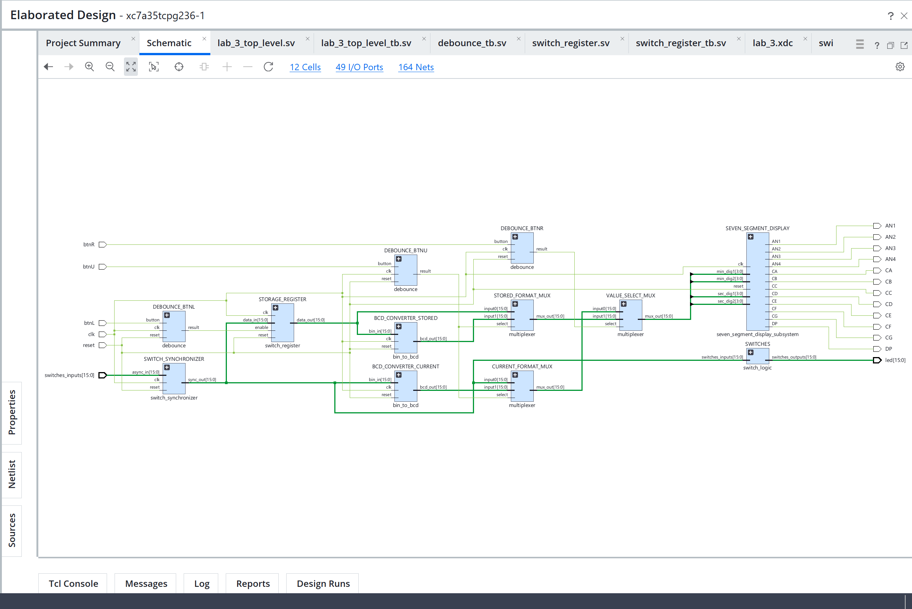
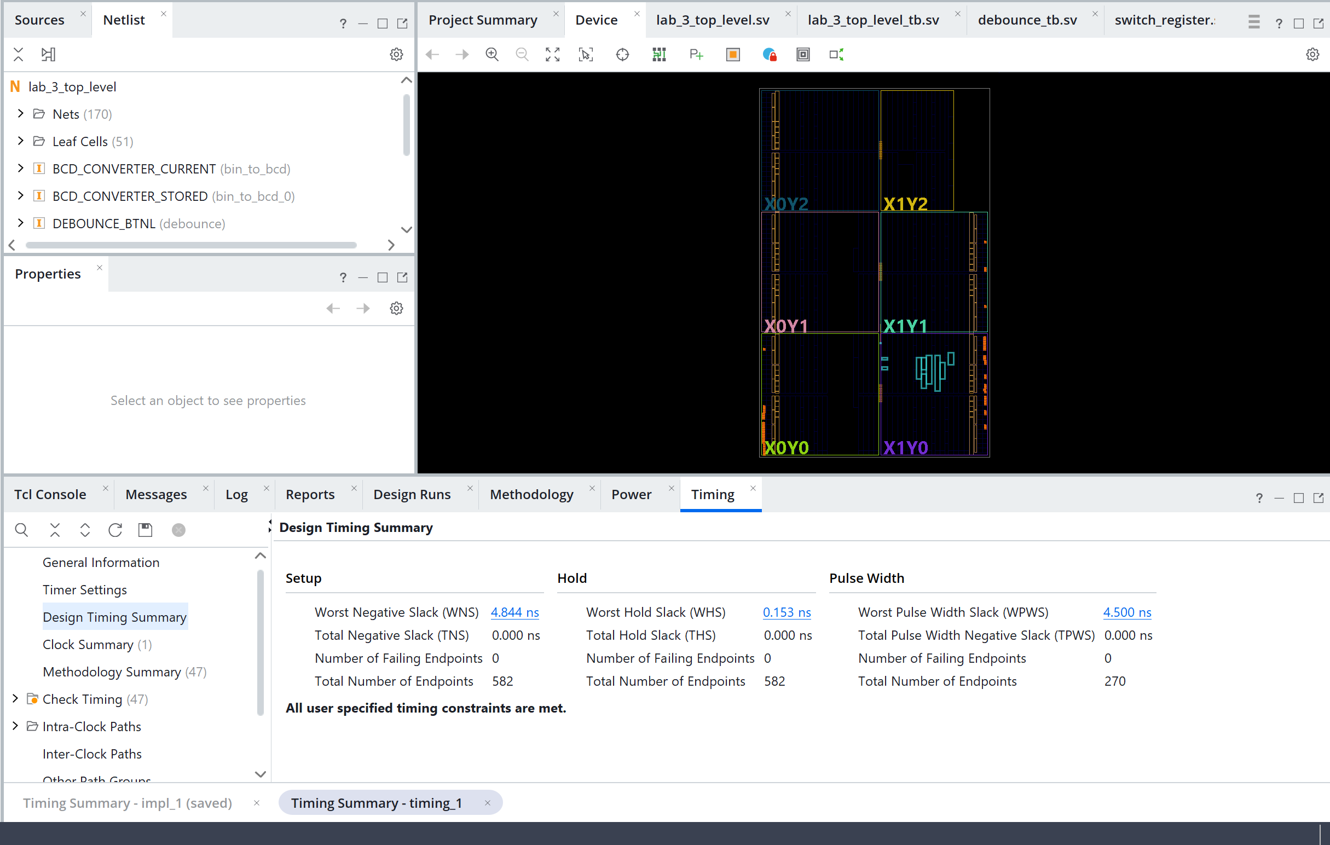
User Clock Period = 10.000 ns
WNS = 4.844 ns
Max frequency = 1 / 10.000 – 4.844 = 193.95 MHz

