ADVANCE SOFTWARE ENGINEERING (CSSE-414)

SIR MUHAMMAD UMAIR KHAN

4th  Semester

**Group Members:**

* Arsalan Muhammad Yousuf B16158014
* Hammad Ahmed Ghazi B16158032
* Moosa Raza B16158088
* Nabeel Imran B16158070
* Wasiq Ahmed Sheikh B16158102



**LAB 02**

**Requirement Analysis:**

The basic phase of software development is the requirement gathering phase where the all sort of requirement is decided by the client in order to get a software or product for the feasibility and flexibility.

So we as a group decided to create software that deal with the Restaurant System and All the functionality with it. In Requirement Gathering Phase We Collaborate with Our Client he describe Us About the software he need.

In Order to get a proper Software the requirement must be clear to the Client As well as to the Developers.

So to Get rid of All paper works now world comes to the newly technology Era so in the Software there Are some basic Requirement to be done:

* Making Orders (dine In, Take Away, Delivery) and generating bills.
* To manage Inventory about the Billing of customers.
* To manage the inventory for the current bill of a customer to be paid.
* Comprises of the two panel

1. for user to Sign in

2. Checking of inventory & Billing.

* Security of All data (staff info, sales history) in Sign in Form.
* To manage the Products inventory of a Restaurant.
* Online Food ordering for a customer At home to save Time.
* To have a proper Database to handle all orders as well as Inventory of the products.

The Software can be used anywhere to manage the Data of a Restaurant.

Reviewed By: **Customer**, **Designer**, **and System** **Analyst**.

System Roles

1. Admin:

Admin actually have access to all over the system including inventory, staff, and sales history.

2. Users:

Users are of two types:

1. Dine In & take away:

These users directly approach to the counter and place order using monitor.

1. Home delivery:

These users approach our website and place order there and can track their order details.

USE CASE

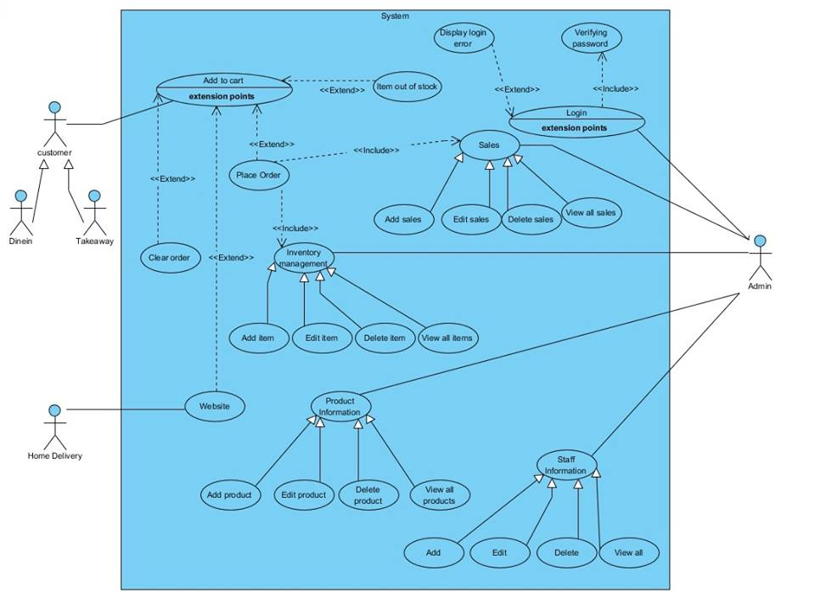

CLASS DIAGRAM

