ADVANCE SOFTWARE ENGINEERING (CSSE-414)

SIR MUHAMMAD UMAIR KHAN

4th  Semester

**Group Members:**

* Arsalan Muhammad Yousuf B16158014
* Hammad Ahmed Ghazi B16158032
* Moosa Raza B16158088
* Nabeel Imran B16158070
* Wasiq Ahmed Sheikh B16158102



**LAB 03**

Activity and Sequence

Diagrams

Activity Diagram

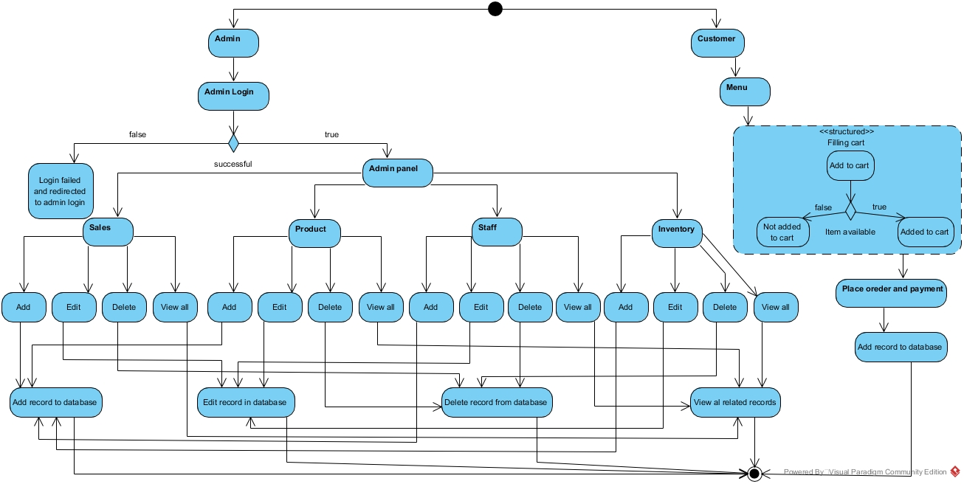

Sequence Diagrams

Admin Flow:

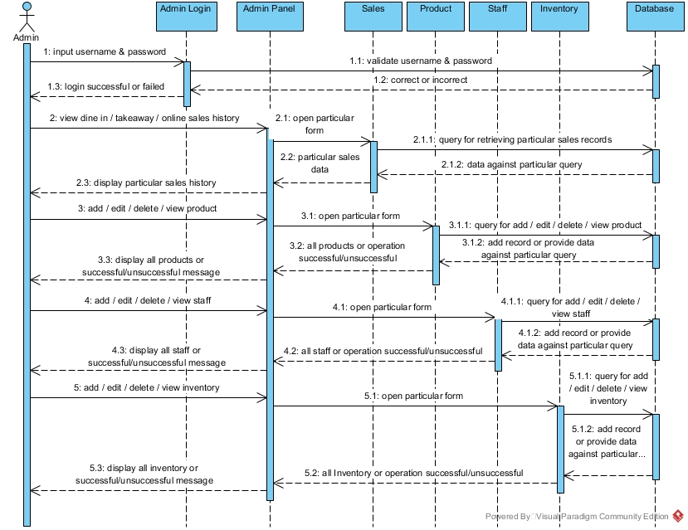

Customer Flow:

