### **Phase 1: Business Registration, Deal Management and HTML updates**

1. **Business Registration Flow**
   * Limit deal and loyalty punch cards photos to **1 image** (auto-set as **Main photo** without user prompt) in business portal.

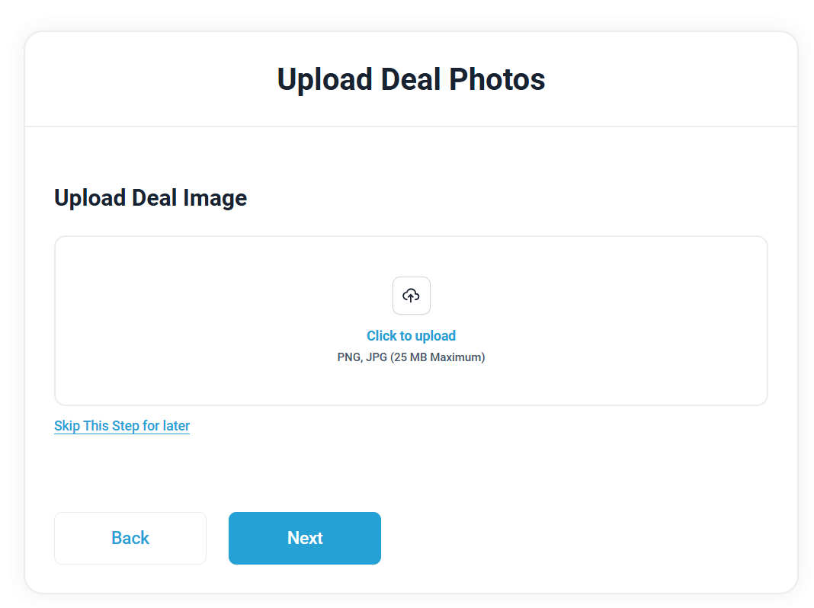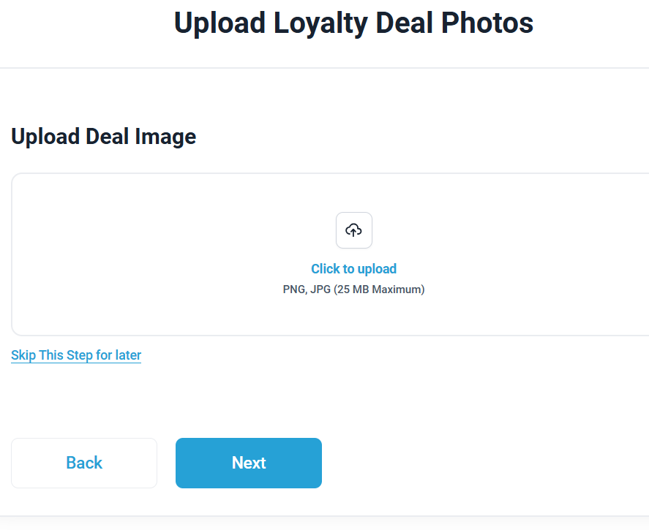

* + Please remove **Make Main Photo**
  + User can select **Click to Upload** to change photo
  + **If user does not upload a photo**, business **logo** continue to set as deal and loyalty punch card photo
  + Please add **Click to Upload** option as shown in screenshot below when user selects **Preview Deal** in **Campaign Management** to allow user to change photo on existing deal or program

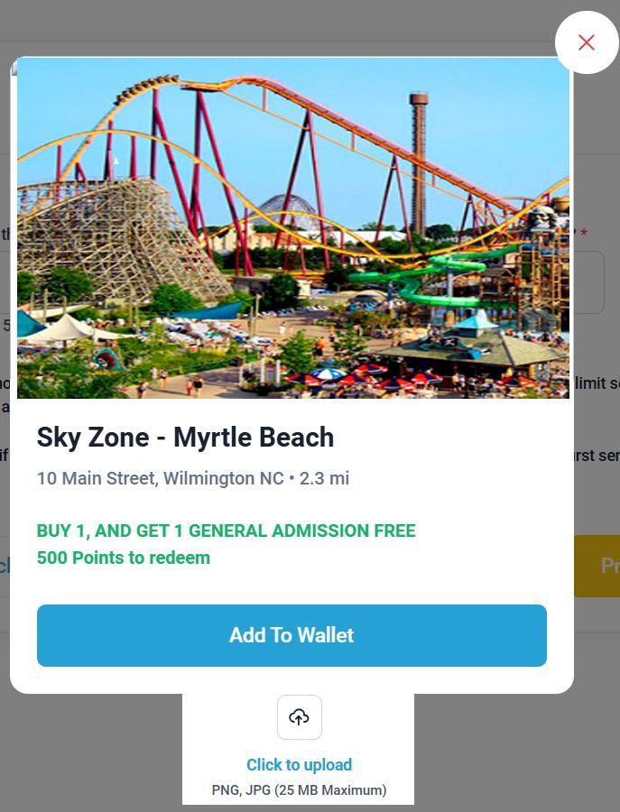

* + Update **Preview Deal** in **Campaign Management** to reflect mobile app preview example as shown in second screenshot below

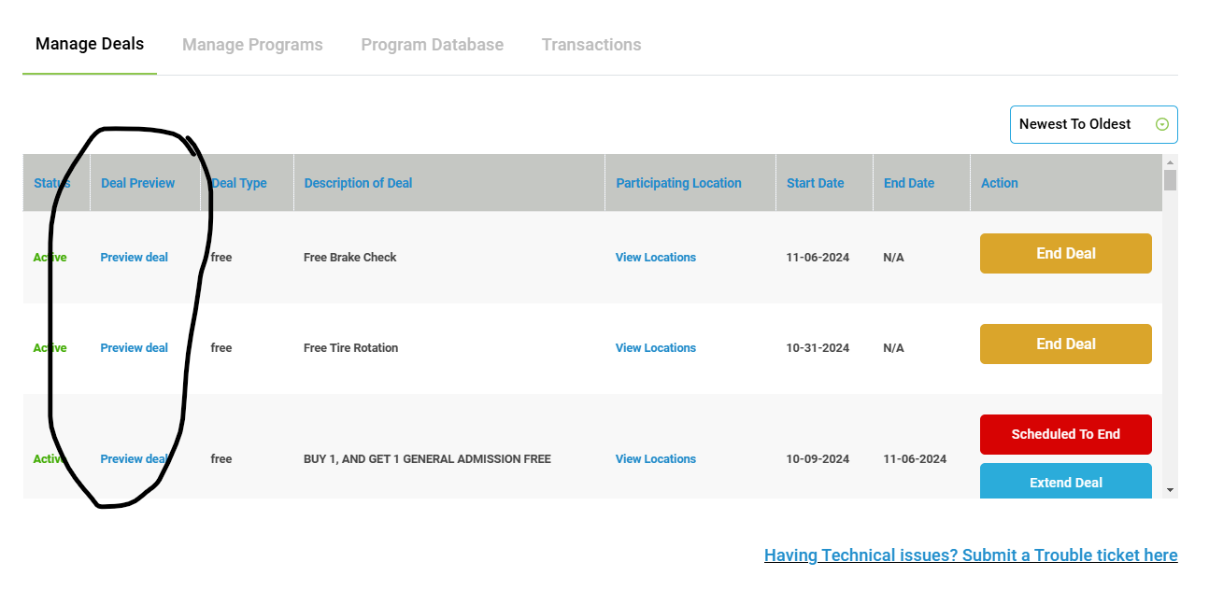

* + - In **Campaign Management > Manage Deals > Preview Deal**



* + Please add **Preview Program** link on **Campaign Management** > **Manage Programs** as shown in screenshot below.

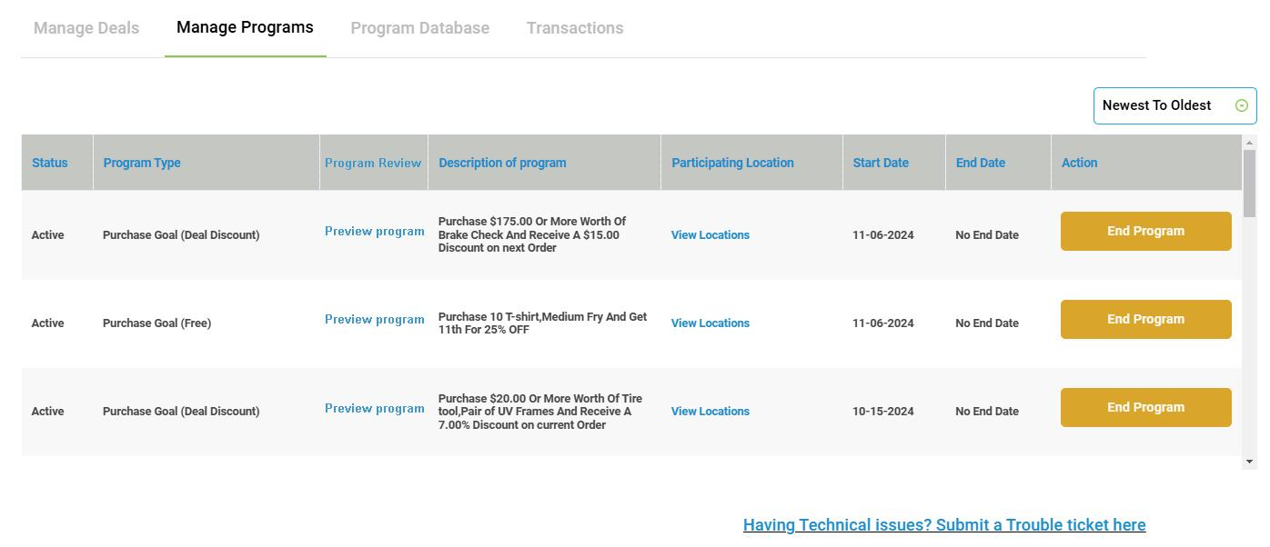

* + When a user selects **Preview program** in **Campaign Management** > **Manage Programs** please reflect mobile app preview example as shown in screenshot below

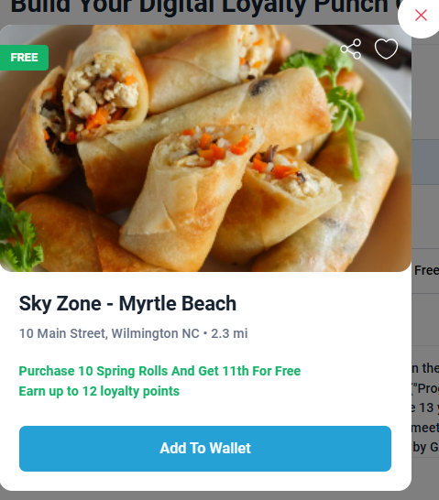

1. **Web HTML page implementation**
   * **Set up HTML pages** for main sections:
     + **Explore Page** (use HTML design)
       1. Add **Coming soon** to **Explore Page** dropdowns as shown below in the first screenshot.
       2. **Disable** action when selecting coming soon links
       3. Remove **Travel and Tourism** Partner and **Community Partner** info from dropdown as shown in second screenshot

### 

### 

* + - **Small Business Signup Page** (use HTML design)
      1. Add **Stripe checkout integration** (Stripe account is active, what is needed?)
    - **Business Pricing Page**
    - **Account** (use HTML design)
    - **My Badges** (use Coming Soon design)
    - **My Family and Friends** (use Coming Soon design)
    - **Mt Favorites** (use HTML design)
    - **Gimmzi Referral Program** (use Coming Soon design)
    - **My Wallet** (use HTML design)

### **Phase 2: Mobile App Rollout, Admin & Production Readiness**

1. **"Coming Soon" Placeholder Screens on the following mobile app screens**
   * Add **Coming Soon** placeholders for:
     + **Earn More Points** (use Coming Soon design)
     + **Gimmzi Referral Program** (use Coming Soon design)
     + **My Inbox** (use Coming Soon design)
     + **My Family and Friends** (use Coming Soon design)
2. **App Development**
   * **Update** the following screens**:**
     + **My Wallet**
       1. **Loyalty Punch Card Redemption Correction** - After each purchase for both purchase and spend goal, the progress is saved and the following purchase is added..
          1. For example, if a member spends $10.54 towards a $25 goal, after that user enters the amount and enters the Gimmzi ID, the amount is saved and the slide adjusts to $10.54. Then the member comes back and makes a new purchase for $8.04. The user will enter $8.04 and the slide will adjust by adding to the existing balance of $10.54 ($10.54 + $8.04 = $18.58) and the slide will then adjust to $18.58. The member will continue to return until the amount reaches $25 or more.
     + **Points Panel**
       1. **Total Points:** Located at top of screen is the total **Earned Loyalty** **Points** and **Gimmzi Badge** points
       2. **Earned Loyalty Points:** These are the first points to be deducted. If available, when a member is redeeming a deal. Members have **45 days** from the last earned point to spend these points. Countdown is reset each time a member earns a point. **Maximum of 800 Earned Loyalty Points.** Points are added to Earned Loyalty Points section when:
          1. A member participates in a loyalty punch cards, the points earned goes here
       3. **Gimmzi Badge**: Badge every member receives for signing up to Gimmzi. All Gimmzi badges are 80 points
          1. **Points** automatically refill to 80 points. If a member uses all of their Earned Loyalty Points (or do not have any earned loyalty points) points are deducted from this bucket. If the member does not use any Gimmzi Badge for the month, no changes, the member will have 80 points to use the next month

Example, if a member uses 74 Gimmzi Badge points and has 6 points left. They attempt to redeem a deal that is 20 points, they will receive an prompt:

You don’t have enough points to add this deal to your wallet. Explore Loyalty Punch Cards to earn more points and unlock more rewards today!

* + - * 1. **Refill Date**: The next refill date. Gimmzi Badges are refilled to 80 points on the first of each month.
    - **Categories**
      1. Update to default to show **ALL categories**

1. **Admin**
   * Issue not allow admin user to approve a business by using **Active** dropdown. When selecting Active and Save, no changes are made. Please correct this to allow onboarding.
2. **Mobile App Publishing**
   * Publish to **Apple App Store** and **Google Play Store** after the above is complete.
3. **Ongoing Web and Mobile app Updates**
   * For all features marked as "Coming Soon," please proceed with pushing the latest updates to the Staging environment and working Gimmzi internal team. After confirming updates, we’ll move forward with deploying these updates to Production in phases until all are fully live.